DISTRICT PLAN TEXT AMENDMENTS
Key:
For the purposes of this plan change, any unchanged text is shown as normal text or in bold, any text proposed to be added by the plan change is shown as bold underlined and text to be deleted as bold strikethrough.
Text in bold red underlined is that from Schedule 3A of the Resource Management Act and must be included.
Text in green font identifies existing terms in Chapter 2 – Definitions. Where the proposed change contains a term defined in Chapter 2 – Definitions, the term is shown as bold underlined text in green and that to be deleted as bold strikethrough in green. New definition in a proposed rule is bold green text underlined in black.
Text in bold purple underlined indicates text recommended in the s42A report to be added and text in bold purple strikethrough text recommended in the s42A report to be deleted. Text in normal black font with purple underline indicates text that was proposed to be deleted in the notified PC14 and is recommended to be reinstated.
Text in purple is a plan change proposal subject to Council Decision.
Text in purple shaded in grey is a Plan Change Council Decision.
Text in black/green shaded in grey is a Council Decision subject to appeal.
Text in bold light blue strickethrough shaded in grey with a purple underline is a Council decision proposed to be deleted by this Plan Change.
Text in blue font indicates links to other provisions in the district Plan and/or external documents. These will have pop-ups and links, respectively, in the on-line Christchurch District Plan.

  - Rules — High Density Residential Central City Zone
    - Activity status tables
- Permitted activities
a. The activities listed below are permitted activities in the High Density Residential Central City Zone if they meet the activity specific standards set out in this table and the built form standards in Rule 14.6.2.
b. Activities may also be controlled, restricted discretionary, discretionary, non­complying or prohibited as specified in Rules 14.6.1.2, 14.6.1.3. 14.6.1.4, 14.6.1.5 or 14.6.1.6.
Activity |  | Activity specific standards
P1 | Residential activity | - No more than one heavy vehicle shall be stored on the site of the residential activity.  - Any motor vehicles and/or boats built, dismantled, repaired or stored on the site of the residential activity shall be owned by people who live on the same site.  - In relation to the building, dismantling, repair or storage of motor vehicles, the vehicles shall be contained in a building, or, if the vehicles are not contained in a building, there shall be no more than three vehicles involved.  - In relation to the building, dismantling, repair or storage of boats, collectively the boats shall occupy no more than 45m².  - There shall be no more than 3 residential units per site.
P2 | Bed and breakfast  (Plan Change 4 Council Decision subject to appeal) | - There shall be:  - a maximum of six guests accommodated at any one time;  - at least one owner of the residential unit residing permanently on site; and  - no guest given accommodation for more than 90 consecutive days.  (Plan Change 4 Council Decision subject to appeal)
P32 | Relocation of a building | Nil
P4 | Development of Lot 1 DP 475662, for the purposes of residential activities.  If the activity specific standards are met then no other provisions apply. | - There shall be not less than 50 residential units and not more than 90 residential units developed on the site.  - The development of these units may proceed in stages of not less than 9 residential units at a time, with the first stage to comprise not less than 10 residential units.  - All residential units shall be completed by 30 June 2020.  - No building shall exceed 15 metres in height.  - The gross floor area of all non­residential activities on the site shall not exceed 525m².  - All non­residential activities shall be situated at ground floor.
P53 | Market gardens, community gardens, and garden allotments. | Nil
P64 | Repair or rebuild of multi-unit residential complexes damaged by the Canterbury earthquakes of 2010 and 2011 on properties with cross leases, company leases or unit titles as at the date of the earthquakes | - Where the repair or rebuild of a building will not alter the footprint of the building, location, or height, the building need not meet the built form standards.  - Where the footprint of the building, location, or height is to be altered no more than necessary in order to comply with legal or regulatory requirements or the advice of a suitably qualified and experienced chartered engineer:  - the only built form standards that shall apply are those specified in Rules 14.6.2.1 – Building height and 14.6.2.2 – Daylight recession planes Height in relation to boundary;  ii. in relation to the road boundary setback, the repaired or rebuilt building shall have a setback of at least 3 metres;  iii. the standards at (i) and (ii) shall only apply to the extent that the repaired or rebuilt building increases the level of non-compliance with the standard(s) compared to the building that existed at the time of the earthquakes.  Advice note:  - Examples of regulatory or legal requirement that may apply include the New Zealand Building Code, Council bylaws, easements, and other rules within this Plan such as the requirements for minimum floor levels in Chapter 5.  - If paragraphs a. and b. do not apply, the relevant built form standards apply.  - Any application arising from not meeting standards a. and b.i. shall not be publicly notified, and may be limited notified to adjoining property owners, (where the consent authority considers this is required, and absent written approval).  - Any application arising from not meeting standard b.ii. (road boundary setbacks), shall not be publicly or limited notified.
P75 | Care of non-resident children within a residential unit in return for monetary payment to the carer | - There shall be:  - a maximum of four non­resident children being cared for in return for monetary payment to the carer at any one time; and  - at least one carer residing permanently within the residential unit.
P86 | Any non-residential activity or home occupation up to 40m² gross in total floor area (including comprising the floor area of the building or part of the building (measured internally) and any area of outdoor storage area used for the activity) that is otherwise not provided for under Rule 14.6.1.1 P97 and P108.  (Plan Change 5D Council Decision) | - Only those persons who reside permanently on the site can be employed in the activity.  - The maximum total number of hours the site shall be open to visitors, clients or deliveries for the activity shall be 40 hours per week, and shall be limited to between the hours of:  - 0700 – 2100 Monday to Friday, and  - 0800 – 1900 Saturday, Sunday, and public holidays.  - The maximum number of vehicle movements per site, other than for residential activities, shall be:  - heavy vehicles: 2 per week; and  - other vehicles: 16 per day.  - Boarding animals on a site shall be limited to a maximum of four animals in the care of a registered veterinarian for medical or surgical purposes only.  - Manufacturing, altering, repairing, dismantling or processing of any materials, goods or articles shall be carried out in a fully enclosed building.  (Plan Change 5D Council Decision)
P97 | Any education facility activity, spiritual activity, health care facility, or preschool (other than as provided for in Rule 14.6.1.1 P75), or guest accommodation up to 40m² gross in total floor area (including comprising the floor area of the bulding or part of the building (measured internally) and any area of outdoor storage area used for activities other than residential activities), except those activities provided for in Rule 14.6.1.1 P108.  (Plan Change 4 Council Decision subject to appeal)  (Plan Change 5D Council Decision) | - Only those persons who reside permanently on the site can be employed in the activity.  - The maximum total number of hours the site shall be open to visitors, clients or deliveries for the activity, other than for guest accommodation activities, shall be 40 hours per week, and shall be limited to between the hours of:  - 07:00 – 21:00 Monday to Friday, and  - 08:00 – 19:00 Saturday, Sunday, and public holidays.  - The maximum number of vehicle movements per site, other than for residential activities, shall be:  - heavy vehicles: 2 per week; and  - other vehicles: 16 per day.  - The activity shall not include the storage of more than one heavy vehicle on the site of the activity.  (Plan Change 4 Council Decision subject to appeal)
P108 | Any community facility, preschool (other than as provided for in Rule 14.6.1.1 P75), or guest visitor accommodation on Fitzgerald Avenue, or Bealey Avenue between Durham Street North and Madras Street.  (Plan Change 4 Council Decision subject to appeal) | - The maximum total number of hours the site shall be open to visitors, clients or deliveries for the activity shall be 40 hours per week, and shall be limited to between the hours of:  - 07:00 – 21:00 Monday to Friday, and  - 08:00 – 19:00 Saturday, Sunday, and public holidays.  - Except that the hours of operation in Rule 14.6.1.1 P108 a.i. and a.ii. do not apply to guest visitor accommodation.  - The maximum number of vehicle movements per site per day for any activity, other than for residential activities, shall be 200 and:  - Vehicles, other than heavy vehicles associated with any residential activity on the site, shall be included in determining the number of vehicle movements to and from any site. Vehicles parking on the street or on any other site, in order that their occupants can visit the site, shall also be included in determining the number of vehicles trips to and from any site.  (Plan Change 4 Council Decision subject to appeal)
P119 | Fire stations on Lot 1 DP 53863 | Nil
P1210 | - Activity associated with a retirement village.  - This activity does not include any new building, or alteration or addition to an existing building, for a retirement village (Refer to Rule 14.6.1.3 RD4 and RD5).  - The built form standards in Rule 14.6.2 do not apply to this activity. | Nil
P1311 | Activity associated with a cultural activity at 52 Rolleston Avenue (Lot 2 DP 496200) | - The hours the site shall be open to visitors, clients or deliveries for any activity other than residential activities shall be limited to between the hours of:  - 07:00 – 21:00 Monday to Friday, and  - 08:00 – 19:00 Saturday, Sunday, and public holidays.
P1412 | Hosted visitor accommodation  (Plan Change 4 Council Decision subject to appeal) | - A maximum of six guests shall be accommodated at any one time.  - The Council shall be notified in writing prior to commencement.  - The owner of the unit shall keep records of the number of nights booked per year, as commencing on 1 January of that year, and the dates used for hosted visitor accommodation and provide those records to the Council on request.  - The owner of the unit shall have procedures in place for managing adverse effects on neighbours from guests checking­in between the hours of 22.00pm and 06.00am, and shall provide those procedures to the Council on request  (Plan Change 4 Council Decision subject to appeal)
P1513 | Visitor accommodation in a heritage item  (Plan Change 4 Council Decision subject to appeal) | - A permanent resident or manager/supervisor for the property shall be in residence on the site for the duration of any visitors’ stays.  - A maximum of ten guests shall be accommodated at any one time.  - The Council shall be notified in writing prior to commencement.  - The owner of the unit shall keep records of the number of nights booked per year, as commencing on 1 January of that year, and the dates used for hosted visitor accommodation and provide those records to the Council on request.  - The owner of the unit shall have procedures in place for managing adverse effects on neighbours from guests checking­in between the hours of 22.00pm and 06.00am, and shall provide those procedures to the Council on request.  (Plan Change 4 Council Decision subject to appeal)

- Controlled activities
There are no controlled activities.
Activity |  | The matters over which Council reserves its control:
C1 | Unhosted visitor accommodation in a residential unit:  - for a total per site of 60 nights or fewer per year;  - for a maximum of six guests at any one time.  (Plan Change 4 Council Decision subject to appeal) | - Provision of information for neighbours and guests, including contact information, parking restrictions, and, where appropriate, hazards information  - Record keeping and provision of information to the Council  - Management of outdoor entertainment and recreation facilities  - Management of solid waste disposal  - Number and size of vehicles used by guests including large vehicles  - Building access arrangements and wayfinding  - Controls on the effects and scale of functions or events  - Controls on check­in and check­out times.  (Plan Change 4 Council Decision subject to appeal)
C2 | Visitor accommodation in a heritage item that does not comply with activity specific standard (a) in Rule 14.6.1.1 P1513.  (Plan Change 4 Council Decision subject to appeal) | - Provision of information for neighbours and guests, including contact information, parking restrictions, and, where appropriate, hazards information  - Record keeping and provision of information to the Council  - Management of outdoor entertainment and recreation facilities  - Management of solid waste disposal  - Number and size of vehicles used by guests including large vehicles  - Building access arrangements and wayfinding  - Controls on the effects and scale of functions or events  - Controls on check­in and check­out times.  (Plan Change 4 Council Decision subject to appeal)
C3 | - Communal waste and recycling area that does not comply with Built Form Standard 14.6.2.11.a.i or iii. (in relation to bin storage only).  - Any application arising from this rule shall not be publicly notified. | - Accessibility to the communal area for the required service vehicle size and type, including the extent of sealed areas required for onsite manoeuvring and effects on safety and onsite amenity;  - Scale of service space and size and number of receptacles to support the number of residential units;  - Screening of service area and separation from residential units and outdoor living areas;  - Management of odour and vermin; and  - Evidence of consultation with the Christchurch City Council Transport and Waste Management Unit about the suitability of the proposed waste management solution.

- Restricted discretionary activities
            - The activities listed below are restricted discretionary activities.
            - Discretion to grant or decline consent and impose conditions is restricted to the matters of discretion set out in Rule 14.15, as set out in the following table.

Activity |  | The Council’s discretion shall be limited to the following matters:
RD1 | - Any permitted activity, or a cultural activity at 52 Rolleston Avenue (Lot 2 DP 496200), that does not meet one or more of the built form standards in Rule 14.6.2.  - Any application arising from the following built form standards shall not be limited or publicly notified:  i. Rule 14.6.2.3 Road boundary building  ii. Rule 14.6.2.5 Fencing and screening  iii. Rule 14.6.2.7 Tree and garden planting  iv. Rule 14.6.2.7 Minimum residential unit size  v. Rule 14.6.2.8 Ground floor habitable space  vi. Rule 14.6.2.9 Outdoor living space  vii. Rule 14.6.2.10 Service space  viii. Rule 14.6.2.11 Minimum site density from development and redevelopment of residential units  cb. Any application arising from Rule 14.6.2.123 shall not be publicly notified and shall be limited notified only to the Fire and EmergencyNew Zealand Fire Service (absent its written approval). | - As relevant to the built form standard that is not met:  - Building height - Rule 14.15.2730.  - Daylight recession planes – Rule 14.15.2831.  - Street scene and accessways – Rule 14.15.2932.  - Minimum building setbacks from internal boundaries - Rule 14.15.303.  - Fencing and screening – Rule 14.15.314.  - Landscaping and tree planting – Rule 14.15.325.  vii. Minimum unit size – Rule 14.15.4.  viii. Ground floor habitable space – Rule 14.15.25.  ix. Outdoor living space - Rule 14.15.20.  x. Service space – Rule 14.15.26.  xi. Minimum site density from development and redevelopment of residential units – Rule 14.15.34.  xii. vii. Water supply for firefighting – Rule 14.15.78
RD2 | - Any activity involving the erection of new buildings and alterations or additions to existing buildings including all accessory buildings, fences and walls associated with that development, that result in:  - three four or more residential units; or  - one or two residential units on a site smaller than 300m² gross site area Any residential unit that does not meet the garage and carport Rule 14.6.2.14 – Garaging and carparkort building location; or  - Any residential unit that does not meet Rule 14.6.2.9 – Ground floor habitable room.  cb. Any application arising from this a.ii or a.iii. of this rule shall not be limited or publicly notified.  c. Any application arising from a.i. of this rule shall not be limited or publicly notified where compliant with the following built form standards:  - 14.6.2.1 – Building height  - 14.6.2.2 – Height in relation to boundary  - 14.6.2.3 – Setbacks  - 14.6.2.4 – Outlook space  - 14.6.2.7 – Landscaped area and tree canopy cover  - 14.6.2.8 – Windows to street  - 14.6.2.10 – Outdoor living space  - 14.6.2.12 – Building coverage | - Urban design in the Residential Central City Zone – Rule 14.15.33  - For RD2 a.i., Rresidential design principles – Rule 14.15.1  - For RD2 a.ii. and a.iii., residential design principles – Rule 14.15.1 d., g., and h., only.
RD3 | - Cultural activity at 52 Rolleston Avenue (Lot 2 DP 496200).  - Any application arising from this rule shall not be limited or publicly notified. | - Urban Design in the High Density Residential Central City Zzone within the Central City – Rule 14.15.336
RD4 | - Any new building, or alteration or addition to an existing building for a retirement village that meet the following built form standards:  - Rule 14.6.2.1 Building height  - Rule 14.6.2.2 Daylight recession planes Height in relation to boundary  - Rule 14.6.2.3 Road boundary building setback  iviii. Rule 14.6.2.43 Minimum building setbacks from internal boundaries  iv. Rule 14.6.2.123 Water supply for firefighting  - Any application arising from this rule shall not be limited or publicly notified. | - Retirement villages – Rule 14.15.910
RD5 | - Any new building, or alteration or addition to an existing building for a retirement village that does not meet one or more of the following built form standards:  - 14.6.2.1 Building height  - Rule 14.6.2.2 Daylight recession planes Height in relation to boundary  - Rule 14.6.2.3 Road boundary building setback  Iviii. Rule 14.6.2.43 Minimum building setbacks from internal boundaries  viv. Rule 14.6.2.123 Water supply for firefighting  - Any application arising from Rule 14.6.2.3 shall not be limited or publicly notified.  - Any application arising from Rule 14.6.2.123 shall not be publicly notified and shall be limited notified only to the Fire and Emergency New Zealand Fire Service (absent its written approval). | - Retirement villages – Rule 14.15.910  And as relevant to the built form standard that is not met:  - Building height in the High Density Residential zone within the Central City – Rule 14.15.2730  - Daylight recession planes High Density Residential zone within the Central City – Rule 14.15.2831  - Street scene and access ways in the High Density Residential zone within the Central City – Rule 14.15.2932.  - Minimum building setbacks from internal boundaries in the High Density Residential Zone within the Central City – Rule 14.15.303.  - Water supply for firefighting – Rule 14.15.78
RD6 | - Any residential activity that does not meet Rule 14.6.1.1.P1.e (number of residential units).  - An application arising from this rule shall not be publicly notified. | - Residential urban design principles – Rule 14.15.1
RD7 | - Any building that does not meet rule 14.6.2.1.a – Building height. between 14-20 metres in height above ground level, when the following standards are met:  - A ground level communal outdoor living space shall be provided at a ratio of 50m² per 10 residential units. The number of units shall be rounded to the nearest 10, in accordance with the Swedish rounding system. This ratio shall be calculated on the number of residential units on the 4th floor of the building and any subsequent floors above, with the maximum required area being 20% of the site area. Any communal outdoor living space shall have a minimum dimension of no less than 8 metres.  - Any building exceeding 20 metres in height up to 32 metres in height above ground level (except within the High Density Residential Precinct, Large Local Centre Intensification Precinct, or Town Centre Intensification Precinct), where the following standards are met:  - The standards in RD7.a. i.;  - The building is set back at least 6 metres from all internal boundaries; and  - The building is set back at least 3 metres from any road boundary. | - Impacts on neighbouring property – Rule 14.15.3.a.
RD8 | - Any building that does not meet rule 14.6.2.1.b – Building height. over 32 metres in height above ground level.  - Any application arising from this rule shall not be publicly notified. building over 20 metres in height above ground level within the High Density Residential Precinct, Large Local Centre Intensification Precinct, or Town Centre Intensification Precinct. | - Impacts on neighbouring property – Rule 14.15.3.a and c.
RD9 | - Buildings that do not meet Rule 14.6.2.2 – Height in Relation to Boundary  - Any application arising from this rule, for up to three residential units per site shall not be publicly notified. | - Height in relation to boundary breaches – Rule 14.15.4
RD10 | - Buildings that do not meet Rule 14.6.2.3 – Setbacks.  - Any application arising from Rule 14.6.2.3.a.i shall not be limited or publicly notified.  - Any application arising from this rule, for up to three residential units per site shall not be publicly notified. | a. Impacts on neighbouring property – Rule 14.15.3.a
RD11 | - Buildings that do not meet Rule 14.6.2.4 – Outlook space.  - Any application arising from this rule, for up to three residential units per site shall not be publicly notified. | - Impacts on neighbouring property – Rule 14.15.3
RD12 | Development that does not meet Rule 14.6.2.6 - Fencing  - Any application arising from this rule shall not be publicly notified. | - Residential fencing – Rule 14.15.14
RD13 | - Development that does not meet Rule 14.6.2.7 – Landscaped area and tree canopy cover.  - Any application arising from this rule shall not be limited or publicly notified. | - Residential landscaping – Rule 14.15.24
RD14 | - Buildings that do not meet Rule 14.6.2.10 – Outdoor living space.  - Any application arising from this rule shall not be limited or publicly notified. | - Outdoor living space – Rule 14.15.21
RD15 | - The erection of new residential units and alterations or additions to residential units that do not meet Rule 14.6.2.8 – Windows to street.  - Any application arising from this rule shall not be limited or publicly notified. | - Street-facing glazing non-compliance – Rule 14.15.23
RD16 | a. Residential units that do not meet Rule 14.6.2.11 a.ii, and a.iii (in relation to washing line area only) and b. – Service, storage and waste management.  b. Any application arising from this rule shall not be publicly notified. | - Service, storage and waste management spaces – Rule 14.15.20
RD17 | - New buildings, structures or additions greater than 20 metres in height from ground level that do not result in wind conditions that exceed the following cumulative standards (Gust Equivalent Mean) more than 5% annually at ground level, within 100 metres of the site based on modelling:  - 4m/s at the any boundary of any site, if that boundary adjoins public open spaces, private outdoor living spaces, and footpath; or  - 6m/s within any carriageway or car parking areas provided within or outside the site.  - New buildings, structures or additions greater than 20 metres in height that do not result in wind speeds exceeding 15 MUZ wind speeds more than 0.3% annually at ground level.  - The requirement of a. and b. shall be demonstrated by a suitably qualified professional. | - Assessment of wind – Rule 14.15.29
RD18 | - Residential units that do not meet Rule 14.6.2.12 – Building coverage.  - Any application arising from this rule, for up to three residential units per site shall not be publicly notified. | - Site density and site coverage – Rule 14.15.2
RD19 | - Buildings that do not meet Rule 14.6.2.5 – Building separation.  - Any application arising from this rule shall not be publicly notified. | - Height in relation to boundary breaches – Rule 14.15.4  - The impact on any communal spaces, including access ways.
RD20 | - Any garage or carport that does not meet the garage and carport Rule 14.6.2.14 – Garaging and carport building location; or  - Any habitable room that does not meet Rule 14.6.2.9 – Ground floor habitable room.  - Any application arising from this rule shall not be limited or publicly notified. | - Residential design principles – Rules 14.15.1.d and 14.15.1.h
RD21 | - Activities that do not meet Rule 14.6.2.15 – Location of outdoor mechanical ventilation.  - Any application arising from this rule shall not be limited or publicly notified. | - Residential design principles – Rules 14.15.1.d and 14.15.1.  - Street scene – road boundary setback, fencing and planting – Rule 14.15.18 a.-d.
RD22 | - Any residential unit that does not meet the building height Rule 14.6.2.1.b (except for Rule 14.6.2.1 (d) (within the Industrial Interface Qualifying Matter Area) refer to Rule 14.6.1.4 D7).  - Any application arising from this rule shall not be limited or publicly notified. | - Minimum building height in the High Density Residential Zone – Rule 14.15.41
RD23 | - Any building that does not meet Rule 14.6.2.17 – Minimum road boundary setback - Qualifying Matter City Spine Transport Corridor | - Residential design principles – Rule 14.15.1.j
RD24 | - Outside the Central City, activities that do not meet one or more of the activity specific standards in Rule 14.6.1.1 (except for P7 standard d., refer to Rule 14.6.1.4 D2) for:  - P7 Any education activity, spiritual activity, health care facility, or preschool (other than as provided for in Rule 14.6.1.1 P5 and Rule 14.6.1.4 D1);  - Any application arising from these rules shall not be limited or publicly notified. | - As relevant to the activity specific standard that is not met:  - Scale and nature of activity - Rule 14.15.6  - Traffic generation and access safety - Rule 14.15.7  - Non-residential hours of operation - Rule 14.15.25
RD25 | - Buildings that do not comply with 14.6.2.18 – Building length.  - Any application arising from these rules shall not be publicly notified. | - Residential design principles – Rule 14.15.1.e.

Advice Note:
- Rule 9.3.4.1.3 RD8 (Restricted Discretionary activities) applies to any new building (except buildings of less than 5 m in height) on a site in the High Density Residential Zone which is located outside a Residential Heritage Area but shares a boundary with a site or sites in a Residential Heritage Area.
- Discretionary activities
  - The activities listed below are discretionary activities
Activity
D1 | Development of Lot 1 DP 475662, for the purposes of residential activities as listed in Rule 14.6.1.1 P4 that does not meet any one or more of the activity specific standards.
D21 | - Within the Central City, Aany education facility, spiritual activity, health care facility, or preschool (other than as provided for in Rule 14.6.1.1 P75 and Rule 14.6.1.4 D3), or guest accommodation that is over 40m² but less than 201m² in gross total floor area (including comprising the floor area of the building or part of the building (measured internally) and any area of outdoor storage area used for activities), other than:  - on a site with frontage to Fitzgerald Avenue, or Bealey Avenue between Durham Street North and Madras Streets; or  - on a site with frontage to a local road,  - provided that the following standards are met:  - For guest accommodation, at least one employee must must reside permanently on the site. (Plan Change 4 Council Decision subject to appeal)  - For guest accommodation, at least one employee must must reside permanently on the site. (Plan Change 5D Council Decision)  - The maximum total number of hours the site shall be open to visitors, clients or deliveries for the activity shall be 40 hours per week, and shall be limited to between the hours of:  - 0700 - 2100 Monday to Friday, and  - 0800 - 1900 Saturday, Sunday and public holidays.  - Except that these hours of operation in Rule 14.6.1.4 D2 b.ii. do not apply to guest accommodation (Plan Change 4 Council Decision subject to appeal)
D32 | - Activities that do not meet any one or more of the activity specific standards in Rule 14.6.1.1 for:  - P1 Residential activity (except P1.e, which is considered under RD2)  - P2 Bed and breakfast (Plan Change 4 Council Decision subject to appeal)  - P75 Care of non-resident children in a residential unit  - Storage of more than one heavy vehicle for activities for P7.
D43 | Any other activity that is not listed as a permitted, restricted discretionary, or non-complying.
D54 | - Hosted visitor accommodation that does not comply with activity specific standards in Rule 14.6.1.1 P1412 and that does not exceed twelve guests per site at any one time.  - Any application arising from this rule shall not be publicly notified but may be limited notified.  (Plan Change 4 Council Decision subject to appeal)
D65 | - Unhosted visitor accommodation that does not comply with Rule 14.6.1.2 C1 and that does not exceed twelve guests per site at any one time.  - Any application arising from this rule shall not be publicly notified but may be limited notified.  (Plan Change 4 Council Decision subject to appeal)
D76 | - Visitor accommodation in a heritage item that does not comply with activity specific standards (b) ­ (e) in Rule 14.6.1.1 P1513 and that does not exceed twenty guests per site at any one time.  - Any application arising from this rule shall not be publicly notified but may be limited notified.  (Plan Change 4 Council Decision subject to appeal)
D7 | Any building for a residential activity that does not meet Rule 14.6.2.1 (d)c. Building height within the Industrial Interface Qualifying Matter Area.

(Plan Change 4 Council Decision subject to appeal)
(Plan Change 5D Council Decision)
- Non-complying activities
- The activities listed below are non-complying activities.
Activity
NC1 | Any non-residential activity or home occupation not otherwise provided for as a permitted, restricted discretionary, discretionary or non-complying activity with a gross total floor area over 40m² (including comprising the floor area of the building or part of the building (measured internally) and any area of outdoor storage area used for that activity).  (Plan Change 5D Council Decision)
NC2 | Any activity listed in Rule 14.6.1.1 P86 that does not meet any one or more of the activity standards in Rule 14.6.1.1 P86 a.-e.
NC3 | Any activity listed in Rule 14.6.1.1 P97 that does not meet any one or more of the activity standards in Rule 14.6.1.1 P97 a.-c.
NC4 | Any activity listed in Rule 14.6.1.1 P108 that does not meet any one or more of the activity standards in Rule 14.6.1.1 P108 a.-b.
NC5 | Within the city centre, Aany education facility, spiritual activity, health care facility, or preschool (other than as provided for in Rule 14.6.1.1 P75 and Rule 14.6.1.4 D3), or guest accommodation with a gross total floor area over 40m² (including comprising the floor area of the building or part of the building (measured internally) and any area of outdoor storage area) with frontage to a local road.  (Plan Change 4 Council Decision subject to appeal)  (Plan Change 5D Council Decision)
NC6 | Within the city centre, Aany education facility, spiritual activity, health care facility, or preschool (other than as provided for in Rule 14.6.1.1 P75 and Rule 14.6.1.4 D3), or guest accommodation that exceeds a gross total floor area of 200m² (including comprising the floor area of the building or part of the building (measured internally) and any area of outdoor storage area) other than on a site with frontage to Fitzgerald Avenue, or Bealey Avenue between Durham Street North and Madras Streets.  (Plan Change 4 Council Decision subject to appeal)  (Plan Change 5D Council Decision)
NC7 | Any activity listed in Rule 14.6.1.4 D21 that does not meet any one or more of the standards in Rule 14.6.1.4 D21 b.i.-ii.
NC8 | - Visitor accommodation (other than as provided for in Rule 14.6.1.1 P108 and 14.6.1.5 NC4): that is:  - not hosted visitor accommodation, unhosted visitor accommodation or visitor accommodation in a heritage item;  - hosted visitor accommodation that exceeds the maximum number of guests in Rule 14.6.1.4 D54;  - unhosted visitor accommodation that exceeds the maximum number of guests in Rule 14.6.1.4 D65; or  - visitor accommodation in a heritage item that exceeds the maximum number of guests in Rule 14.6.1.4 D76.  - Any application arising from this rule shall not be publicly notified but may be limited notified.

(Plan Change 4 Council Decision subject to appeal)

(Plan Change 5D Council Decision)
- Prohibited activities
There are no prohibited activities.
NOTE: None of the medium density residential standards (MDRS) are in immediate legal effect as the Council has proposed a sunlight access qualifying matter that applies to all of the medium and high density residential zones (see section 86BA(1)(c)(ii) of the Resource Management Act 1991). They will not be in legal effect until after an IHP hearing and recommendation by the IHP to Council on those rules.
NB: This advice note should be removed prior to the sub-chapter becoming operative.

    - Built form standards

- The following built form standards shall be met by all permitted activities and restricted discretionary activities RD2, unless otherwise stated.

Advice note:
- There is no spare, or limited, wastewater, storm water, or water supply infrastructure capacity in some areas of Christchurch City which may create difficulties in granting a building consent for some developments. Alternative means of providing for those services may be limited or not available. Compliance with the District Plan does not guarantee that connection to the Council’s reticulated infrastructure is available or will be approved. Connection to the Council’s reticulated infrastructure requires separate formal approval from the Council. There is a possibility that approval to connect will be declined, or development may trigger the need for infrastructure upgrades or alternative servicing at the developer’s cost. Anyone considering development should, at an early stage, seek information on infrastructure capacity from Council’s Three Waters Unit. Please contact the Council’s Three Waters Unit at WastewaterCapacity@ccc.govt.nz, WaterCapacity@ccc.govt.nz and Stormwater.Approvals@ccc.govt.nz.
- Reference should be made to 6.1A for applicable qualifying matters that may apply further restrictions to development.
- Building height
- Buildings must not exceed 14 metres in height above ground level. The maximum height of any buildings shall be as shown on the Central City Maximum Building Height planning map, except that the Central City Maximum Building Height planning map does not apply to the following land where a maximum building height of 20 metres shall apply to buildings for a retirement village:
- Lot 1 DP 77997 CT CB46D/74;
- Town Section 118 DP 3780; and
- Town Section 119 DP 3780.
- Residential units shall not be less than 7 metres in height above ground level.
- Buildings for a residential activity within the Industrial Interface Qualifying Matter Area must not exceed 7 metres in height above ground level or two storey, whichever is the lesser.
- Other than where b.v. applies, buildings must not exceed the following height above ground level:
  - 22 metres; or
  - 39 metres within the Central City Residential Precinct.
- The following standards also apply:
  - For any building exceeding 14 metres in height above ground level:
    - any part of the building above 14 metres is set back at least 4 metres from the road boundary.
    - A ground level communal outdoor living space shall be provided at a ratio of 50m² per 10 residential units. The number of units shall be rounded to the nearest 10, in accordance with the Swedish rounding system. This ratio shall be calculated on the number of residential units on the 4th floor of the building and any subsequent floors above, with the maximum required area being 20% of the site area. Any communal outdoor living space shall have a minimum dimension of no less than 8 metres.
  - For any building between 19-22 metres height above ground level (except in the Central City Residential Precinct):
    - That part of the building above 19 metres shall be set back a minimum of 2 metres from the highest part of each façade (including balustrades or similar architectural features) at or below 19 metres; or
    - the roof shall have a pitch of less than 45 degrees measured from the external walls of the building (excluding eaves and gutters to a maximum combined width of 650mm per wall);
  - For any building between 36-39 metres within the Central City Residential Precinct:
    - That part of the building above 36 metres in height above ground level shall be set back between 2 and 5 metres from the highest part of each façade (including balustrades or similar architectural features) at or below 36 metres in height above ground level; or
    - the roof shall have a pitch of less than 45 degrees measured from the external walls of the building (excluding eaves and gutters to a maximum combined width of 650mm per wall);
- Other than where d. applies, residential units shall not be less than be a minimum of 7 metres in height above ground level or two storeys (not including mezzanine floors), whichever is lesser, when developing three or more residential units.
- Buildings for residential activity within the Industrial Interface Qualifying Matter Area must not exceed 7 8 metres in height above ground level or two storeys, whichever is the lesser.

- Daylight recession planes Height in relation to boundary
- No part of any building below a height of 12 metres shall project beyond a building envelope constructed by recession planes shown in Appendix 14.16.2 Diagram D from points 3 metres above ground level along all boundaries. Where the boundary forms part of a legal right of way, entrance strip, access site, or pedestrian access way, the height in relation to boundary applies from the farthest boundary of that legal right of way, entrance strip, access site, or pedestrian access way.
- For any part of a building above 12 metres in height, the recession plane under a. shall apply, unless that part of the building above 12 metres in height is set back from the relevant boundary of a development site as set out below:
- northern boundary: 6 metres;
- southern boundary: 8 metres; and
- eastern and western boundaries: 7 metres
where the boundary orientation is as identified in Appendix 14.16.2 Diagram D, in which case there shall be no recession plane requirement for that part of the building above 12 metres in height.

- This standard does not apply to—
- a boundary with a road:
- existing or proposed internal boundaries within a site:
- site boundaries where there is an existing common wall between 2 buildings on adjacent sites or where a common wall is proposed.
- the construction of three or more residential units to of a maximum of 14 metres in height from above ground level, to any part of a building:
- along the first 20 metres of a side boundary measured from the road boundary; or
- within 60% of the site depth, measured from the road boundary, whichever is lesser. For corner sites, depth is measured from the internal boundaries, that are perpendicular to the road boundary. See Figure 1, below.
except where the boundary is with a site in a residential zone other than HRZ, or an Open Space zone, where iv. A and B shall not apply.

a. Buildings shall not project beyond a building envelope constructed by recession planes from points 2.3 metres above internal boundaries with other sites as shown in Appendix 14.16.2C, except that:
- Where an internal boundary of a site abuts an access lot, access strip, or access to a rear allotment, the recession plane may be constructed from points 2.3 metres above the furthest boundary of the access lot, access strip, or access to a rear allotment or any combination of these areas;
- Where buildings on adjoining sites have a common wall along an internal boundary the recession planes shall not apply along that part of the boundary covered by such a wall.
b. Where the building is located in a Flood Management Area, the exemptions in Rule 5.4.1.3 apply (for activities P1-P4 in Table 5.4.1.1b).
c. The level of internal boundaries shall be measured from filled ground level except where the site on the other side of the internal boundary is at a lower level, then that lower level shall be adopted.

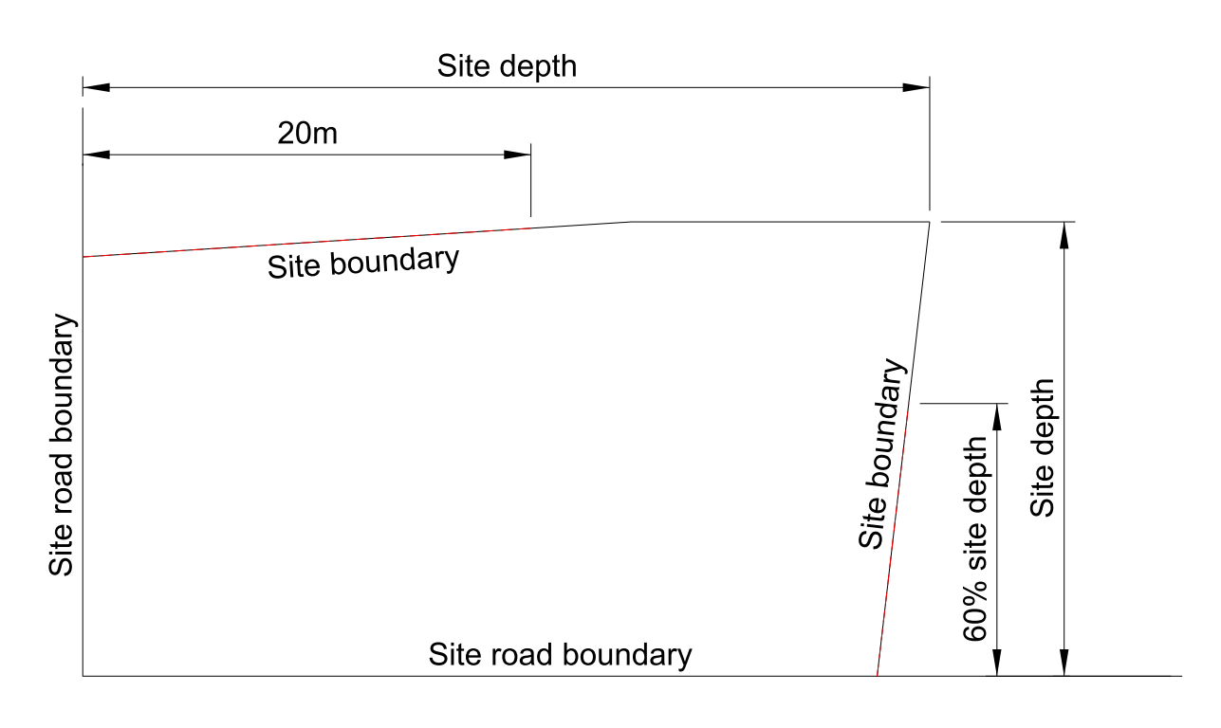
Figure 1: Application of height in relation to boundary exemption for corner sites (14.6.2.2.bc.iv.B)
- Road boundary building Setbacks
            - Buildings must be set back from the relevant boundary by the minimum depth listed below:
- Front: 1.5 metres
- Side: 1 metre
- Rear: 1 metre (excluded on corner sites)
            - This standard does not apply to site boundaries;
- where there is an existing common wall between 2 buildings on adjacent sites or where a common wall is proposed;
- For side and rear setbacks: for accessory buildings, or garages that internally access a residential unit, where the accessory building or garage is less than 3 metres in height and the total length of the building does not exceed 10.1m; and
- For front boundary setbacks: where eaves, and roof overhangs, and gutters, up to 300mm in width and guttering up to 200mm from the wall of a building may intrude into the front boundary setback by a maximum of 650mm (combined measurement); and/or a porch with a maximum width of 1.2m may intrude into the front boundary setback by a maximum of 800mm.
a. For sites fronting Bealey Avenue, buildings shall be setback a minimum of 6 metres from the road boundary of Bealey Avenue;
b. In the locations indicated as Central City Building Setbacks, on the Central City Active Frontages and Verandas and Building Setback Planning Map, buildings shall be setback a minimum of 4.5 metres from road boundaries;
c. In all other instances, buildings shall be setback a minimum of 2 metres from road boundaries, except that:
              - Where a garage has a vehicle door facing a road, the garage door shall be setback a minimum of 4.5 metres unless the garage door projects outward, in which case the garage door shall be setback a minimum of 5.5 metres;
              - Where a garage has the vehicle door facing a shared accessway, the garage door shall be setback a minimum of 7 metres measured from the garage door to the furthest formed edge of the adjacent shared access unless the garage door projects outwards, in which case the garage door shall be setback a minimum of 8 metres;
              - For street fronting residential units, garages, carports, and other accessory buildings (excluding basement parking areas and swimming pools) shall be located at least 1.2 metres further from the road boundary than the front facade of any ground level habitable space of that residential unit.
c. Advice note: Building setback requirements are further controlled by the Building Code. This includes the provision for firefighter access to buildings and egress from buildings. Plan users should refer to the applicable controls within the Building Code to ensure compliance can be achieved at the building consent stage. Issuance of a resource consent does not imply that waivers of Building Code requirements will be considered/granted.

- Minimum building setbacks from internal boundaries
            - Buildings that immediately adjoin an access lot, access strip, or access to a rear site shall be setback a minimum of 1 metres from that part of an internal boundary of a site.
            - Buildings shall be setback a minimum of 1.8 metres from other internal boundaries of a site, except that:
              - no setback is required from an access lot or access strip on the same site, provided that any windows on the ground floor facing and within 1 metre of the access lot or access strip are non­opening;
              - no setback for accessory buildings is required, provided the total length of walls or parts of accessory buildings facing and located within the setback is less than 10.1 metres and/or where the accessory building faces the ground floor window of a habitable space on the adjoining site it shall be setback a minimum of 1.8 metres from that neighbouring window for a minimum length of 2 metres either side of the window;
              - no setback is required along that part of an internal boundary where buildings on adjoining sites have a common wall along the internal boundary;
              - no setback is required for basements, provided that any part of a basement located within 1.8 metres of an internal boundary is wholly below ground level.
            - Parts of a balcony or any window of a living area at first floor level or above shall not be located within 4 metres of an internal boundary of a site, except that this shall not apply to a window at an angle of 90o or greater to the boundary, or a window or balcony which begins within 1.2 metres of ground level (such as above a garage which is partly below ground level).
            - For the purposes of this rule this excludes guttering up to 200mm in width from the wall of a building.

14.6.2.4 Outlook space
            - An outlook space must be provided for each residential unit as specified in this clause.
            - An outlook space must be provided from habitable room windows as shown in the diagram below:
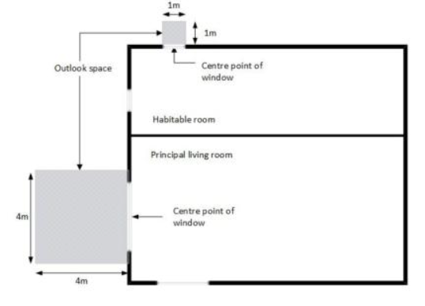
Figure 2: Outlook space
            - The minimum dimensions for a required outlook space are as follows:
              - a principal living room must have an outlook space with a minimum dimension of 4 metres in depth and 4 metres in width; and
              - all other habitable rooms must have an outlook space with a minimum dimension of 1 metre in depth and 1 metre in width.
            - The width of the outlook space is measured from the centre point of the largest window on the building face to which it applies.
            - Outlook spaces may be over driveways and footpaths within the site or over a public street or other public open space.
            - Outlook spaces may overlap where they are on the same wall plane in the case of a multi-storey building.
            - Outlook spaces may be under or over a balcony.
            - Outlook spaces required from different rooms within the same building may overlap.
            - Outlook spaces must—
              - be clear and unobstructed by buildings (excluding any doors or windows opening into an outlook space from the principal living room or habitable room); and
              - not extend over an outlook space or outdoor living space required by another dwelling.
14.6.2.5 Building separation
- Residential units above 12 metres in height above ground level must be separated from any other residential units above 12 metres in height above ground level on the same development site by at least 10 metres measured horizontally, except where a other than where these buildings are joined by a common wall is included.
- 14.6.2.5 Fencing and screening
            - Parking areas shall be screened on internal boundaries by landscaping, wall(s), fence(s), or a combination of these to a minimum height of 1.5 metres from any adjoining site. Where this screening is by way of landscaping it shall be for a minimum depth of 1.5 metres and the minimum height shall be the minimum height at the time of planting;
            - Other than for screening of the required area of service space or outdoor living space, fences and other screening structures shall not exceed 1 metre in height where they are located either:
i. within 2 metres of the road boundary; or
            - a. The maximum height above ground level for any fencing shall be:
 | Fence location | Fence height standard
i. | road boundary – non-arterial road | 50% road boundary width (excluding accessways): 1.58m  Remaining road boundary width: 1.0m
ii. | road boundary – arterial road | 50% road boundary width (excluding accessways): 1.8m  Remaining road boundary width: 1.0m
iii. | Side, rear, and internal boundary (other than where iv. applies) | 2.0m
iv | On the boundary with any land zoned Open Space Community Parks, Open Space Water and Margins and Avon River Precinct/Te Papa Ōtākaro | 1.0m; or  2.0m where the whole fence or screening structure is a minimum of 50% visually transparent.
b. Any fencing requirements under Rule 14.6.2.11 shall not be in addition to the above standards, unless the required fence height in this rule is less than 1.2m adjacent to the proposed storage area/s.
- 1m in height maximum on the boundary with any land zoned Open Space Community Parks Zone, Open Space Water and Margins Zone and Avon River Precinct/Te Papa Ōtākaro Zone, except that the maximum height shall be 2 metres if the whole fence or screening structure is at least 50% transparent.
- For the purposes of this rule, a fence or other screening structure is not the exterior wall of a building or accessory building.
- 14.6.2.6 Tree and garden planting Landscaped area and tree canopy cover
            - A residential unit at ground floor level must have a landscaped area of a minimum of 20% of a developed site with grass or plants, and can include the canopy of trees regardless of the ground treatment below them.
            - The landscaped area may be located on any part of the development site, and does not need to be associated with each residential unit.
            - The 20% landscaped area may be provided as a sum across the site, as long as there is a minimum dimension of 0.6m.
Advice note:
- In addition to these rules, the tree canopy cover and financial contributions requirements in Chapter 6.10A apply to residential development in residential zones resulting in one or more residential units, except where (d) applies.
d. For single and/or multi residential unit developments, a minimum tree canopy cover of 20% of the development site area must be provided in accordance with the Chapter 6.10A rules. The tree canopy cover planting area may be combined with the landscaping area in whole or in part, may be located on any part of the development site, and does not have to be associated with each residential unit.
e. An additional tree canopy cover equivalent to 15% of the road corridor area must be provided in the road corridor in a new greenfield residential subdivision and/or development, or a brownfield site subject to comprehensive residential development where new roads have been / will be created, as specified in the Chapter 6.10A rules.
f. Where the tree canopy cover area is not achieved in full or in part through retaining existing trees and/or planting new trees, the remaining tree canopy cover requirement will be subject to the payment of financial contributions in lieu of tree planting, as specified in the Chapter 6.10A rules.
d.g. For developments not intended for residential activity, Aa minimum of 20% of the site shall be provided for landscaping (which may include private or communal open space in residential developments), where
              - at least 50% of the landscaping shall be trees and shrubs, and
              - a minimum of one native tree for every 250m² of gross site area (prior to subdivision), or part thereof, is included within the lanscaping;
              - b. Aall trees shall be not less than 1.5 metres high at the time of planting;
              - c. Aall trees and landscaping required by this rule shall be maintained and if dead, diseased or damaged, shall be replaced.

14.6.2.7 Minimum residential unit size
            - The minimum net floor area (including toilets and bathrooms) for any residential unit (excluding parking areas, garages, or balconies allocated to each unit) shall be:
              - Studio 35m²
              - 1 Bedroom 45m²
              - 2 Bedroom 70m²
              - 3 or more Bedrooms 90m².
14.6.2.8 Windows to street
- Any residential unit facing the street must have a minimum of 20% of the street-facing façade in glazing. This can be in the form of windows or doors.
- For the purpose of this rule:
  - the area of a single gable facing the street shall not be included in the calculation of the street-facing façade, with the area of the gable, as per Figure 3 below, where the internal ceiling height is measured from the highest room:
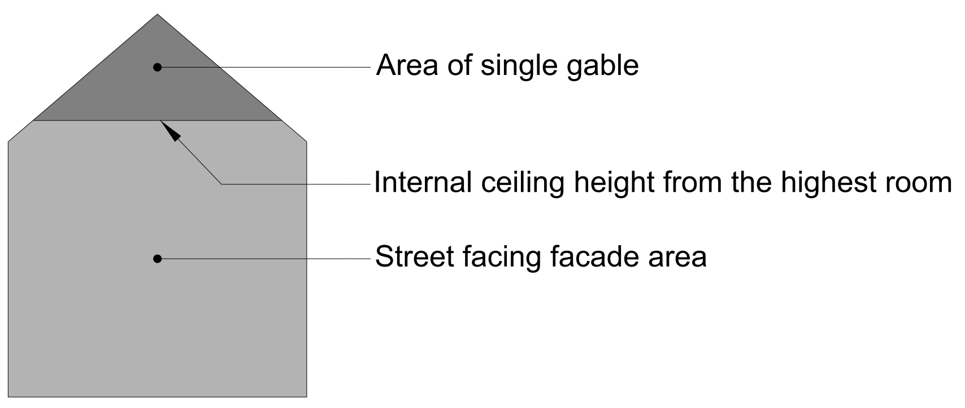
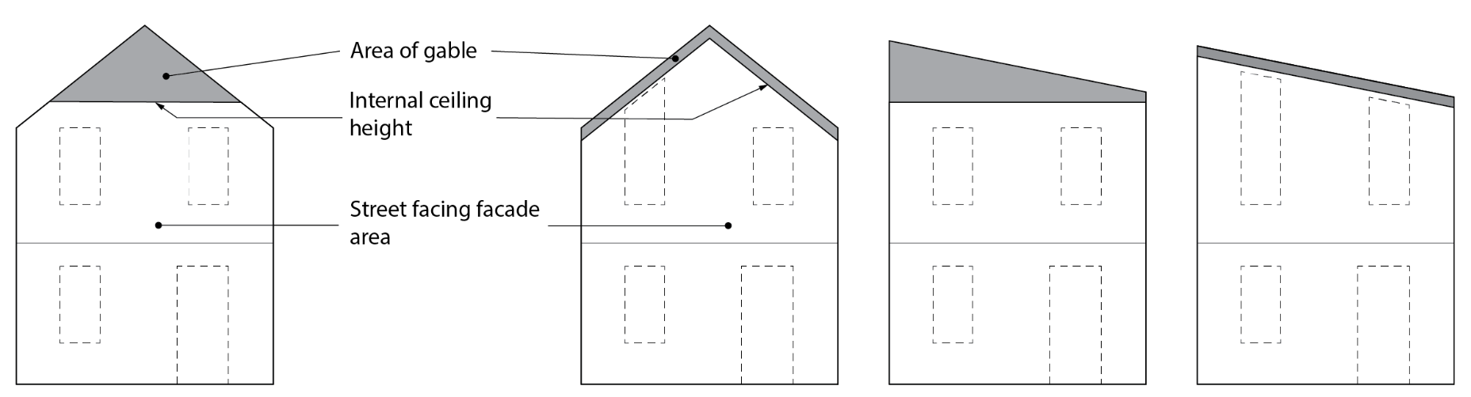
Figure 3: How to measure street facing gable Example of different buildings with front gables excluded from calculation
- Rule 14.6.2.8 a. and b. shall only apply to the a residential unit(s) with a street-facing façade within 12 metres of:
  - a road boundary, and/or;
  - a road designation on the site;
where there are no other residential units with street-facing façades located between the subject residential unit(s) and the road boundary and/or road designation.
- Where units have a hinged front door facing the street with direct access to a residential unit (excluding a garage), the door may be counted toward the glazing requirement under a., up to a maximum of 2m², regardless of whether it is glazed.
- Total required glazing for that residential unit may further be reduced to 17.5 15% (inclusive of the door area) provided that the residential unit has:
- a hinged front door facing the street that has direct access to the residential unit (but not where this access is directly to a garage) there is at least 1m² of clear glazing with a sill height of no more than 1.2m above interior floor level from ground floor habitable room/s, in addition to any glazing in the hinged front door; and
- a ground floor habitable room with a transparent glazed window on the street facing facade with a minimum area of 1m² and a maximum still height of 1.2m (measured from the internal floor level) at least 20% of the ground floor street-facing façade of residential units consist of glazing (inclusive of the hinged front door as described above).

14.6.2.89 Ground floor habitable space room
            - Any residential unit fronting a road or public open space, unless built over an access way or another residential unit, shall have a habitable space located at ground level.
            - At least 30% of all residential units within a development shall have a habitable space located at ground level.
c. At least one habitable space located at the ground level of a residential unit shall have a minimum floor area of 12m² and a minimum internal dimension of 3 metres.
            - Any building containing residential units shall:
- where a residential unit fronts a road or public open space, unless built over another ground floor residential unit, have a habitable room located at ground level with minimum internal dimension of 3 metres. This rule does not apply to any upper-level residential unit that is built over a ground floor residential unit; and
- have at least 50% of any ground floor area as habitable rooms, except on sites where at least 25% of the building footprint is more than 4 storeys gross floor area of the building is at fifth floor level and above, which shall have at least 30% of any the ground floor area as habitable rooms.

14.6.2.910 Outdoor living space
            - A residential unit at ground floor level must have an outdoor living space that is at least 20 square metres and that comprises ground floor, balcony, patio, or roof terrace space that,—
- where located at ground level, has no dimension less than 3 metres; and
- where provided in the form of a balcony, patio, or roof terrace, is at least 8 square metres and has a minimum dimension of 1.8 metres; and
- is accessible from the residential unit; and
- may be
  - grouped cumulatively by area in 1 communally accessible location; or
  - located directly adjacent to the unit.
- is free of buildings, parking spaces, and servicing and manoeuvring areas.
            - A residential unit located above ground floor level must have an outdoor living space in the form of a balcony, patio, or roof terrace that—
              - is at least 8 square metres and has a minimum dimension of 1.8 metres; and
              - is accessible from the residential unit; and
              - may be
                - grouped cumulatively by area in 1 communally accessible location, in which case it may be located at ground level; or
                - located directly adjacent to the unit.
            - For residential studio units with an internal floor area exceeding 35m², or single bedroom units with an internal floor area exceeding 45m², the following outdoor living space areas apply:
              - 15m² for residential units on the ground floor, with a minimum dimension of 3 metres; and
              - 6m² for residential units above the ground floor, with a minimum dimension of 1.5 metres for of balconies, patios or roof terraces.
            - Each residential unit shall provide on site an outdoor living space of at least 24m².
            - The required outdoor living space for each residential unit can be provided through a mix of private and communal areas, at the ground level or in balconies, provided that:
              - each residential unit shall have private outdoor living space of at least 8m² in total, not occupied by parking areas or access;
              - each private outdoor living space dimension shall be a minimum of 4 metres when provided at ground level and a minimum of 1.5 metres when provided by a balcony;
              - at least one private outdoor living space is to be directly accessible from a living area of that residential unit;
              - each outdoor living space provided as a communal space shall be accessible for use by all on site residents and each dimension shall be a minimum of 4 metres;
              - 50% of the outdoor living space required across the entire site shall be provided at ground level;
vi. any communal space may be located indoors provided its use is explicitly for a recreation activity for the exclusive use of the residents of, and guests to the units on the site.

14.6.2.101 Service space, storage and waste management
            - Each residential unit shall be provided with at least 3m² of indoor or outdoor service space at ground floor level for the dedicated storage of waste and recycling bins.
            - The required service space for each residential unit shall be provided either individually, or within a dedicated shared communal space, but shall not be located between the road boundary and any habitable space.
c. Service space for the storage of waste and recycling bins shall be fully screened from any site, road and outdoor living space which adjoins the service space.
            - For any development resulting in four or more residential units on a development site:
- each residential unit shall have at least 2.25m² of outdoor or indoor space at ground floor level for the dedicated storage of waste and recycling bins. This space shall have with a minimum dimension of 1.2 metres. Where located between a residential unit and the road boundary or access (pedestrian or vehicle) bins shall be screened by a solid fence with a minimum height of 1.2 metres;
- each ground floor residential unit shall have at least 3m² of dedicated outdoor space at ground floor level for washing lines. This space shall have a minimum dimension of 1.5 metres; and
- the required spaces in i. and/or ii. for each residential unit shall be provided either individually, or within a dedicated shared communal space. Any communal area shall be at least the sum total of the spaces required under (i) and (ii) for serviceable residential units.
            - Each residential unit shall have covered and secure storage areas, (in addition to storage in kitchens, bathrooms, bedrooms, and the space set aside for car parking in garages (at a dimension of 5.5m deep, 3.1m wide, 2.4m high) with a minimum dimension of 600mm, to a total cumulative volume of:
- 6m³ for one-bed units;
- 8m³ for two-bedroom units; or
- 10m³ for three-bedroom units or greater;
with at least 50% of storage provided internal to the unit. The required storage shall be additional to any storage in the kitchen, bathroom/s and/or bedroom/s of the residential unit, and additional to the area dedicated to car parking in any garage which for the purpose of this rule is deemed to be an area 5.5m deep, 3.1m wide and 2.4m high, per garage.

14.6.2.112 Minimum site density from development and redevelopment of residential units Building coverage
- The maximum building coverage must not exceed 50% of the net site area;
  - Any eaves and roof overhangs up to 300mm in width and guttering up to 26500mm in total cumulative width from the wall of a building shall not be included in the building coverage calculation.
  - In addition to 14.6.2.12.a.i, a total site building coverage of up to 60% if of the net site area is permitted when the following is are met:
    - except where required under Chapter 7, where no on-site vehicle parking is provided;
    - a ground level communal outdoor living space shall be is provided, with an area of to a scale of 10% of the development site area, with a minimum dimension of 8 metres;
    - a the minimum development site dimension of is 25m is achieved; and
    - at least 50% of the landscaping provided in compliance with 14.6.2.7 shall be shrubs.
- The minimum residential site density to be achieved when a site is developed or redeveloped with a residential unit or units shall be not less than one residential unit for every complete 200m² of site area (e.g. a site area of 399m² requires 1 residential unit, a site area of 400m² requires 2 residential units).

14.6.2.123 Water supply for firefighting
- Provision for sufficient water supply and access to water supplies for firefighting shall be made available to all buildings (excluding accessory buildings that are not habitable buildings) via Council’s urban reticulated system (where available) in accordance with the New Zealand Fire Service Firefighting Water Supplies Code of Practice (SNZ PAS 4509:2008).
- Where a reticulated water supply compliant with SNZ PAS:4509:2008 is not available, water supply and access to water supplies for fire fighting that is in compliance with the alternative firefighting water sources provisions of SNZ PAS 4509:2008 must be provided.

14.6.2.14 Garaging and carpark location
            - When developing four or more residential units on a single site, any detached garage or carport on a front site shall be located behind the rear façade of a residential unit.
  - For residential units fronting roads; garages, carports, loading bays and car parking areas shall be located at least 1.2 metres further from the road boundary than the street-facing façade of that residential unit.

14.6.2.15 Location of outdoor mechanical ventilation
- Outdoor heat pump units, or other similar mechanical ventilation units, located at ground level between a street-facing façade and a road boundary shall be screened shall not be located within 3 metres from the boundary between a residential site and a road or shared accessway (including a proposed accessway). by up to a maximum of 50% visually transparent fencing a minimum of 1.2 metres in height above ground level, or the height of ventilation/heat pump unit, (whverwhichever is the higher).

14.6.2.16 Minimum unit size
            - The minimum net floor area for any residential unit shall be:
              - Studio 35m²
              - 1 Bedroom 45m²
              - 2 Bedroom 60m²
              - 3 or more Bedrooms 90m².

14.6.2.17 Minimum road boundary setback - Qualifying Matter City Spine Transport Corridor
- For all properties fronting the City Spine Transport Corridor:
  - where the road is 24m or less in width, a minimum building setback from the road boundary of 4m is required; and
  - any fencing provided along the road boundary shall not exceed 1m in maximum height above ground level maximum, except that the maximum height shall be 2 metres if the whole fence or screening structure is at least 75% transparent; and
  - any outdoor living space must not be located within 1.5m of the road boundary.

14.6.2.18 Building length

- For new buildings the maximum length of a building elevation shall not exceed 30 metres (see Figure 4 below), measured from the external face of the building.
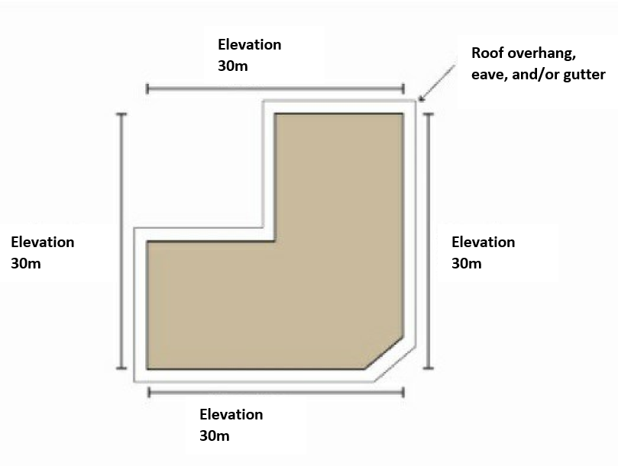

Figure 4: Measurement of building elevation
    - Area-specific rules - High Density Residential Zone
- The following rules apply to the areas specified. All activities are also subject to Rules 14.6.1 and 14.6.2 unless specified otherwise.
14.6.3.1 Area-specific activities
14.6.3.1.1 Area-specific permitted activities
- The activities listed below are permitted activities if they meet the activity specific standards set out in this table; and the built form standards in Rule 14.6.2 unless specified otherwise in Rule 14.6.3.2.
- Activities may also be controlled, restricted discretionary, discretionary, non-complying or prohibited as specified in Rules 14.6.1.2, 14.6.1.3, 14.6.1.4, 14.6.1.5, and 14.6.1.6 (unless specified otherwise in area specific rules); and Rules 14.6.3.1.2, 14.6.3.1.3, 14.6.3.1.4, 14.6.3.1.5 or 14.6.3.1.6.

Activity/area |  | Activity specific standards
P1 | - The following activities in the Accommodation and Community Facilities Overlay:  - Preschools;  - Health care facility;  - Veterinary care facility;  - Education activity;  - Place of assembly;  - Spiritual activities;  - Community correction facilities;  - Care facility. | - The activity specific standards in Rule 14.6.1.1 do not apply.  - The facility or activity shall:  i. comprise less than 500m² gross leasable floor space; and  ii. limit the hours of operation when the site is open to visitors, students, clients, and deliveries to between the hours of 07:00-21:00 Monday to Sunday.
P2 | - Visitor accommodation in the Accommodation and Community Facilities Overlay including ancillary office, meeting and conference facilities, fitness facilities and provision of goods and services primarily for the convenience of guests. | - The maximum size of all ancillary activities shall not exceed 25% of the GFA of all buildings on the same site.  - No individual types of ancillary activity shall be more than 250m² GLFA.
P3 | - Retirement villages in the Accommodation and Community Facilities Overlay | - The activity shall achieve the following built form standards as follows:  - 14.6.2.1 Building height  - 14.6.2.2 Height in relation to boundary  - 14.6.2.3 Setbacks  - 14.6.2.12 Building coverage  - 14.6.2.13 Water supply for firefighting  - Building façade length – there must be a recess in the façade of a building where it faces a side or rear boundary from the point at which a building exceeds a length of 16 metres. The recess must:  - be at least 1 metre in depth, for a length of at least 2 metres;  - be for the full height of the wall; and  - include a break in the eave line and roof line of the façade.

14.6.3.1.2 Area-specific controlled activities
There are no area-specific controlled activities.

14.6.3.1.3 Area-specific restricted discretionary activities
- The activities listed below are restricted discretionary activities.
- Discretion to grant or decline consent and impose conditions is restricted to the matters of discretion set out in Rule 14.15, or as specified, as set out in the following table:
Activity |  | The Council’s discretion shall be limited to the following matters:
RD1 | - Service stations in the Accommodation and Community Facilities Overlay.  - Any application arising from this rule shall not be limited or publicly notified. | - Scale and nature of activity – Rule 14.15.6  - Non-residential hours of operation – Rule 14.15.25  - Traffic generation and access safety – Rule 14.15.7
RD2 | - Ancillary activities to visitor accommodation listed in Rule 14.6.3.1.1 P2 in the Accommodation and Community Facilities Overlay that do not meet one or more of the activity specific standards in Rule 14.6.3.1.1 P2.

14.6.3.1.4 Area-specific discretionary activities
There are no area-specific discretionary activities.

14.6.3.1.5 Area-specific non-complying activities
There are no area-specific non-complying activities.

14.6.3.1.6 Area-specific prohibited activities
There are no area-specific prohibited activities.

14.6.3.2 Area-specific built form standards
14.6.3.2.1 Building height
- This applies to Accommodation and Community Facilities Overlay.
- The maximum height of any building shall be:
  - 11 metres, or
  - 12 metres for that part of the building where a pitched roof of at least 22 degrees is provided.

14.6.3.2.2 Maximum continuous building length
- Within the Accommodation and Community Facilities Overlay and in association with the following activities:
 |  | Standards
i. | Visitor accommodation; and a | - For new buildings the maximum length of a building elevation shall not exceed 15 metres (see Figure 5  - For existing buildings any addition to the building elevation shall not exceed a length of 10 metres.
ii. | Community facility;
iii. | Preschool;
iv. | Education facility;
v. | Health care facility;
vi. | Place of assembly; and
vii. | Veterinary care facility.

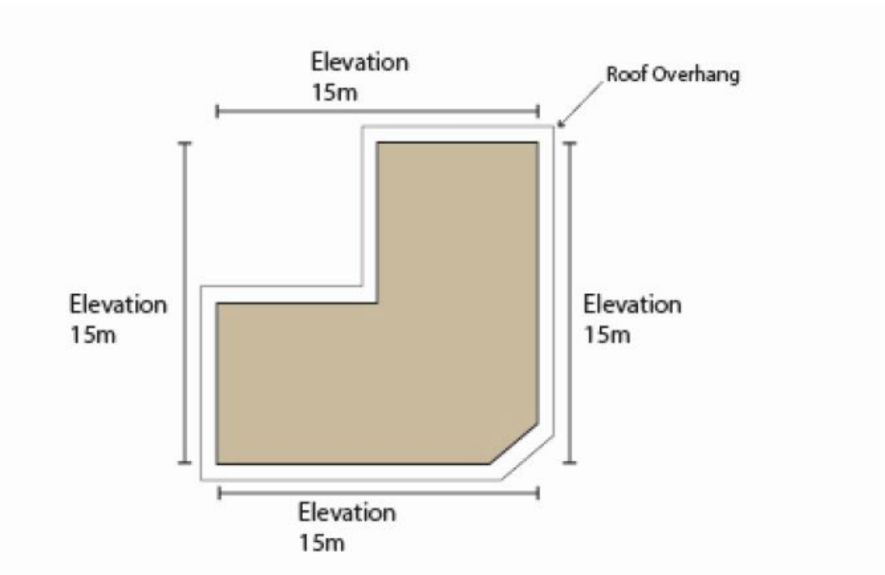
Figure 5: Measurement of a building elevation.

14.6.3.2.3 Front entrances and facades
- Within the Accommodation and Community Facilities Overlay the following front entrance and façade treatment shall be provided for:
 | Buildings associated with: | Standards
i. | Visitor accommodation; and a | - Pedestrian access shall be directly from the road frontage.  - A minimum of 30% glazing on the road frontage on ground floor.  - A minimum of 20% glazing on the road frontage on elevations above ground level.
ii. | Community facility;
iii. | Preschool;
iv. | Education facility;
v. | Health care facility;
vi. | Place of assembly; and
vii. | Veterinary care facility.

14.6.3.2.4 Landscaped areas
- Planting shall be provided as follows:
  - Within the Accommodation and Community Facilities Overlay for non-residential activities:
    - In areas adjoining the road frontage of all sites:
      - A minimum density of 1 tree per every 10 metres of road frontage or part thereof, distributed across the frontage; and
      - A minimum 2 metre planted strip.
    - On sites adjoining residential and open space zones, trees shall be planted adjacent to the shared boundary at a ratio of at least 1 tree for every 10 metres of the boundary or part thereof, with the trees evenly spaced along that boundary.

