DISTRICT PLAN TEXT AMENDMENTS
Key:
For the purposes of this plan change, any unchanged text is shown as normal text or in bold, any text proposed to be added by the plan change is shown as bold underlined and text to be deleted as bold strikethrough.
Text in bold red underlined is that from Schedule 3A of the Resource Management Act and must be included.
Text in green font identifies existing terms in Chapter 2 – Definitions. Where the proposed change contains a term defined in Chapter 2 – Definitions, the term is shown as bold underlined text in green and that to be deleted as bold strikethrough in green. New definition in a proposed rule is bold green text underlined in black.
Text in bold purple underlined indicates text recommended in the s42A report to be added and text in bold purple strikethrough text recommended in the s42A report to be deleted. Text in normal black font with purple underline indicates text that was proposed to be deleted in the notified PC14 and is recommended to be reinstated.
Text in purple is a plan change proposal subject to Council Decision.
Text in purple shaded in grey is a Plan Change Council Decision.
Text in black/green shaded in grey is a Council Decision subject to appeal.
Text in light blue shaded in grey is a Council Decision proposed to be deleted by this Plan Change.
Text in blue font indicates links to other provisions in the district Plan and/or external documents. These will have pop-ups and links, respectively, in the on-line Christchurch District Plan.
Chapter 14 Residential

14.4 Rules ­ Residential Suburban Zone and Residential Suburban Density Transition Zone

14.4.1 Activity status tables

14.4.1.1 Permitted activities
- The activities listed below are permitted activities in the Residential Suburban Zone and Residential Suburban Density Transition Zone if they meet the activity specific standards set out in this table, the built form standards in Rule 14.4.2, and the area specific rules in Rule 14.4.3.
- Activities may also be controlled, restricted discretionary, discretionary, non­complying or prohibited as specified in Rules 14.4.1.2, 14.4.1.3, 14.4.1.4, 14.4.1.5, and 14.4.1.6 or in the area specific rules in Rule 14.4.3

Activity |  | Activity specific standards
P1 | Residential activity, except for residential units containing more than six bedrooms and boarding houses | - No more than one heavy vehicle shall be stored on the site of the residential activity.  - Any motor vehicles and/or boats dismantled, repaired or stored on the site of the residential activity shall be owned by people who live on the same site.
P2 | Minor residential unit where the minor unit is a detached building and the existing site it is to be built on contains only one residential unit | - The existing site containing both units shall have a minimum net site area of 450m².  - The minor residential unit shall have a minimum gross floor area of 35m² and a maximum gross floor area of 80m².  - The parking areas of both units shall be accessed from the same access.  - This requirement replaces the general outdoor living space requirements set out in Rule 14.4.2.5.There shall be a total outdoor living space on the existing site (containing both units) with a minimum area of 90m² and a minimum dimension of 5 metres. This total space can be provided as:  - a single continuous area; or  - be divided into two separate spaces, provided that each unit is provided with an outdoor living space that is directly accessible from that unit and is a minimum of 30m² in area.
P3 | Student hostels owned or operated by a secondary education activity or tertiary education and research activity containing up to 6 bedrooms | Nil
P4 | Multi-unit residential complexes within the Residential Suburban Density Transition Zone – up to and including four residential units. | - The minimum net floor area (including toilets and bathrooms, but excluding parking area, garages or balconies) for any residential unit in the complex shall be:  Number of bedrooms Minimum Net floor area  i. Studio. 35m²  ii. 1 Bedroom. 45m²  iii. 2 Bedrooms. 60m²  iv. 3 or more Bedrooms 90m²  - Any residential unit fronting a road or public open space shall have a habitable space located at the ground level, and at least 50% of all residential units within a complex shall have a habitable space located at the ground level.  - Each of these habitable spaces located at the ground level shall have a minimum floor area of 9m² and a minimum internal dimension of three metres and be internally accessible to the rest of the unit.
P5 | Social housing complexes – up to and including four residential units.
P6 | Older person’s housing unit | - Any older person’s housing unit shall have a maximum gross floor area of 120m².
P7 | Retirement villages | - Building façade length – there must be a recess in the façade of a building where it faces a side or rear boundary from the point at which a building exceeds a length of 16 metres. The recess must:  - be at least 1 metre in depth, for a length of at least 2 metres;  - be for the full height of the wall; and  - include a break in the eave line and roof line of the façade.
P8 | Conversion of an elderly person’s housing unit existing at 6 December 2013, into a residential unit that may be occupied by any person(s) and without the need to be encumbered by a bond or other appropriate legal instrument (P8 only applies until 30 April 2018) | - There shall be no reduction in the areas and dimensions of the lawfully established outdoor living space associated with each unit.
P9 | Conversion of a family flat existing at 6 December 2013 into a residential unit that may be occupied by any person(s) and without the need to be encumbered by a legal instrument | - Each converted flat shall have a minimum gross floor area, excluding terraces, garages, sundecks, and verandahs, of 35m².  - This requirement replaces the general outdoor living space requirements set out in Rule 14.4.2.5. There shall be a total outdoor living space on the existing site (containing the residential unit and the family flat) with a minimum area of 90m² and a minimum dimension of 5 metres. This total space can be provided as a single contiguous area, or be divided into two separate spaces, provided that each unit is provided with an outdoor living space that is directly accessible from that unit and is a minimum of 30m² in area.
P10 | Conversion of a residential unit (within, or as an extension to, a residential unit) into two residential units | - Each residential unit shall have a minimum gross floor area, excluding terraces, garages, sundecks and verandahs, of 35m².  - This requirement replaces the general outdoor living space requirements set out in Rule 14.4.2.5. There shall be a total outdoor living space on the existing site with a minimum area of 90m² and a minimum dimension of 5 metres. This total space can be provided as a single contiguous area, or be divided into two separate spaces, provided that each unit is provided with an outdoor living space that is directly accessible from that unit and is a minimum of 30m² in area.  - The residential unit to be converted shall be outside:  - the tsunami inundation area as set out in Environment Canterbury report number R12/38 “Modelling coastal inundation in Christchurch and Kaiapoi from a South American Tsunami using topography from after the 2011 February Earthquake (2012), NIWA”; as shown in Appendix 14.16.5;  ii. the Riccarton Wastewater Interceptor Overlay identified on the Planning Maps 38, 37, 31, 30, 23; except after the completion of infrastructure work to enable capacity in the identified lower catchment; and  iii any Flood Management Area.
P11 | Replacement of a residential unit with two residential units | - The existing site shall be occupied by one residential unit and that residential unit has been, or will be, demolished because the insurer(s) of that unit have determined that the residential unit was uneconomic to repair because of earthquake damage.  - The existing site shall be outside:  - the tsunami inundation area as set out in Environment Canterbury report number R12/38 “Modelling coastal inundation in Christchurch an Kaiapoi from a South American Tsunami using topography from after the 2011 February Earthquake (2012), NIWA”; as shown in Appendix 14.16.5;  - the Riccarton Wastewater Interceptor Overlay identified on the Planning Maps 38, 37, 31, 30, 23; except after the completion of infrastructure work to enable capacity in the identified lower catchment; and  - any Flood Management Area.  c. This requirement replaces the general outdoor living space requirements set out in Rule 14.4.2.5. There shall be a total outdoor living space on the existing site with a minimum area of 90m² and minimum dimension of 5 metres. This total space can be provided as a single contiguous area, or be divided into two separate spaces, provided that each unit is provided with an outdoor living space that is directly accessible from that unit and is a minimum of 30m² in area.
P12 | Construction of two residential units on a site that was vacant prior to the Canterbury earthquakes of 2010 and 2011 | - The existing site shall be outside:  - the tsunami inundation area as set out in Environment Canterbury report number R12/38 “Modelling coastal inundation in Christchurch an Kaiapoi from a South American Tsunami using topography from after the 2011 February Earthquake (2012), NIWA”; as shown in Appendix 14.16.5;  - the Riccarton Wastewater Interceptor Overlay identified on the Planning Maps 38, 37, 31, 30, 23; except after the completion of infrastructure work to enable capacity in the identified lower catchment; and  - any Flood Management Area.  Ba. This requirement replaces the general outdoor living space requirements set out in Rule 14.4.2.5. There shall be a total outdoor living space on the existing site with a minimum area of 90m² and minimum dimension of 5 metres. This total space can be provided as a single contiguous area, or be divided into two separate spaces, provided that each unit is provided with an outdoor living space that is directly accessible from that unit and is a minimum of 30m² in area.
P13 | Home occupation | - The gross total floor area of the building or part of the building (measured internally), plus the area used for any outdoor storage area, occupied by the home occupation shall be less no more than 40m².  - The maximum number of FTE persons employed in the home occupation, who reside permanently elsewhere than on the site, shall be two.  - Any retailing retail activity shall be limited to:  - the sale of goods grown or produced on the site,;  - goods incidental to an on-site service provided by the home occupation where the goods storage and/or display occupies no more than 1m² of floor area; or  - internet-based sales where no customer visits occur; and  - retail activity shall exclude food and beverage outlets.  - Manufacturing, altering, repairing, dismantling or processing of any materials, goods or articles shall be carried out in a fully enclosed building.  - The hours of operation, when the site is open to visitors, clients, and deliveries, shall be limited to between the hours of:  - 07:00 – 21:00 Monday to Friday; and  - 08:00 – 19:00 Saturday, Sunday and public holidays.  - Visitor, courier vehicle and or staff parking areas shall be within the net site area of the property and outside the road boundary setback.  - Vehicle movements associated with the home occupation shall not exceed:  - heavy vehicles: 2 per week; and  - other vehicles: 16 per day.  - Outdoor advertising Signage shall be limited to a maximum area of 20.5m², except that where the activity is located on sites with frontage to Memorial Avenue or Fendalton Road there shall be no signage.  (Plan Change 5D Council Decision)
P14 | Care of non-resident children within a residential unit in return for monetary payment to the carer | - There shall be:  - a maximum of four non-resident children being cared for in return for monetary payment to the carer at any one time; and  - at least one carer residing permanently within the residential unit.
P15 | Bed and breakfast  (Plan Change 4 Council Decision subject to appeal) | - There shall be:  - a maximum of six guests accommodated at any one time;  - at least one owner of the residential unit residing permanently on site; and  - no guest given accommodation for more than 90 consecutive days.  (Plan Change 4 Council Decision subject to appeal)
P16 | Education activity | - The activity shall:  - only locate on sites with frontage and the primary entrance to a minor arterial road or collector road where:  - a right turn offset, either informal or formal, is available, or;  - a solid median prevents right turns into or out of the primary entrance.  - only occupy a gross floor area of building of less than 200m², or in the case of a health care facility, less than 300m²;  - limit outdoor advertising to a maximum area of 2m²;  - limit the hours of operation when the site is open to visitors, students, patients, clients, and deliveries to between the hours of:  - Education activity - 07:00 – 21:00 Monday to Saturday; and II. Closed Sunday and public holidays.  B. Preschools I. 07:00 – 21:00 Monday to Friday, and - 07:00 – 13:00 Saturday, Sunday and public holidays.  - Health care facility - 07:00 – 21:00.  D. Veterinary care facility  E. Places of assembly  - in relation to preschools, limit outdoor play areas and facilities to those that meet Rule 6.1.5.2.1 Table 1: Zone noise limits outside the Central City;  - in relation to preschools, veterinary care facilities and places of assembly (see Figure 1):  - only locate on sites where any residential activity on an adjoining front site, or front site separated by an access, with frontage to the same road is left with at least one residential neighbour. That neighbour shall be on an adjoining front site, or front site separated by an access, and have frontage to the same road; and  - only locate on residential blocks where there are no more than two non-residential activities already within that block;  - in relation to veterinary care facilities, limit the boarding of animals on the site to a maximum of four;  - in relation to places of assembly, entertainment activities shall be closed Sunday and public holidays;  - in relation to noise sensitive activities, not be located within the 50 dB _{Ldn} Air Noise Contour and the Qualifying Matter Airport Noise Influence Area as shown on the planning maps; and  - not include the storage of more than one heavy vehicle on the site of the activity.
P17 | Preschools, other than as provided for in Rule 14.4.1.1 P14.
P18 | Health care facility
P19 | Veterinary care facility
P20 | Places of assembly, except at Kate Sheppard House, 83 Clyde Road, where Rule 14.4.3.1.1 P31 applies  (Plan Change 5F Council Decision)
P21 | Spiritual activities | - The activity shall:  - limit the hours of operation to 07:00-22:00; and  - not include the storage of more than one heavy vehicle on the site of the activity.
P22 | Community corrections facilities | - The facility shall:  - limit the hours of operation when the site is open to clients and deliveries to between the hours of 07:00 – 19:00; and  - limit signage to a maximum area of 2m².
P23 | Community welfare facilities
P24 | Emergency service facilities | Nil
P25 | Repair or rebuild of multi-unit residential complexes damaged by the Canterbury earthquakes of 2010 and 2011 on properties with cross leases, company leases or unit titles as at the date of the earthquakes. | - Where the repair or rebuild of a building will not alter the building footprint, location, or height, the building need not meet the built form standards.  - Where the building footprint, location, or height is to be altered no more than necessary in order to comply with legal or regulatory requirements or the advice of a suitably qualified and experienced chartered engineer:  - the only built form standards that shall apply are those specified in Rules 14.4.2.3 – Building height and 14.4.2.6 – Daylight recession planes;  - in relation to the road boundary setback, the repaired or rebuilt building shall have a setback of at least 3 metres;  - the standards at (i) and (ii) shall only apply to the extent that the repaired or rebuilt building increases the level of non-compliance with the standard(s) compared to the building that existed at the time of the earthquakes.  Advice note:  - Examples of regulatory or legal requirement that may apply include the New Zealand Building Code, Council bylaws, easements, and other rules within this Plan such as the requirements for minimum floor levels in Chapter 5.  - If paragraphs a. and b. do not apply, the relevant built form standards apply.  - Any application arising from not meeting standards a. and b.i. shall not be publicly notified, and may be limited notified to adjoining property owners (where the consent authority considers this is required, and absent written approval).  - Any application arising from not meeting standard b.ii. (road boundary setbacks), shall not be limited or publicly notified.
P26 | - Temporary lifting or moving of earthquake damaged buildings where the activity does not meet one or more of Rules:  - 14.4.2.3 – Building height;  - 14.4.2.4 – Site coverage;  - 14.4.2.5 – Outdoor living space;  - 14.4.2.6 – Daylight recession planes; or  - 14.4.2.7 – Minimum building setbacks from internal boundaries and railway lines. | - Buildings shall not be:  - moved to within 1 metre of an internal boundary and/or within 3 metres of any water body, scheduled tree, listed heritage item, areas listed as Sites of Ecological Significance (in Sub-chapter 9.1), Natural Landscapes, Features or Character (in Sub-chapter 9.2), or Sites of Ngāi Tahu Cultural Significance (in Sub-chapter 9.5), any Council owned structure, archaeological site, or the coastal marine area; or  - lifted to a height exceeding 3 metres above the applicable recession plane or height control.  - The building must be lowered back or moved back to its original position, or a position compliant with the District Plan or consistent with a resource consent, within 12 weeks of the lifting or moving works having first commenced.  - In all cases of a building being moved or lifted, the owners/occupiers of land adjoining the sites shall be informed of the work at least seven days prior to the lift or move of the building occurring. The information provided shall include details of a contact person, details of the lift or move, and the duration of the lift or move.  - The Council’s Resource Consents Manager shall be notified of the lifting or moving the building at least seven days prior to the lift or move of the building occurring. The notification must include details of the lift or move, property address, contact details and intended start date.
P27 | Relocation of a building | Nil
P28 | Market gardens, community gardens, and garden allotments
P29 | Hosted visitor accommodation  (Plan Change 4 Council Decision subject to appeal) | - A maximum of six guests shall be accommodated at any one time.  - The Council shall be notified in writing prior to commencement.  - The owner of the unit shall keep records of the number of nights booked per year, as commencing on 1 January of that year, and the dates used for hosted visitor accommodation and provide those records to the Council on request.  - The owner of the unit shall have procedures in place for managing adverse effects on neighbours from guests checking-in between the hours of 22.00pm and 06.00am, and shall provide those procedures to the Council on request.  (Plan Change 4 Council Decision subject to appeal)
P30 | Visitor accommodation in a heritage item  (Plan Change 4 Council Decision subject to appeal) | - A permanent resident or manager/supervisor for the property shall be in residence on the site for the duration of any visitors’ stays.  - A maximum of ten guests shall be accommodated at any one time.  - The Council shall be notified in writing prior to commencement.  - The owner of the unit shall keep records of the number of nights booked per year, as commencing on 1 January of that year, and the dates used for hosted visitor accommodation and provide those records to the Council on request.  - The owner of the unit shall have procedures in place for managing adverse effects on neighbours from guests checking-in between the hours of 22.00pm and 06.00am, and shall provide those procedures to the Council on request.  (Plan Change 4 Council Decision subject to appeal)

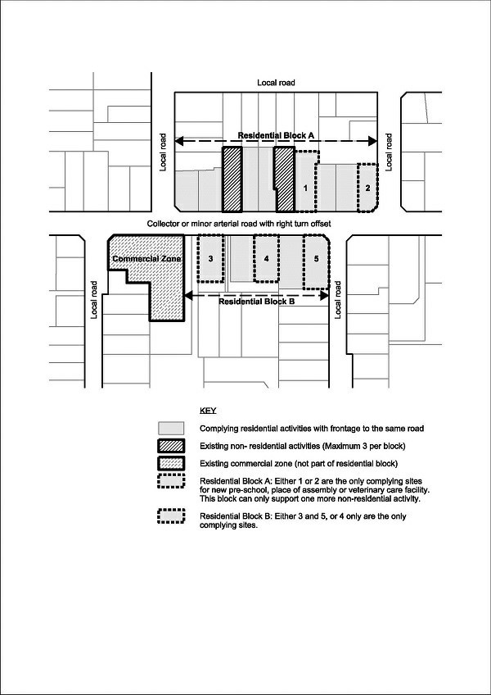
Figure 1: Residential coherence

14.4.1.2 Controlled activities
- The activities listed below are controlled activities.
- Unless otherwise specified, any application arising from the controlled activity rules listed below shall not be limited or publicly notified.
- Discretion to impose conditions is restricted to the matters over which control is reserved in Rule 14.15, as set out in the following table.
Activity |  | The matters over which Council reserves its control:
C1 | Fences that do not meet Rule 14.4.2.10 – Street scene amenity and safety ­ fences | - Street scene – road boundary building setback, fencing and planting – Rule 14.15.178
C2 | Residential units (including any sleep-outs) containing more than six bedrooms in total | - Scale and nature of activity – Rule 14.15.56  - Traffic generation and access safety – Rule 14.15.67  (Plan Change 5D Council Decision)
C3 | Multi-unit residential complexes and social housing complexes that do not meet Rule 14.4.2.2 – Tree and garden planting | - Street scene – road boundary building setback, fencing and planting – Rule 14.15.178
C4 | Multi­unit residential complexes and social housing complexes that do not meet Rule 14.4.2.12 – Service, storage and waste management spaces | - Service, storage and waste management spaces – Rule 14.15.1920
C5 | Social housing complexes, where the complex does not meet one or more of the activity specific standards in Rule 14.4.1.1 P5 b. or c. | - Street scene – road boundary building setback, fencing and planting – Rule 14.15.178
C6 | Multi­unit residential complexes in the Residential Suburban Density Transition Zone, where the complex does not meet one or more of the activity specific standards in Rule 14.4.1.1 P4 b. or c.
C7 | Unhosted visitor accommodation:  - For a total per site of 60 nights or fewer per year;  - for a maximum of six guests at any one time.  (Plan Change 4 Council Decision subject to appeal) | - Provision of information for neighbours and guests, including contact information, parking restrictions, and, where appropriate, hazards information  - Record keeping and provision of information to the Council  - Management of outdoor entertainment and recreation facilities  - Management of solid waste disposal  - Number and size of vehicles used by guests including large vehicles  - Building access arrangements and wayfinding  - Controls on the effects and scale of functions or events  - Controls on check­in and check­out times.  (Plan Change 4 Council Decision subject to appeal)
C8 | Visitor accommodation in a heritage item that does not comply with activity specific standard (a) in Rule 14.4.1.1 P30.  (Plan Change 4 Council Decision subject to appeal) | - Provision of information for neighbours and guests, including contact information, parking restrictions, and, where appropriate, hazards information  - Record keeping and provision of information to the Council  - Management of outdoor entertainment and recreation facilities  - Management of solid waste disposal  - Number and size of vehicles used by guests including large vehicles  - Building access arrangements and wayfinding  - Controls on the effects and scale of functions or events  - Controls on check-in and check-out times.  (Plan Change 4 Council Decision subject to appeal)

14.4.1.3 Restricted discretionary activities
- The activities listed below are restricted discretionary activities.
- Discretion to grant or decline consent and impose conditions is restricted to the matters of discretion set out in Rule 14.15, or as specified, as set out in the following table.
Activity |  | The Council’s discretion shall be limited to the following matters:
RD1 | Residential unit in the Residential Suburban Zone contained within its own separate site with a net site area between 400 and 450m² | - Site density and site coverage – Rule 14.15.2
RD2 | Residential unit in the Residential Suburban Density Transition Zone contained within its own separate site with a net site area between 300m² and 330m²
RD3 | Minor residential unit where the minor unit is a detached building and does not meet one or more of the activity specific standards in Rule 14.4.1.1 P2 a., b., c., and d. | - Minor residential units - Rule 14.15.226
RD4 | Conversion of a residential unit (within or as an extension to a residential unit) into two residential units that does not meet one or more of the activity specific standards in Rule 14.4.1.1 P10 a. and b.
RD5 | Social housing complexes, where any residential unit in the complex does not meet activity specific standard Rule 14.4.1.1 P5 a. | - Minimum unit size and unit mix – Rule 14.15.45
RD6 | Multi-unit residential complexes in the Residential Suburban Density Transition Zone where any residential unit in the complex does not meet activity specific standard Rule 14.4.1.1 P4 a.
RD7 | Social housing complexes – over four residential units | - Residential design principles – Rule 14.15.1
RD8 | Multi-unit residential complexes in Residential Suburban Density Transition Zone – over four residential units
RD9 | Older person’s housing units that do not meet activity specific standard in Rule 14.4.1.1 P6 a. | - Scale and nature of activity - Rule 14.15.56  (Plan Change 5D Council Decision)
RD10 | Retirement villages that do not meet one or more of the activity specific standards in Rule 14.4.1.1 P7 | - Retirement villages - Rule 14.15.910
RD11 | Boarding house | - Scale and nature of activity - Rule 14.15.56  - Traffic generation and access safety - Rule 14.15.67  (Plan Change 5D Council Decision)
RD12 | Student hostels owned or operated by a secondary education activity or tertiary education and research activity containing 7 to 9 bedrooms | - Scale and nature of activity – Rule 14.15.56  (Plan Change 5D Council Decision)
RD13 | - Convenience activities where:  - the site is located on the corner of a minor arterial road that intersects with either a minor arterial road or collector road;  - the total area occupied by retailing on the site is no more than 50m² public floor area;  - the activity does not include the sale of alcohol;  - outdoor advertising is limited to no more than 2m² and shall be within the road boundary setback;  - the hours of operation when the site is open to business visitors or clients are limited to between the hours of 07:00 – 22:00 Monday to Sunday and public holidays; and  - there is no provision of on-site parking area for visitors or service purposes. | - Residential design principles - Rule 14.15.1  - Scale and nature of activity – Rule 14.15.56  - Non-residential hours of operation – Rule 14.15.215  - Traffic generation and access safety – Rule 14.15.67  (Plan Change 5D Council Decision)
RD14 | - Integrated family health centres where:  - the centre is located on sites with frontage and the primary entrance to a minor arterial road or collector road where right turn offset, either informal or formal is available;  - the centre is located on sites adjoining a Neighbourhood Local centre, District Town centre or Key activity centre;  - the centre occupies a gross floor area of building of between 301m² and 700m²;  - outdoor advertising signage is limited to a maximum area of 2m²; and  - the hours of operation when the site is open to patients, or clients, and deliveries is limited to between the hours of 07:00 – 21:00. | - Scale and nature of activity - Rule 14.15.56  - Traffic generation and access safety - Rule 14.15.67  - Non-residential hours of operation - Rule 14.15.215  (Plan Change 5D Council Decision)
RD15 | - Animal shelter at 14 and 18 Charlesworth Street.  - Any application arising from this rule shall not be publicly notified and may be limited notified only to directly abutting landowners and occupiers (where the consent authority considers this is required, and absent their written approval). | - Scale and nature of activity – Rule 14.15.5  - Traffic generation and access safety - Rule 14.15.6  - Non-residential hours of operation – Rule 14.15.21  (Plan Change 5D Council Decision)
RD16 | - Spiritual activities that do not meet the hours of operation in Rule 14.4.1.1 P21.  - Any application arising from this rule shall not be publicly notified and shall be limited notified only to directly abutting land owners and occupiers (absent their written approval). | - Non-residential hours of operation – Rule 14.15.215
RD17 | - Community corrections facilities and community welfare facilities that do not meet one or more of the activity specific standards in Rule 14.4.1.1 P22 or P23.  - Any application arising from this rule shall not be limited or publicly notified. | - As relevant to the activity specific standard that is not met:  - Scale and nature of activity – Rule 14.15.56  - Traffic generation and access safety – Rule 14.15.67  - Non-residential hours of operation – Rule 14.15.215  (Plan Change 5D Council Decision)
RD18 | - Temporary lifting or moving of earthquake damaged buildings that does not meet one or more of the activity specific standards in Rule 14.4.1.1 P26.  - Any application arising from this rule shall not be limited or publicly notified. | - Relocation of a buildings and temporary lifting or moving of earthquake damaged buildings – Rule 14.15.167
RD19 | Buildings that do not meet Rule 14.4.2.3 – Building height (except for Rule 14.4.2.3 (iv) (within the Industrial Interface Qualifying Matter Area) refer to Rule 14.4.1.4 D11). | - Impacts on neighbouring property – Rule 14.15.3
RD20 | Buildings that do not meet Rule 14.4.2.6 – Daylight recession planes
RD21 | - Activities and buildings that do not meet Rule 14.4.2.4 – Site coverage where the site coverage is between 35% and 40%.  - Any application arising from this rule shall not be limited or publicly notified. | - Site density and site coverage – Rule 14.15.2
RD22 | - Multi-unit residential complexes, social housing complexes, and older person’s housing units that do not meet Rule 14.4.2.4 – Site coverage, where the site coverage is between 40-45% (calculated over the net site area of the site of the entire complex or group of units).  - Any application arising from this rule shall not be limited or publicly notified.
RD23 | - Market gardens where the site coverage exceeds 55%.  - Any application arising from this rule shall not be limited or publicly notified. | - Site density and site coverage – Rule 14.15.2
RD24 | - Residential units that do not meet Rule 14.4.2.5 – Outdoor living space.  - Any application arising from this rule shall not be limited or publicly notified. | - Outdoor living space – Rule 14.15.201
RD25 | - Buildings that do not meet Rule 14.4.2.9 – Road boundary building setback.  - Any application arising from this rule shall not be limited or publicly notified. | - Street scene – road boundary building setback, fencing and planting – Rule 14.15.178
RD26 | Buildings that do not meet Rule 14.4.2.7 – Minimum building setbacks from internal boundaries and railway lines, other than Rule 14.4.2.7(vi) (refer to Rule 14.4.1.3 RD28) | - Impacts on neighbouring properties – Rule 14.15.3  - Minimum building, window and balcony setbacks – Rule 14.15.189
RD27 | Buildings that do not meet Rule 14.4.2.8 – Minimum setback and distance to living area windows and balconies and living space windows facing internal boundaries
RD28 | Buildings that do not meet Rule 14.4.2.7(vi) relating to rail corridor boundary setbacks | - Whether the reduced setback from the rail corridor will enable buildings to be maintained without requiring access above, over, or on the rail corridor.
RD29 | - Residential units that do not meet Rule 14.4.2.11 – Water supply for firefighting.  - Any application arising from this rule shall not be publicly notified and shall be limited notified only to the New Zealand Fire Service (absent its written approval). | - Water supply for fire fighting – Rule 14.15.78
RD30 | - Activities and buildings that do not meet one or more of the activity specific standards in Rule 14.4.1.1 (except for P16 - P18 standard ix. relating to noise sensitive activities in the 50 dB _{Ldn} Air Noise Contour and the Qualifying Matter Airport Noise Influence Area, refer to Rule 14.4.1.3 RD3430; or P16-P19 standard x. relating to storage of heavy vehicles, refer to Rule 14.4.1.4 D2) for:  - P13 Home occupations;:  - that do not meet standard a. and occupy a total area, comprising the floor area of the building or part of the building (measured internally) and any outdoor storage area, no greater than 40% of the GFA of the residential unit, with the GFA calculation excluding detached accessory buildings;  - that do not meet one or more of standards b. to h.  - P16 Education activity  - P17 Preschools, other than as provided for in Rule 14.4.1.1 P14 and Rule 14.4.1.4 D2;  - P18 Health care facility;  - P19 Veterinary care facility.  - Any application arising from this rule shall not be limited or publicly notified.  (Plan Change 5D Council Decision) | - As relevant to the activity specific standard that is not met:  - Scale and nature of activity - Rule 14.15.56  - Traffic generation and access safety - Rule 14.15.67  - Non-residential hours of operation – Rule 14.15.215  (Plan Change 5D Council Decision)
RD31 | - Activities and buildings that do not meet one or more of Rule 14.4.1.1 P10 standard c.iii, or Rule 14.4.1.1 P11 standard b.iii, or Rule 14.4.1.1 P12 standard a.iii.  - Any application arising from this rule shall not be limited or publicly notified. | - The setting of the minimum floor level.  - The frequency at which any proposal is predicted to be flooded and the extent of damage likely to occur in such an event.  - Any proposed mitigation measures, and their effectiveness and environmental impact, including any benefits associated with flood management.  - Any adverse effects on the scale and nature of the building and its location in relation to neighbouring buildings, including effects the privacy of neighbouring properties as a result of the difference between minimum and proposed floor levels, and effects on streetscape.
RD32 | - Activities and buildings that do not meet one or more of Rule 14.4.1.1 P10 standard c.ii, or P11 standard b.ii., or P12 standard a.ii.  - Any application arising from this rule shall not be limited or publicly notified. | - Whether there is adequate capacity in the wastewater system to provide for the additional residential activity.
RD33 | Retirement villages that do not meet Rule 14.4.2.4 – Site coverage, where the site coverage is greater than 45% (calculated over the net site area of the site of the entire village). | - Retirement villages – 14.15.910.
RD34 | - The following activities and facilities located within the 50 dB _{Ldn} Air Noise Contour and the Qualifying Matter Airport Noise Influence Area as shown on the Planning Maps as [insert operative date or pre-PC14 date of decision]:  - Residential activities which are not provided for as a permitted or controlled activity;  - Education activities (Rule 14.4.1.1 P16);  - Preschools (Rule 14.4.1.1 P17); or  - Health care facilities (Rule 14.4.1.1 P18)  - Visitor accommodation in a heritage item Rule 14.4.1.1 P30).  (Plan Change 4 Council Decision subject to appeal)  - Any application arising from this rule shall not be publicly notified and shall be limited notified only to Christchurch International Airport Limited (absent its written approval). | - The extent to which effects, as a result of the sensitivity of activities to current and future noise generation from aircraft, are proposed to be managed, including avoidance of any effect that may limit the operation, maintenance or upgrade of Christchurch International Airport.  - The extent to which appropriate indoor noise insulation is provided with regard to Appendix 14.16.4.

14.4.1.4 Discretionary activities
- The activities listed below are discretionary activities.
Activity
D1 | Any activity not provided for as a permitted, controlled, restricted discretionary, or non-complying activity
D2 | - Activities that do not meet one or more of the activity specific standards in Rule 14.4.1.1 for:  - P1 Residential activity;  - P8 Conversion of an elderly person’s housing unit into a residential unit;  - P14 Care of non-resident children in a residential unit;  - P15 Bed and breakfast;  - P20 Places of assembly; or  - Storage of more than one heavy vehicle for P16-P19 and P21.  (Plan Change 4 Council Decision subject to appeal)
D3 | Student hostels owned or operated by a secondary education activity or tertiary education and research activity containing 10 or more bedrooms
D4 | Show homes
D5 | Integrated family health centres which do not meet one of more of the requirements specified in Rule 14.4.1.3 RD14
D6 | Multi-unit residential complexes in Residential Suburban Zones
D7 | - Hosted visitor accommodation that does not comply with activity specific standards in Rule 14.4.1.1 P29 and that does not exceed twelve guests per site at any one time.  - Any application arising from this rule shall not be publicly notified but may be limited notified.  (Plan Change 4 Council Decision subject to appeal)
D8 | - Unhosted visitor accommodation that does not comply with Rule 14.4.1.2 C7 and that does not exceed twelve guests per site at any one time.  - Any application arising from this rule shall not be publicly notified but may be limited notified.  (Plan Change 4 Council Decision subject to appeal)
D9 | - Visitor accommodation in a heritage item that does not comply with activity specific standards (b) – (e) in Rule 14.4.1.1 P30 and that does not exceed twelve guests per site at any one time.  - Any application arising from this rule shall not be publicly notified but may be limited notified.  (Plan Change 4 Council Decision subject to appeal)
D10 | Home occupation with a total area, comprising the floor area of the building or part of the building (measured internally) and any outdoor storage area occupied, greater than 40% of the GFA of the residential unit, with the GFA calculation excluding detached accessory buildings.  (Proposed Plan Change 5D subject to Council Decision)
D11 | Any building for a residential activity that does not meet Rule 14.6.2.1 (iv) Building height within the Industrial Interface Qualifying Matter Area.

- Non-complying activities
- The activities listed below are non-complying activities.
Activity
NC1 | Any non-residential activity, other than a home occupation, located on a site with frontage to Memorial Avenue or Fendalton Road.  (Plan Change 5D Council Decision)
NC2 | Residential units in the Residential Suburban Zone that do not meet Rule 14.4.2.1, where the residential unit is contained within a site with a net site area of less than 400m² net site area.
NC3 | Residential units in the Residential Suburban Density Transition Zone that do not meet Rule 14.4.2.1, where the residential unit is contained within a site with a net site area of less than 300m² net site area
NC4 | Activities and buildings that do not meet Rule 14.4.2.4 where the site coverage exceeds 40% (except as provided for in Rule 14.4.1.5 NC5)
NC5 | Multi-unit residential complexes, social housing complexes and older person’s housing units that do not meet Rule 14.4.2.4, where the site coverage exceeds 45% (calculated over the net site area of the site of the entire complex or group of units)
NC6 | - Sensitive activities and buildings (excluding accessory buildings associated with an existing activity):  - within 12 metres of the centre line of a 110kV or 220kV National Grid transmission line or within 12 metres of the foundation of an associated support structure; or  - within 10 metres of the centre line of a 66kV National Grid transmission line or within 10 metres of a foundation of an associated support structure; or  - Fences within 5 metres of a National Grid transmission line support structure foundation.  - Any application arising from this rule shall not be publicly notified and shall be limited notified only to Transpower New Zealand Limited (absent its written approval).  Advice note:  - The National Grid transmission lines are shown on the planning maps.  - Vegetation to be planted around the National Grid should be selected and/or managed to ensure that it will not result in that vegetation breaching the Electricity (Hazards from Trees) Regulations 2003.  - The New Zealand Electrical Code of Practice for Electrical Safe Distances (NZECP 34:2001) contains restrictions on the location of structures and activities in relation to National Grid transmission lines. Buildings and activity in the vicinity of National Grid transmission lines must comply with NZECP 34:2001.
NC7 | - Sensitive activities and buildings (excluding accessory buildings associated with an existing activity):  - within 10 metres of the centre line of a 66kV electricity distribution line or within 10 metres of a foundation of an associated support structure; or  - within 5 metres of the centre line of a 33kV electricity distribution line or within 5 metres of a foundation of an associated support structure; or  - within 5 metres of the centre line of the 11kV Heathcote to Lyttelton electricity distribution line (except that this shall not apply to any underground section) or within 5 metres of a foundation of an associated support structure.  - Fences within 5 metres of a 66kV or 33kV electricity distribution line support structure foundation.  - Fences within 5 metres of an 11kV Heathcote to Lyttelton electricity distribution line support structure foundation.  - Any application arising from this rule shall not be publicly notified and shall be limited notified only to Orion New Zealand Limited or other electricity distribution network operator (absent written approval).  Advice note:  - The electricity distribution lines are shown on the planning maps.  - Vegetation to be planted around electricity distribution lines should be selected and/or managed to ensure that it will not result in that vegetation breaching the Electricity (Hazards from Trees) Regulations 2003.  - The New Zealand Electrical Code of Practice for Electrical Safe Distances (NZECP 34:2001) contains restrictions on the location of structures and activities in relation to electricity distribution lines. Buildings and activity in the vicinity of electricity distribution lines must comply with NZECP 34:2001.
NC8 | - Visitor accommodation that is:  - not hosted visitor accommodation, unhosted visitor accommodation or visitor accommodation in a heritage item;  - hosted visitor accommodation that exceeds the maximum number of guests in Rule 14.4.1.4 D7;  - Unhosted visitor accommodation that exceeds the maximum number of guests in Rule 14.4.1.4 D8; and  - Visitor accommodation in a heritage item that exceeds the maximum number of guests in Rule 14.4.1.4 D9.  - Any application arising from this rule shall not be publicly notified but may be limited notified.  (Plan Change 4 Council Decision subject to appeal)

- Prohibited activities
There are no prohibited activities.

14.4.2 Built form standards
- Site density
          - Each residential unit shall be contained within its own separate site. The site shall have a minimum net site area as follows:
 | Activity | Standard
i. | Residential Suburban Zone (excluding residential units established under Rule 14.4.1.1 P8, P9, P10, P11 and P12) | 450m²
ii. | Residential Suburban Density Transition Zone (excluding residential units established under Rule 14.4.1.1 P8, P9, P10, P11 and P12) | 330m²
iii. | Social housing complexes | There shall be no minimum net site area for any site for any residential unit or older person’s housing unit
iv. | Multi-unit residential complexes
v. | Older person’s housing units
vi. | Retirement village
- Tree and garden planting
          - For multi-unit residential complexes and social housing complexes only, sites shall include the following minimum tree and garden planting:
            - a minimum of 20% of the site shall be provided for landscaping (which may include private or communal open space), where
              - at least 50% of the landscaping shall be trees and shrubs, and
              - a minimum tree canopy cover of 20% of the development site area must be provided in accordance with the Chapter 6.10A rules. The tree canopy cover planting area may be located on any part of the site, such as communal outdoor living space or landscaping area, and does not need to be associated with each residential unit. a minimum of one tree for every 250m² of gross site area (prior to subdivision), or part thereof, is included within the landscaping, and
              - at least one tree shall be planted adjacent to the road boundary;
            - all trees required by this rule shall be not less than 1.5 metres high at the time of planting;
            - all trees and landscaping required by this rule shall be maintained and if dead, diseased or damaged, shall be replaced; and
            - the minimum tree and garden planting requirements shall be determined over the site of the entire complex.
Advice note:
- In addition to these rules, the tree canopy cover and financial contributions requirements in Chapter 6.10A apply to residential development in residential zones resulting in one or more residential units, except where (a) above applies.
b. For single and/or multi residential unit developments, other than multi-unit residential complexes and social housing complexes, a minimum tree canopy cover of 20% of the development site area must be provided in accordance with the Chapter 6.10A rules. The tree canopy cover planting area may be combined with the landscaping area in whole or in part, may be located on any part of the development site, and does not have to be associated with each residential unit.
c. An additional tree canopy cover equivalent to 15% of the road corridor area must be provided in the road corridors in a new greenfield residential subdivision and/or development, or a brownfield site subject to comprehensive residential development, where new roads have been / will be created, as specified in the Chapter 6.10A rules.
d. Where the tree canopy cover area is not achieved in full or in part through retaining existing trees and/or planting new trees, the remaining tree canopy cover requirement will be subject to the payment of financial contributions in lieu of tree planting, as specified in the Chapter 6.10A rules.

- Building height
          - The maximum height of any building shall be:
 | Activity / area | Standard
i. | All buildings unless specified below. | 8 metres
ii. | Minor residential units in the Residential Suburban Zone | 5.5 metres and of a single storey only
iii. | All buildings on the Woolston Fire Station and Training Centre site at 929 Ferry Road, Lot 1 DP72727. | 20 metres
iv. | All buildings within the Qualifying Matter Riccarton Bush Interface Area | 8 metres
v. | Any building for a residential activity within the Industrial Interface Qualifying Matter Area | 7 metres or 2 storeys, whichever is the lesser
Advice note:
- See the permitted height exceptions contained within the definition of height.
- Site coverage
          - The maximum percentage of the net site area covered by buildings shall be as follows:
 | Zone/activity | Standard
i. | All zones / activities unless specified below | 35%
ii. | Multi-unit residential complexes, social housing complexes, and groups of older person’s housing units where all the buildings are single storey.  The percentage coverage by buildings shall be calculated over the net site area of the entire complex or group, rather than over the net area of any part of the complex or group. | 40%
iii. | Market gardens | 55%
iv. | Retirement villages | 45%

          - For the purposes of this rule this excludes:
- fences, walls and retaining walls;
- eaves and roof overhangs up to 600mm in width and guttering up to 200mm in width from the wall of a building;
- uncovered swimming pools up to 800mm in height above ground level; and
- decks, terraces, balconies, porches, verandahs, bay or box windows (supported or cantilevered) which:
- are no more than 800mm above ground level and are uncovered or unroofed; or
- where greater than 800mm above ground level and/or covered or roofed, are in total no more than 6m² in area for any one site.
- Outdoor living space
            - Each residential unit shall be provided with an outdoor living space in a continuous area, contained within the net site area with a minimum area and dimension as follows:
 | Activity/area | Standard
 |  | Minimum area | Minimum dimension
i. | Residential Suburban Zone | 90m² | 6 metres
ii. | Residential Suburban Density Transition Zone | 50m² | 4 metres
iii. | Multi-unit residential complexes, social housing complexes and older person’s housing units | 30m² | 4 metres
            - The required minimum area shall be readily accessible from a living area of each residential unit.
            - The required minimum area shall not be occupied by any building, access, or parking space, other than:
- an outdoor swimming pool; or
- accessory building of less than 8m²; or
- any buildings or parts of a building without walls (other than a balustrade) on at least a quarter of its perimeter, and occupies no more than 30% of the area of the outdoor living space.
            - This rule only applies to structures on the same site.
            - This rule does not apply to residential units in a retirement village.
- Daylight recession planes
            - Buildings shall not project beyond a building envelope constructed by recession planes, as shown in Appendix 14.16.2 Diagram A and Diagram B as relevant, from points 2.3 metres above:
- ground level at the internal boundaries; or
- where an internal boundary of a site abuts an access lot or access strip the recession plane may be constructed from points 2.3 metres above ground level at the furthest boundary of the access lot or access strip or any combination of these areas; or
- where buildings on adjoining sites have a common wall along an internal boundary the recession planes shall not apply along that part of the boundary covered by such a wall.
            - Where the building is located in an overlay that has a permitted height of more than 11 metres, the recession plane measurement shall commence from points 2.3 metres above ground level at the internal boundaries and continue on the appropriate angle to points 11 metres above ground level, at which point the recession plane becomes vertical.
            - Where the building is located in a Flood Management Area, the exemptions in Rule 5.4.1.3 apply (for activities P1-P4 in Table 5.4.1.1b).
Advice note:
- Refer to Appendix 14.16.2 for permitted intrusions.
- Minimum building setbacks from internal boundaries and railway lines
          - The minimum building setback from internal boundaries shall be as follows:
 | Activity / area | Standard
i. | All buildings not listed in table below | 1 metre
ii. | Accessory buildings where the total length of walls or parts of the accessory buildings within 1 metre of each internal boundary does not exceed 10.1 metres in length | Nil
iii. | Decks and terraces at or below ground floor level to a maximum height of 300mm above ground level within 1m of the boundary. | Nil
iv. | Buildings that share a common wall along an internal boundary | Nil
v. | All other buildings where the internal boundary of the site adjoins an access or part of an access | 1 metre
vi. | Buildings, balconies and decks on sites adjacent to or abutting a designated rail corridor | 4 metres from the rail corridor boundary
vii. | Except where 14.4.2.7.viii applies, all two storey buildings where the internal boundary of the site adjoins the Avonhead Cemetery (Council landscape buffer) | 5 metres
viii. | For two storey buildings adjoining the Avonhead Cemetery (Council landscape buffer) that have high-set windows on the second floor facing the cemetery | 3 metres

          - For the purposes of this rule this excludes guttering up to 200mm in width from the wall of a building.
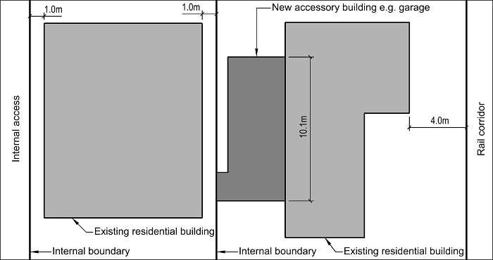
Figure 2: Separation from neighbours
- Minimum setback for balconies and living space windows from internal boundaries
            - The minimum setback from an internal boundary for balconies shall be 4 metres.
            - Where a wall of a residential unit is located between 1 metre and 4 metres from an internal boundary, any living space window located on this wall at first floor level and above shall only contain glazing that is permanently obscured.
            - For a retirement village, this rule only applies to the internal boundaries of the site of the entire retirement village.
            - This rule shall not apply to a window at an angle of 90 degrees or greater to the boundary.
            - For the purposes of this rule, permanently obscured glazing does not include glazing obscured by applied means such as film or paint.
Advice note:
- See sill height in the definition of window.
- Road boundary building setback
          - The minimum road boundary building setback shall be:
 | Activity | Standard
i. | All buildings and situations not listed below | 4.5 metres
ii. | Where a garage has a vehicle door that generally faces a road or shared access | 5.5 metres from the shared access or road kerb
          - Rule 14.4.2.9.a applies except for:
- A garage where (See Figure 3):
- the side walls are parallel to the road boundary and no more than 6.5 metres in length;
- the side walls facing the road contain a window with a minimum dimension of at least 0.6 metres (including the window frame);
- the space between the side wall and the road boundary contains a landscaping strip of at least 2 metres in width that includes a minimum of two trees capable of reaching four metres height at maturity; and
- where the access to the garage is located adjacent to a side boundary:
- a landscaping strip of at least 0.6 metres width, planted with species capable of reaching 1.5 metres height at maturity, is located along the side boundary up to the line of the residential unit.
- where the planting conflicts with required visibility splays the visibility splay rules will prevail and the planting not be required.

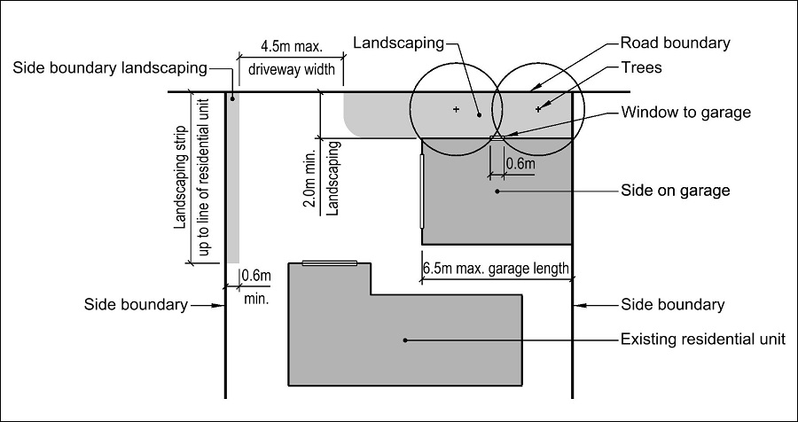
Figure 3: Side extension
- A garage where (See Figure 4):
- the garage is a single garage, with the door facing the road boundary, accessed from a local road;
- the garage is a maximum 3.6 metres wide;
- the garage is fitted with a sectional door that does not intrude into the driveway when open and can be operated with an automatic opener. Where the garage is more than 3.5 metres from the road boundary an automatic opener is not required; and
- no part of the garage door when opening or shutting extends beyond the site boundary.
- Rule 14.4.2.9 b.i. and b.ii. above do not apply to garages in the Character Area Overlay.
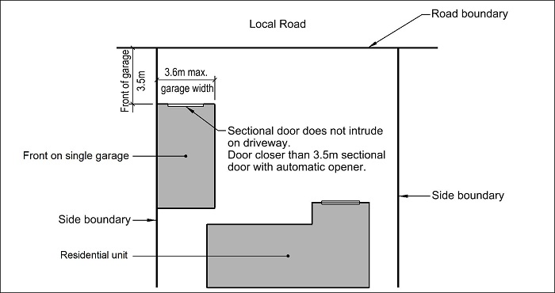
Figure 4: Front extension

- Street scene amenity and safety – fences
            - The maximum height of any fence in the required building setback from a road boundary shall be 1.8 metres.
            - This rule shall not apply to fences or other screening structures located on an internal boundary between two properties zoned residential, or residential and commercial or industrial.
            - For the purposes of this rule, a fence or other screening structure is not the exterior wall of a building or accessory building.
- Water supply for fire fighting
            - Sufficient water supply and access to water supplies for fire fighting shall be made available to all residential units via Council’s urban fully reticulated system and in accordance with the New Zealand Fire Service Fire Fighting Water Supplies Code of Practice (SNZ PAS:4509:2008).
- Service, storage and waste management spaces
            - For multi-unit residential complexes and social housing complexes only:
              - each residential unit shall be provided with at least 2.25m² with a minimum dimension of 1.5 metres of outdoor or indoor space at ground floor level for the dedicated storage of waste and recycling bins;
              - each residential unit shall be provided with at least 3m² with a minimum dimension of 1.5 metres of outdoor space at ground floor level for washing lines; and
              - the required spaces in a. and/or b. for each residential unit shall be provided either individually, or within a dedicated shared communal space.

14.4.3 Area-specific rules — Residential Suburban Zone and Residential Suburban Density Transition Zone, and Qualifying Matter Airport Noise Influence Area
a. The following rules apply to the areas specified. All activities are also subject to Rules 14.4.1 and 14.4.2 unless specified otherwise.

14.4.3.1 Area-specific activities

14.4.3.1.1 Area-specific permitted activities
a. The activities listed below are permitted activities if they meet the activity specific standards set out in this table; and the built form standards in Rule 14.4.2, unless specified otherwise in Rule 14.4.3.2
b. Activities may also be controlled, restricted discretionary, discretionary, non-complying or prohibited as specified in Rules 14.4.1.2, 14.4.1.3, 14.4.1.4, 14.4.1.5 and 14.4.1.6 (unless specified otherwise in area specific rules); and Rules 14.4.3.1.2, 14.4.3.1.3, 14.4.3.1.4, 14.4.3.1.5, or 14.4.3.1.6.
Activity |  | Activity specific standards
P1 | - The following activities in the Accommodation and Community Facilities Overlay:  - Preschools;  - Health care facility;  - Veterinary care facility;  - Education activity;  - Place of assembly;  - Spiritual activities;  - Community corrections facilities;  - Community welfare facilities;  - Care facility. | - The activity specific standards in Rule 14.4.1.1 do not apply.  - The facility or activity shall:  - comprise less than 500m² gross leasable floor space; and  - limit the time when the site is open to visitors, students, patients, clients, and deliveries to between 07:00-21:00 Monday to Sunday.
P2 | Guest accommodation Visitor accommodation in the Accommodation and Community Facilities Overlay including ancillary office, meeting and conference facilities, fitness facilities and provision of goods and services primarily for the convenience of guests.  (Plan Change 4 Council Decision subject to appeal) | Nil  - The maximum size of all ancillary activities shall not exceed 25% of the GFA of all buildings on the same site.  - No individual type of ancillary activity shall be more than 250m² GLFA.  (Plan Change 4 Council Decision subject to appeal)
P3 | Place of Assembly, including functions, conferences, community events and festivals at Kate Sheppard House, 83 Clyde Road  (Plan Change 5F Council Decision) | - There shall be a maximum of 5 parking spaces on the site.  - The maximum hours of operation during which the site may be open to visitors, staff and deliveries shall be:  - 07:00 – 23:00 Monday to Saturday; and  - 07:00 – 22:00 Sundays and Public Holidays.  - There shall be no amplified music after 22.00 on any day.  - No more than 15 events shall be held outside the house in any twelve month time period.  (Plan Change 5F Council Decision)

14.4.3.1.2 Area-specific controlled activities
a. The activities listed below are controlled activities.
b. Discretion to impose conditions is restricted to the matters over which control is reserved in Rule 14.15, as set out in the following table.
 | Location | Controlled activity | The matters over which Council reserves its control
C1 | Character Area Overlay | - The relocation of a building onto the site, erection of new buildings and alterations or additions to existing buildings, accessory buildings, fences and walls associated with that development, where it is:  - visible from the street;  - located in that part of the site between the road boundary and the main residential unit on the site; or  - involves changes to the front façade of the main residential unit of the site.  - This rule does not apply to:  - fences that are 1 metre in height or less  - accessory buildings that are located to the rear of the main residential unit on the site and are less than 5 metres in height  - fences that are located on a side or rear boundary of the site, except where that boundary is adjacent to a public space; or  - rear sites or those located on private lanes in CA4 – Beckenham Loop.  - Activities that do not meet Rule 14.4.3.2.17 Landscape areas.  - Any application arising from this rule shall not be limited or publicly notified. | - Character Area Overlay – Rule 14.15.23

14.4.3.1.3 Area-specific restricted discretionary activities
a. The activities listed below are restricted discretionary activities.
b. Discretion to grant or decline consent and impose conditions is restricted to the matters of discretion set out in Rule 14.15, or as specified, as set out in the following table:
 | Location | Restricted discretionary activity | The Council’s discretion shall be limited to the following matters
RD1 | Residential area in Wigram as shown on Figure 6 | - Activities that do not meet Rule 14.4.3.2.9 – Outdoor living space at West Wigram.  - Any application arising from this rule shall not be publicly notified and may be limited notified only to the New Zealand Defence Force (where the consent authority considers this is required and absent its written approval). | - Development plans - Rule 14.15.15  - Special setback provision - Residential Suburban Zone Low Density Residential Airport Influence Zone Wigram - Rule 14.15.13
RD2 | Mairehau Final Development Area  (Plan Change 6 Council Decision subject to appeal) | - Any development of land that is not in accordance with the layout shown in the development plan in Figure 5.  - Any application arising from this rule shall not be limited or publicly notified.  (Plan Change 6 Council Decision subject to appeal) | - Development plans - Rule 14.15.15  (Plan Change 6 Council Decision subject to appeal)
RD2 | Mairehau Final Development Area | - Any development of land that is not in accordance with the layout shown in the development plan in Figure 5.  - Any application arising from this rule shall not be limited or publicly notified. | - Development plans - Rule 14.15.15
RD3 | Prestons Road Retirement Village Overlay | - Residential units that do not comply with Rule 14.4.3.2.4 - Outdoor living space.  - Any application arising from this rule shall not be limited or publicly notified.  - This clause shall cease to have effect on 31st December 2018. | - Outdoor living space - Rule 14.15.20
RD4 | - Peat Ground Condition Constraint Overlay;  - Stormwater Capacity Constraint Overlay; or  - Prestons Road Retirement Village Overlay. | - Activities and buildings that do not comply with Rule 14.4.3.2.5 - Minimum building setbacks from internal boundaries.  - Any application arising from this rule shall not be limited or publicly notified. | - Minimum building, window and balcony setbacks - Rule 14.15.18
RD5 | - Peat Ground Condition Constraint Overlay;  - Stormwater Capacity Constraint Overlay;  - Existing Rural Hamlet Overlay in the area to the east of the 50 dB Ldn Air Noise Contour shown on Planning Map 18; or  - Existing Rural Hamlet Overlay in the area to the west of the 50 dB Ldn Air Noise Contour shown on Planning Map 18. | Residential units that do not comply with Rule 14.4.3.2.1 - Site density | - Site density and site coverage – Rule 14.152.2  - Whether the development design adequately mitigates any adverse effects of the additional building coverage on the environmental condition giving rise to the constraint.
RD6 | Prestons Road Retirement Village Overlay | - Activities and buildings that do not comply with Rule 14.4.3.2.2 - Building height.  - This clause shall cease to have effect on 31st December 2018 in relation to the Prestons Road Retirement village. | - Impacts on neighbouring property – Rule 14.15.3
RD7 | - Peat Ground Condition Constraint Overlay;  - Stormwater Capacity Constraint Overlay;  - Existing Rural Hamlet Overlay;  - Prestons Road Retirement Village Overlay. | - Activities and buildings that do not comply with Rule 14.4.3.2.3 - Site coverage | - Site density and site coverage – Rule 14.15.2  - Whether the development design adequately mitigates any adverse effects of the additional building coverage on the environmental condition giving rise to the constraint.
RD8 | Character Area Overlay | Residential units that do not comply with Rule 14.4.3.2.1 – Site density, where the minimum site density is between 400m² and 600m² | - Character Area Overlay – Rule 14.15.23
RD9 | Accommodation and Community Facilities Overlay | - Service stations.  - Any application arising from this rule shall not be limited or publicly notified. | - Scale and nature of activity – Rule 14.15.5  - Hours of operation – Rule 14.15.21  - Traffic generation and access safety – Rule 14.15.6  (Plan Change 5D Council Decision)
RD10 |  | Activities listed in Rule 14.4.3.1.1 P1 that do not comply with any one or more of the activity specific standards in Rule 14.4.3.1.1 P1. | - Scale and nature of activity – Rule 14.15.5  - Hours of operation – Rule 14.15.21  - Traffic generation and access safety – Rule 14.15.6  - Impacts on neighbouring property - Rule 14.15.3  (Plan Change 5D Council Decision)
RD11 | - Prestons Road Retirement Village Overlay  - Accommodation and Community Facilities Overlay | Buildings that do not meet Rule 14.4.3.2.11 – Daylight recession planes | - Impacts on neighbouring property – Rule 14.15.3
RD12 | Accommodation and Community Facilities Overlay | - Activities and buildings that do not meet Rule 14.4.3.2.3 - Site coverage | - Site density and site coverage – Rule 14.15.2
RD13 |  | - Buildings that do not meet Rule 14.4.3.2.12 – Maximum continuous building length.  - Any application arising from this rule shall not be limited or publicly notified. | - Impacts on neighbouring property – Rule 14.15.3  - Residential design principles – Rule 14.15.1.e only
RD14 |  | - Buildings that do not comply with Rule 14.4.3.2.13 – Building setbacks from road boundaries.  - Any application arising from this rule shall not be limited or publicly notified. | - Street scene – road boundary building setback, fencing and planting – Rule 14.15.17
RD15 |  | - Buildings that do not comply with Rule 14.4.3.2.14 – Front entrances and facades.  - Any application arising from this rule shall not be limited or publicly notified. | - Residential design principles – Rule 14.15.1
RD16 |  | - Buildings that do not comply with Rule 14.4.3.2.15 – Building overhangs.  - Any application arising from this rule shall not be limited or publicly notified. | - Residential design principles – Rule 14.15.1
RD17 |  | - Activities that do not comply with Rule 14.4.3.2.16 – Fences and screening.  - Any application arising from this rule shall not be limited or publicly notified. | - Street scene – road boundary building setback, fencing and planting – Rule 14.15.17
RD18 |  | - Activities that do not comply with Rule 14.4.3.2.17 – Landscaped areas  - Any application arising from this rule shall not be limited or publicly notified. | - Street scene – road boundary building setback, fencing and planting – Rule 14.15.17
RD19 | Accommodation and Community Facilities Overlay  (Plan Change 4 Council Decision subject to appeal) | Ancillary activities to visitor accommodation listed in Rule 14.4.3.1.1 P2 that do not comply with any one or more of the activity specific standards in Rule 14.4.3.1.1 P2.  (Plan Change 4 Council Decision subject to appeal) | - Scale of activity – Rule 14.15.5  - Hours of operation – Rule 14.15.21  - Traffic generation and access safety – Rule 14.15.6  (Plan Change 4 Council Decision subject to appeal)
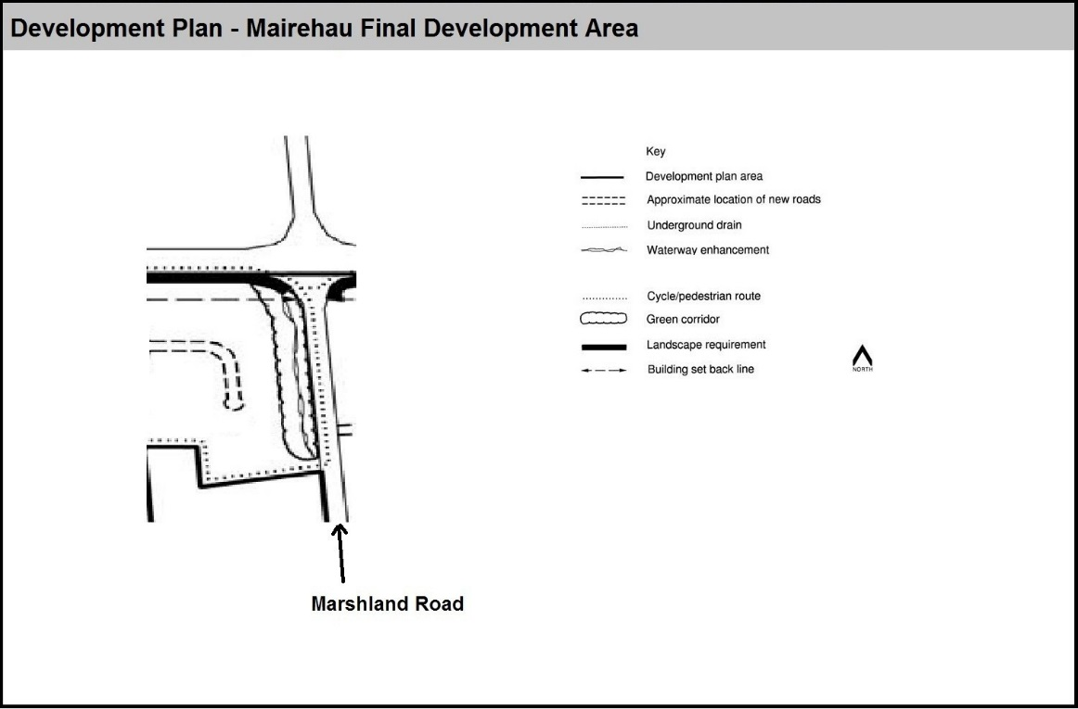

Figure 5: Mairehau final development area
(Private Plan Change 6 Council Decision)

14.4.3.1.4 Area-specific discretionary activities
a. The activities listed below are discretionary activities.
Activity/area
D1 | Activities and buildings that do not comply with Rule 14.4.3.2.10 - Use of site and buildings Prestons Road Retirement Village Overlay.  This clause shall cease to have effect on 31st December 2018.
D21 | Activities and buildings that do not comply with Rule 14.4.3.2.63 – Minimum building setback from zone boundary Russley Road/Memorial Avenue
D3 | Activities and buildings that do not comply with 14.4.3.2.8 - Building types and limits Prestons Road Retirement Village Overlay
D42 | Place of Assembly, including functions, conferences, community events and festivals at Kate Sheppard House, 83 Clyde Road that does not comply with one or more of the activity specific standards in rule 14.4.3.1.1 P31.  ( Plan Change 5F Council Decision)

14.4.3.1.5 Area-specific non-complying activities
a. The activities listed below are a Non Complying Activity.
Activity
NC1 | Activities and buildings that do not comply with Rule 14.4.3.2.74 - Noise insulation
NC2 | Activities and buildings that do not comply with Rule 14.4.3.2.9 - Outdoor living space West Wigram
NC3 | Residential units in the Character Area Overlay that do not comply with Rule 14.4.3.2.1, where the residential unit is contained within a site with a net site area of less than 400m².

14.4.3.1.6 Area-specific prohibited activities
There are no prohibited activities.

14.4.3.2 Area-specific built form standards

14.4.3.2.1 Site density
            - This applies to:
- Peat Ground Condition Constraint Overlay;
ii. Stormwater Capacity Constraint Overlay;
iii. Existing Rural Hamlet Overlay; and
iv. Character Area Overlay.
            - Each residential unit shall be contained within its own separate site. The site shall have a minimum net site area as follows:
 | Activity | Standard
i. | Peat Ground Condition Constraint Overlay | 2000m²
ii. | Stormwater Capacity Constraint Overlay | 1 residential unit for each allotment existing at June 1995
iii. | Existing Rural Hamlet Overlay | 2000m²
iv. | Residential Suburban Zone within the Character Area Overlay | 600m²
v. | Residential Suburban Density Transition Zone and within the Character Area Overlay (except as specified in 6. Below) | 400m²
vi. | Character Area Overlay – Character Area 8 - Beverley | 500m²
Advice note:
- Refer also to the subdivision rules in Chapter 8.

14.4.3.2.2 Building height
            - This applies to:
- Prestons Road Retirement Village Overlay; and
- Accommodation and Community Facilities Overlay.
            - Maximum height of any building shall be:
 | Activity/area | Standard
i. | Prestons Road Retirement Village Overlay, except as listed in ii. below.  This clause shall cease to have effect on 31st December 2018. | 6.5 metres and of a single storey only
ii. | Prestons Road Retirement Village Overlay in the health facility.  This clause shall cease to have effect on 31st December 2018. | 13 metres
iii. | Activities that are not residential activities in the Accommodation and Community Facilities Overlay | 9 metres, or 12 metres for a building with a pitched roof of at least 22 degrees.
            - For the purposes of determining building height in the Prestons Road Retirement Village Overlay, ground level shall be taken as the level of ground existing when filling or excavation for new buildings on the land has been completed.
            - Rule 14.4.2.3 - Building height shall not apply in the Prestons Road Retirement Village Overlay until Rule 14.4.3.2.2 ceases to have effect.
Advice note:
- See the permitted height exceptions contained within the definition of height.

14.4.3.2.3 Site coverage
            - This applies to:
              - Peat Ground Condition Constraint Overlay;
ii. Stormwater Capacity Constraint Overlay;
iii. Existing Rural Hamlet Overlay;
iv. Prestons Road Retirement Village Overlay; and
v. Accommodation and Community Facilities Overlay.
            - Rule 14.4.2.4 - Site coverage shall not apply in the Prestons Road Retirement Village Overlay area until Rule 14.4.3.2.3 ceases to have effect.
The maximum percentage of the net site area covered by buildings shall be as follows: | Activity/area | Standard
i. | Peat Ground Condition Constraint, Stormwater Capacity Constraint, and Existing Rural Hamlet. | 40% or 300m² whichever is the lesser
ii. | Prestons Road Retirement Village Overlay, except as stated in iii. below. This clause shall cease to have effect on 31st December 2018. | 40% (calculated over the net site area of the entire complex)
iii. | Prestons Road Retirement Village Overlays: residential activities with garages. This clause shall cease to have effect on 31st December 2018. | 40% or 300m² whichever is the lesser
iv. | Activities that are not residential activities in the Accommodation and Community Facilities Overlay | 45%

            - For the purposes of this rule this excludes :
              - fences, walls and retaining walls;
              - eaves and roof overhangs up to 600mm in width and guttering up to 200mm in width from the wall of a building;
              - uncovered swimming pools up to 800mm in height above ground level; and
              - decks, terraces, balconies, porches, verandahs, bay or box windows (supported or cantilevered) which:
- are no more than 800mm above ground level and are uncovered or unroofed; or
- where greater than 800mm above ground level and/or covered or roofed, are in total no more than 6m² in area for any one site;

14.4.3.2.4 Outdoor living space Prestons Road Retirement Village Overlay
            - Each residential unit shall be provided with an outdoor living space in a continuous area, contained within the net site area with a minimum area and dimension as follows:

 | Activity/area | Standard
 |  | Minimum Area | Minimum Dimension
i. | Prestons Road Retirement Village Overlay: for any older person’s housing unit  This clause shall cease to have effect on 31st December 2018. | 30m² | 3 metres
            - The required minimum area shall be readily accessible from a living area of each residential unit. This rule only applies to structures on the same site.
            - The required minimum area shall not be occupied by any building, access or parking space, other than:
- an outdoor swimming pool; or
- accessory building of less than 8m² in area; or
- any buildings or parts of a building without walls (other than a balustrade) on at least a quarter of its perimeter, which occupies no more than 30% of the area of the outdoor living space.
d. Rule 14.4.2.5 Outdoor living space shall not apply to any older person’s housing unit in the Prestons Road Retirement Village Overlay until Rule 14.4.3.2.4 ceases to have effect.

14.4.3.2.5 Minimum building setbacks from internal boundaries
            - This applies to:
- Peat Ground Condition Constraint Overlay;
- Stormwater Capacity Constraint Overlay;
- Prestons Road Retirement Village Overlay.
            - Rule 14.4.2.7 (other than Rule 14.4.2.7(vi)) - Minimum building setbacks to internal boundaries shall not apply in the Prestons Road Retirement Village Overlay areas until Rule 14.4.3.2.5 ceases to have effect.
            - Minimum building setback from boundaries shall be as follows:
 | Area | Standard
i. | Peat Ground Condition Constraint and Stormwater Capacity Constraint Overlays | 3 metres
ii. | Prestons Road Retirement Village Overlay.  This clause shall cease to have effect on 31st December 2018. | - From Prestons Road – 15 metres  - From internal boundaries – 1.8 metres

14.4.3.2.61 Minimum building setback from zone boundary Russley Road/Memorial Avenue
- At Russley Road/Memorial Avenue, where the eastern boundary of the Residential Suburban Zone abuts the western boundary of the Industrial Park Zone, the minimum building setback from the eastern boundary of the zone where it abuts the Industrial Park Zone shall be 5 metres.

14.4.3.2.7 Noise insulation
            - This applies to:
              - the area adjacent to State Highway 73 (Southern Motorway) between Annex and Curletts Roads;
              - the area adjacent to State Highway 75 (Curletts Road) between the intersection with State Highway 73 and Lincoln Road;
              - Peat Ground Condition Constraint Overlay; and
              - Existing Rural Hamlet Overlay.
 | Location | Standard
b. | On that land which is:  - adjacent to State Highway 73 (Southern Motorway) between Annex and Curletts Roads; and  - adjacent to State Highway 75 (Curletts Road) between the intersection with State Highway 73 and Lincoln Road. | - Building setbacks, or building location, or acoustic barriers, or other means, either singly or in combination shall be used such that the following noise insulation standards are met:  - Sound levels attributable to traffic from these roads shall not exceed a level of 57 _{dBA} L10 (18 hour) 54 _{dBA} Leq (24 hour) in any outdoor area of the site and a design level of 60 _{dBA} L10 (18 hour) 57 _{dBA} Leq (24 hour) measured 1 metre from the façade of any residential unit. All measured in accordance with NZS 6801:1991 Assessment of Sound.
c. | Mairehau Final Development Area identified in Figure 5 – on land which is on the western side of Marshlands Road between Queen Elizabeth Drive and Briggs Road  (Private Plan Change 6 Council Decision subject to appeal) | - There shall be no minimum building setback where:  - mounding or other physical barrier to noise transmission capable of reducing traffic noise intrusion to all parts of any site by at least 10_{dBA} is provided within 20 metres of the road boundary across the entire width of the site;  - the mounding in i. is screened from the adjoining road by landscaping with a minimum depth of 1.5 metres and a minimum height of 1.8 metres at time of planting;  - the minimum building setback from a limited access road shall be 40 metres.  - where a.i. and a.ii. are complied with and all external windows and doors of a residential units including those installed in the roof are acoustically treated to achieve a sound transmission loss of at least 25 _{dBA} with windows and doors closed the minimum setback shall be 20 metres.  - Where a. and b. do not apply the minimum building setback shall be 80 metres.  - For the purpose of this rule the minimum building setback shall be measured from the road carriageway to the residential unit.  (Private Plan Change 6 Council Decision subject to appeal)
d. | Peat Ground Condition Constraint Overlay | The minimum building setback from the boundary with the Residential Suburban Zones Low Density Residential Airport Influence Zones or the boundary with Lot 1, Lot 2 or Lot 3 DP 49320 shall be 6 metres.
e. | Existing Rural Hamlet Overlay | - In the Existing Rural Hamlet Overlay west of the 50 dB _{Ldn} Air Noise Contour and the Qualifying Matter Airport Influence Area:  - Any new residential units, or additions to existing residential units shall be insulated from aircraft noise so as to meet the provisions of Appendix 14.16.4; and  - Buildings, other than residential units, shall also be insulated, where applicable, to meet the provisions of Appendix 14.16.4.

14.4.3.2.8 Building types and limits Prestons Road Retirement Village Overlay
            - There shall be a maximum of 165 independent older person’s housing units.
            - Where a unit shares a common wall with another unit, there shall be no more than 4 units in any such arrangement.
            - There shall be a maximum of 45 serviced older person’s housing units contained within the health facility.
            - There shall be a maximum of one health facility with ground floor area of 2500m².
            - The maximum floor area for any one residential unit shall be 165m².

14.4.3.2.9 Outdoor living space West Wigram
          - On the frontage shown in Figure 6, residential units shall have their primary outdoor living space facing away from the aerodrome site. Windows to living areas which directly face the RNZAF Bequest Land shall be double glazed. In addition, a 2 metre wide landscape strip and a close solid and continuous 1.8 metre high fence shall be placed along the boundary of the RNZAF Bequest Land and be completed before any residential units are built.
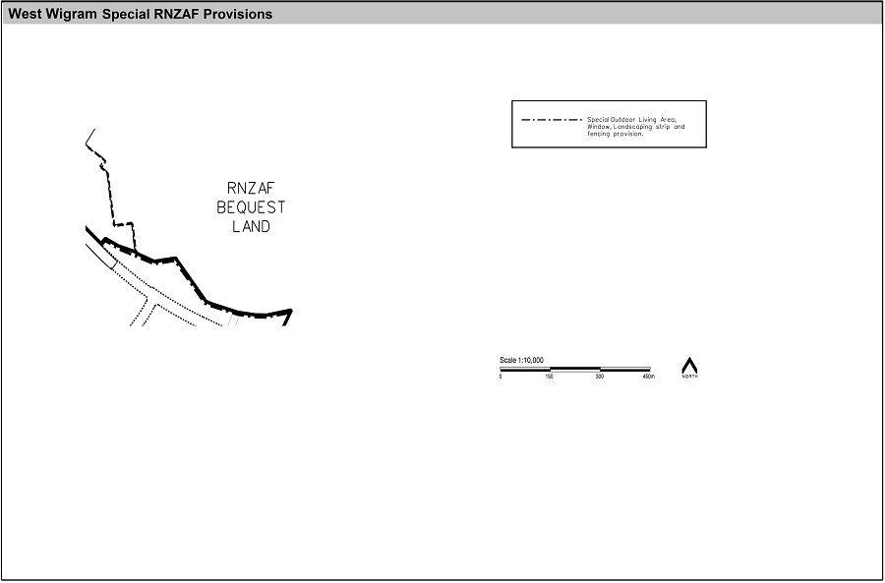
Figure 6: West Wigram Special RNZAF Provisions

14.4.3.2.10 Use of the site and buildings Prestons Road Retirement Village Overlay
          - Any site or buildings shall only be used for housing for persons over the age of 55 and ancillary health, managerial, administrative, social and professional and retail activities associated with the provision of services to those over the age of 55 residing on site.

14.4.3.2.11 Daylight recession planes
            - This applies to:
- Prestons Road Retirement Village Overlay; and
- Accommodation and Community Facilities Overlay.
            - Buildings shall not project beyond a building envelope constructed by recession planes, using the applicable recession planes in the following table, from points 2.3 metres above:
- ground level at the internal boundaries; or
- where an internal boundary of a site abuts an access lot or access strip the recession plane may be constructed from points 2.3 metres above ground level at the furthest boundary of the access lot or access strip or any combination of these areas; or
- where buildings on adjoining sites have a common wall along an internal boundary the recession planes shall not apply along that part of the boundary covered by such a wall.
 | Area | Applicable to | Standard
A. | Prestons Road Retirement Village Overlay | All buildings | Diagram A, Appendix 14.16.2
B. | Accommodation and Community Facilities Overlay | Activities that are not residential activities | Diagram C, Appendix 14.16.2

14.4.3.2.12 Maximum continuous building length
            - Within the Accommodation and Community Facilities Overlay the maximum continuous building length shall be applicable to buildings for:
Applicable to | Standard
- Guest Visitor accommodation;  - Community facility;  - Preschool;  - Education facility;  - Health care facility;  - Place of assembly; and  - Veterinary care facility. | - New buildings: 15 metres
 | - Additions to an existing building: 10 metres

(Plan Change 4 Council Decision subject to appeal)

14.4.3.2.13 Building setback from road boundaries
            - Within the Accommodation and Community Facilities Overlay for activities that are not residential activities, the minimum building setback from road boundaries shall be 3 metres.

14.4.3.2.14 Front entrances and façades
            - Within the Accommodation and Community Facilities Overlay, the following front entrance and façade treatment shall be provided and is applicable to buildings for:
Applicable to | Standard
- Guest Visitor accommodation;  - Community facility;  - Preschool;  - Education facility;  - Health care facility;  - Place of assembly; and  - Veterinary care facility. | - Pedestrian access shall be directly from the road frontage.  - A minimum of 30% glazing on the road frontage on ground floor.  - A minimum of 20% glazing on the road frontage on elevations above ground level.

(Plan Change 4 Council Decision subject to appeal)

14.4.3.2.15 Building overhangs
            - Within the Accommodation and Community Facilities Overlay for activities that are not residential activities, no internal floor area located above ground floor level shall project more than 800mm horizontally beyond the gross floor area at ground level.
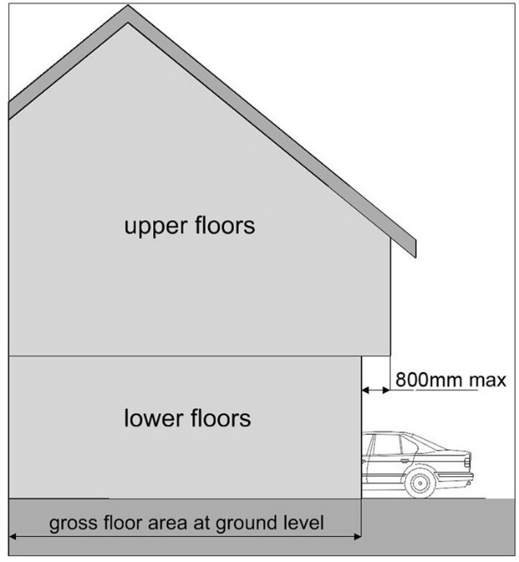
Figure 9: Building overhangs
Advice note:
- This diagram is an illustrative example only, showing a way the rule may be applied.

14.4.3.2.16 Fences and screening
            - Within the Accommodation and Community Facilities Overlay for activities that are not residential activities, fencing and/or screening shall be provided as follows:
  - Screening of outdoor storage areas shall ensure that outdoor storage is not visible from 1.8 metres above ground level on any adjoining road or site, and
  - outdoor storage is not located within any required 2 metre planted strip adjoining the road frontage.

14.4.3.2.17 Landscaped areas
            - Within the Accommodation and Community Facilities Overlay for non-residential activities:
  - In areas adjoining the road frontage of all sites:
    - a minimum density of 1 tree per every 10 metres of road frontage or part thereof, distributed across the frontage; and
    - a minimum 2 metre planted strip.
  - On sites adjoining residential, and open space zones, trees shall be planted adjacent to the shared boundary at a ratio of at least 1 tree for every 10 metres of the boundary or part thereof, with the trees evenly spaced along that boundary.
- Within the Character Area Overlay for all activities, a landscape strip with a minimum width of 3 metres shall be planted:
  - comprising a combination of tree and garden planting; and
  - along the length of the road boundary excluding that part required for a driveway or pedestrian access.

