DISTRICT PLAN TEXT AMENDMENTS
Key:
For the purposes of this plan change, any unchanged text is shown as normal text or in bold, any text proposed to be added by the plan change is shown as bold underlined and text to be deleted as bold strikethrough.
Text in bold red underlined is that from Schedule 3A of the Resource Management Act and must be included.
Text in green font identifies existing terms in Chapter 2 – Definitions. Where the proposed change contains a term defined in Chapter 2 – Definitions, the term is shown as bold underlined text in green and that to be deleted as bold strikethrough in green. New definition in a proposed rule is bold green text underlined in black.
Text in bold purple underlined indicates text recommended in the s42A report to be added and text in bold purple strikethrough text recommended in the s42A report to be deleted. Text in normal black font with purple underline indicates text that was proposed to be deleted in the notified PC14 and is recommended to be reinstated.
Text in purple is a plan change proposal subject to Council Decision.
Text in purple shaded in grey is a Plan Change Council Decision.
Text in black/green shaded in grey is a Council Decision subject to appeal.
Text in blue font indicates links to other provisions in the district Plan and/or external documents. These will have pop-ups and links, respectively, in the on-line Christchurch District Plan.

14.16 Appendices

Appendix 14.16.1 Measurement and assessment of noise
- The measurement of noise shall be in accordance with NZS 6801:1991, 'Measurement of Sound' and assessed in accordance with NZS 6802:1991, 'Assessment of Environmental Sound'.
- For the purposes of administering these rules the following meanings shall apply:
  - dBA means the A­frequency weighted sound pressure level in decibels relative to a reference sound pressure of 20 micro pascals.
  - L10 means the L10 exceedance level set in A­weighted decibels which is equalled or exceeded 10% of the measurement time.
  - Lmax means the period of time between 22:00 and 07:00 the following day.
  - Night­time means the period of time between 22:00 and 07:00 the next day.
  - Long­term average sound level shall be the time­average sound level (day­night level) Ldn and shall be determined from the inverse­logarithmic mean of the measured Ldn level for each day over any five day period in a week.
  - The 'notional boundary' of any boundary shall be 20 metres from the façade of that dwelling, or the legal boundary of the site where this is closer to the boundary.

Minimum construction requirements for all Central City zones

 | Building Element | Minimum Construction Requirement
1. | External walls of habitable spaces | - Walls with cladding: Minimum not to be less than 25kg/m ¹ being the combined mass of external and internal linings excluding structural elements (e.g. window frames or wall studs).  Assumes minimum 100mm wall cavity. Minimum exterior cladding to be 20mm timber or 9mm compressed fibre cement sheet over timber frame (100mm x 200mm). Fibrous acoustic blanket (Batts or similar) required in cavity for all exterior walls. Interior: One layer of 13mm gypsum plasterboard.  Mass walls²: 190mm concrete block, strapped and lined internally with 9.5mm gypsum plaster board OR 150mm concrete wall.  Notes:  ¹ (e.g. brick veneer or minimum 25mm stucco plaster), internal wall linings need to be no thicker than 10mm gypsum plasterboard.  ² Where exterior wall cladding has a mass of greater than 25kg/m.
2. | Windows of habitable spaces | - Windows of up to 35% of floor area: 10/12/6 double glazing or 14mm laminate glass or glazing systems of equivalent acoustic performance.  - Window areas greater than 35% of floor area will require a specialist acoustic report to show conformance with the insulation rule.  - Frames to be new aluminium window frames with compression seals or equivalent.
3. | Pitched roof | - Cladding: 0.55mm profiled steel or tiles or 6mm corrugated fibre cement.  Frame: Timber truss with 100mm acoustic blanket. Fibrous acoustic blanket (Batts or similar) required for all ceilings with combined mass of less than 25kg/m².  Ceiling: 13mm gypsum plaster board.  Note: (e.g. brick veneer or minimum 25mm stucco plaster), internal wall linings need to be no thicker than 10mm gypsum plasterboard.
4. | Skillion roof | - Cladding: 0.55mm profiled steel of 6mm fibre cement.  Sarking: 20mm particle board (no gaps).  Frame: 100mm gap with acoustic blanket.  Ceiling: two layers of 9.5mm gypsum plaster board (no through ceiling lighting penetrations unless correctly acoustically rated).  Fibrous acoustic blanket (Batts or similar) required for all ceilings with combined mass 25kg/m².  Note: (e.g. brick veneer or minimum 25mm stucco plaster), internal wall linings need to be no thicker than 10mm gypsum plasterboard.
5. | External Door to habitable spaces | - Solid core door (min 24kg/m²) with weather seals (where the door is exposed to exterior noise).  Note: (e.g. brick veneer or minimum 25mm stucco plaster), internal wall linings need to be no thicker than 10mm gypsum plasterboard.
Advice note:
      - Compliance with ventilation requirements of any other Act and these District Plan noise insulation requirements shall be concurrent. Ventilation should be provided in accordance with the provisions of the New Zealand Building Code G4 in a manner which does not compromise sound insulation. To this effect, relying on opening windows for ventilation will compromise the sound insulation performance provided by the District Plan standard. Alternative ventilation methods such as mechanical ventilation or passive methods should be considered. Inlets and outlets for passive and mechanical ventilation systems, and ventilation ductwork, are to be designed to incorporate acoustic insulation to ensure that the acoustic performance of the building facade achieves a minimum noise reduction consistent with the relevant rules.
      - In determining the insulation performance of roof/ceiling arrangements, roof spaces are assumed to have no more than the casual ventilation typical of the jointing, capping and guttering detail used in normal construction.

Appendix 14.16.2 Recession planes

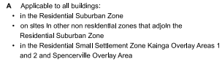
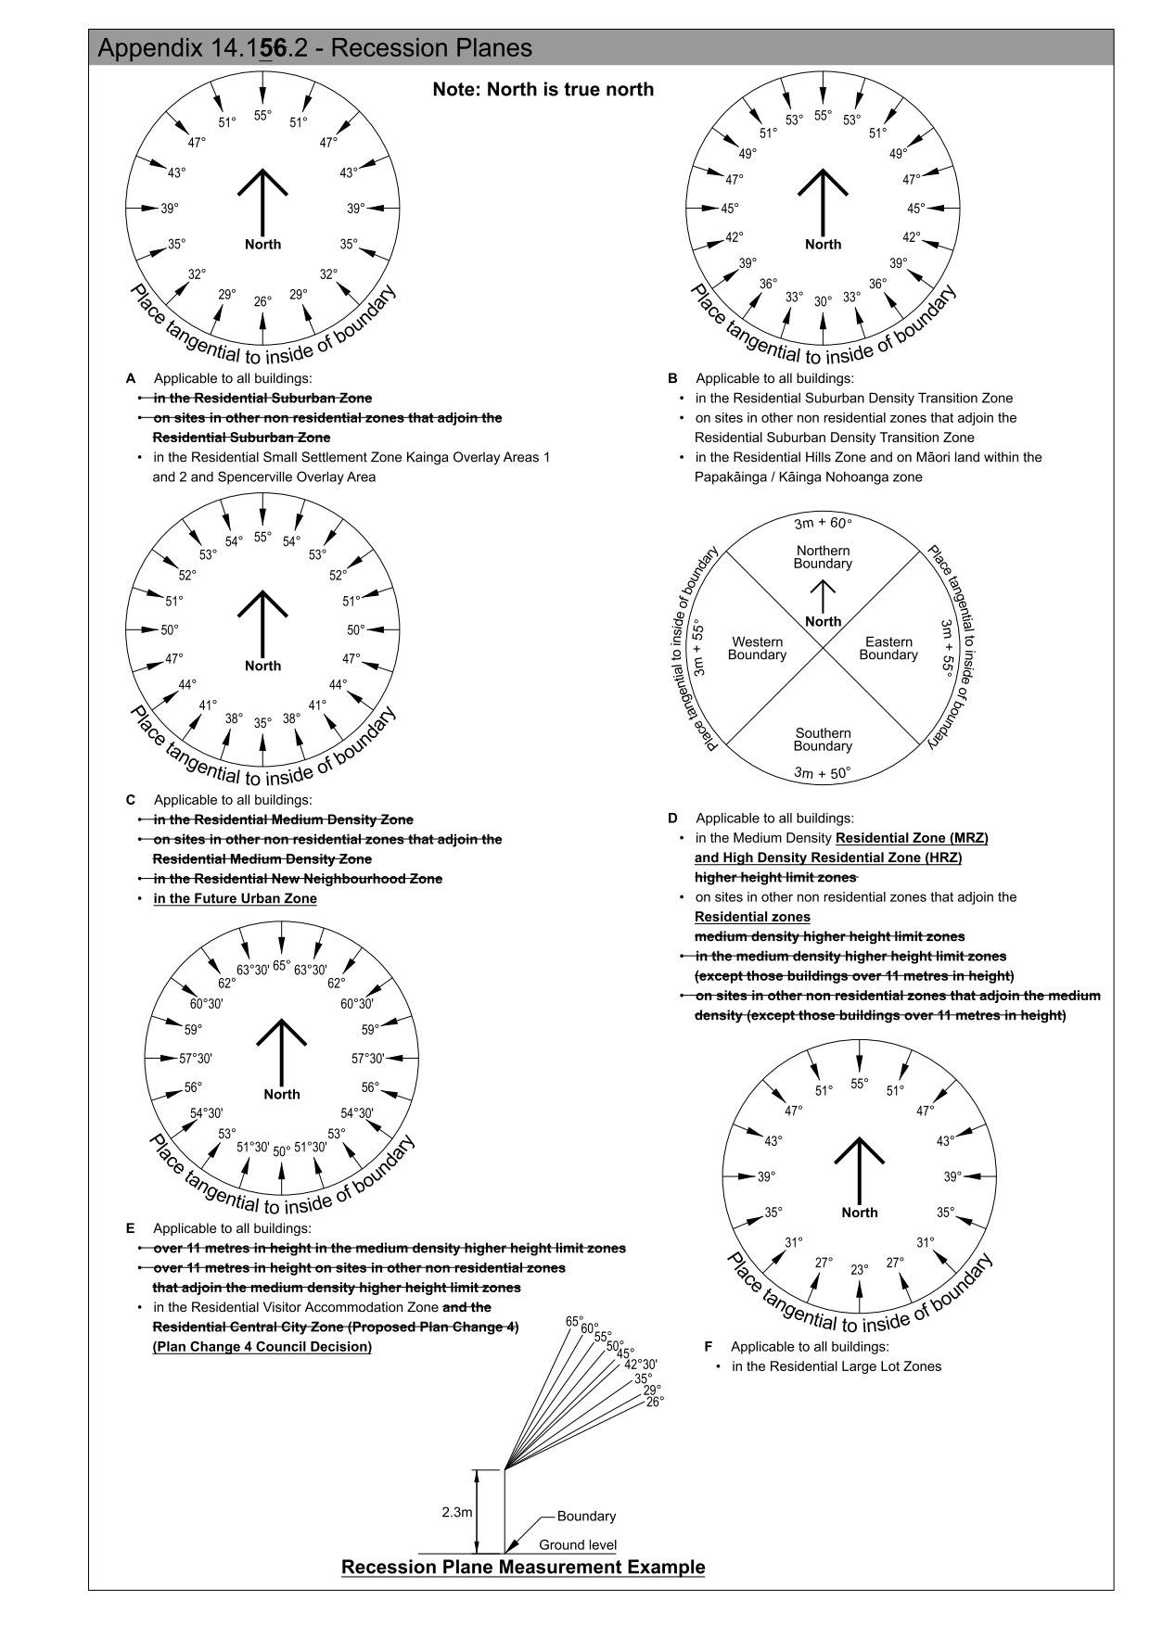
The following intrusions are permitted in the RS, RSDT, RLL and RSS zones only:
- Gutters and eaves by up to 0.2 metres measured vertically;
- Solar panels up to two metres in length per boundary;
- Chimneys, ventilation shafts, spires, poles and masts (where poles and masts are less than nine metres above ground level), provided that the maximum dimension thereof parallel to the boundary for each of these structures shall not exceed 1 metre.
- Lift shafts, stair shafts, and roof water tanks provided that there is a maximum of one intrusion of a lift shaft or stair shaft or roof water tank (or structure incorporating more than one of these) permitted for every 20 metre length of internal boundary and the maximum dimension thereof parallel to the boundary for this structure shall not exceed 3 metres, and provided that for buildings over three storeys, such features are contained within or are sited directly against the outside structural walls.
- Where a single gable end with a base (excluding eaves) of 7.5 metres or less faces a boundary and a recession plane strikes no lower than half way between the eaves and ridge line, the gable end may intrude through the recession plane.
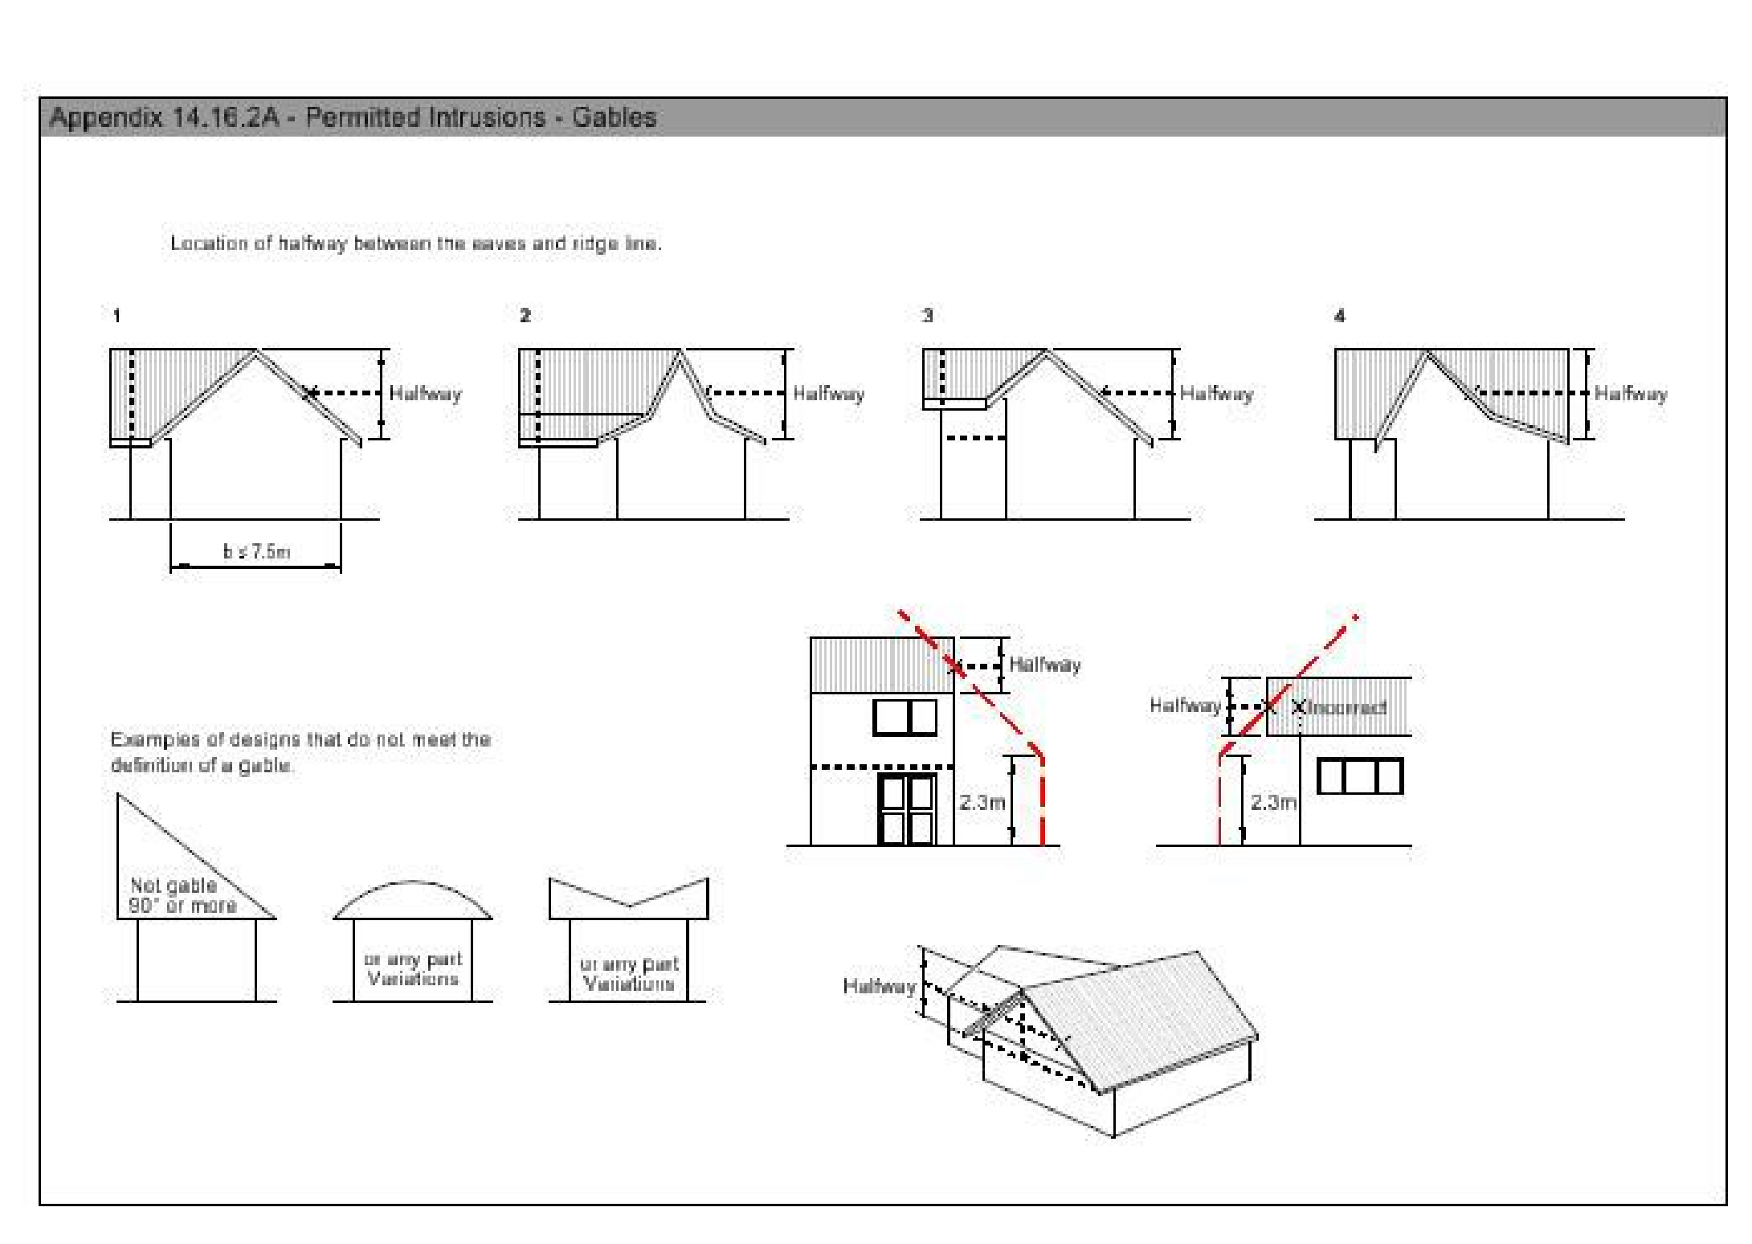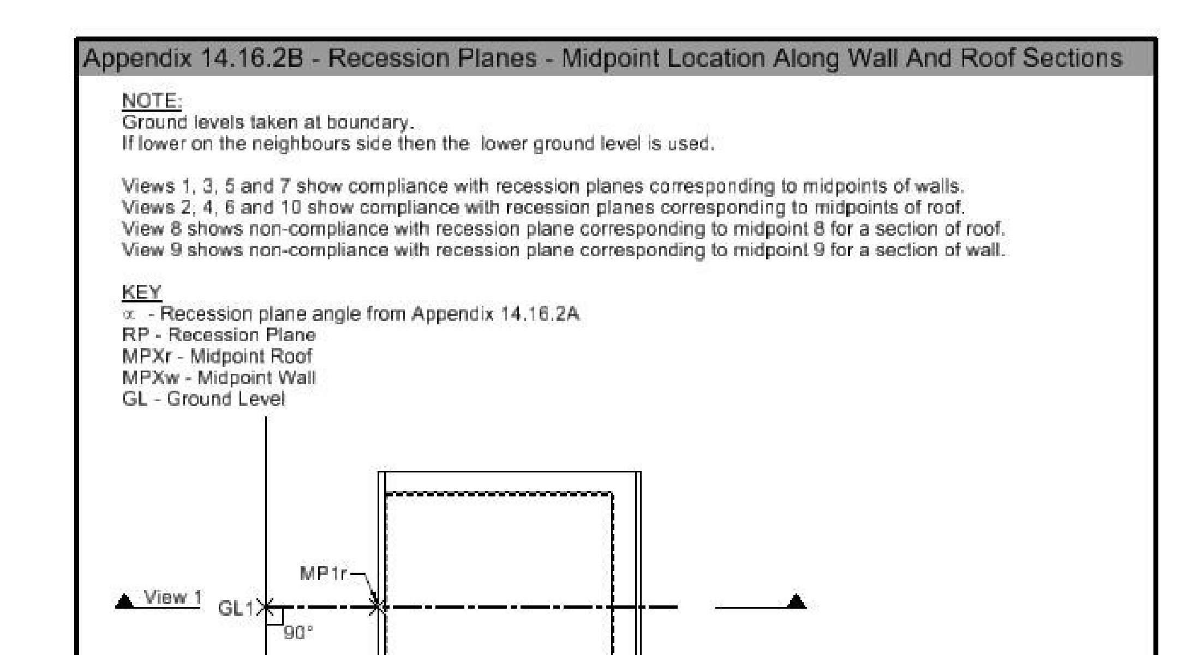
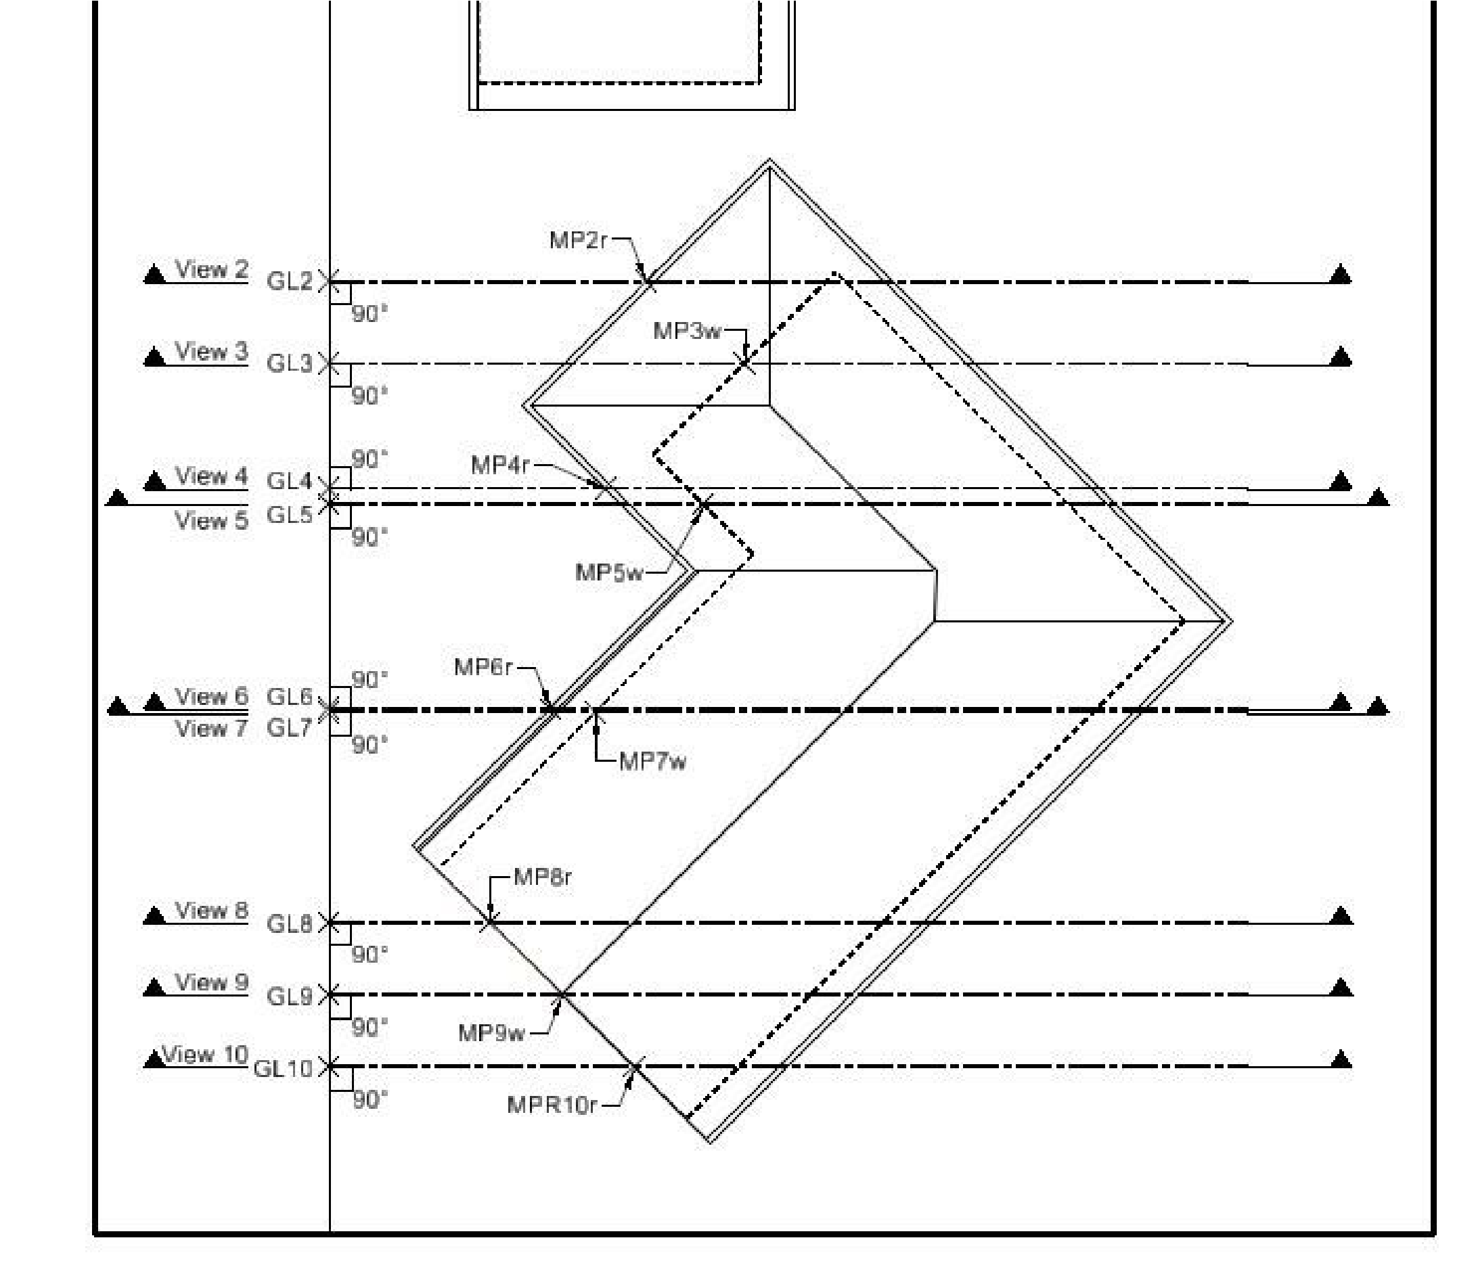
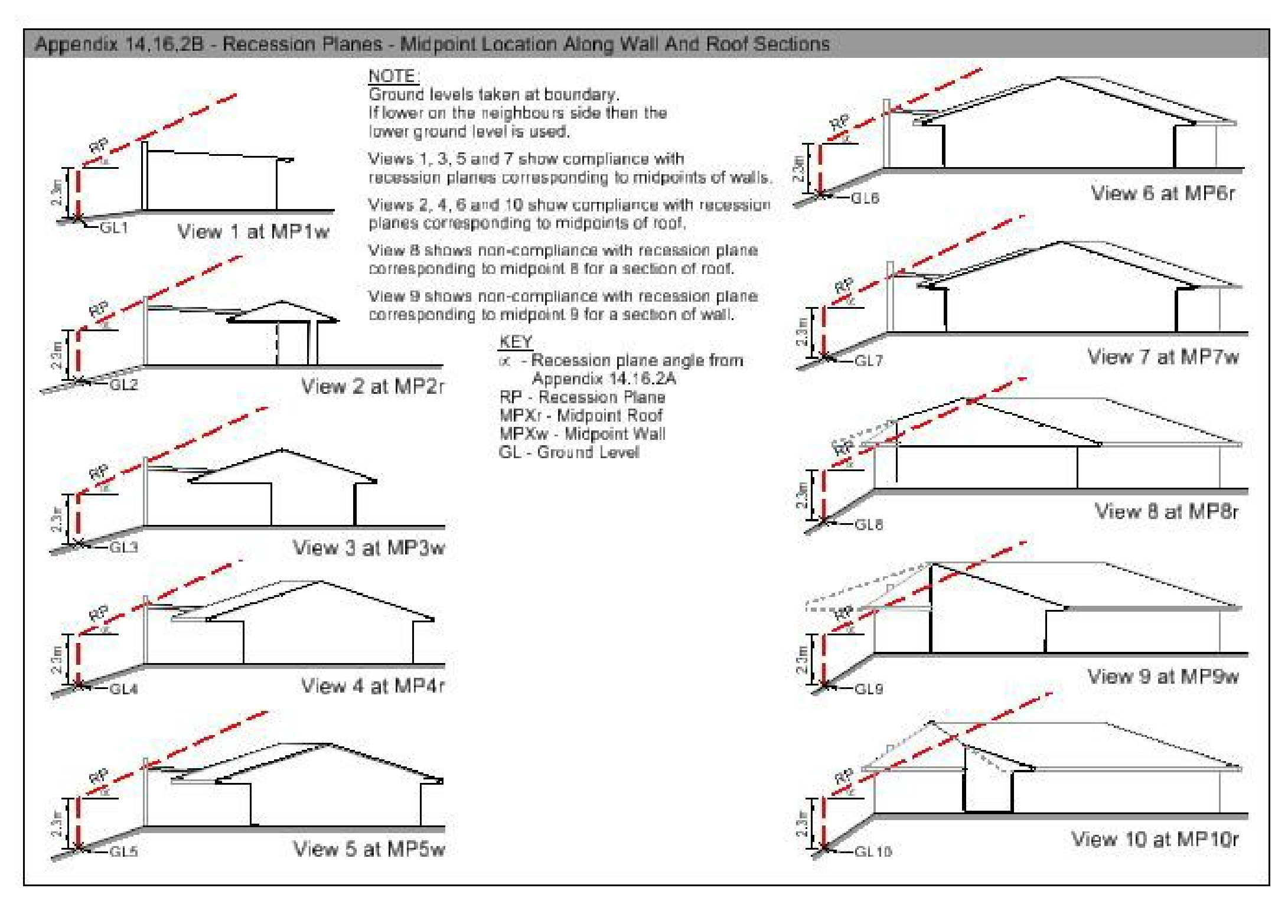

Appendix 14.16.3 Development plan Addington
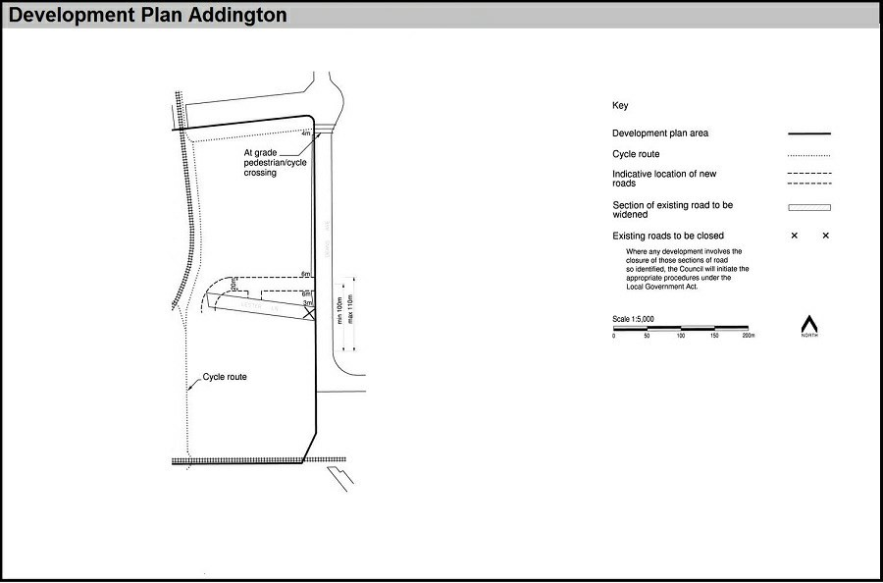

Appendix 14.16.4 Aircraft noise exposure
This appendix derives from Rules 14.4.1.3, 14.11.1.1 and 14.4.3.2.7.
1.1 Indoor design sound levels
New buildings and additions to existing buildings located within the 50 dB Ldn Air Noise Contour as shown on the planning maps shall be designed to ensure the indoor sound levels stated in the table below, are not exceeded with all windows and doors closed.
Indoor design sound levels
Building type and activity | Indoor design and sound levels
 | SEL dB | dB Ldn
Residential units, and older person’s housing, hosted visitor accommodation and unhosted visitor accommodation

(Plan Change 4 Council Decision subject to appeal)
Sleeping areas | 65 | 40
Other habitable areas | 75 | 50
Guest Visitor accommodation (except where specified above), resort hotels, hospitals and health care facilities

(Plan Change 4 Council Decision subject to appeal)
Relaxing or sleeping | 65 | 40
Conference meeting rooms | 65 | 40
Service activities | 75 | 60
Education activities
Libraries, study areas | 65 | 40
Teaching areas, assembly areas | 65 | 40
Workshops, gymnasia | 85 | 60
Retail activities, commercial services and offices
Conference rooms | 65 | 40
Private offices | 70 | 45
Drafting, open offices, exhibition spaces | 75 | 50
Typing, data processing | 80 | 55
Shops, supermarkets, showrooms | 85 | 60
1.2 Noise insulation calculations and verification
- Building consent applications must contain a report detailing the calculations showing how the required sound insulation and construction methods have been determined.
- For the purpose of sound insulation calculations the external noise levels for a site shall be determined by application of the air noise contours L_{dn} and SEL. Where a site falls within the contours the calculations shall be determined by linear interpolation between the contours.
- If required as part of the final building inspection, the sound transmission of the facade shall be tested in accordance with ISO 140-5 or ASTM to demonstrate that the required facade sound insulation performance has been achieved. A test report is to be submitted. Should the facade fail to achieve the required standard then it shall be improved to the required standard and re-tested prior to occupation.

Appendix 14.16.5 Tsunami inundation area
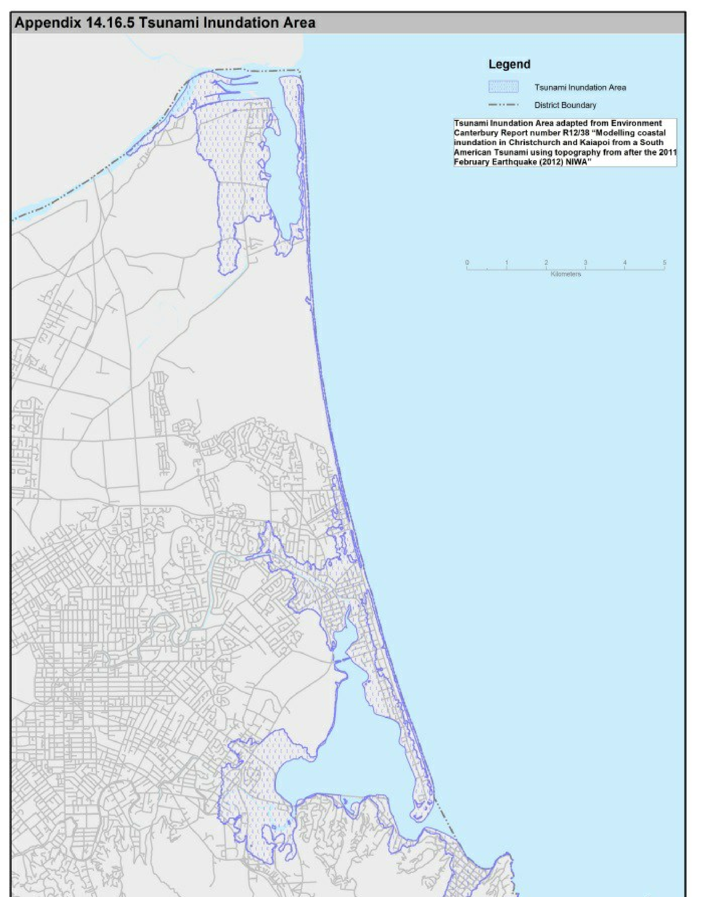

Appendix 14.16.6 Sumner Master Plan Overlay
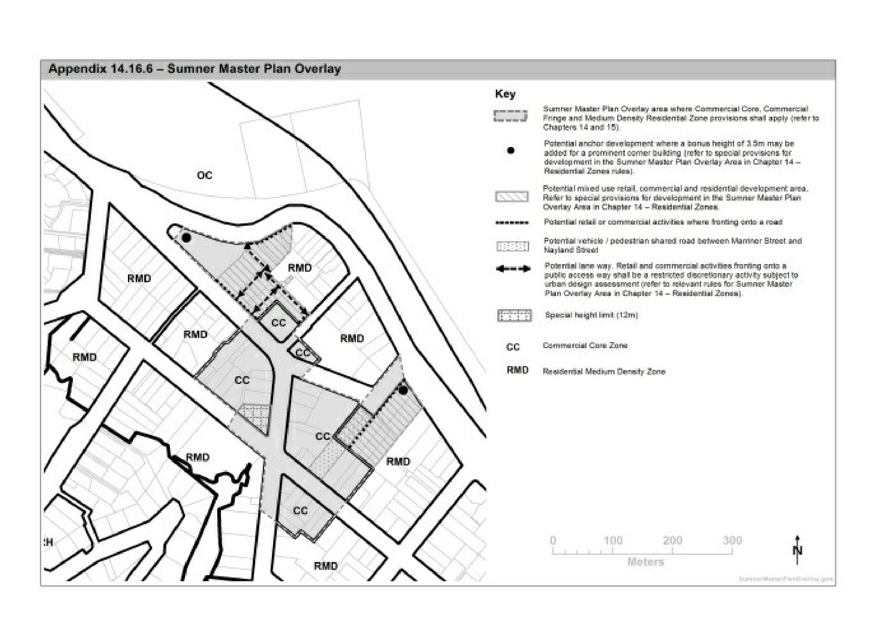

Appendix 14.16.7 Montgomery Spur ­ minimum building setback from ridgeline
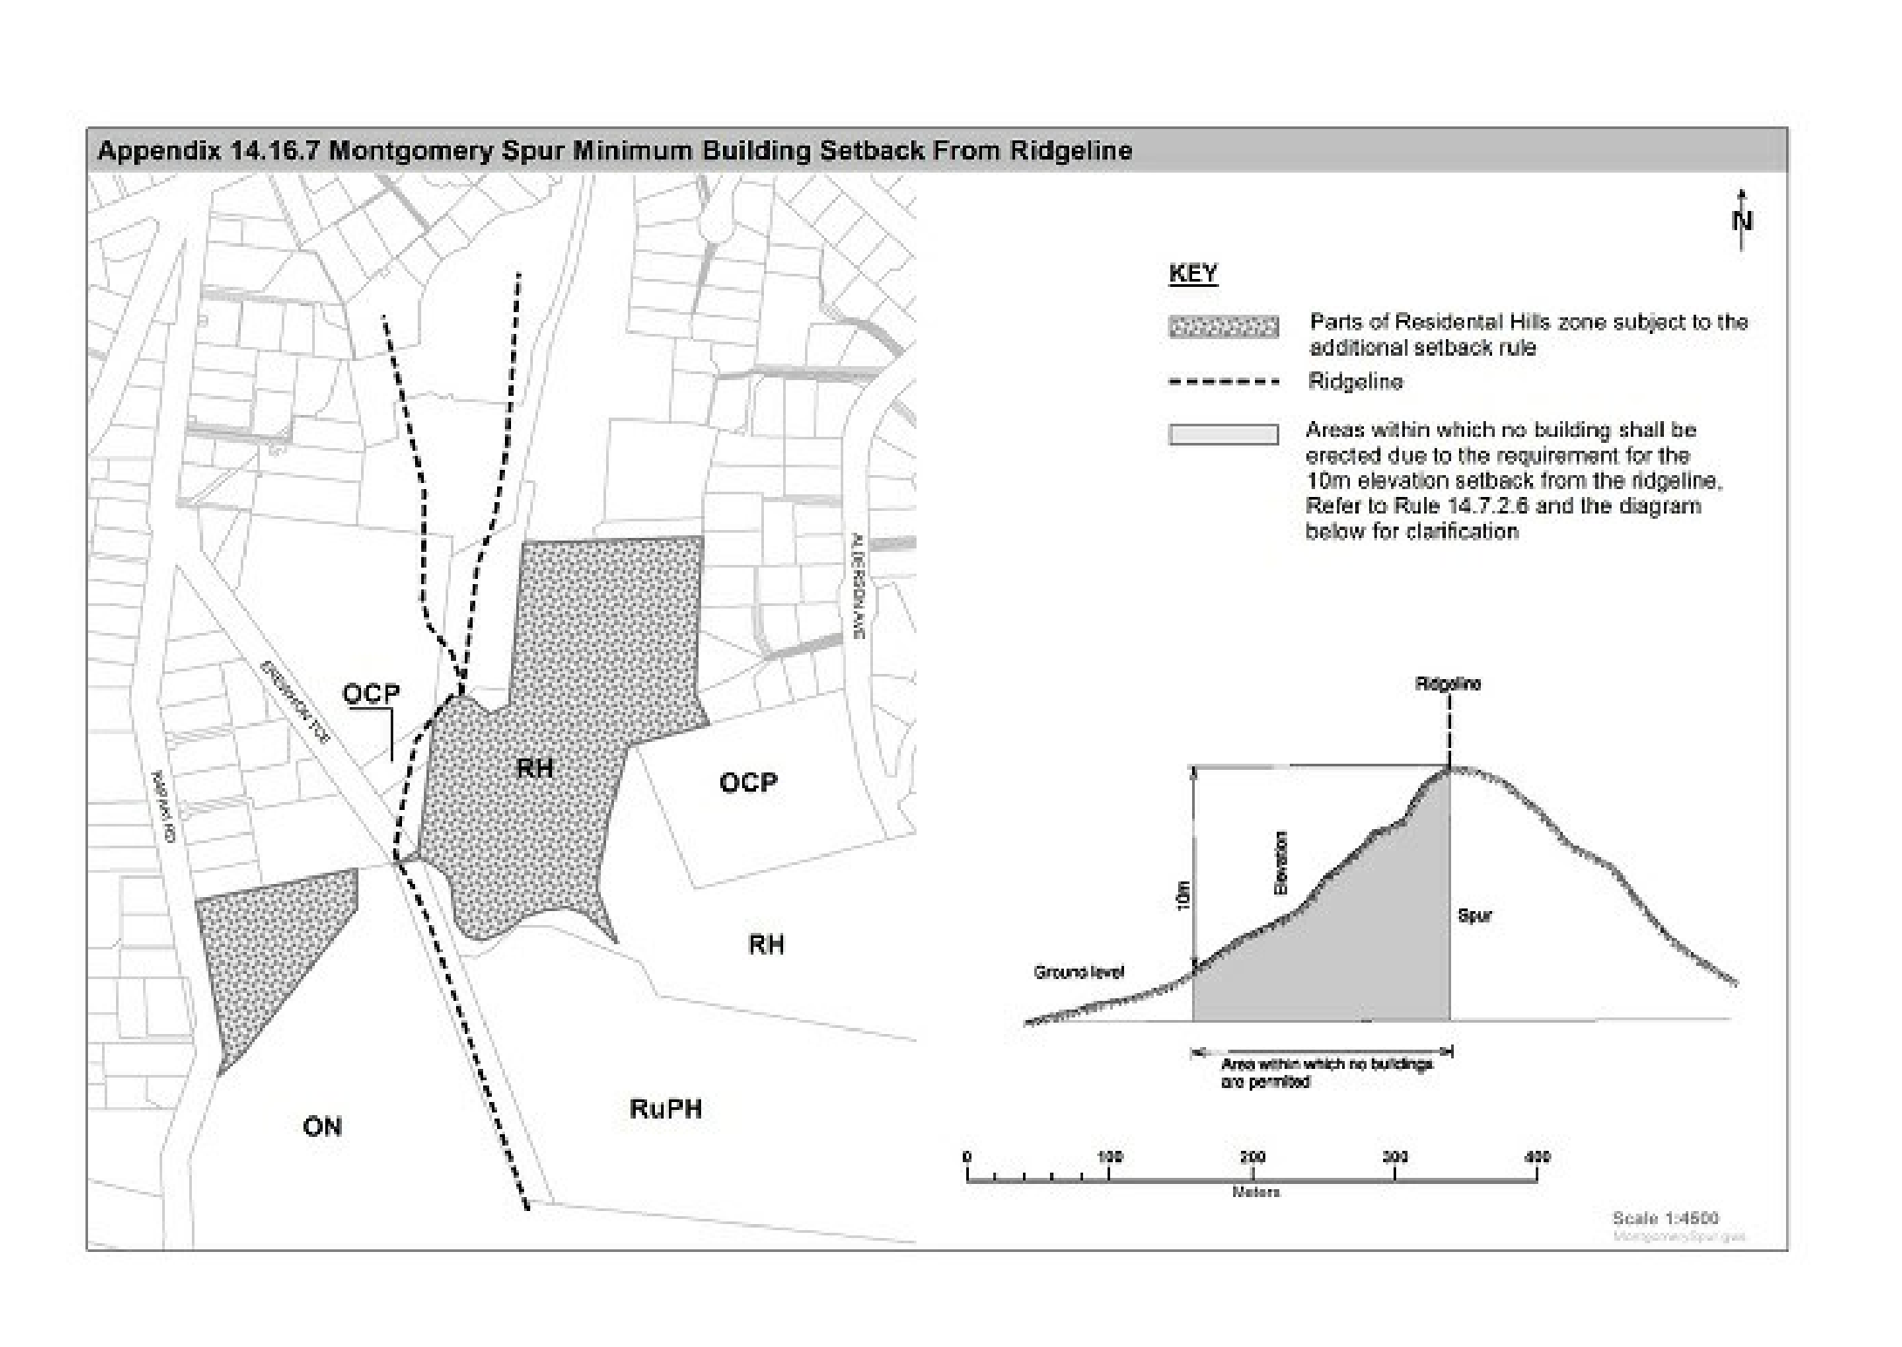

Appendix 14.16.8 Worsleys Road ­ areas subject to specific standards

Appendix 14.16.8A ­ Worsleys Road ­ area subject to specific building setback and site coverage standards
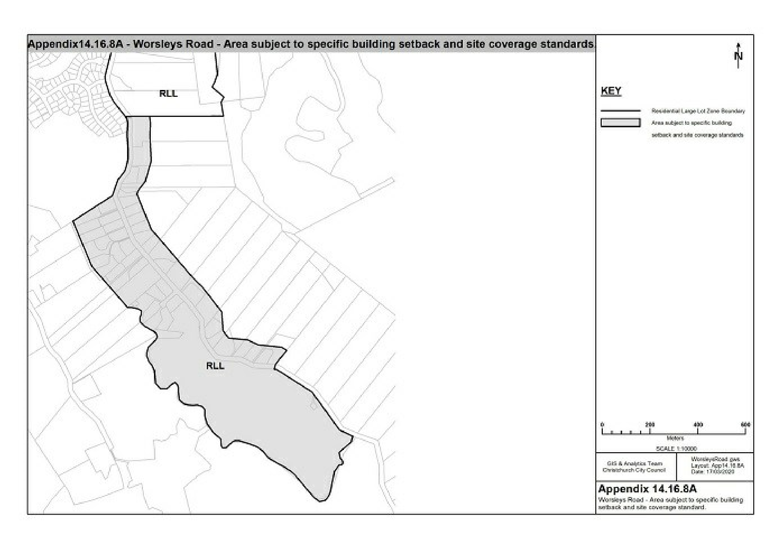

Appendix 14.16.8B ­ Worsleys Road ­ area subject to specific building reflectivity and colour, and landscape standards
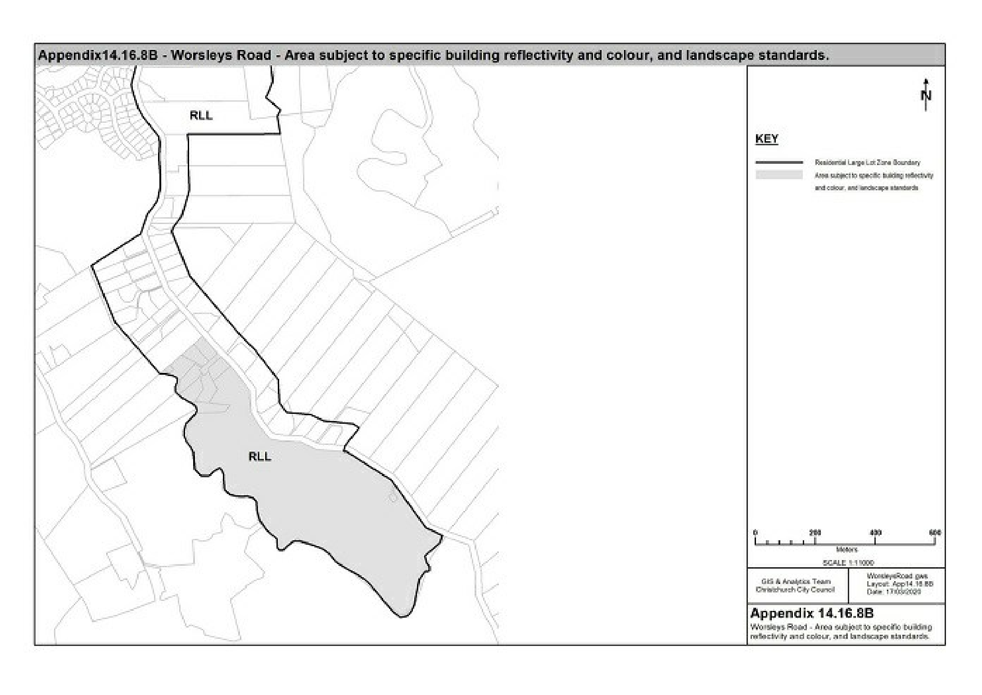
Colour | Reflectivity | Colour | Reflectivity
00 A 13 | 6% | 10 B 29 | 3%
10 B 27 | 8% | 02 A 11 | 18%
08 A 14 | 2% | 22 B 25 | 12%
16 A 07 | 30% | 18 B 23 | 20%
18 A 14 | 7% | 18 B 21 | 30%
16 A 11 | 20% | 10 B 23 | 22%
18 B 27 | 6% | 08 B 23 | 19%
18 B 29 | 7% | 12 B 29 | 2%
06 A 07 | 30% | 00 A 09 | 20%
08 B 25 | 10% | 12 B 27 | 8%
08 B 29 | 7% | 00 A 11 | 12%
10 A 11 | 12% | 12 B 23 | 20%
12 B 21 | 34% | 08 B 21 | 27%
10 A 07 | 27% | 02 A 07 | 30%
10 B 21 | 30% | 08 B 27 | 8%
10 A 09 | 20% | 18 B 25 | 13%
00 A 07 | 30% | 06 A 11 | 12%
12 B 25 | 12%

Appendix 14.16.9 Samarang Bay and Allandale colour palette
Roof Colours, Body/Wall and Trim Colours
Resene Acrylic Roof Chart | Ebony | 10 HA­5
 | Thunder | 11 HA­12
 | Storm Dust | 14 HA­25
 | Mirage | 14 HB­11
 | Steel Grey | 15 HB­13
 | Stratos | 10 HC­4.5
 | Gulf Blue | 11 HC­8
 | Cloud Burst | 12 HC­14
 | Blue Wale0 | 14 HC­7.5
 | Cocoa Brown | 10 HD­4
 | Clinker | 11 HD­7.5
 | Rustic Red | 10 HF­5
 | Jarrah | 11 HF­3
 | Morocco Brown | 10 HE­7
 | Hunter Green | 10 HH­4
 | Green Kelp | 11 HH­7.5
 | Mikado | 12 HH­7.5
 | Nordic | 10 HI­4
 | Seaweed | 12 HI­7.5
 | Palm Green | 12 HI­4
 | Gable Green | 13 HL­5.5
Stratco Coated Steel Colour Chart | Ironsand
 | Lignite
 | Karaka
 | Permanent Green
 | New Denim Blue
 | Grey Friars
Resene | Ship Grey | 00 A 11
 | Baltic Sea | 00 A 13
 | Cape Cod | 16 A 11
 | Rangoon Green | 12 B 29
 | Black Bean | 14 C 40
 | Charade | 18 B 27
 | Cinder | 18 B 29
 | Blue Bark | 18 C 40
 | Cardin Green | 14 E 58
 | Haiti | 22 B 29

TRIM AND ACCENT COLOURS

The following colours include those colours that are complementary or of a less grey nature than those derived from the landscape background.

They are accent colours and should only be used in small proportions to add visual interest at close range.

Applications include:

- Fascia boards
- Doors and door frames
- Windows and window frames
- Window sills
- Spouting and down pipes
Trim and Accent Colours Only
Resene | Birch | 10 B 27
 | Kelp | 12 B 25
 | Scrub | 12 B 27
 | Turtle Green | 12 C 39
 | Pine Tree | 12 C 40
 | Madras | 10 C 39
 | Dark Tan | 04 C 39
 | Chocolate | 04 C 40
 | Toledo | 02 C 40
 | Persian Red | 04 E 58
 | Pirate Gold | 08 E 56
 | Rich Gold | 06 E 56
 | St Tropaz | 20 D 44
 | Catalina Blue | 20 D 45
 | Biscay | 20 C 39
 | Outer Space | 20 C 40
 | Elm | 16 D 43
 | Blue Stone | 16 D 44
 | Cyprus | 16 D 45
 | Hot Chili | 04 D 45
 | Wistful | 22 D 41
 | Martinique | 22 B 27
 | Mardi Gra | 24 C 40
 | Plum | 24 E 58

Appendix 14.16.10 Akaroa ­ 12A, 12B and 12D Vangioni Lane
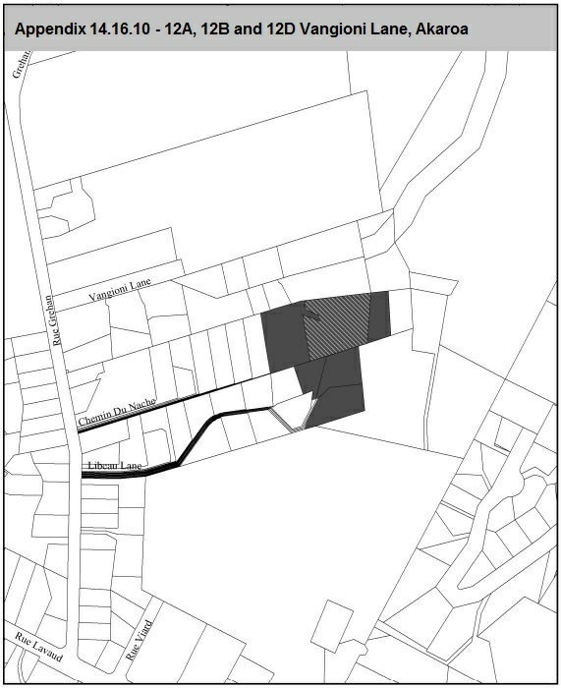

Appendix 14.16.11 Grouping of Residential Guest Visitor Accommodation Zone Sites
The following table sets out the groupings for Residential Guest Visitor Accommodation Zone sites for the purpose of determining the applicable zone rules for permitted and restricted discretionary activities (other than for guest visitor accomodation (P1) and permitted activities on the YMCA site (P3)).
The Residential Guest Visitor Accommodation Zone site locations are contained in the figures following this table.
(Plan Change 4 Council Decision subject to appeal)
ID | Name | Address | Legal Description | Zones applicable to  Rule 14.11.1.1 P2 and  Rule 14.11.1.3 RD3
Group A Sites (sites located in a lower density residential environment, typically zoned Residential Suburban Medium Density Residential Zone)
GA1 | Wigram Base | 14 Henry Wigram Drive | Lot 82 DP 81079 | Residential Suburban  Medium Density Residential Zone
GA2 | Wigram Lodge | 15 Sioux Avenue | Lot 1 DP 81926
GA3 | Garden Hotel | 110 Marshland Road | Lot 2 DP 456038
GA8 | Addington Court Motel | 197 Lincoln Road | Lot 1 DP 79547
GA4 | Redwood Hotel | 340 Main North Road | Lot 10 DP 60941
GA5 | Racecourse Hotel | 116­118 Racecourse  Road | Lot 1 DP 301568, Lot 2  DP 301568
GA6 | Commodore Hotel | 447­449 and 455  Memorial Avenue | Lot 1 DP 28781, Lot 2  DP 74459
Group B Sites (sites located in a medium density residential environment, generally zoned Residential Medium Density High Density Residential Zone)
GA7 | Quality Hotel Elms | 456 Papanui Road | Lot 2 DP 29110, Pt Lot  13 DP 959 | Residential Suburban Density Transition  Residential Medium Density  High Density Residential Zone, with Intensification Precinct
GA8 | Addington Court Motel | 197 Lincoln Road | Lot 1 DP 79547
GA13 | Avon | 356 Oxford Terrace | Lots 1,2,3,4 DP 1907,  Pt Lots 7,7,8,8,9,9 DP  281, Lot 1 DP 28239, Pt Lot 1 DP 432, Lot 1 DP432, Pt Lot 2 DP 48542, Lots 1,2 DP 7045, Pt Res 28, 77  Christchurch Town
GA3 | Garden Hotel | 110 Marshland Road | Lot 2 DP 456038
GA9 | Chateau on the Park | 189 Deans Avenue | Lot 1 DP51050, Lot 1  DP6807
GA15 | Hall | 294 Barbadoes Street | Pt TR 16 ChCh City  CT 316­191
GA16 | Round the World  Backpackers | 314 Barbadoes Street | Lot 2 DP 33590
GA22 | Vagabond Backpackers | 232 Worcester Street | Pt Res 55 Christchurch  Town
Group C Sites (sites adjoining Residential Central City Zone zoned High Density Residential Zone)
GA10 | Peterborough (George  Hotel) | 54 Park Terrace | Lot 2 DP12364, Lot 1  DP37827, Lots 1 ­ 6  DP27448, Lot 2  DP1973, Pt Rs 125  Canterbury District,  Sections 127 and 128 Christchurch Town. | Residential Central City  High Density Residential Zone, within Central City Residential Precinct
GA11 | Montreal (Hotel Montreal) | 363 Montreal Street | Lot 2 DP473673, Lot 2  DP81571, Lot 2  DP480221, Lot 1  DP480221
GA12 | Latimer (Rydges) | 30 Latimer Square | Lot 1 DP 338487  Lot 7 DP1189  Lot 18, DP1189
GA13 | Avon | 356 Oxford Terrace | Lots 1,2,3,4 DP 1907,  Pt Lots 7,7,8,8,9,9 DP  281, Lot 1 DP 28239, Pt Lot 1 DP 432, Lot 1 DP432, Pt Lot 2 DP 48542,Lots 1,2 DP 7045, Pt Res 28, 77  Christchurch Town
GA14 | Windsor Private Hotel | 52 Armagh Street | Sec 1 SO 13661
GA15 | Hall | 294 Barbadoes Street | Pt TR 16 ChCh City  CT 316­191
GA16 | Round the World  Backpackers | 314 Barbadoes Street | Lot 2 DP 33590
GA17 | Stonehurst  Accommodation | 241­263 Gloucester  Street | Lot 2 DP 80988, Pt  Secs 640,642,642  Christchurch Town,  Lots 1, 2 DP 7888, Lot  1 DP 410496, Lot 2 DP  410496
GA18 | YMCA | 12 Hereford Street | Lots 1,2,3 DP 25197,  Lot 1 DP 46151, Pt Sec  441 Christchurch Town
GA19 | YHA Hereford Street | 36 Hereford Street | Sec 457 Christchurch  Town
GA20 | Foley Towers | 208 Kilmore Street | Lot 1 DP 60425
GA21 | YHA Worcester Street | 5 Worcester Street | Lot 1 DP 496200
GA22 | Vagabond Backpackers | 232 Worcester Street | Pt Res 55 Christchurch  Town

Any breach in height under 14.11.1.1 P2 will be considered under the applicable restricted discretionary rule for the commensurate residential zone, as follows:
- Group A – Medium Density Residential Zone: 14.4.1.3 RD14
- Group B – High Density Residential Zone, with Intensificaiton Precinct: 14.5.1.3 RD7 or RD8, as applicable.
- Group C – High Density Residential Zone: 14.5.1.3 RD7 or RD8, as applicable.

Residential Guest Visitor Accommodation Zone site locations
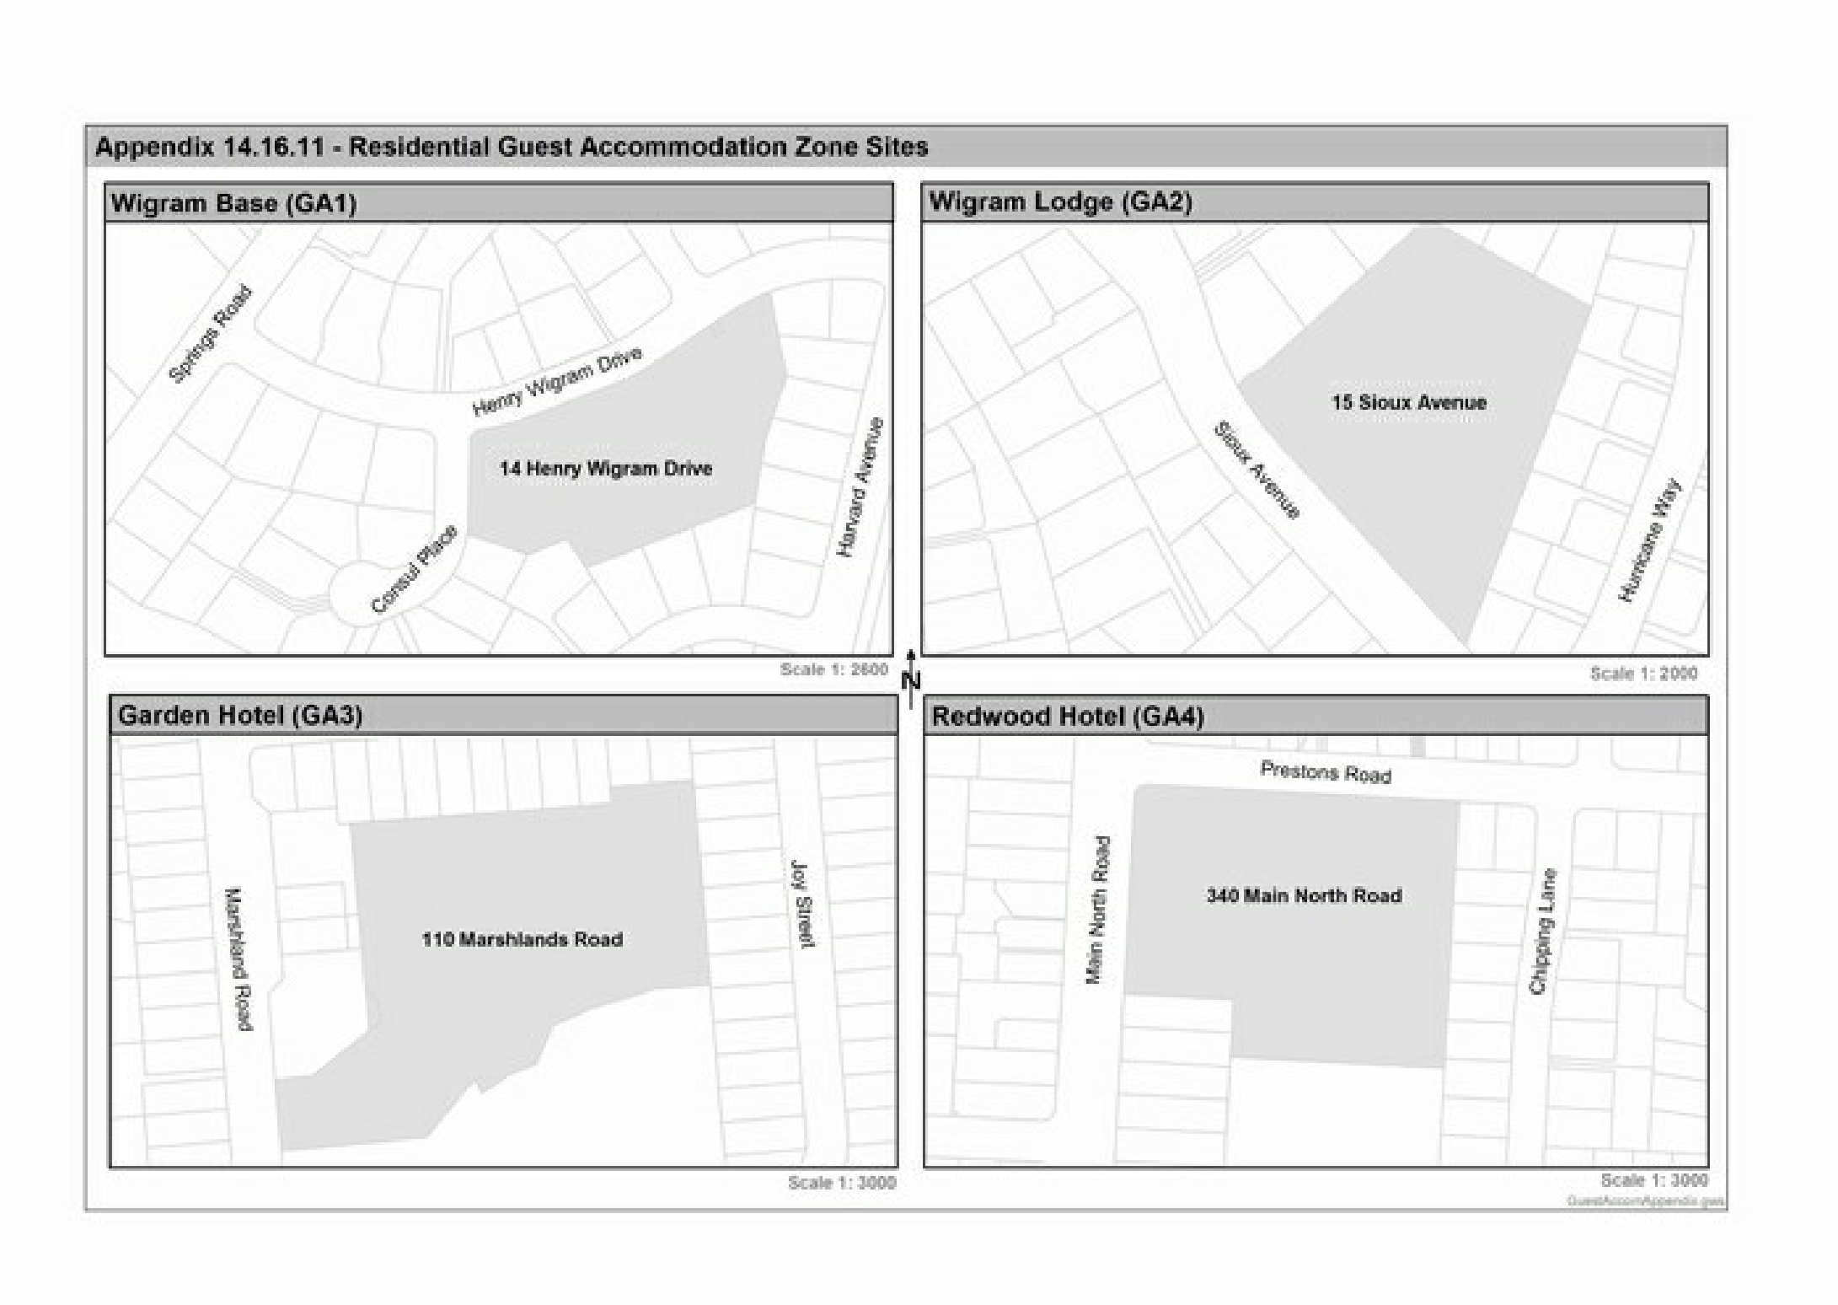
(Plan Change 4 Council Decision subject to appeal)
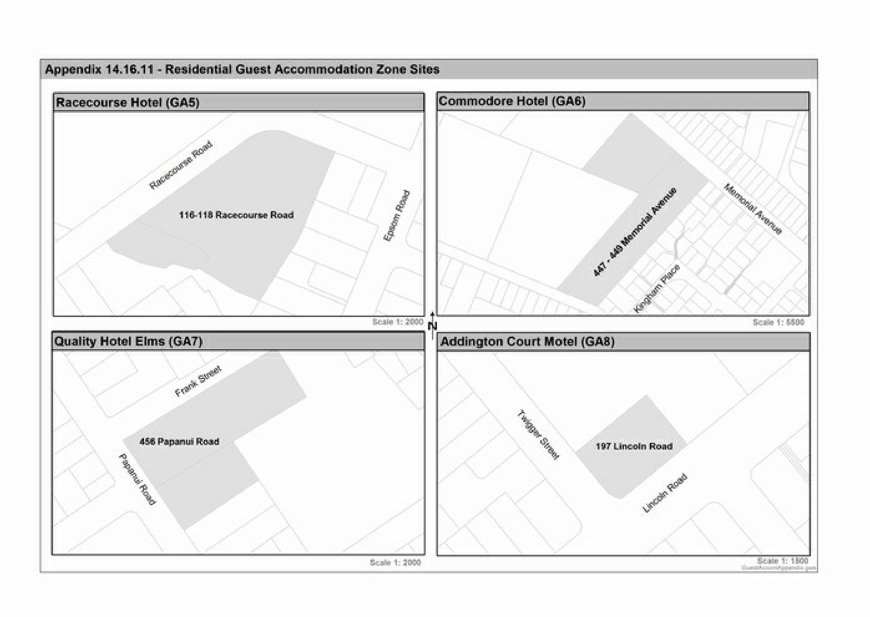
(Plan Change 4 Council Decision subject to appeal)
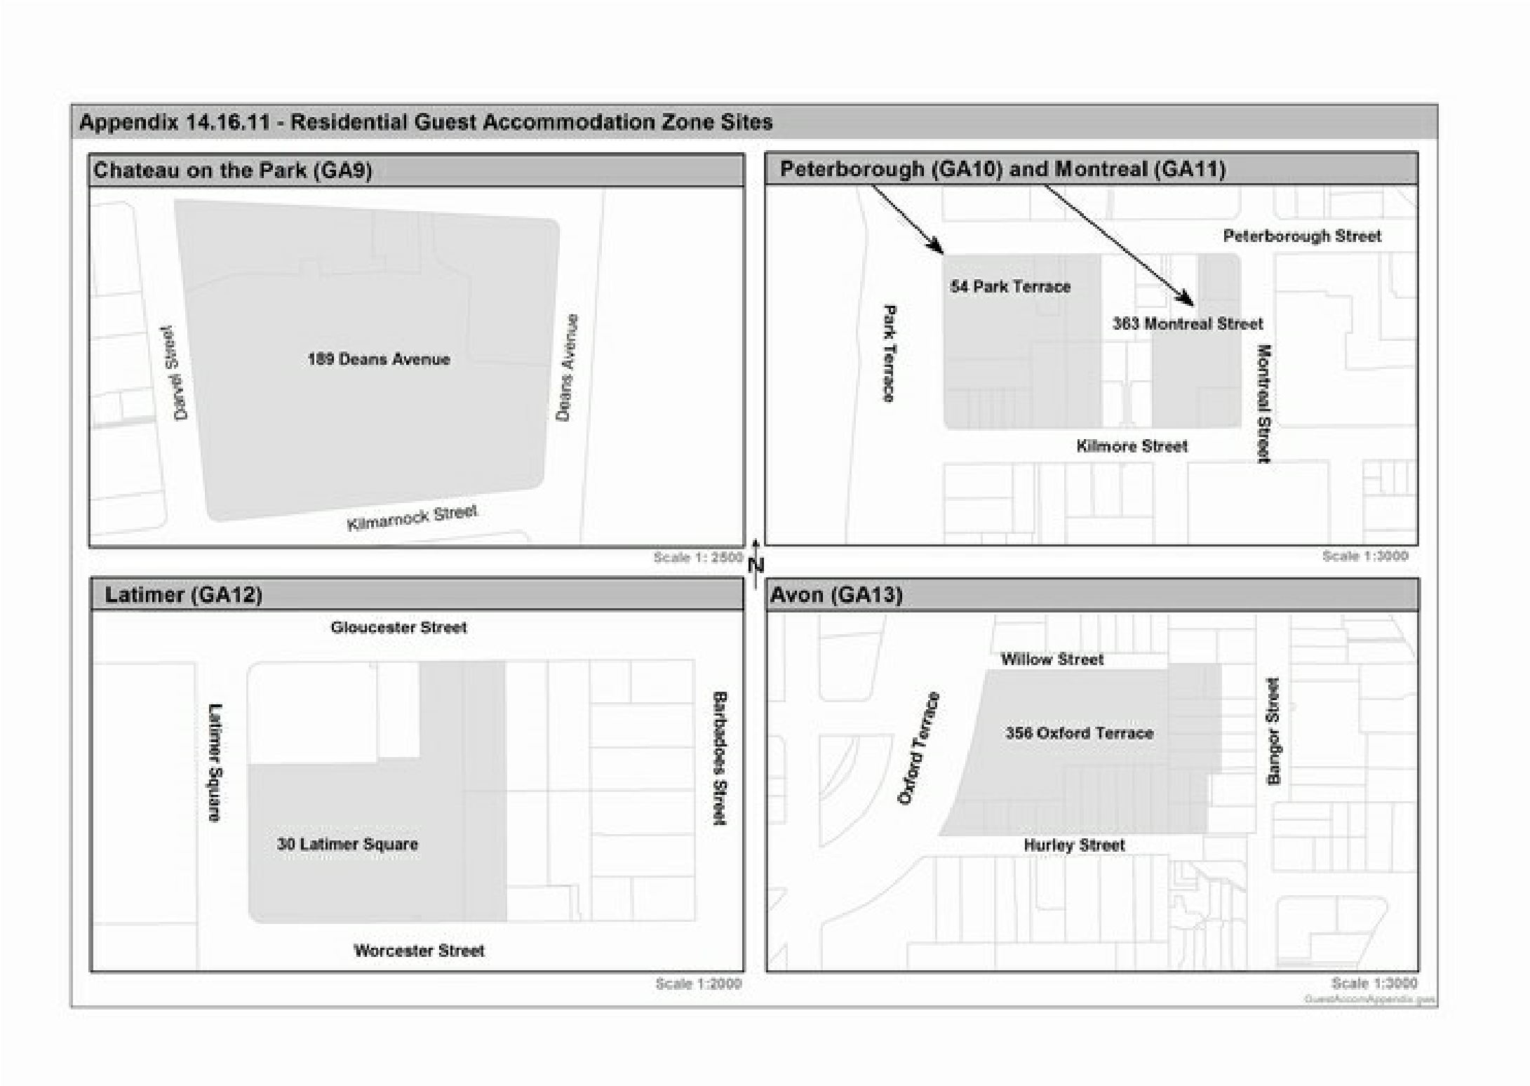
(Plan Change 4 Council Decision subject to appeal)
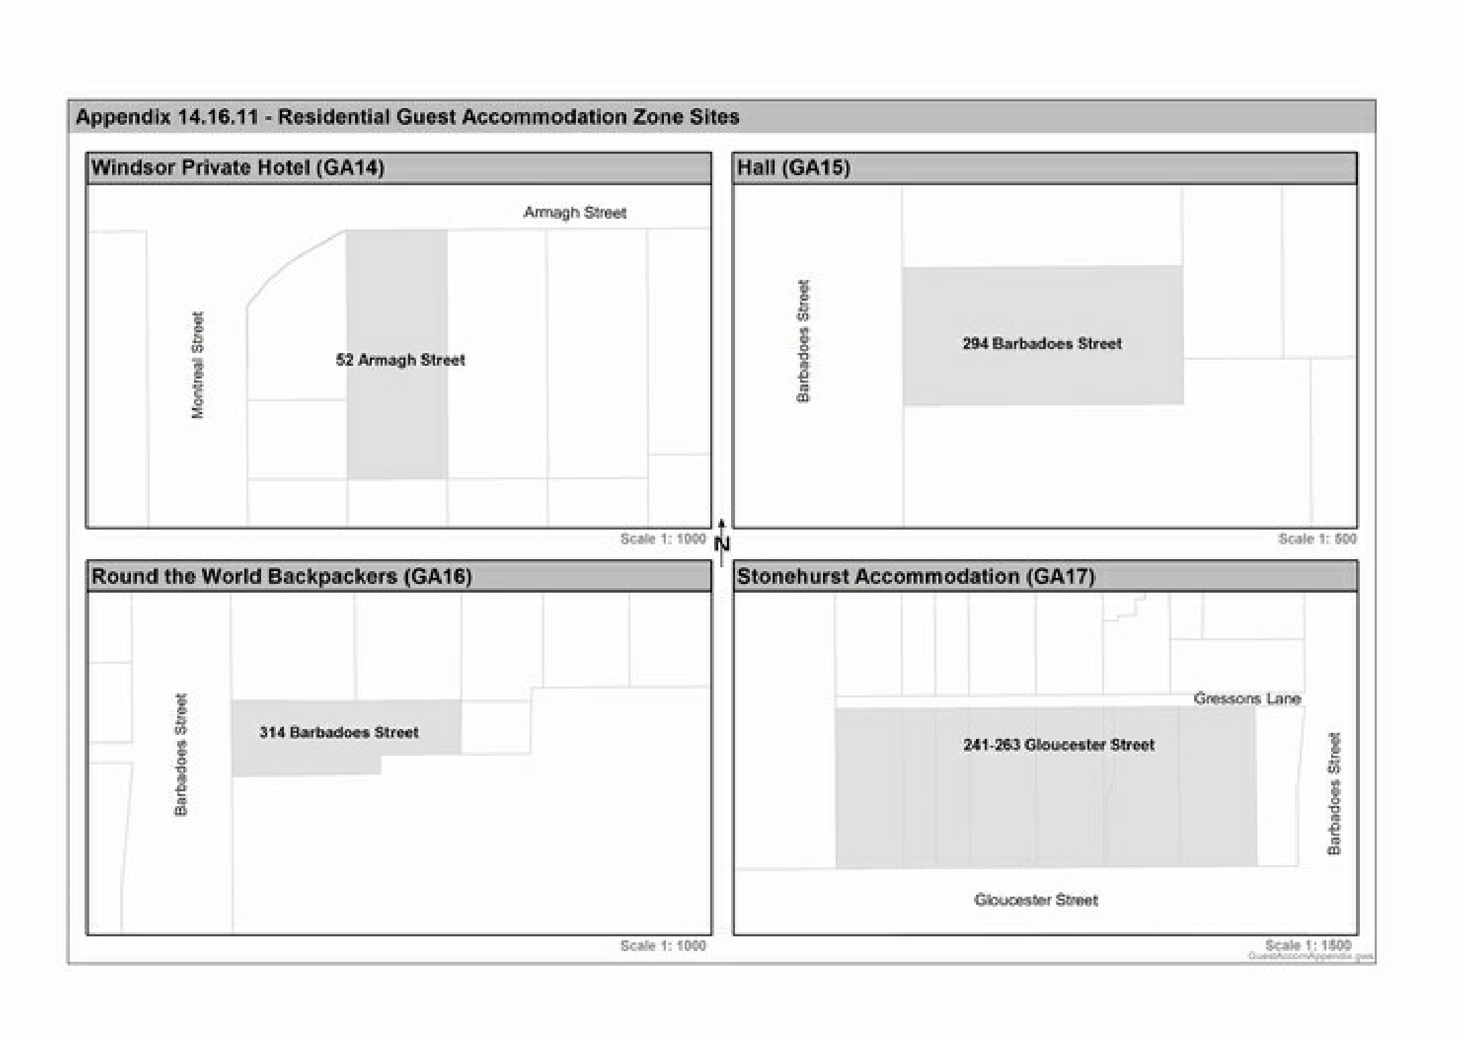
(Plan Change 4 Council Decision subject to appeal)
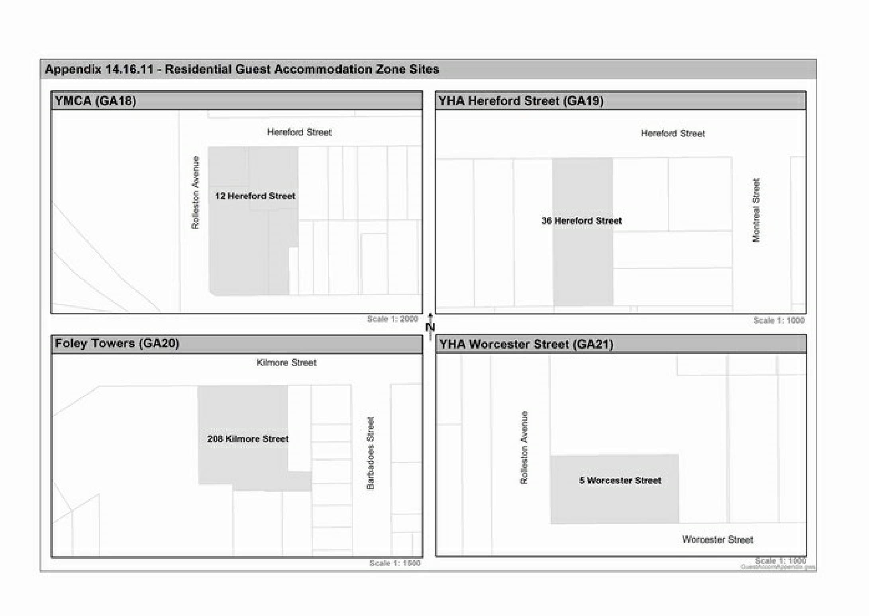
(Plan Change 4 Council Decision subject to appeal)
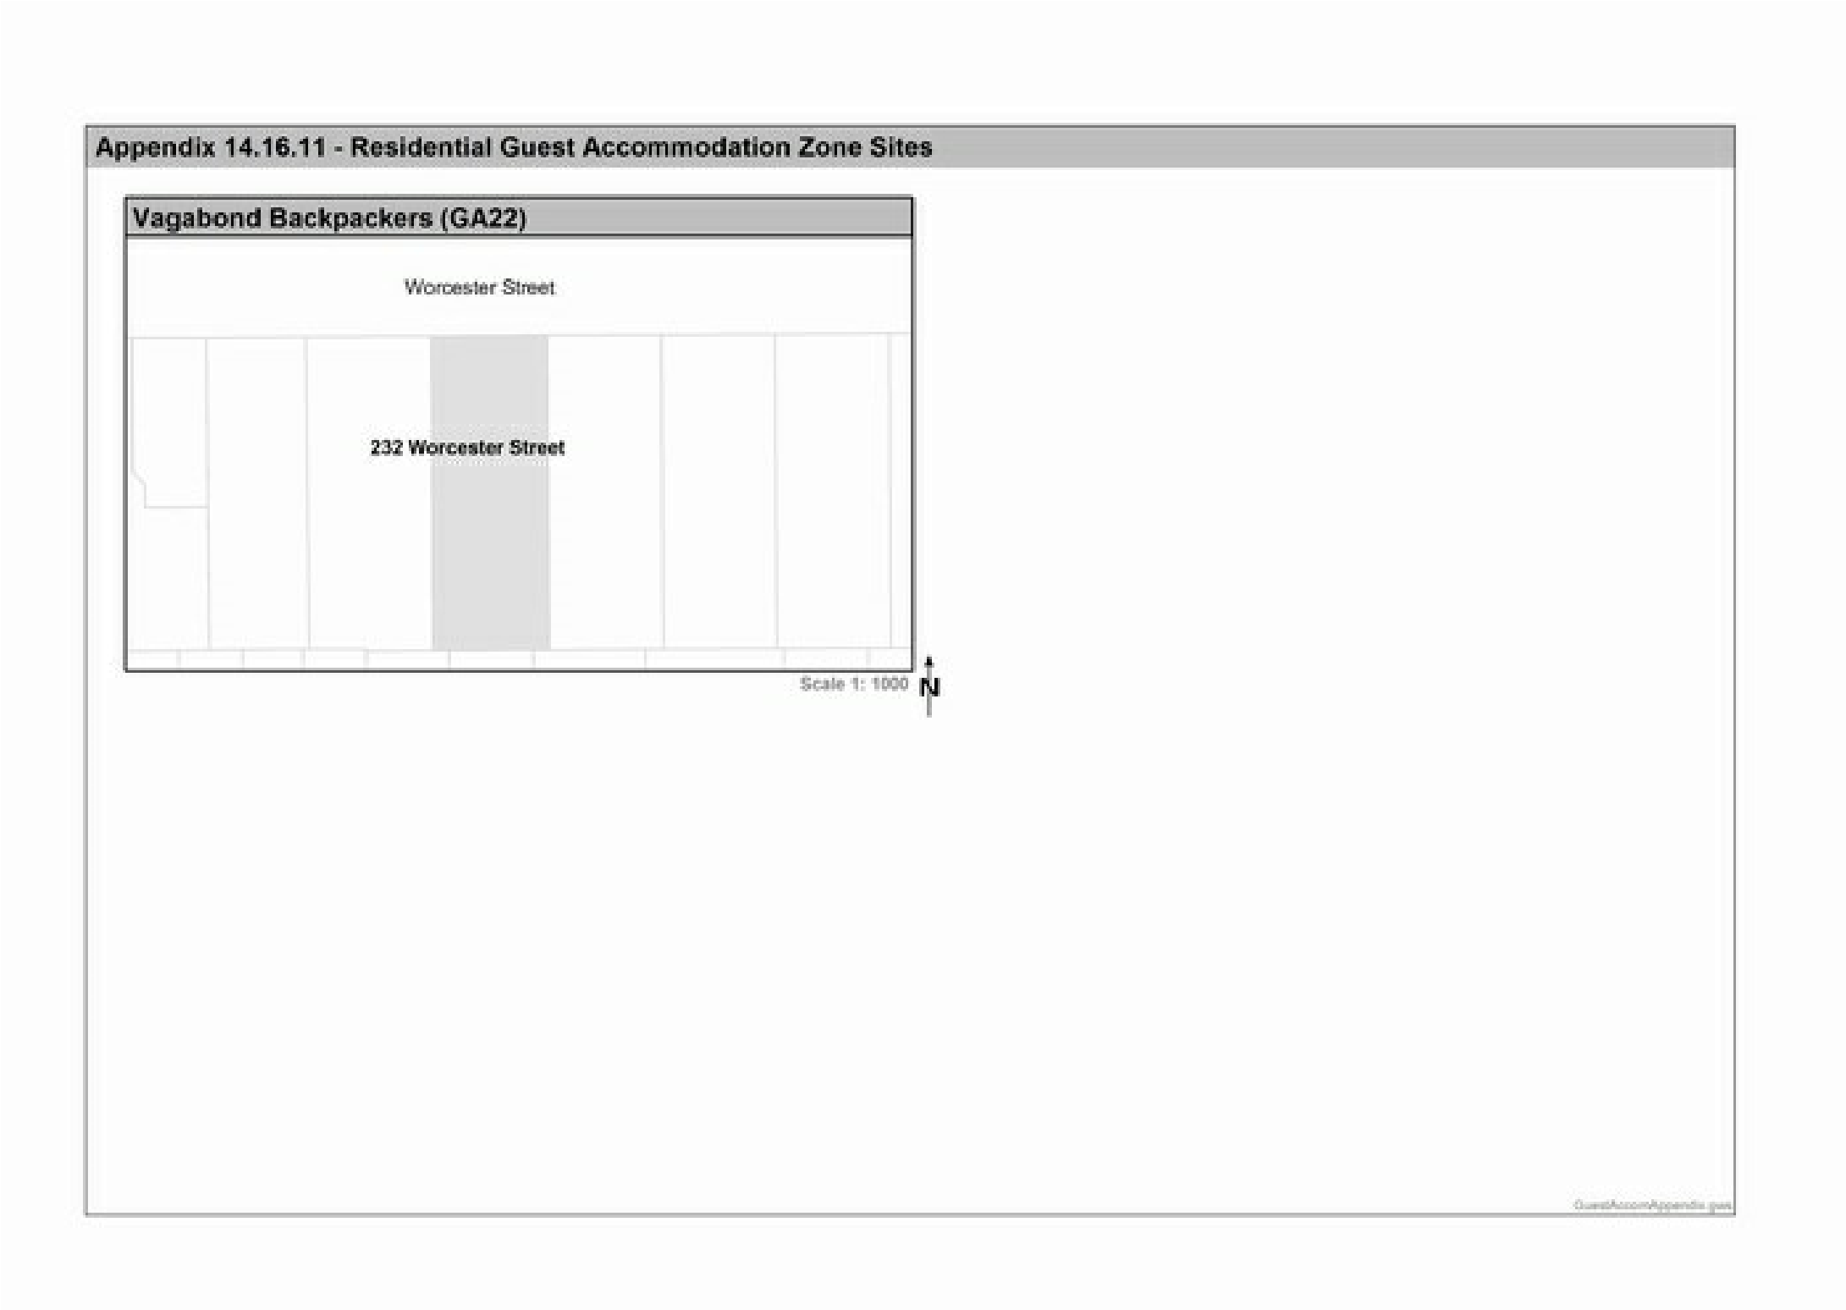
(Plan Change 4 Council Decision subject to appeal)

