Appendix B – PC14 - District Plan text amendments with recommended changes

Transport Chapter
_________________________________________
Key:

For the purposes of this plan change, any unchanged text is shown as normal text or in bold, any text proposed to be added by the plan change is shown as bold underlined and text to be deleted as bold strikethrough.

Text in bold purple underlined indicates text recommended in the s42A report to be added and text recommended in the s42A report to be deleted in bold purple strikethrough. Text in normal black font purple underlined indicates text that was proposed to be deleted in the notified PC14 and is recommended to be reinstated.

Text in bold red underlined is that from Schedule 3A of the Resource Management Act and must be included.
Text in green font identifies existing terms in Chapter 2 – Definitions. Where the proposed change contains a term defined in Chapter 2 – Definitions, the term is shown as bold underlined text in green and that to be deleted as bold strikethrough in green. New definition in a proposed rule is bold green text underlined in black.
Text in purple is a plan change proposal subject to Council Decision.
Text in purple shaded in grey is a Plan Change Council Decision.
Text in black/green shaded in grey is a Council Decision subject to appeal.
Text in light blue strikethrough shaded in grey is a Council Decision proposed to be deleted by this Plan Change.
Text in blue font indicates links to other provisions in the district Plan and/or external documents. These will have pop-ups and links, respectively, in the on-line Christchurch District
________________________________________

- Transport
  - Introduction
          - This introduction is to assist the lay reader to understand how this chapter works and what it applies to. It is not an aid to interpretation in a legal sense.
          - This chapter relates to transport requirements for all activities that occur throughout the District and to activities within the Transport Zone. Objectives, policies, rules, standards and assessment criteria relating to transport are provided that are not zone specific, as well specific provisions for the Transport Zone. This approach is informed by national and regional planning documents, but in particular the Canterbury Regional Policy Statement.
          - Functioning transport networks and transport modes are essential facilities and services that assist meet the needs of people and communities and promote the efficient functioning of the District. The land transport network therefore forms an important component of the physical resources of the District.
          - In the life of the plan new roads will be vested and some roads will be stopped. The plan provides that when new roads are vested they become part of the Transport Zone and are subject to all the provisions of that zone. Where roads are stopped they become part of the adjoining zone as shown on the planning maps. Where there are different zones on each side of the road those zones shall apply to the area of stopped road on the basis that the zone boundaries shall be the centre line of the road.
          - The provisions in this chapter give effect to the Chapter 3 Strategic Directions objectives.
  - Objectives and Policies
    - Objective — Integrated transport system for Christchurch District
- An integrated transport system for Christchurch District:
              - that is safe and efficient for all transport modes;
              - that is responsive to the current recovery needs, future needs, and enables economic development, in particular an accessible Central City able to accommodate projected population growth;
              - that supports safe, healthy and liveable communities by maximising integration with land use;
              - that reduces dependency on private motor vehicles and promotes the use of public and active transport;
              - that is managed using the one network approach.
Advice note:
1. The “One Network Approach” is an approach where the transport network is considered as a whole. The aim of this approach is to ensure that the management and provision of all transport infrastructure (including all transport modes) is well connected and undertaken in an efficient and integrated manner. For more guidance on how the "one network approach" is applied, please refer to the Greater Christchurch Transport Statement 2012 and Christchurch Transport Strategic Plan 2012.
      - Policy – Establishment of a road classification system
            - Identify a road network that connects people and places and recognises different access and movement functions for all people and transport modes, whilst:
              - supporting the safe and efficient operation of the transport network;
              - providing for public places in accordance with the function of the road to enable community activities including opportunities for people to interact and spend time;
              - providing space for utility services;
              - reflecting neighbourhood identity and amenity values;
              - recognising cross-boundary connections with adjoining districts, and
              - providing for the efficient and effective functioning of the strategic transport network, including for freight.
            - Recognise the Central City in the road classification system by establishing a people-focused and slow vehicle inner zone which provides safe and effective access and movement for all forms of transport.

Advice note:
- Refer to Appendix 7.5.12 for a description of the road classification system.
- Policy 7.2.1.1 also achieves Objective 7.2.2.
      - Policy – High trip generating activities
- Manage the adverse effects of high trip generating activities, except for permitted activities within the Central City, on the transport system by assessing their location and design with regard to the extent that they:
              - are permitted by the zone in which they are located;
              - are located in urban areas and generate additional vehicle trips beyond what is already established or consented, unless the already established or consented vehicle trips are specifically included in rule thresholds;
              - are accessible by a range of transport modes and encourage public and active transport use;
              - do not compromise the safe, efficient and effective use of the transport system;
              - provide patterns of development that optimise use of the existing transport system;
              - maximise positive transport effects;
              - avoid significant adverse transport effects of activities where they are not permitted by the zone in which they are located;
              - mitigate other adverse transport effects, such as effects on communities, and the amenity values of the surrounding environment, including through travel demand management measures;
              - provide for the transport needs of people whose mobility is restricted; and
              - integrate and coordinate with the transport system, including proposed transport infrastructure and service improvements; and
              - Incorporate measures to promote opportunities for safe and efficient travel other than by conventional private vehicles, that seek to reduce greenhouse gas emissions from vehicular trips associated with the activity.

Refers to the activity being listed as a permitted activity in the activity status table for the zone in which it is located.

Advice note:
- Policy 7.2.1.2 also achieves Objective 7.2.2.
      - Policy – Vehicle access and manoeuvring
- Provide vehicle access and manoeuvring, including for emergency service vehicles, compatible with the road classification, which ensures safety, and the efficiency of the transport system.

Advice note:
- Policy 7.2.1.3 also achieves Objective 7.2.2.
      - Policy – Requirements for car parking and loading
          - Outside the Central City
              - Require mobility parking spaces and loading spaces which provide for the expected needs of an activity in a way that manages adverse effects.
          - Within the Central City:
              - Enable activities to provide car parking spaces and loading spaces, whilst minimising any adverse effects on the efficiency and safety of the transportation networks, including public transport, to the extent practicable.
              - Manage the development of commercial car parking buildings and parking lots within the Central City so that they:
                - support the recovery of the Central City;
                - are easily accessible for businesses within the Central City;
                - minimise any adverse effects on the efficiency and safety of the transportation networks of all users, to the extent practicable;
                - protect the amenity values of the Central City;
                - reduce the need for activities to provide their own on-site parking;
                - do not significantly adversely affect the demand for public transport to, from or within the Central City.
              - Allow for temporarily vacant sites to be used for car parking areas within the Central City until 30 April 2018.

Advice note:
- Policy 7.2.1.4 also achieves Objective 7.2.2.
      - Policy – Design of car parking areas and loading areas
- Require that car parking areas and loading areas are designed to:
              - operate safely and efficiently for all transport modes and users;
              - function and be formed in a way that is compatible with the character and amenity values of the surrounding environment; and
              - be accessible for people whose mobility is restricted.

Advice note:
- Policy 7.2.1.5 also achieves Objective 7.2.2.
      - Policy – Promote public transport and active transport
- Promote public and active transport, by:
              - ensuring new, and upgrades to existing, road corridors provide sufficient space and facilities to promote safe walking, cycling and public transport, in accordance with the road classification where they contribute to the delivery of an integrated transport system;
              - ensuring activities provide an adequate amount of safe, secure, and convenient cycle parking and, outside the Central City, associated end of trip facilities;
              - encouraging the use of travel demand management options that help facilitate the use of public transport, cycling, walking and options to minimise the need to travel; and
              - requiring new Town Centres to provide opportunities for a public transport interchange.
              - encouraging the formation of new Central City lanes and upgrading of existing lanes in the Central City, where appropriate, to provide for walking and cycling linkages and public spaces.
              - developing a core pedestrian area within the Central City which is compact, convenient and safe, with a wider comprehensive network of pedestrians and cycle linkages that are appropriately sized, direct, legible, prioritized, safe, have high amenity, ensure access for the mobility impaired and are free from encroachment.

Advice note:
- Policy 7.2.1.6 also achieves Objective 7.2.2.
      - Policy – Rail level crossings
- Improve or maintain safety at road/rail level crossings by:
              - requiring safe visibility at uncontrolled level crossings;
              - managing vehicle accesses close to level crossings; and
              - managing the creation of new level crossings.

Advice note:
- Policy 7.2.1.7 also achieves Objective 7.2.2.
      - Policy – Effects from transport infrastructure
            - Avoid or mitigate adverse effects and promote positive effects from new transport infrastructure and changes to existing transport infrastructure on the environment, including:
              - air and water quality;
              - connectivity of communities
              - noise, vibration and glare;
              - amenity and effects on the built environment;
              - well-being and safety of users

Advice note:
- Policy 7.2.1.8 also achieves Objective 7.2.2.

7.2.1.9 Policy ­ Pedestrian Access
- Pedestrian access is designed to:
- be of a sufficient width and grade that the pedestrian access meets the access requirements of all users, including persons with a disability or with limited mobility;
- have a surface treatment that provides for all weather access; and
- where required for consistency with Crime Prevention Through Environmental Design (CPTED), have sufficient illumination to provide for the safety of users after dark.
Advice note:
- Policy 7.2.1.9 also achieves Objectives 7.2.2 and 14.2.4
    - Objective – Adverse effects from the transport system
- Enable Christchurch District’s transport system to provide for the transportation needs of people and freight whilst managing adverse effects from the transport system.
      - Policy – Effects from the strategic transport network
            - To manage any adverse effects from the ongoing use, repair, and development of the strategic transport network, whilst recognising the national and regional scale and economic importance of this network, and the role of the strategic transport network in the recovery of Christchurch.
      - Policy – Activities within the Transport Zone
- Enable activities for transport purposes and ancillary activities within the Transport Zone that seek to provide, maintain or improve:
              - the safety, amenity values, efficiency and functionality of the Transport Zone, in particular the strategic transport network; and
              - structures, facilities, services and installations of the transport network.
- Enable non-transport related activities which contribute to public amenity values and/or provide a public place for community activities, including opportunities for people to interact and spend time whilst not having an adverse effect on:
              - the safety, amenity, efficiency and functionality of the transport function of the Zone; and
              - the potential for the full width of the Transport Zone to be utilised for transport use in the future.
- Outside the Central City, where land in the Transport Zone is not immediately required for transport purposes, enable non-transport related activities that:
              - will not give rise to reverse sensitivity effects that would undermine transport activities in the zone;
              - do not prevent land designated for transport purposes reverting to a transport use when required;
              - do not undermine the future transport use of the land designated for transport purposes; and
              - are consistent with the activities provided for in the adjoining zones.
- Ensure the development of the Central City South Frame Pedestrian Precinct as shown on the planning maps provides, in particular, for safe and convenient pedestrian and cycle access through the South Frame.
      - Policy – Effect on adjacent land uses to the Transport Zone
- Manage the adverse effect(s) of an activity within the Transport Zone so that the effects of the activity are consistent with the amenity values and activity of adjacent land uses, whilst providing for the transport network, in particular the strategic transport network to function efficiently and safely.
- To ensure adjacent land uses are designed, located and maintained in such a way as to avoid reverse sensitivity effects on the strategic transport network.

Advice note:
- Policies 7.2.1.1, 7.2.1.2, 7.2.1.3, 7.2.1.4, 7.2.1.5, 7.2.1.6, 7.2.1.7, 7.2.1.8 also apply to Objective 7.2.2.
- Policies 7.2.2.2, 7.2.2.3 also apply to Objective 7.2.1.
- For more details on the Council’s vision, expectation and plans for transport, during the recovery period and longer term, please refer to the ‘Christchurch Transport Strategic Plan’.

  - How to interpret and apply the rules
- The transport rules that apply to activities in all zones, outside the Specific Purpose (Lyttelton Port) Zone, are contained in:
              - The activity status tables (including activity specific standards) in Rule 7.4.2 - Transport; and
              - Rule 7.4.3 - Standards - Transport.
- Activities, outside the Transport Zone, covered by the rules in this chapter are also subject to the rules in the relevant zone chapters.
- The activity status table and standards in the following chapters also apply:

4 Hazardous Substances and Contaminated Land;

5 Natural Hazards;

6 General Rules and Procedures;

8 Subdivision, Development and Earthworks;

9 Natural and Cultural Heritage; and

11 Utilities and Energy.
- Where the Transport Zone overlaps the Open Space Water and Margins Zone or Avon River Precinct Zone, as shown on the planning maps, the Transport Zone provisions apply only to the bridge/roadway above the waterway.

  - Rules – Transport

7.4.1 Deeming provisions for Transport Zone

- Any land vested in the Council, or the Crown, as road pursuant to any enactment or provision in this District Plan, from the date of vesting shall be deemed to be Transport Zone and be subject to all the provisions for that zone.
- If a road within the Transport Zone has been lawfully stopped under any enactment, and any relevant designation removed, then the land shall no longer be subject to the provisions for the Transport Zone but will instead be deemed to be included in the same zone as that of the land that adjoins it (as shown on the planning maps) and subject to all the provisions for that zone from the date of the stopping and removal of any relevant designation.
- Where the zoning of the land that adjoins one side of the road being stopped is different to that of the land that adjoins the other side of that road, then the road shall be deemed to be included in both zones (as shown on the planning maps) on the basis that the zone boundaries shall be deemed as the centre line of the road.
    - Activity status tables – Transport (All zones outside the Specific Purpose (Lyttelton Port) Zone)
      - Permitted activities
- The activities listed below are permitted activities if they meet the activity specific standards set out in this table and the standards in Rule 7.4.3.
- Activities may also be controlled, restricted discretionary, discretionary, non-complying or prohibited as specified in Rules 7.4.2.2, 7.4.2.3, 7.4.2.4, 7.4.2.5 and 7.4.2.6 below.
 | Activity | Activity specific standards
P1 | Any activity that meets Rule 7.4.3.1 - Minimum number and dimensions of car parking spaces required. | Nil
P2 | Any activity that meets Rule 7.4.3.2 - Minimum number of cycle parking facilities required.
P3 | Any activity that meets Rule 7.4.3.3 - Minimum number of loading spaces required.
P4 | Any activity that meets Rule 7.4.3.4 - Manoeuvring for parking areas and loading areas.
P5 | Any activity that meets Rule 7.4.3.5 - Gradient of parking areas and loading areas.
P6 | Any activity that meets Rule 7.4.3.6 - Design of parking areas and loading areas.
P7 | Any activity that meets Rule 7.4.3.7 - Access design.
P8 | Any activity that meets Rule 7.4.3.8 - Vehicle crossings.
P9 | Any activity that meets Rule 7.4.3.9 - Location of buildings and access in relation to road/rail level crossings.
P10 | Any activity that does not require resource consent in accordance with Rule 7.4.3.10 - High trip generators.
P11 | Only until 30 April 2018, in the Rural Quarry Zone, heavy vehicle trips for any quarrying activity that do not exceed the average daily heavy vehicle trip generation that existed for the 12 month period prior to 27 August 2014.  Advice note:  - P11 is a temporary measure to allow existing activities in the Rural Quarry Zone to continue while they seek the necessary consents required by this chapter. The average daily heavy trip generation relates to, and shall be calculated for, each calendar month.
P12 | The operation or maintenance of transport infrastructure (including ancillary offices and car parking areas) and freight handling activities in the Transport Zone.
P13 | New transport infrastructure and additions to existing transport infrastructure in the Transport Zone (excluding activities or structures listed in Rule 7.4.2.1 P15) and new freight handling activities. | - The maximum height for any building (excluding street lighting, poles, traffic signals, safety cameras and fences) shall be as follows:  Distance of the closest point of the building from the boundary of a Residential, Commercial (excluding Commercial Retail ParkLarge Format Retail), Specific Purpose Hospital Zone or Open Space Community Park Zone: Maximum height - within a road reserve: Maximum height - not within a road reserve:#:  i. Less than 15 metres 5 metres* 8 metres  ii. 15-50 metres 5 metres* 10 metres  iii. More than 50 metres 10 metres 15 metres  - The maximum gross floor area of buildings in the locations marked * shall be 5 m²  - Any building not within road reserve # that is located on a site which has a boundary with a residential zone, shall have minimum setback of 1.8 metres from that boundary; and shall not project beyond a building envelope constructed by the recession planes which apply in the adjacent residential zone.  - The maximum height for any buildings in the South Frame Pedestrian Precinct shown on the planning maps shall be 3 metres.  Advice note:  - Provisions for signs and temporary activities and buildings can be found in Chapter 6.  - Road design standards (including road widths) for new roads are contained in Chapter 8. Road design standards (including road widths) for existing roads are controlled by the Council’s Infrastructure Design Standards.
P14 | Public transport facilities (including any office or retail activity ancillary to a public transport facility), public amenities and landscaping in the Transport Zone. | - Buildings located in road reserve where the closest point of the facility is within 50m of the boundary of a Residential, Commercial (excluding Commercial Retail ParkLarge Format Retail), Specific Purpose Hospital Zone or Open Space Community Park Zone shall be less than 5m in height.  - Buildings (excluding lighting, poles, traffic signals, safety cameras and fences) shall be less than 3m in height in the South Frame Pedestrian Precinct shown on the planning maps.  - Buildings in any other location shall be less than 10 metres in height.  - The maximum area of buildings in the South Frame Pedestrian Precinct shown on the planning maps is 5m².
P15 | All public artwork, street furniture, community markets, cultural activities or community fund-raising events within road reserve in the Transport Zone or South Frame Pedestrian Precinct shown on the planning maps. | Nil.  Advice note:  - The Council or New Zealand Transport Agency as owner of roads and KiwiRail as the owner of rail corridors may require permits/approval for such activities under other legislation.
P16 | Any verandas, balconies or floor area of a building overhanging road reserve within the Transport Zone. | Nil.  Advice note:  - The Council or New Zealand Transport Agency as owner of roads and KiwiRail as the owner of rail corridors will have their own separate approval process for granting rights to build overhanging their land. The Council has a policy that is relevant to this process.
P17 | - Outside the Central City, any activity in the Transport Zone (except for sensitive activities within 50m of a railway line) permitted in the adjoining zone.  - For the avoidance of doubt, any activity permitted in the Industrial General Zone, shall be a permitted activity on 99 Ensors Road (Sec 1 SO 448367).  Advice note:  - For the purpose of this rule, where the Transport Zone adjoins two different zones, the provisions of the adjoining zone only apply up to the centre of the Transport Zone in that location. | - The height limits, maximum gross floor area of a building, setbacks and recession planes in Rule 7.4.2.1 P13 apply  - The applicable activity specific standards and built form standards (except for any minimum building setback from the railway corridor) for the activity in the adjoining zone also apply  - On sites adjacent to the rail corridor the minimum building setback from the railway corridor shall be 1.5 metres from the site boundary adjacent to the railway corridor.
P18 | Construction and/or reconstruction of Selkirk Place, Hawkins Road, Hills Road and Prestons Road within the New Neighbourhood Zone (Highfield) Greenfields Precinct. Future Urban Zone | - Works shall be in general accordance with the cross-sections shown in Appendix 8.10.26 Diagram A in Chapter 8.
P19 | In Central City - Any activity that complies with Rule 7.4.3.11 - Vehicle access to sites fronting more than one street. | Nil
P20 | In Central City - Any activity that complies with Rule 7.4.3.12 - Central City lane formation. | Nil
P21 | Any construction or reconstruction of a roadway within the Central City. | - Footpaths on both sides of the road shall be provided, unless the legal width of the road is less than 10 metres or the road is designed as a shared space street or is a Central City lane.  Advice note:  - Road design standards (including road and footpath widths) for new and existing roads are controlled by the Council’s Infrastructure Design Standards.
      - Controlled activities – Outside the Central City
- The activities listed below are controlled activities.
- Discretion to impose conditions is restricted to the matters of control set out in the following table, and as set out for those matters in Rule 7.4.4.

 | Activity | The matters over which Council reserves its control
C1 | - Outside the Central City, any activity that requires resource consent in accordance with Rule 7.4.3.10 - High trip generators, and where:  - the land use activity is otherwise permitted in the zone where it is located; and  - the activity does not exceed the thresholds in Table 7.4.4.19.1; and  - direct vehicle access is not obtained from a state highway, major arterial road, or crosses a railway line; and  - for a quarrying activity and/or an ancillary aggregates-processing activity in the Rural Quarry Zone, where a vehicle access to the activity is located further than 250 metres from a residential unit.  Advice note:  - Refer to the Rule 7.4.3.10 for provisions regarding notification. | Rule 7.4.4.18 - High trip generators.
C2 | - Outside the Central City, any activity in the Transport Zone (except for sensitive activities) that is a controlled activity in the adjoining zone.  - For the purpose of this rule, where the Transport Zone adjoins two different zones, the provisions of the adjoining zone only apply up to the centre of the Transport Zone in that location. | - The applicable matters of control for the adjoining zone; and  - Rule 7.4.4.19 - Transport infrastructure in the Transport Zone.
      - Restricted discretionary activities
- The activities listed below are restricted discretionary activities.
- Discretion to grant or decline consent and impose conditions is restricted to the matters of discretion set out in the following table, and as set out for those matters in 7.4.4.

 | Activity | The Council’s discretion shall be restricted to the following matters:
RD1 | - Any activity that does not meet any one or more of the standards in Rule 7.4.3; or any activity that requires resource consent in accordance with Rule 7.4.3.10 - High trip generators except where otherwise provided for by Rule 7.4.2.2 C1.  Advice note:  - Refer to the relevant standard for provisions regarding notification. | - As relevant to the standard that is not met, and as specified for each standard in Rule 7.4.3:  - Rules 7.4.4.1 - 7.4.4.18 and 7.4.4.21 - 7.4.4.22.
RD2 | Activities P13, P14 and P18 listed in Rule 7.4.2.1, that do not meet any one or more of the activity specific standards. | - Rule 7.4.4.19 - Transport infrastructure in the Transport Zone.
RD3 | Any formation of an unformed legal road. | - Rule 7.4.4.20 - Formation of unformed legal roads.
RD4 | - Outside the Central City, any activity (except for sensitive activities) in the Transport Zone that is a restricted discretionary activity in the adjoining zone.  - For the purpose of this rule, where the Transport Zone adjoins two different zones, the provisions of the adjoining zone only apply up to the centre of the Transport Zone in that location.  - For the avoidance of doubt, any restricted discretionary activity in the Industrial General Zone, shall be a restricted discretionary activity on 99 Ensors Road (Sec 1 SO 448367). | - The applicable matters of discretion for the adjoining zone; and  - Rule 7.4.4.19 - Transport infrastructure in the Transport Zone.
RD5 | Activity P17 listed in Rule 7.4.2.1, that does not meet any one or more of the activity specific standards. | - The applicable matters of discretion for the adjoining zone; and  - Transport infrastructure in the Transport Zone – Rule 7.4.4.19.
RD6 | In the Central City, any site temporarily used for car parking areas, where car parking area is the primary activity on that site until 30 April 2018. | - Temporary car parks during the earthquake recovery period – Rule 7.4.4.24
RD7 | In the Central City, any permitted activity that does not comply with the activity specific standard in Rule 7.4.2.1 for P21. | - Central City Road Cross sections – Rule 7.4.4.23
RD8 | In Central City, any permanent car parking buildings or parking lots where car parking is the primary activity on that site. | - Commercial car parking buildings and parking lots – Rule 7.4.4.25
      - Discretionary activities
- The activities listed below are discretionary activities.
 | Activity
D1 | Any activity in the Transport Zone not provided for as a permitted, controlled, restricted discretionary, non-complying or prohibited activity.
      - Non complying activities
- The activities listed below are non-complying activities.
 | Activity
NC1 | - Except where provided for in P12 – P16 and P18 listed in Rule 7.4.2.1, or in RD2 or RD3 listed in Rule 7.4.2.3, any activity in the Transport Zone that is a non-complying activity in the adjoining zone.  - For the purpose of this rule, where the Transport Zone adjoins two different zones, the provisions of the adjoining zone only apply up to the centre of the Transport Zone in that location.
NC2 | - Any building or structure in the Transport Zone (except transport infrastructure and utilities that comply with the New Zealand Electrical Code of Practice for Electrical Safe Distances (NZECP 34:2001)) that exceeds 2.5 metres in height within:  - 12 metres of the centre line of a 110kV or a 220kV National Grid transmission line, and/or  - 10 metres of the centre line of a 66kV National Grid transmission line.
NC3 | Any activity within the Commercial Central City Business City Centre Zone (Core) that does not comply with 7.4.3.1 b.i.

Advice note:
- The National Grid transmission lines are shown on the planning maps.
- Vegetation to be planted around the National Grid should be selected and/or managed to ensure that it will not breach the Electricity (Hazards from Trees) Regulations 2003.
- The New Zealand Electrical Code of Practice for Electrical Safe Distances (NZECP 34:2001) contains restrictions on the location of structures and activities in relation to National Grid transmission lines. Buildings and activities in the vicinity of National Grid transmission lines must comply with the NZECP 34:2001.
      - Prohibited activities
- There are no prohibited activities
    - Standards — Transport (All zones outside the Specific Purpose (Lyttelton Port) Zone)
      - Minimum and maximum number and dimensions of car parking spaces required
- Outside of the Central City:
 | Applicable to: | Standard | The Council’s discretion shall be limited to the following matters:
i. | Any car parking spaces available to the general public. | Car parking spaces shall be provided with the minimum dimensions in Table 7.5.1.2 in Appendix 7.5.1. | Rule 7.4.4.1 - Parking space dimensions.
ii. | Any activity:  - where standard car parking spaces are provided (except a. residential developments with less than 3 residential units); or b. visitor accommodation for up to ten guests); or  - containing buildings with a GFA of more than 2,500m².  (Plan Change 4 Council Decision subject to appeal) | At least the minimum number of mobility parking spaces in accordance with Table 7.5.1.2 in Appendix 7.5.1 shall be provided on the same site as the activity. | Rule 7.4.4.2 - Mobility parking spaces.
iii. | Any activity at the Yaldhurst Recreation and Sports Facility at 466-482 Yaldhurst Road, as shown in Appendix 18.11.4. | - Car parking spaces shall comply with the relevant standards in Rules 7.4.2 and 7.4.3; and  - The maximum number of car parking spaces shall be 650. If the maximum number of car parking spaces is exceeded, the High Trip Generator Rules 7.4.3.10(xii) and 7.4.4.18.1(l) shall apply. | - Rule 18.10.27 - Additional matters for the Yaldhurst Recreation and Sports Facility.  - Rule 7.4.4.18 - High Trip Generators.

Advice: note:
- For the avoidance of doubt there is no on-site carparking required outside of the Central City.

- Within the Central City:
 | Applicable to | Standard | The Council’s discretion shall be limited to the following matters:
i. | Any activity (except within the Residential Central City High Density Residential Zone) | Any car parking and associated manoeuvre area shall be no greater than 50% of the GLFA of the buildings on the site. | Rule 7.4.4.26 – Car parking areas
ii. | Any car parking spaces provided, except residential activities. | Any car parking spaces provided shall have the minimum dimensions in Appendix 7.5.1, Table 7.5.1.2. | Rule 7.4.4.1 – Parking space dimensions
iii. | Any activity (other than in respect of: a. residential activities): or b. visitor accommodation for up to ten guests.  - where standard car parking spaces are provided (except residential developments with less than 3 residential units); or  - containing buildings with a GFA of more than 2,500m².  (Plan Change 4 Council Decision subject to appeal) | The minimum number of mobility parking spaces in accordance with Appendix 7.5.1 shall be provided on the same site as the activity. | Rule 7.4.4.2 – Mobility parking spaces

Advice note:
- For the avoidance of doubt there is no on-site carparking required within the Central City. There is also no requirement to provide mobility parking spaces for residential activities or for the visitor accommodation activities specified in 7.4.3.1(b)iii) above within the Central City.

(Plan Change 4 Council Decision subject to appeal)
      - Minimum number of cycle parking facilities required
 | Applicable to: | Standard | The Council’s discretion shall be limited to the following matters:
a. | Any activity. | At least the minimum amount of cycle parking facilities in accordance with Appendix 7.5.2 shall be provided on the same site as the activity. | Rule 7.4.4.3 - Minimum number of cycle parking facilities.
      - Minimum number of loading spaces required
 | Applicable to: | Standard | The Council’s discretion shall be limited to the following matters:
a. | Any activity where standard car parks are provided. | At least the minimum amount of loading spaces in accordance with Appendix 7.5.3 shall be provided on the same site as the activity. | Rule 7.4.4.4 - Minimum number of loading spaces required
      - Manoeuvring for parking areas and loading areas
 | Applicable to: | Standard | The Council’s discretion shall be limited to the following matters:
a. | Any activity with a vehicle access. | On-site manoeuvring area shall be provided in accordance with Appendix 7.5.6. | Rule 7.4.4.5 - Manoeuvring for parking areas and loading areas
b. | Any activity with a vehicle access to:  - a major arterial road or minor arterial road; or  - a collector road where three or more car parking spaces are provided on site; or  - six or more car parking spaces; or  - a heavy vehicle bay required by Rule 7.4.3.3; or  - a local street or local distributor street within the Central City core; or  - a main distributor street within the Central City where the vehicle access serves three or more parking spaces; or  - a local street outside the Central City core and the vehicle access serves six or more parking spaces. | On-site manoeuvring area shall be provided to ensure that a vehicle can manoeuvre in a forward gear on to and off a site. | Rule 7.4.4.5 - Manoeuvring for parking areas and loading areas
- Any application arising from this rule shall not be limited or publicly notified.
      - Gradient of parking areas and loading areas
Applicable to: |  | Standard | The Council’s discretion shall be limited to the following matters:
- All non-residential activities with vehicle access (except visitor accommodation for up to ten guests).  (Plan Change 4 Council Decision subject to appeal) | - Gradient of surfaces at 90 degrees to the angle of parking (i.e. parking stall width). | Gradient shall be ≤ 1:16 (6.26%). | Rule 7.4.4.6 - Gradient of parking areas and loading areas
 | - Gradient of surfaces parallel to the angle of parking (i.e. parking stall length). | Gradient shall be ≤ 1:20 (5%).
 | - Gradient of mobility parking spaces. | Gradient shall be ≤ 1:50 (2%).
- Any application arising from this rule shall not be limited or publicly notified.
      - Design of parking areas and loading areas
 | Applicable to: | Standard | The Council’s discretion shall be limited to the following matters:
a. | All non-residential activities with parking areas and/or loading areas used during hours of darkness (except hosted visitor accommodation or unhosted visitor accommodation).  Plan Change 4 Council Decision subject to appeal) | Lighting of parking areas and loading areas shall be maintained at a minimum level of two lux, with high uniformity, during the hours of operation. | Rule 7.4.4.7 - Illumination of parking areas and loading areas
b. | Any urban activity, except:  - residential activities, hosted visitor accommodation or unhosted visitor accommodation, containing less than three car parking spaces; or  - sites where access is obtained from an unsealed road; or  - temporary activities and buildings.  Plan Change 4 Council Decision subject to appeal) | The surface of all car parking areas, loading areas, and associated access areas shall be formed, sealed and drained and car parking spaces permanently marked. | Rule 7.4.4.8 - Surface of parking areas and loading areas
- Any application arising from this rule shall not be limited or publicly notified.
      - Access design
 | Applicable to: | Standard | The Council’s discretion shall be limited to the following matters:
a. | Any activity with vehicle access. | Access shall be provided in accordance with Appendix 7.5.7. | Rule 7.4.4.9 - Vehicle access design
b. | Any residential activity where shared pedestrian access is to three or more residential units. | Pedestrian access shall be provided in accordance with Appendix 7.5.7 c. and d. | Rule 7.4.4.27 - Pedestrian access
b.c. | Any activity providing 4 or more car parking spaces or residential units. | Queuing spaces shall be provided in accordance with Appendix 7.5.8. | Rule 7.4.4.10 - Queuing spaces
c.d. | Outside the Central City, any vehicle access:  - to an urban road serving more than 15 car parking spaces or more than 10 heavy vehicle movements per day; and/or  - on a key pedestrian frontage.; and/or  - on the same side of the road as a major cycle route. | Either an audio and visual method of warning pedestrians of the presence of vehicles or a visibility splay in accordance with Appendix 7.5.9 shall be provided. If any part of the access lies within 20 metres of a Residential Zone any audio method should not operate between 20:00 and 08:00 hours. | Rule 7.4.4.11 - Visibility splay
d.e. | - Within the Central City, any vehicle access to a road serving more than 15 car parking spaces or more than 10 heavy vehicle movements per day, where the site provides access onto any street within the core. | An audio and visual method of warning pedestrians of the presence of vehicles about to exit the access point shall be provided. | Rule 7.4.4.11 – Visibility splay
e.f | Within the Central City, any vehicle access to a road serving more than 15 car parking spaces or more than 10 heavy vehicle movements per day, in any other location not covered by clause d above. | Either an audio and visual method of warning pedestrians of the presence of vehicles about to exit the access point or a visibility splay in accordance with Appendix 7.5.9 – Visibility splay, shall be provided. If any part of the access lies within 20 metres of a Residential Central City High Density Residential Zone any audio method should not operate between 20:00 and 08:00 hours, except when associated with an emergency service vehicle. | Rule 7.4.4.11 - Visibility splay
f. g. Any application arising from this rule shall not be limited or publicly notified.
      - Vehicle crossings
 | Applicable to: | Standard | The Council’s discretion shall be limited to the following matters:
a. | Any activity with a vehicle access to any road or service lane. | A vehicle crossing shall be provided constructed from the property boundary to the edge of the carriageway / service lane. | Rule 7.4.4.12 - Vehicle crossing design
b. | Any vehicle crossing on an arterial road or collector road. with a speed limit 70 kilometres per hour or greater. | Vehicle crossing shall be provided in accordance with Appendix 7.5.10. | Rule 7.4.4.12 - Vehicle crossing design
c. | Any vehicle crossing to any land, building or part of a building located in a rural zone, on or in which rural produce is offered for sale by wholesale and/or retail. | Vehicle crossing shall be provided in accordance with Figure 14 in Appendix 7.5.10. | Rule 7.4.4.12 - Vehicle crossing design
d. | Any vehicle crossing on a road with a speed limit 70 kilometres per hour or greater. | The minimum spacing to an adjacent vehicle crossing on the same side of the frontage road, shall be in accordance with Table 7.5.11.1 in Appendix 7.5.11. | Rule 7.4.4.13 - Minimum distance between vehicle crossings
e. | Any activity with a vehicle crossing. | The maximum number of vehicle crossings shall be in accordance with Table 7.5.11.2 (outside the Central City) and Table 7.5.11.3 (within the Central City) in Appendix 7.5.11. | Rule 7.4.4.14 - Maximum number of vehicle crossings
f. | Any activity with a vehicle crossing. | The minimum distance between a vehicle crossing and an intersection shall be in accordance with the Table 7.5.11.4 5 (outside the Central City) and Table 7.5.11.5 6 (within the Central City) in Appendix 7.5.11. | Rule 7.4.4.15 - Minimum distance between vehicle crossings and intersections
g. | Any vehicle crossing on a rural road. | The minimum sight lines to vehicle crossings shall be provided in accordance with Figure 18 in Appendix 7.5.11. | Rule 7.4.4.16 - Sight lines at vehicle crossings
h. | Any vehicle crossing onto an urban road | The layout of vehicle crossings shall be in accordance with Rule 7.4.3.13. | Rule 7.4.4.28 - Vehicle crossing layout
h. i. Any application arising from this rule shall not be publicly notified and be limited notified only to the New Zealand Transport Agency (NZTA) and only where there is direct access to a state highway and the NZTA has not given its written approval.

Advice note:
- All vehicle crossings designed and constructed onto public roads managed by Council require a vehicle crossing application and the form can be found at: https://ccc.govt.nz/vehiclecrossing. An approval must be given before construction can start. Design and construction works shall be at the Owner or Developer’s own expense. Standards for the design of vehicle crossings can be found in Council’s Construction Standard Specifications.
      - Location of buildings and access in relation to road/rail level crossings
 | Applicable to: | Standard | The Council’s discretion shall be limited to the following matters:
a. | Any new road or access that crosses a railway line. | No new road or access shall cross a railway line. | Rule 7.4.4.17 - Location of buildings and access in relation to rail/road level crossings
b. | All new road intersections located less than 30 metres from a rail level crossing limit line. | The road intersection shall be designed to give priority to rail movements at the level crossing through road traffic signals. | Rule 7.4.4.17 - Location of buildings and access in relation to rail/road level crossings
c. | All new vehicle crossings located less than 30 metres from a rail level crossing limit line. | No new vehicle crossing shall be located less than 30 metres from a rail level crossing limit line unless the boundaries of a site do not enable the vehicle crossing to be more than 30 metres from a rail level crossing limit line. | Rule 7.4.4.17 - Location of buildings and access in relation to rail/road level crossings
d. | Any building located close to a level crossing not controlled by automated warning devices (such as alarms and/or barrier arms). | Buildings shall be located outside of the sight triangles in Appendix 7.5.13. | Rule 7.4.4.17 - Location of buildings and access in relation to rail/road level crossings
- Any application arising from this rule shall not be publicly notified and be limited notified only to KiwiRail and where KiwiRail has not given its written approval.
      - High trip generators
- This rule applies to activities located outside the Central City, and activities within the Central City that are not exempt from this rule under b. below, that exceed the following thresholds.
- Within the Central City - Permitted activities are exempt from this rule.
² Permitted Activities are those listed in the permitted activity tables in the zone chapters and are generally anticipated in the zones. For the purpose of this rule permitted activities must comply with the built form standards for the maximum building height for activity in the zone, any site coverage standards for the activity in the zone, and all the activity specific standards for the activity in the zone. Non-compliance with any other built form standards or being subject to an urban design assessment does not trigger the need to be subject to this rule.
c. | Applicable to: | Resource consent under Rule 7.4.2.2 C1 or Rule 7.4.2.3 RD1 is required for activities with: | The matters over which Council reserves its control or restricts its discretion shall be limited to the following matters:
i. | Education Activities (Schools). | More than 150 students | Rule 7.4.4.18 - High trip generators
ii. | Education Activities (Pre-School). | More than 50 children
iii. | Education Activities (Tertiary Education and Research Activities). | More than 250 FTE students
iv. | Health Care Facilities. | More than 500 m² GFA
v. | Industrial Activities (excluding Warehousing and Distribution Activities).  High Technology Industrial Activities.  Heavy Industrial Activities. | More than 5,000 m² GFA
vi. | Industrial Activities (Warehousing and Distribution Activities). | More than 10,000 m² GFA
vii. | Offices. | More than 1750 m² GFA
viii. | Residential Activities. | More than 60 residential units
ix. | Retail Activities (excluding factory shops, retail park zones, trade suppliers and food and beverage outlets). | More than 500 m² GLFA
x. | Retail Activities (factory shops, retail park zones, but excluding trade suppliers and food and beverage outlets). | More than 1000 m² GLFA
xi. | Mixed use and other activities (not listed above), except where Rule 7.4.2.1 P11 or Rule 7.4.3.10(c)(xii) below applies. | More than 50 vehicle trips per peak hour or 250 heavy vehicle trips per day (whichever is met first)  ‘Peak hour’ are those hours between 15:00 and 19:00 hours on a weekday.
xii. | Yaldhurst Recreation and Sports Facility at 466-482 Yaldhurst Road, as shown in Appendix 18.11.4 (all activities within the site including existing, consented and proposed activities). | Resource consent under Rule 7.4.2.3 RD1 is required if:  - More than 650 vehicle trips per peak hour will be generated by all activities on the site; and/or  - More than 650 car parking spaces are to be provided on the site.  ‘Peak hour' is the continuous 60 minute period between 15:00 and 19:00 hours on a weekday when the greatest number of vehicle trips occurs.
- When resource consent under (c) is required:
- An Integrated Transport Assessment shall be undertaken for activities that are High Trip Generators (i.e. are controlled or restricted discretionary activities under Rule 7.4.2.2 C1 or Rule 7.4.2.3 RD1).
- If an Integrated Transport Assessment has already been approved for the site as part of a granted resource consent, then these rules do not apply to any development that is within the scope of that Integrated Transport Assessment and in accordance with the resource consent, unless the resource consent has lapsed. This part of Rule 7.4.3.10 does not apply to the Yaldhurst Recreation and Sports Facility as shown in Appendix 18.11.4.
- A basic Integrated Transport Assessment shall be undertaken for High Trip Generators that do not exceed the thresholds in Rule 7.4.4.18 Table 7.4.4.18.1. A full Integrated Transport Assessment shall be undertaken for activities that exceed the thresholds in Rule 7.4.4.18 Table 7.4.4.18.1.
- Guidance on preparing an Integrated Transport Assessment to address the assessment matters in Rule 7.4.4.18 may be obtained from Council’s Integrated Transport Assessment Guidelines.
- For the purposes of calculating the thresholds in Rule 7.4.3.10(i) to (xi) (and table 7.4.4.18.1(a) to (k)):
                - for existing activities with access to urban roads, the level of trip generation and scale of activity that existed prior to the plan becoming operative will not be included;
                - for existing activities with access to rural roads, the level of trip generation and scale of activity that existed prior to the plan becoming operative shall be included;
                - for education activities the thresholds in Rule 7.4.3.10 (and table 7.4.4.18.1) shall only apply to any additional traffic generation from a site which increases the number of children, students or FTE students.
                - However, A. and C. do not apply if the existing activity’s vehicle access arrangements change so that more than 50 vehicle trips per peak hour will use a new vehicle access to the activity and / or the volumes using any existing vehicle access to the activity increases by more than 50 vehicle trips per peak hour.
- For the purposes of calculating the thresholds in Rule 7.4.3.10(xii) and Table 7.4.4.18.1(l) for the Yaldhurst Recreation and Sports Facility as shown in Appendix 18.11.4, Rules 7.4.3.10(v)(A) to (v)(D) do not apply.
- Other than as required by viii. or ix. below, the application shall not be publicly or limited notified where:
                - the land use activity is otherwise permitted in the zone where it is located and direct vehicle access is not from a state highway or crosses a KiwiRail railway line; or
                - the land use activity is otherwise permitted in the zone where it is located and direct vehicle access is from a state highway or crosses a KiwiRail railway line and written approval/s have been provided by the New Zealand Transport Agency and/or KiwiRail (whichever is relevant);
- Where written approvals have not been provided under vii. B. above, Council shall give limited notification of the application to the New Zealand Transport Agency and/or KiwiRail only.
- For a quarrying activity and/or an ancillary aggregates-processing activity in the Rural Quarry Zone, where a vehicle access to the activity is located within 250 metres of a residential unit, the Council shall give limited notification of the application to the owners/occupiers of that residential unit only, unless such approvals have already been provided.
      - Vehicle access to sites fronting more than one street – Within the Central City
 | Applicable to | Standard | The Council’s discretion shall be limited to the following matters:
a | Any new vehicle access. | Vehicle access shall be provided in accordance with Appendix 7.5.14. | Rule 7.4.4.21 - Vehicle access to sites fronting more than one street – within the Central City
      - Lane Formation – Within the Central City
 | Applicable to | Standard | The Council’s discretion shall be limited to the following matters:
a | Any new Central City lane created. | The legal width of the Central City lane shall be between 6m and 12m and have a minimum height clearance of 4.5m. | Rule 7.4.4.22 - Central City lane formation – within the Central City

7.4.3.13 Co-Location of Vehicle Crossings
 | Applicable to | Standard | The Council's discretion shall be limited to the following matters:
a. | Any new vehicle crossing in an urban area | - no more than two adjacent sites shall share a single vehicle crossing;  - the total width of a vehicle crossing shared between two adjacent sites shall not exceed 7m; and  - the minimum distance between a shared vehicle crossing and any other vehicle crossing shall be 13m.  See 7.5.11.4 for a diagram illustrating the prescribed distances specified in clauses (b) and (c) of this rule. | Rule 7.4.4.28 ­ Vehicle Crossing Co-Location Layout

    - Rules - Matters of control and discretion
          - When considering applications for controlled activities, the Council’s power to impose conditions is restricted to the matters over which control is reserved in the table in Rule 7.4.2.2, and as set out for that matter below.
          - When considering applications for restricted discretionary activities, the Council’s discretion to grant or decline consent, or impose conditions, is restricted to the matters over which discretion is restricted in the table in Rule 7.4.2.3, and as set out for that matter below.
      - Parking space dimensions
          - The following are matters of discretion for Rule 7.4.3.1 a.i. and b.ii.:
              - The safety and usability of the parking spaces.
              - Whether a parking stacker or a similar mechanism is being used.
      - Mobility parking spaces
          - The following are matters of discretion for Rule 7.4.3.1 a.ii. and b.iii.:
              - Whether the equivalent number of mobility parking spaces can be provided on a separate site which:
                - is sited within a readily accessible distance from the activity for persons whose mobility is restricted; and
                - is clearly associated with the activity through signage or other means.
              - Whether the nature of the particular activity is such that it will generate less mobility car parking demand than is required by this District Plan.
              - Whether the safety of people whose mobility is restricted will be affected by being set down on-street.
              - Outside the Central City, the following assessment matters also apply:
                - Whether the parking demand occurs at a different time from another land use activity, with which a parking area could be shared;
                - Whether a legal agreement has been entered into securing mutual usage of any parking areas shared with other activities;
                - whether the required parking can physically be accommodated on the site and/or off the site;
                - whether the movement function, safety and amenity values of the road network and surrounding environment may be adversely affected by extra parked and manoeuvring vehicles on these roads;
                - whether the site is well serviced by public transport and is designed or operated to facilitate public transport use;
                - the cumulative effect of the lack of onsite mobility parking spaces for the proposal in conjunction with other activities in the vicinity which are not providing the required number of mobility parking spaces;
                - whether the reduction in mobility parking spaces will affect the ability of future activities on the site to meet the mobility parking space requirements;
                - whether a reduction in, or waiver of, the required onsite car parking will enable a significant improvement in the urban design, appearance, and amenity values of the site and a more efficient site layout without compromising the amenity values, safety and efficiency of the transport network;
                - whether a reduction in, or waiver of, the required on-site mobility parking spaces is appropriate because there are other public parking facilities close to the activity that can be used by people accessing the activity; and
                - whether a reduction in or waiver of required on-site mobility parking spaces would contribute to the protection of water body setbacks or natural, historic heritage or cultural (including Ngāi Tahu/mana whenua) values.
      - Minimum number of cycle parking facilities required
          - Outside the Central City, the following are matters of discretion for Rule 7.4.3.2:
              - Whether adequate alternative, safe and secure cycle parking and end of trip facilities (such as showers and lockers), meet the needs of the intended users, and are available in a nearby location that is readily accessible.
              - Whether the parking can be provided and maintained in a jointly used cycle parking area.
              - Whether a legal agreement has been entered into securing mutual usage of any cycle parking areas shared with other activities.
              - Whether the cycle parking facilities are designed and located to match the needs of the intended users.
              - Whether the provision, design and location of cycle parking facilities may disrupt pedestrian traffic, disrupt active frontages, or detract from an efficient logical and coherent site layout or street scene amenity values.
              - Whether the number of cycle parking spaces and end of trip facilities provided are sufficient considering the nature of the activity on the site and the anticipated demand for cycling.
          - Within the Central City, the following are matters of discretion for Rule 7.4.3.2:
              - The extent to which alternative adequate cycle parking is available which is within easy walking distance of the development entrance.
              - Whether the provision for cyclists is sufficient considering the nature of the activity on the site and the anticipated demand for cycling to the site and adjacent activities.
              - Whether the provision for cyclists is practicable and adequate considering the layout of the site, and the operational requirements of the activity on the site.
              - Matters of discretion a,ii. and a.iv. also apply within the Central City.
      - Minimum number of loading spaces required
          - The following are matters of discretion for Rule 7.4.3.3:
              - Whether the nature and operation of the particular activity will require loading spaces of a different size, number and frequency of use.
              - Whether an off-street shared loading area can be safely and efficiently provided in conjunction with an adjacent activity.
              - In addition, outside of the Central City:
                - Whether a legal agreement has been entered into securing mutual usage of any loading areas shared with other activities.
                - Whether loading can be safely and efficiently undertaken on-street.
                - Whether the movement function and/or safety of the surrounding transport network may be adversely affected by extra parked and manoeuvring vehicles on street.
                - Whether loading and service functions disrupt pedestrian and cycling traffic, disrupt active frontages, or detract from street scene amenity values.
                - Whether there is an existing on-street loading facility, that can be used safely, within 50m of the site, and the route between the loading facility and the site does not require crossing any road.
      - Manoeuvring for parking areas and loading areas
          - The following are matters of discretion for Rule 7.4.3.4:
              - Whether there would be any adverse effects on the efficiency, safety and amenity values of users of transport modes within and passing the site, and/or function of the frontage road.
              - The number and type of vehicles using the parking or manoeuvring area.
              - Whether the required manoeuvring area can physically be accommodated on the site.
              - Whether the strategic transport network is adversely affected.
      - Gradient of parking areas and loading areas
          - The following are matters of discretion for Rule 7.4.3.5:
              - Whether the gradient noncompliance affects any mobility parking spaces, and whether the proposed gradient will make it difficult for people whose mobility is restricted to use these parking spaces.
              - The total number of parking spaces affected by the gradient noncompliance.
              - Whether the gradient will make the use of the parking and loading spaces impracticable.
              - Whether the drainage facilities are adequately designed and will not cause adverse effects on neighbouring sites.
      - Illumination of parking areas and loading areas
          - The following are matters of discretion for Rule 7.4.3.6 a.:
              - Whether the facility is often used during the hours of darkness.
              - Whether other light sources in the area give adequate light to provide security for users of the area.
              - Whether glare from the light source will adversely affect the safety of surrounding roads and/or the rail corridor.
      - Surface of parking areas and loading areas
          - The following are matters of discretion for Rule 7.4.3.6 b.:
              - Whether the noncompliance will cause adverse effects on the activity and on other sites in the area in terms of noise and dust nuisance.
              - Whether mud or gravel will be carried on to public roads, footpaths or the rail corridor.
              - Whether the materials used for the surface of the car parking area and the car parking area’s stormwater management system will adequately manage contaminants from runoff and flooding.
              - Outside the Central City, whether permeable surfaces are suitable.
              - Whether car parking spaces that are not permanently marked will affect the ability to reasonably access and utilise the spaces.
      - Vehicle access design
          - The following are matters of discretion for Rule 7.4.3.7 a.:
              - Whether the driveway serves more than one site or residential unit and the extent to which other users of the driveway may be adversely affected.
              - Whether there are any adverse effects on the safety and amenity values of neighbouring properties and/or the function of the transport network.
              - The effects on the safety and security of people using the facility.
              - Whether the access disrupts, or results in conflicts with, active frontages, convenient and safe pedestrian circulation and cycling flows or will inhibit access for emergency service vehicles where on-site access is required.
              - Whether the safety of pedestrians, particularly the aged and people whose mobility is restricted, will be compromised by the length of time needed to cross a wider driveway.
              - Whether the legal width of access is restricted by the boundaries of an existing site and/or an existing building.
              - Where the access exceeds the maximum gradient standards, in addition to i. to vi. above:
                - whether the gradient will make the use of the access impracticable, including inhibiting access for emergency service vehicles where on-site access is required.
                - whether the drainage facilities are adequately designed and will not cause adverse effects on neighbouring sites.
              - For 1027 Colombo Street (Lot 1 DP 17924), whether there are any adverse effects of vehicle access design and access points on the safe and efficient operation of the transport network, including the Major Cycle Route network.
(Plan Change 5F Council Decision)
      - Queuing spaces
          - The following are matters of discretion for Rule 7.4.3.7 b c.:
              - Whether there would be any adverse effects on the safety, amenity values and/or efficient operation and functioning of the frontage road or a rail level crossing.
              - The effect of queuing vehicles on the safety of pedestrians and cyclists.
      - Visibility splay
          - The following are matters of discretion for Rule 7.4.3.7 c., d. and e. d., e., and f.:
              - Whether vehicles exiting the vehicle access, and cyclists and pedestrians on the footpath or frontage road, are likely to be aware of each other in time to avoid conflicts.
              - Whether the speed and volume of vehicles using a vehicle access, and/or the volumes of cyclists and pedestrians on the footpath or frontage road, will exacerbate the adverse effects of the access on people’s safety.
              - Outside the Central City, if a visibility splay is unable to be provided, whether alternative adequate methods of improving pedestrian safety at the vehicle access have been provided, for example an audio and/or visual method of warning pedestrians of the presence of vehicles about to exit the access.
      - Vehicle crossing design
          - The following are matters of discretion for Rule 7.4.3.8 a., b. and c.:
              - The number of pedestrian movements and the number and type of vehicles using or crossing the vehicle crossing.
              - The ability for vehicles to use the vehicle crossing without adversely affecting the safety and/or efficiency of the frontage road or rail level crossing.
              - The speed at which vehicles will be able to enter/exit the site and the effect of this on the safety of pedestrians and other road users.
              - Within the Central City, whether the safety of pedestrians, particularly the aged and people whose mobility is restricted will be compromised by the length of time needed to cross a wider driveway.
      - Minimum distance between vehicle crossings
          - The following are matters of discretion for Rule 7.4.3.8 d.:
              - Whether the landscaping adjacent to the road will be adversely affected by the location of the vehicle crossing.
              - Whether safety will be adversely affected by conflict between manoeuvring vehicles at the crossings.
      - Maximum number of vehicle crossings
          - The following are matters of discretion for Rule 7.4.3.8 e.:
              - Whether the extra crossing(s) will adversely affect the efficient and safe operation of the road for all road users.
              - Any cumulative effects of the introduction of extra vehicle crossings when considered in the context of existing and future vehicle crossings serving other activities in the vicinity.
              - Whether the physical form of the road will minimise the adverse effects of the extra vehicle crossings for example the presence of a solid median to stop right hand turns.
              - Outside of the Central City, whether the landscaping adjacent to the road will be adversely affected by the vehicle crossings.
      - Minimum distance between vehicle crossings and intersections
          - The following are matters of discretion for Rule 7.4.3.8 f. - Outside the Central City:
              - Whether extra conflict may be created by vehicles queuing across the vehicle crossing.
              - Whether any potential confusion between vehicles turning at the crossing or the intersection may have adverse effects on safety.
              - The effects on the safety of users of all transport modes.
              - Whether the number and type of vehicles generated by the activity on the site will adversely affect the frontage road, particularly at times of peak traffic flows on the road.
              - Whether the speed and volume of vehicles on the road will exacerbate the adverse effects of the vehicle crossing on the safety of users of all transport modes.
              - Whether the geometry of the frontage road and intersections will mitigate the adverse effects of the vehicle crossing.
              - Whether there are present, or planned, traffic controls along the road corridor where the vehicle crossing is proposed.
              - Any cumulative effects when considered in the context of existing and future vehicle crossings serving other activities in the vicinity.
              - Whether traffic mitigation measures such as medians, no right turn or left turn signs, or traffic calming measures are proposed.
          - The following are matters of discretion for Rule 7.4.3.8 f. – within the Central City:
              - the extent to which any extra conflict may be created by confusion between vehicles turning at the crossing or the intersection; and the need for drivers to assimilate information thereby adversely affecting concentration and consequently the safety of the road;
              - the extent to which the number and type of vehicles generated by the site will adversely affect the frontage road and intersections, particularly at times of peak traffic flows on the road;
              - whether the speed and volume of vehicles on the frontage road and intersections will exacerbate the adverse effects of the access on the safety of road users;
              - whether the geometry of the frontage road and intersections will mitigate the adverse effects of the access.
      - Sight lines at vehicle crossings
          - The following are matters of discretion for Rule 7.4.3.8 g.:
              - Whether the operating speed environment of the road is such that the sight line standards can be safely reduced.
              - Whether the sight line distances at the vehicle crossing are adequate to provide safe ingress/egress.
      - Location of building and access in relation to rail/road level crossings
          - The following are matters of discretion for Rule 7.4.3.9 a., b. and c.:
              - Where a new road or access crosses a railway line and/or a road intersection or vehicle crossing does not comply with the minimum setback from a rail level crossing limit line:
                - whether the safety and efficiency of rail and road operations will be adversely affected;
                - whether a grade separated crossing will be provided; and/or
                - whether connectivity and accessibility for pedestrians, cyclists and vehicles will be improved, without compromising safety.
          - The following are matters of discretion for Rule 7.4.3.9 d.:
              - Where the minimum setbacks for buildings are not provided:
                - whether there will be an adverse effect on the safety of the level crossing for vehicles and pedestrians; and/or
                - whether visibility and safe sight distances will be adversely affected, particularly to the extent that vehicles entering/exiting the level crossing can see trains.
      - High trip generators
          - The following are matters of control for Rule 7.4.2.2 C1 or matters of discretion for Rule 7.4.2.3 RD1. The following diagram shows the matters of control or discretion that apply to each activity.

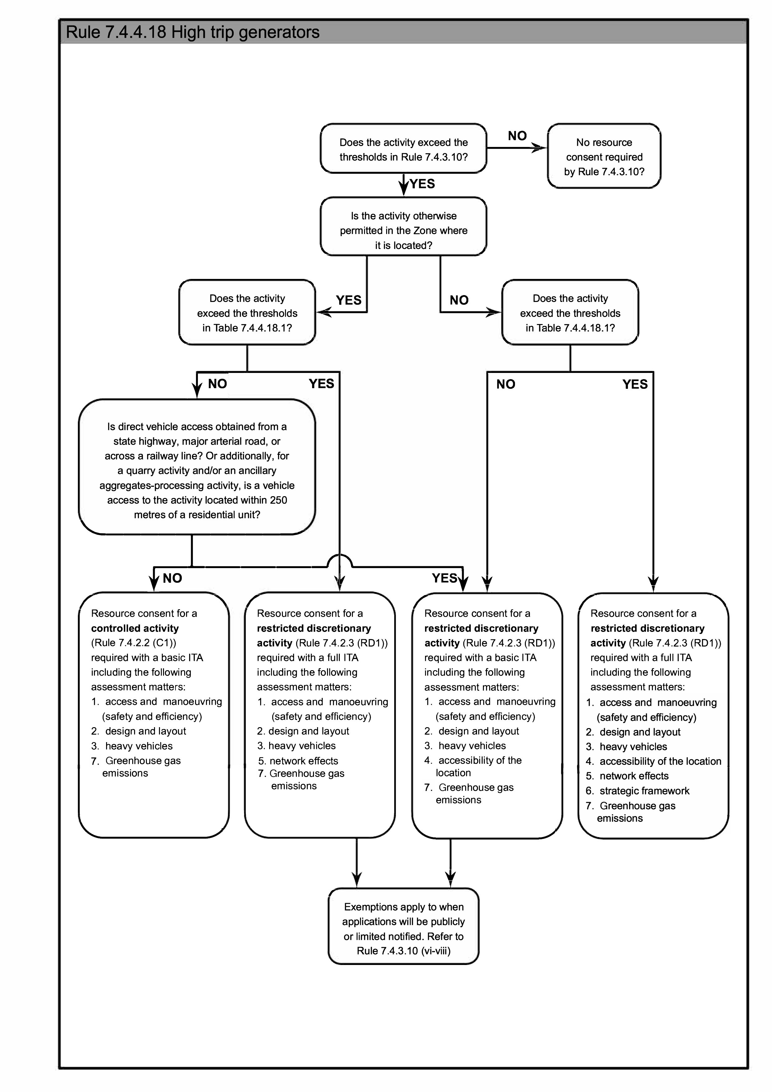
              - Access and manoeuvring (safety and efficiency): Whether the provision of access and on-site manoeuvring area associated with the activity, including vehicle loading and servicing deliveries, affects the safety, efficiency, accessibility (including for people whose mobility is restricted) of the site, and the transport network (including considering the road classification of the frontage road).
              - Design and Layout: Whether the design and layout of the proposed activity maximises opportunities, to the extent practicable, for travel other than by private car, including providing safe and convenient access for travel by such modes. Within the Northern Homebase Centre, this includes consideration of:
                - the provision of pedestrian and cycle access for the public and users of the Centre through the site from Sanctuary Gardens or Havana Gardens to Marshland Road;
                - integration of pedestrian and cycle access with development (including building frontages, circulation routes, sightlines and lighting) within the Northern Homebase Centre; and
                - any potential safety or nuisance effects and methods to address such effects including by way of a Crime Prevention Through Environmental Design (“CPTED”) assessment.
              - Heavy vehicles: For activities that will generate more than 250 heavy vehicle trips per day, whether there are any effects from these trips on the roading infrastructure.
              - Accessibility of the location: Whether the proposed activity has demonstrated the accessibility of the site by a range of transport modes and whether the activity’s location will minimise or reduce travel to and from the activity by private vehicles and encourage public and active transport use.
              - Network effects: Having particular regard to the level of additional traffic generated by the activity and whether the activity is permitted by the zone in which it is located, whether measures are proposed to adequately mitigate the actual or potential effects on the transport network arising from the anticipated trip generation (for all transport modes) from the proposed activity, including consideration of cumulative effects with other activities in the vicinity, proposed infrastructure, and construction work associated with the activity.
              - Strategic framework: Whether the proposal is consistent with the local and regional transport policy framework.
              - Greenhouse gas emissions: Whether measures are proposed to be implemented to promote opportunities for safe efficient travel other than by conventional provide vehicles, to seek to reduce the greenhouse gas emissions from vehicle use associated with the activity, and the ability for the measures to be implemented and maintained over the lifetime of the activity.

(Plan Change 6 Decision by Consent Order)

Advice note:
- For clarity, the following table also shows which matters of control or discretion apply to which situations:
 | Matters of Control or Discretion | Activities that are otherwise permitted in the Zone’s Activity Status Table |  | Activities that are not permitted in the Zone’s Activity Status Table
 |  | Basic ITA /Controlled activity | Full ITA | Basic ITA | Full ITA
i. | Access and manoeuvring (safety and efficiency) | Yes | Yes | Yes | Yes
ii. | Design and Layout | Yes | Yes | Yes | Yes
iii. | Heavy vehicles | Yes | Yes | Yes | Yes
iv. | Accessibility of the location |  |  | Yes | Yes
v. | Network effects |  | Yes |  | Yes
vi. | Strategic framework |  |  |  | Yes
vii | Greenhouse gas emissions | Yes | Yes | Yes | Yes

Table 7.4.4.18.1 – Thresholds for full Integrated Transport Assessments
 | Activity | Thresholds
a. | Education Activities (Schools). | More than 450 students
b. | Education Activities (Pre-School). | More than 150 children
c. | Education Activities (Tertiary Education and Research Activities). | More than 750 FTE students
d. | Health Care Facilities. | More than 1000 m² GFA
e. | Industrial Activities (excluding Warehousing and Distribution Activities).  High Technology Industrial Activities.  Heavy Industrial Activities. | More than 10,000 m² GFA
f. | Industrial Activities (Warehousing and Distribution Activities). | More than 20,000 m² GFA
g. | Offices. | More than 4000 m² GFA
h. | Residential Activities. | More than 120 residential units
i. | Retail Activities (excluding factory shops, retail park zones, trade suppliers and food and beverage outlets). | More than 1000 m² GLFA  and/or  in a Local Centre or Neighbourhood Centre identified in Chapter 15, where the total area of development* over any three year period exceeds 1000 m² GLFA.  Advice note:  1. * Development refers to either consented or constructed developments.
j. | Retail Activities (factory shops and retail park zones, but excluding trade suppliers and food and beverage outlets). | More than 2000 m² GLFA
k. | All other activities (not covered by the thresholds above or the thresholds in (l) below). | More than 120 vehicle trips per peak hour or 1000 vehicle trips per day (whichever is met first).  ‘Peak hour’ are those hours between 15:00 and 19:00 hours on a weekday.
l. | Yaldhurst Recreation and Sports Facility at 466-482 Yaldhurst Road, as shown in Appendix 18.11.4 (all activities within the site, including existing, consented and proposed activities). | - More than 650 vehicle trips per peak hour will be generated by all the activities on the site; and/or  - More than 650 car parking spaces are proposed on the site.  - For the avoidance of doubt, if the existing number of vehicle trips and/or the existing number of car parking spaces already exceed these limits, any increase in vehicle trips and/or car parking spaces as a result of a new proposal will trigger the need for a full Integrated Transport Assessment.  ‘Peak hour' is the continuous 60 minute period between 15:00 and 19:00 hours on a weekday when the greatest number of vehicle trips occurs.
      - Transport infrastructure in the Transport Zone
          - The following are the matters of control for Rule 7.4.2.2 C2 or matters of discretion for Rule 7.4.2.3 RD2 and RD4:
- Whether there is a need for the development in relation to improving the safety, amenity, efficiency or functionality of the Transport Zone.
- Any adverse effects on the current or future safety and efficiency of transport modes.
- Whether the scale and location of buildings will adversely affect or dominate its surrounding setting including adjacent buildings and the environment. In particular:
  - where a larger building is proposed to locate adjacent to areas with smaller buildings, the massing and design of the proposed building should not overly dominate the built scale or open space of the surrounding area. Methods to moderate the bulk of the proposed building may include:
    - varying roof forms;
    - window placement;
    - appropriate use of materials; and
    - modulation of facades.
- Whether the building adversely affects the environment, amenity values or activity of adjacent land uses.
- Whether there is adequate access to sunlight.
- Whether the location or/and the scale of the building does not solely or cumulatively affect public access.
- Whether the building results in areas of entrapment or concealment.
- In addition, outside of the Central City:
                - The extent to which the development and activity specific standards of the adjoining zone mitigates potential adverse effects.
                - If the land is being used for non-transport related activities, the extent to which the activity does not undermine the future use of the land for transport purposes.
      - Formation of unformed legal roads
          - The following are matters of discretion for Rule 7.4.2.3 RD3:
              - Whether there is ability to form the unformed legal road in a way that is safe, functional and maintainable at a reasonable cost.
              - Whether the use of the unformed legal road will adversely affect the environment and/or character of the location and surrounding area (including effects from dust, noise and vibration and effects on visual amenity).
              - Whether the use of the unformed legal road will adversely affect safe access for other current and potential users of the unformed legal road, including pedestrians and cyclists.
              - Any effects on public access to and along the coastal marine area and the adequacy of measures to address adverse effects on public access to and along the coastal marine area.
              - Matters of discretion in Rule 9.6.3.1 Effects of activities on the coastal environment and Rule 9.2.8.3 Natural character in the coastal environment.
      - Vehicle access to sites fronting more than one street – within the Central City
          - The following are matters of discretion for Rule 7.4.3.11:
              - Whether there would be any adverse effects on the safety and amenity of all types of road user passing the site, and/or the function of the frontage road, particularly at times of peak traffic flows on the road and the access; and
              - The extent to which the access disrupts active frontages, key pedestrian frontages, or major cycle routes.
      - Central City lane formation – within the Central City
          - The following is the matter of discretion for Rule 7.4.3.12:
              - The extent to which the width and height of the lane will adversely affect the amenity of the lane and the safety and efficiency of the lane for all users, including whether the lane provides adequate access for fire appliances.
      - Central City Road Cross sections
          - The following are matters of discretion for Rule 7.4.2.3 RD7:
              - The effect on access to adjacent properties;
              - Any effects on the safety of movement along the road for drivers, pedestrians, cyclists or public transport users;
              - Any likely adverse effects in terms of the efficiency of traffic movement;
              - The quality of the streetscape, including the adequacy of provision for street planting and/or grassed berms;
              - The setback of buildings along the street, and the amenities of properties adjoining the road; and
              - The amount of on street parking which may be lost or made unavailable and whether this can be accommodated elsewhere.
      - Temporary Car Parks during the Earthquake Recovery period – within the Central City
          - The following are matters for discretion for Rule 7.4.2.3 RD6:
              - The extent to which the safety and convenience of people within and passing the site, including vehicles, pedestrians and cyclists, will be affected by the design or location of the car parking area and access ways;
              - Whether the design or location of the car parking area will disrupt active frontages or detract from streetscape amenity values in the area;
              - Whether the car park can be used by other activities to reduce the need for these activities to provide their own parking spaces;
              - The length of time that the car parking area is proposed to be operating for; and
              - The potential activities that may use the additional parking spaces and the degree to which the car parking area will be utilised.
          - Any resource consents granted under this Rule will need to set the duration of the consent. The duration of the consent should not exceed a period that is reasonably necessary to support the recovery of the surrounding area. It is intended that the duration of consents under this rule will be no longer than 30 April 2018.
      - Commercial car parking buildings and parking lots – within the Central City
- The following are matters for discretion for Rule 7.4.2.3 RD8:
              - the potential activities that may use the car park and the degree to which the car park will be utilised;
              - the need for the car park considering the amount of car parking spaces already provided in the surrounding area;
              - whether the car parking spaces are needed to meet existing unsatisfied parking demand or are being provided due to anticipated future need;
              - the integration of the car park area with existing car park areas to operate in a coordinated manner;
              - the legibility of the car park and the way in which the location of car park is communicated to motorists;
              - the extent to which the safety and convenience of people within and passing the site, including vehicles, pedestrians and cyclists, will be affected by the design or location of the car park;
              - whether the design or location of the car park will disrupt active frontages or detract from streetscape amenity values in the area;
              - whether the car park can be used by other activities to reduce the need for these activities to provide their own parking spaces;
              - the extent to which the car parking facility may adversely affect the demand for public transport to, from or within the Central City.

Advice note:
- A parking plan for the Central City has been developed as part of the implementation of the An Accessible City chapter of the Christchurch Central Recovery Plan, which provides more guidance about parking within the Central City.
      - Carparking area – within the Central City
- The following are matters of discretion for Rule 7.4.3.1 b.i.:
              - the extent to which the safety and amenity of people within and passing the site, including vehicular traffic, pedestrians and cyclists, will be affected by the design or location of parking spaces and access ways;
              - whether the design or location of the parking spaces will disrupt active frontages or detract from streetscape amenity values in the area.

7.4.4.27 Pedestrian Access
a. The following are matters of discretion for Rule 7.4.3.7 b:
- whether the pedestrian access is suitable for use by persons with a disability or with limited mobility;
- whether any alternative pedestrian access is provided and the formation and safety of that alternative;
- the effects on the safety and security of people using the pedestrian access and those occupying residential units on the site; and
- the functionality of the pedestrian access to meet the needs of occupants including but not limited to the transportation of rubbish and recycling for collection and the ability for cyclists to safely access any private and shared cycle storage areas.; and,
v. whether the pedestrian access is suitable for use by emergency services.

7.4.4.28 Vehicle Crossing Co-Location Layout
a. The following are matters of discretion for Rule 7.4.3.13:
- the effects on the safety of pedestrians and cyclists from additional vehicle crossings;
- whether the proximity of vehicle crossings to one another, or the width of shared vehicle crossings, detract from the streetscape amenity of the local area; and
- whether the co-location of vehicle crossings results in improved traffic safety or streetscape amenity outcomes compared to separate vehicle crossings.

7.5 Appendices
Appendix 7.5.1 – Parking space requirements
            - Any space required for off-street parking spaces other than for a residential activity shall be available for staff and visitors during the hours of operation and shall not be diminished by the subsequent erection of any structure, storage of goods, or any other use.
            - Mobility parking spaces shall be provided at the closest possible point to the accessible entrance to the activity with which they are associated, and the most direct route from the mobility parking spaces to the activity shall be accessible for people whose mobility is restricted. The spaces shall be clearly signed.
            - All car parking spaces and aisle widths shall be laid out in accordance with Table 7.5.1.3 and Figure 1.
            - Critical manoeuvring areas such as aisles in or between major structures, or changes in grade, shall be designed to accommodate the 99 percentile design vehicle as set out in Appendix 7.5.5.
            - All other manoeuvring areas shall be designed to accommodate the 85 percentile design motor car as set out in Appendix 7.5.4.

Advice note:

1. It is recommended that blue colouring be used to help better identify mobility parking spaces.
Table 7.5.1.1 – Minimum number of mobility parking spaces required

The minimum number of mobility parking spaces provided must be calculated using the following method:

(1) Non-residential activities
 | Total number of car parking spaces being provided (excluding private parking areas for residential units). | Minimum number of mobility parking spaces
a. | 1 – 20 | 1
b. | 21 – 50 | 2
c. | > 50 | 2 for the first 50 car parking spaces + 1 additional mobility parking spaces for every additional 50 car parking spaces or part thereof
- Rule 7.4.3.1 requires all buildings with a GFA greater than 2,500 m² to provide mobility parking spaces, even if no other parking spaces are provided. If no other car parking spaces are provided, the amount of mobility parking spaces required shall be calculated by determining how many mobility parking spaces would be required if one standard parking space per 100 m² GFA were provided.
(2) Residential activities
 | Number of units | Minimum number of mobility parking spaces
a. | < 7 units | 0
b. | 7 - 18 | 1
c. | 19 - 31 | 2
d. | 32 - 43 | 3
d. | > 43 | 3 for the first 43 car parking spaces + 1 additional mobility parking spaces for each 12.5 units thereafter

Table 7.5.1.2 – Minimum car parking space dimensions
 | Type of use | Parking angle | Parking stall width (metres) (refer to p) | Aisle width (metres) (refer to Note 4) | Parking stall depth (metres) (refer to q) | Over hang (metres) | Total width (stall depth and  aisle width) (metres)
a. | Long term (refer to Note 1) | 90º | 2.4 | 6.6 | 5.0 | 0.6 | 11.6
b. | Medium term (refer to Note 2) |  | 2.5 | 6.4 |  |  | 11.4
c. | Short term (refer to Note 3) |  | 2.6 | 6.2 |  |  | 11.2
d. | Mobility parking spaces |  | 3.6 | 6.6 |  |  | 11.6
e. | Long term (refer to Note 1) | 60º | 2.4 | 5.4 | 5.0 | 0.4 | 10.4
f. | Medium term (refer to Note 2) |  | 2.5 | 5.1 |  |  | 10.1
g. | Short term (refer to Note 3) |  | 2.6 | 4.8 |  |  | 9.8
h. | Long term (refer to Note 1) | 45º | 2.4 | 4.5 | 5.0 | 0.4 | 9.5
i. | Medium term (refer to Note 2) |  | 2.5 | 4.2 |  |  | 9.2
j. | Short term (refer to Note 3) |  | 2.6 | 3.9 |  |  | 8.9
k. | Long term (refer to Note 1) | 30º | 2.3 | 4.1 | 4.0 | 0.4 | 8.1
l. | Medium term (refer to Note 2) |  | 2.4 | 3.8 |  |  | 7.8
m. | Short term (refer to Note 3) |  | 2.5 | 3.5 |  |  | 7.5
n. | Mobility parking spaces | Parallel | 3.6 | 3.3  (one way)  5.5 (two way) | 6.1
o. | All users | Parallel | 2.0 | 3.3  (one way)  5.5 (two way) | 6.1
- Stall widths shall be increased by 300 millimetres where they abut permanent obstructions such as a wall, column or other permanent obstruction. Where there is such an obstruction on both sides of a parking space the minimum width shall be increased by 600mm.
- The stall depth may be reduced by the corresponding overhang length if a low kerb allows overhang, but this overhang shall not encroach any pedestrian facilities or required landscape areas.
Advice note:
- Long term parking: generally all day parking.
- Medium term parking: generally two to four hour parking.
- Short term parking: generally two hour parking or less.
- Aisle widths for 90° parking allow for two-way operation. If not otherwise specified, all other aisle widths are given for one-way operation with forward entry to spaces.
- Design guidance for parking areas in buildings may be obtained from the New Zealand Building Code D1/AS1: Access Routes or Australian/New Zealand Standard Offstreet Parking, Part 1: Car Parking Facilities, AS/NZS 2890.1:2004, and any subsequent amendments. Compliance with the Australian/ New Zealand Standard is recommended, but is not a requirement to achieve permitted activity status.
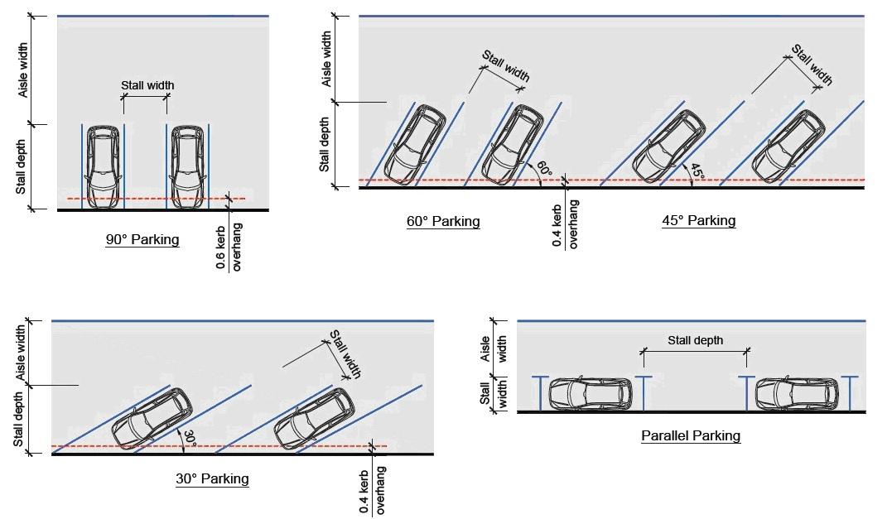
Figure 1: Car park dimensions
Appendix 7.5.2 – Cycle parking facilities
- Visitor Ccycle parking facilities shall be provided as follows:
              - The number of visitor cycle parks provided on the same site as the activity shall be at least the minimum number of visitor cycle parks specified in Table 7.5.2.1.
- when calculating the overall cycle parking requirements for an activity the separation of areas into different activities will be required where the GFA of an activity (or PFA or other such measurement that the standards for the relevant activity is based upon) exceeds 10 per cent of the total GFA of the activity. The total cycle parking requirement for any activity will be the sum of the parking requirements for each area.
- where the calculation of the required cycle parks results in a fractional space, any fraction that is less than one-half will be disregarded and any fraction of one-half or more will be counted as one space. The parking requirements for different types of cycle parks (i.e. staff, visitors etc) shall be calculated and rounded separately.
- where an activity falls under the definition of more than one activity in Table 7.5.2.1, then the higher cycle parking requirement shall apply.
- where an activity does not fall within a particular category, the activity which is closest in definition shall apply.
              - Stands shall be securely anchored to an immovable object.
              - Stands shall support the bicycle frame and front wheel.
              - Stands shall allow the bicycle frame to be secured.
              - Cycle parking facilities shall be clearly signposted or visible to cyclists entering the site.
              - Cycle parking facilities shall be located so as not to impede pedestrian thoroughfares including areas used by people whose mobility or vision is restricted.
              - Cycle parking facilities shall be located so that the bicycle is at no risk of damage from vehicle movements within the site.
              - Cycle parking facilities shall be located as close as possible to and no more than 30 metres from at least one main pedestrian public entrance to the building/activity. However, the requirement to provide visitor cycle parking does not apply to a building on a key pedestrian frontage that has no setback from the road frontage, which results in there being no space for the visitor cycle parking to be provided within 30 metres of at least one main pedestrian public entrance. Within the Central City, any activity where the building has no road frontage setback for the entire length of the site visitor cycle parking is not required.
              - Lighting must comply with the lighting requirements in Rule 7.4.3.6 a.
              - Stands shall have the minimum dimensions in Figure 2 and within the Central City and for all residential developments, shall be designed to accommodate the turning path of a cycle as shown in Figure 3.
              - Cycle parking facilities shall be available during the hours of operation and shall not be diminished by the subsequent erection of any structure, storage of goods, or any other use.

Advice note:
- Where there is more than one public entrance to the building, it is recommended that visitor cycle parking is apportioned between the entrances in accordance with their potential usage.

2. The installation of standard 240V electrical power points in cycle parking facilities is strongly encouraged to enable the charging of e-bikes, e-scooters and other micro mobility devices. A ratio of 1 power point to 5 parking spaces is recommended to accommodate future growth.
- Staff/residents/students cycle parking facilities shall be provided as follows:
              - The number of staff/residents/students cycle parks provided shall be at least the minimum number of staff/residents/students cycle parks in Table 7.5.2.1. Where an activity does not fall within a particular category, the activity which is closest in definition shall apply. Where the calculation of the required parks results in a fractional space, any fraction that is less than one-half will be disregarded and any fraction of one-half or more will be counted as one space. The parking requirements for different types of carparks (i.e. staff, visitors etc) shall be calculated and rounded separately.
              - Staff/residents/students cycle parking facilities shall be located so it is easily accessible for staff, residents or students of the activity, except within the Central City staff cycle parking may be provided on a site within 200 metres of the site on which the activity is undertaken.
              - Staff/ residents/ tertiary students’ cycle parking facilities shall be located in:
                - a covered area; and
                - a secure area, unless located in an area where access by the general public is generally excluded.

Advice note:
- It is recommended that cycle parking at schools is designed and managed to discourage theft of bicycles.
              - Where a stand is provided, it shall meet the visitor cycle parking requirements in (a) except for (a)(v) and (a)(viii).
              - Outside the Central City, the number of on-site cycle parking end of trip facilities provided shall be at least the minimum number of cycle parking end of trip facilities set out in Table 7.5.2.2.
- Full time equivalent student numbers for Tertiary Education and Research Activities shall be assessed annually as of 1 July, and shall be rounded to the nearest 100 FTE students, if there are more than 1000 FTE Students at the activity in total.. Any additional cycle facilities required shall be provided within 12 months of the date of assessment.
- For sites with activities that existed on 3 September 2010 (i.e. prior to the Canterbury earthquakes of 2010/2011), Table 7.5.2.1 shall be applied to the rebuild of that activity, as follows:
              - For the size of the activity’s building floor area/ scale of the activity that existed on 3 September 2010, Table 7.5.2.1 does not apply, as long as the activity provides at least the same amount of on-site cycle parking that existed on 3 September 2010.
              - For any addition to the size of the activity’s building floor area/ scale of the activity that is an increase to what existed on 3 September 2010, Table 7.5.2.1 shall apply in respect of the increase.

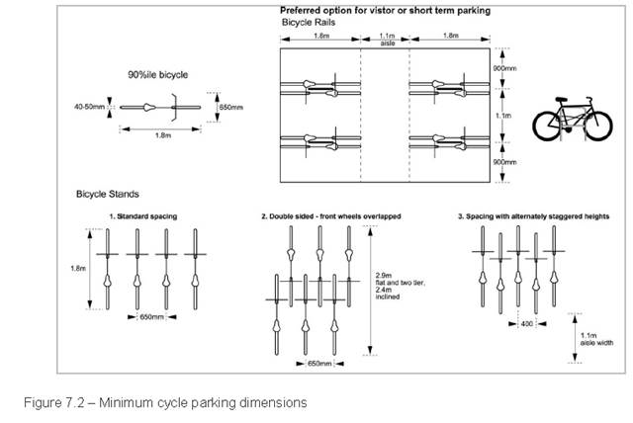

Figure 2 – Minimum cycle parking dimensions

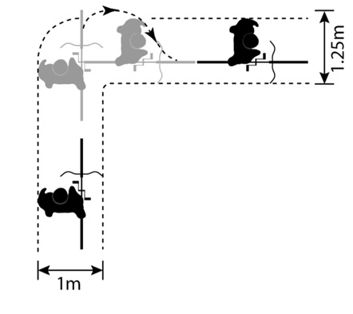
Figure 3 – Cycle turning circle - within the Central City

Table 7.5.2.1 – Minimum numbers of cycle parks required
 | Activity | Visitor cycle parks (within the Central City visitor spaces can be used by students) | Staff/ residents/ students cycle parks

EDUCATION ACTIVITIES
a. | Preschools | i. 1 space/ 10 children (Outside the Central City)  ii. 1 space/ 5 children (within the Central City) | 1 staff space/ 3 FTE staff (Outside the Central City)  1 staff space/100 children (within the Central City)
b. | Schools | i. 1 space/ 30 students (year 8 and below) (Outside the Central City)  ii. 1 space/ 5 children (within the Central City)  iii. 1 space/ 100 students (year 9 and above) (Outside the Central City)  iv. 3 spaces/ 4 students (within the Central City) | 1 space/ 7 students (year 8 and below) (Outside the Central City)  1 staff space/ 100 students (within the Central City)  1 space/ 5 students (year 9 and above) (Outside the Central City)  1 staff space/ 100 students (within the Central City)
c. | Tertiary education and research activities | i. 1 space/ 100 FTE students (Outside the Central City)  ii. 1 space/ 4 FTE students (within the Central City) | 1 staff space/ 4 FTE staff and 1 student space/ 4 FTE students (Outside the Central City)  1 staff space/ 100 FTE students (within the Central City)

ENTERTAINMENT ACTIVITIES AND RECREATION FACILITIES
d. | Cinemas and theatres (small to medium venues up to 500 seats) | 1 space/ 30 seats | 1 space/ 1 screen
e. | Cinemas and theatres (large venues more than 500 seats) | 1 space/ 60 seats | 1 space/ 60 seats
f. | Museums and galleries | 1 space/ 200 m2 PFA | 1 space/ 1000 m2 PFA
g. | Libraries | 1 space/ 100 m2 PFA | 1 space/ 400 m2 PFA
h. | Gymnasiums (for public, or private club use), dance studios | 1 space/ 50 m2 GFA | 1 space/ 600 m2 PFA
i. | Sports courts (for public, or private club use) | 1 space/ 150 m2 court area | 1 space/ 500 m2 court area
j. | Sports fields (for public, or private club use) | 10 spaces/ ha pitch area | 5 spaces/ ha pitch area
k. | Swimming pools (for public, or private club use) | 1 space/ 10 m2 pool area | 1 space/ 500 m2 pool area
l. | Other entertainment activities/ recreation facilities, if not specified above | 1 space/ 50 m2 PFA | 10% of visitor requirements
m. | FIRE STATIONS and AMBULANCE STATIONS | 1 space/ emergency service vehicle bay | 1 space/ emergency service vehicle bay
n. | GUEST VISITOR ACCOMMODATION except for hosted visitor accommodation or unhosted visitor accommodation  (Plan Change 4 Council Decision subject to appeal) | 1 space/ 20 bedrooms  (Outside the Central City)  1 space/ 20 beds (except 1 space/ 30 bedrooms for Hotels) (within the Central City) | 1 space/ 5 FTE staff  (Outside the Central City)  1 space/ 80 beds (except 1 space/ 80 bedrooms for Hotels ) (within the Central City)

HEALTH CARE FACILITIES
o. | Hospitals | 1 space/ 1000 m2 GFA | 1 space/ 300 m2 GFA
p. | Other health care facilities, if not specified above | 1 space/ 500 m2 GFA | 1 space/ 300 m2 GFA

INDUSTRIAL ACTIVITIES
q. | Warehousing and distribution activities | 1 space/ 2000 m² GFA (1 space minimum) | 1 space/ 1000 m2 GFA
r. | Other industrial activities if not specified above, high technology industrial activities and heavy industrial activities | 1 space/ 1000 m2 GFA | 1 space/ 500 m2 GFA
s. | OFFICES | i. 20% of staff requirements (2 spaces minimum) (Outside the Central City)  ii. 1 space/ 500m2 GFA (within the Central City) | 1 space/ 150 m2 GFA
t. | QUARRYING ACTIVITY and ANCILLARY AGGREGATES-PROCESSING ACTIVITY | Nil | Nil
u. | RESERVES (if there is not a specified cycle parking requirement in this table for the activity on the reserve) | Nil | Nil

RESIDENCES
v. | Care facilities (including a care home within a retirement village) | 1 space/ 50 clients | 1 space/ 30 clients
w. | Retirement village (excluding a care home within a retirement village) | 1 space/ 10 units, for developments with 10 or more units | Nil
x. | Residential activities provided under EDM and CHRM | Nil | 1 residents’ space/dwelling without a garage
y. x | Social housing complex | 1 space/ 10 units, for developments with 10 or more units | 1 residents’ space/dwelling without a garage  For developments involving 3 or more residential units –  i. For residential units with one or two bedrooms- 1 space/ residential unit without a garage;  ii. For residential units with three or more bedrooms- 2 spaces/ residential unit without a garage;
z y | Student hostel accommodation | 1 space/ 10 beds | 1 space/ 3 beds
aa. z. | Other residential activities, if not specified above | 1 space/ 20 units for developments with 20 or more units | 1 residents' space/ dwelling without a garage  For residential units with one or two bedrooms - 1 space/ residential unit without a garage;  For residential units with three or more bedrooms- 2 spaces/ residential unit without a garage

RETAIL ACTIVITIES AND COMMERCIAL SERVICES
bb. | Commercial services | 1 space/ 500 m2 GFA | 1 space/ 200 m2 GFA
cc. | Factory shops, retail activities in commercial retail park large format retail zones | 1 space/ 1000 m2 GLFA | 1 space/ 750 m2 GLFA
dd. | Food and beverage outlets | i. 1 space/ 300 m2 PFA (Outside the Central City)  ii. 1 space/ 125m2 PFA (within the Central City) | 1 space/ 100 m2 PFA (2 spaces minimum) (Outside the Central City)  1 space/ 400m2 PFA (within the Central City)
ee. | Other retail activities, if not specified above | i. 1 space/ 300 m2 GLFA (Outside the Central City)  ii. 1 space/ 350m2 GLFA (within the Central City) | 1 space/ 750 m2 GLFA (Outside the Central City)  1 space/ 200m2 GLFA (within the Central City)
ff. | SERVICE STATIONS | 1 space/ 1000 m2 GLFA | 1 space/ 750 m2 GLFA
gg. | SPIRITUAL ACTIVITIES | 1 space/ 100 m2 PFA | 10% of visitor requirement
hh. | TRADE SUPPLIERS | 1 space/ 1000 m2 GLFA | 1 space/ 750 m2 GLFA
ii. | UTILITIES (that have no permanent staff) | Nil | Nil
jj. | YARD-BASED SUPPLIERS | 1 space/ 1000 m2 GLFA | 1 space/ 750 m2 GLFA
Advice note: for x. and z. A communal garage or parking building used for parking by more than one residential unit is not considered to be a garage for the purposes of this rule.
Table 7.5.2.2 - Minimum number of cycle parking end of trip facilities required for Commercial activities, Tertiary education and research activities and Hospitals
 | Number of staff cycle parks required | Number of end of trip facilities required
 | 1 - 10 | None
 | 11 - 100 | i. 1 shower¹ per every 10² staff cycle parks required  ii. 1 locker³ per every staff cycle park provided
 | > 100 | i. 10 showers¹ for the first 100 staff cycle parks required + 2 showers¹ for each additional 50² staff cycle parks required  ii. 1 locker³ per every staff cycle park provided

¹ Showers only need to be shown on building consent plans. If the activity requires a resource consent, the location and design of any required showers do not need to be shown at that stage as long as the application states the number of showers proposed to be provided.

² Where the calculation of the required showers results in a staff cycle space value that is not a round number of 10, any value that is 4 or less will be disregarded and any value 5 or more will be counted as one shower.

³ The minimum internal dimensions of a single locker shall be: height - 85 centimetres, depth - 45 centimetres, width - 20 centimetres

Appendix 7.5.3 – Loading areas
            - The minimum number of on-site loading spaces provided shall be in accordance with Table 7.5.3.1.
              - Where an activity does not fall within a particular category, the activity which is closest in definition shall apply.
              - Where the calculation of the required loading space results in a fractional space, any fraction that is less than one-half will be disregarded and any fraction of one-half or more will be counted as one space. The loading space requirements for different types of carparks (i.e. staff, visitors etc) shall be calculated and rounded separately.
              - The loading space requirements listed in Table 7.5.3.1 are categorised by activity. When calculating the overall loading space requirements for an activity the separation of areas into different activities will be required where the GFA of an activity (or PFA or other such measurement that the standards for the relevant activity is based upon) exceeds 10 per cent of the total GFA of the activity. The total loading space requirement for any activity will be the sum of the loading space requirements for each area.
              - Where an activity falls under the definition of more than one activity in Table 7.5.3.1, then the higher loading space requirement shall apply.
              - Any space required for loading, other than for a residential activity, fire stations and ambulance stations, shall be available during the hours of operation and shall not be diminished by the subsequent erection of any structure, storage of goods, or any other use.
              - Full time equivalent student numbers for Tertiary Education and Research Activities shall be assessed annually as of 1 July, and shall be rounded to the nearest 100 FTE students, if there are more than 1000 FTE Students at the activity in total.. Any additional loading spaces required shall be provided within 12 months of the date of assessment.
              - For sites with activities, listed under Rule 7.4.3.3 a., that existed on 3 September 2010 (i.e. prior to the Canterbury earthquakes of 2010/2011), Table 7.5.3.1 shall be applied to the rebuild of that activity, as follows:
                - For the size of the activity’s building floor area/ scale of the activity that existed on 3 September 2010, Table 7.5.3.1 does not apply, as long as the activity provides at least the same amount of on-site loading spaces that existed on 3 September 2010.
                - For any addition to the size of the activity’s building floor area/ scale of the activity that is an increase to what existed on 3 September 2010, Table 7.5.3.1 shall apply in respect of the increase.
              - Within the Central City, no loading is required where a suitable on- or off-street loading facility is provided within 50 metres of any part of the site and the route between the loading facility and the site does not require crossing any road. Use of an off-street loading facility on a separate site by an activity must be protected for the use of that activity (and any future activity on the site) by an appropriate legal instrument. A copy of the appropriate legal instrument shall be provided to Council for its records.
            - Minimum loading area dimensions:
              - A heavy vehicle bay shall comply with one of the following vehicle sizes in Table 7.5.3.2 (depending on the largest vehicle expected to use the loading space). For commercial and industrial sites where waste collection occurs internally, a loading space and associated manoeuvring area large enough to accommodate a medium rigid vehicle must be allowed for.
              - A 99 percentile vehicle bay shall be designed to the following minimum standards in Table 7.5.3.3:

Advice note:
- Design guidance for commercial vehicle access and parking may be obtained from the Australian Standard Parking Facilities Part 2: Off street commercial vehicle facilities, AS 2890.2:2002, and any subsequent amendments. Please note compliance with AS 2890.2:2002 is recommended, but is not a requirement to achieve permitted activity status.

Table 7.5.3.1 – Minimum numbers of loading spaces required
 | Activity | Number of heavy vehicle bays to be provided | Number of 99 percentile vehicle bays to be provided

EDUCATION ACTIVITIES:
a. | Schools and preschools | With 100 or more students: 1 bay | i. With 20 students or more, but less than 100: 1 bay  ii. With 100 or more students: 1 bay/100 students
b. | Tertiary education and research activities | 1 bay per site | 1 bay/100 FTE students

ENTERTAINMENT ACTIVITIES AND RECREATION FACILITIES:
c. | Cinemas | 1 bay per cinema complex | Nil
d. | Theatres | 1 bay per theatre | Nil
e. | Gymnasium (for public, or private use), dance studios | 1/8,000 m² GFA | Nil
f. | Sports courts (for public, or private use) | Nil | Nil
g. | Sports fields (for public, or private use) | Nil | Nil
h. | Swimming pools (for public, or private use) | 1 bay/ 2000 m2 pool area | Nil
i. | Other entertainment activities/ recreation facilities, if not specified above | Nil | 1 bay/2000 m² PFA
j. | FIRE STATIONS and AMBULANCE STATIONS | 1 bay per site | Nil

GUEST VISITOR ACCOMMODATION:
k. | Hotels | 1 bay/ 100 bedrooms (for the first 300 bedrooms, nil thereafter) | 1 bay /50 bedrooms
l. | Other guestvisitor accommodation, if not specified above  (Plan Change 4 Council Decision subject to appeal) | 1 bay/ 100 units or 100 bedrooms, whichever is the greater (for the first 200 units or 200 nil thereafter) | 1 bay/50 units or 50 bedrooms, whichever is the greater

HEALTH CARE FACILITIES:
m. | Hospitals | 1/ bay 8,000 m2 GFA | Nil
n. | Other health care facilities, if not  specified above | Nil | Nil

INDUSTRIAL ACTIVITIES:
o. | Warehousing and distribution activities | 1 bay/ 1,000 m2 GFA (up to 2,000 m2 GFA);  1 bay/ 2,000 m2 GFA (for 2,000 m2 – 10,000 m2 GFA); and  1 bay/ 2,750 m2 GFA (after 10,000 m2 GFA). | Nil
p. | Other industrial activities, if not specified above, high technology industrial activities and heavy industrial activities | 1 bay/ 1,000 m2 GFA | Nil
q. | OFFICES | 1 bay/ 8,000m2 GFA (up to 16,000 m2 GFA); and  1 bay/ 20,000 m2 GFA (after 16,000 m2 GFA). | 1 bay/ 8,000 m2 GFA
r. | PUBLIC TRANSPORT INTERCHANGES | Nil | Nil
s. | QUARRYING ACTIVITY and ANCILLARY AGGREGATES-PROCESSING ACTIVITY | Nil | Nil
t. | RESERVES (if there is not a specified loading requirement in this table for the activity on the reserve) | Nil | Nil

RESIDENCES:
u. | Care facilities | Nil | One for care facilities with more than 20 clients
v. | Student hostel accommodation | 1 bay per hostel | 1 bay/100 beds
w. | Other residential activities, if not specified above | Nil | Nil  For developments of 20 or more residential units – 1 bay

RETAIL ACTIVITIES AND COMMERCIAL SERVICES:
x. | Food and beverage outlets | 1 bay/1000 m² PFA | Nil
y. | Other retail activities or commercial services, if not specified above | 1 bay/ 1600 m2 GLFA for the first 6,400 m2 GLFA, and  1/ 5,000 m2 GLFA thereafter. | Nil
z. | SERVICE STATIONS | 1 unmarked bay for fuel deliveries | Nil
aa. | SPIRITUAL ACTIVITIES | Nil | 1 loading space/ site
bb. | TRADE SUPPLIERS | 1 bay/ 1600 m2 GLFA for the first 6,400 m2 GLFA, and  1/ 5,000 m2 GLFA thereafter. | Nil
cc. | UTILITIES (that have no permanent staff) | Nil | Nil
dd. | YARD-BASED SUPPLIERS | 1 bay/ 1600 m2 GLFA for the first  6,400 m2 GLFA; and  1/ 5,000 m2 GLFA thereafter. | Nil

Table 7.5.3.2 – Loading space dimensions for Heavy Vehicle Bays
 | Largest vehicle expected to use the loading space | Minimum dimensions (metres) | Minimum dimensions (if loading space is parallel to the access to the loading space) (metres) | Associated manoeuvring areas shall be designed to accommodate the minimum turning area shown in:
a. | Small rigid vehicle | 3.5 x 6.4 | 3.5 x8.4 | Figure 4
b. | Medium rigid vehicle | 3.5 x 8.8 | 3.5 x 10.8 | Figure 5

Table 7.5.3.3 – Loading space dimensions for 99 percentile vehicle bay
 | Minimum dimensions (metres) | Minimum dimensions (if loading space is parallel to the access to the loading space) (metres) | Associated manoeuvring areas shall be designed to accommodate the minimum turning area shown in:
a. | 3.5 x 5.2 | 3.5 x 7.2 | Appendix 7.5.5

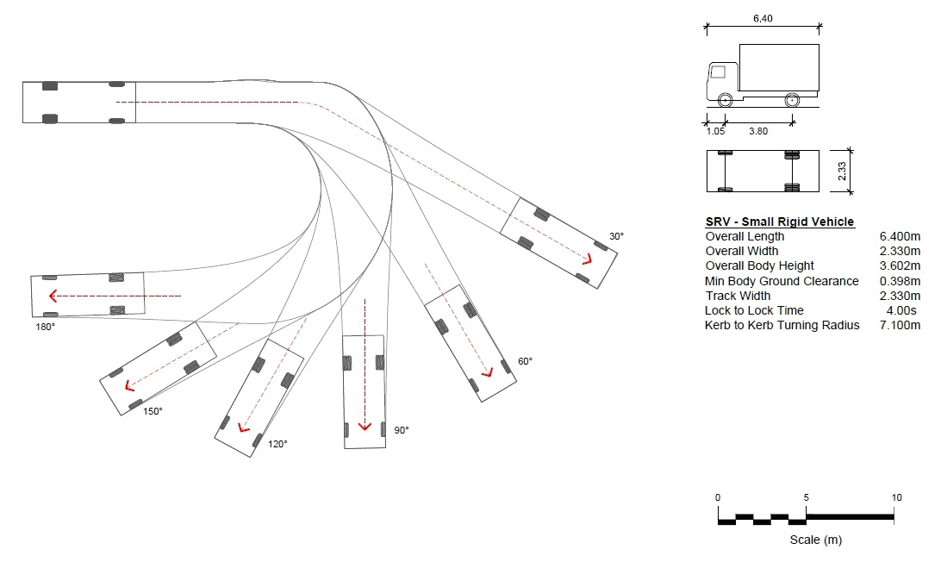
Figure 4 – Turning area for Small Rigid Vehicles

Advice note:

1. The source of this tracking curve is Australian Standard Parking Facilities Part 2: Off street commercial vehicle facilities, AS 2890.2:2002

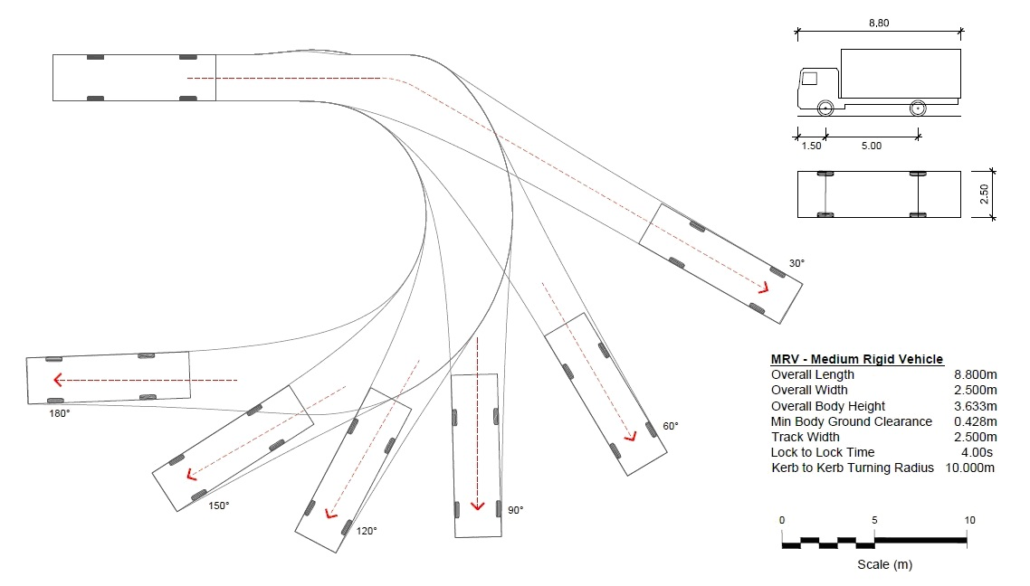

Figure 5 – Turning area for Medium Rigid Vehicles

Advice note:

1. The source of this tracking curve is Australian Standard Parking Facilities Part 2: Off street commercial vehicle facilities, AS 2890.2:2002.
Appendix 7.5.4 – 85 percentile design motor car
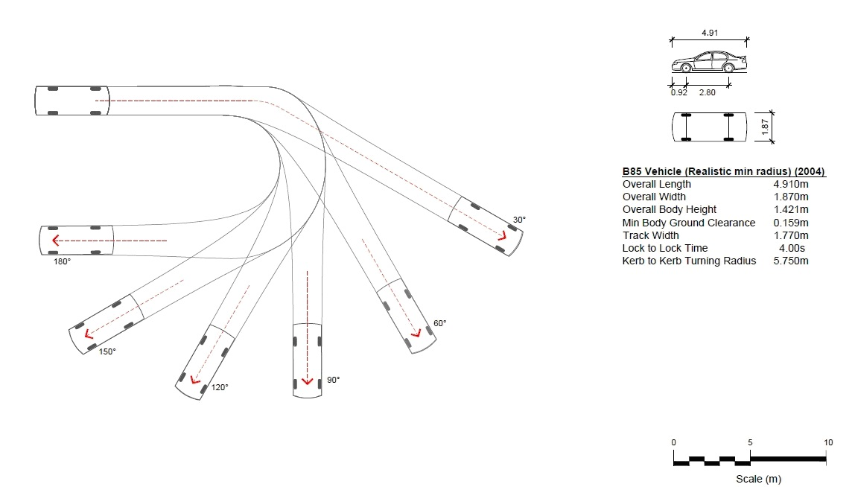
Figure 6 – 85 percentile design motor car

Advice note:

1. The source of this tracking curve is Australian/New Zealand Standard Offstreet Parking, Part 1: Car Parking Facilities, AS/NZS 2890.1:2004.
Appendix 7.5.5 – 99 percentile design vehicle

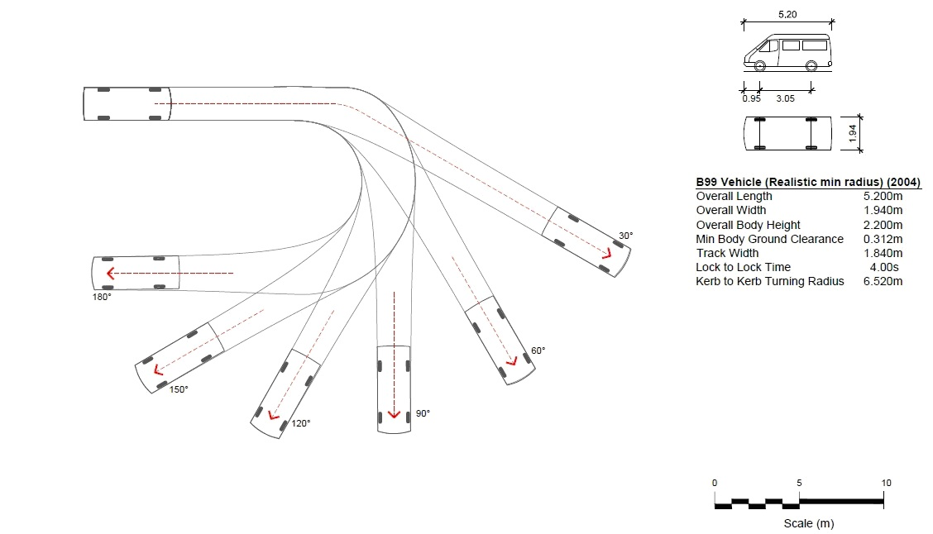

Figure 7 – 99 percentile design vehicle

Advice note:

1. The source of this tracking curve is Australian/New Zealand Standard Offstreet Parking, Part 1: Car Parking Facilities, AS/NZS 2890.1:2004.
Appendix 7.5.6 – Manoeuvring for parking areas and loading areas
            - Parking spaces shall be located so as to ensure that no vehicle is required to carry out any reverse manoeuvring when moving from any vehicle access to any parking spaces, except for parallel parking spaces.
            - Parking spaces and loading spaces shall be located so that vehicles are not required to undertake more than one reverse manoeuvre when manoeuvring out of any parking space or loading space.
            - For any activity, the vehicle access manoeuvring area shall be designed to accommodate the 85th percentile design motor car, as specified in Appendix 7.5.4, as a minimum.
Appendix 7.5.7 – Access design and gradient
            - All vehicle access to and within a site shall be in accordance with the standards set out in Table 7.5.7.1 below. For the purposes of Table 7.5.7.1 visitor accommodation for up to ten guests shall comply with the standards for residential activities.
(Plan Change 4 Council Decision subject to appeal)
            - Any vehicle accesses longer than 50 metres and with a formed width less than 5.5 metres wide shall provide passing opportunities (with a minimum width of 5.5 metres) at least every 50 metres, with the first being at the site boundary.
            - Where a vehicle access serves nine or more parking spaces or residential units and there is no other pedestrian and/or cycle access available to the site then a minimum 1.5 metres wide space for pedestrians and/or cycle shall be provided and the legal width of the access shall be increased by 1.5 metres.
c. For developments of three or more residential units, each unit shall be accessed by either a combined vehicle-pedestrian access or a dedicated pedestrian access that is a minimum of 3 metres in width with a formed pathway of at least 1.5m; and each access shall be from the street to the front door of the unit and any garage or parking space for that unit.
            - Any pedestrian access longer than 50m with a formed width of less than 1.8m shall provide passing opportunities with a minimum length of 2m and a minimum width of 1.8m at least every 50m.
d. e. All vehicle access to and /or from a site in a residential zone, shall allow clear visibility above 1 metre within a triangle measured for a width of at least 1.5 metres either side of the entrance, and for a length at least 2 1.5 metres measured from the road boundary. This rule does not apply to sites that have an existing vehicle access, unless there has been a change in the location of the entrance of the vehicle access (at the road boundary) and/or an increase in the number of residential units that the vehicle access serves. Where the vehicle access is located less than 1.5m from a side boundary of the site, then the required width of clear visibility triangle on that side of the access shall be the distance between the vehicle access and the side boundary. For the avoidance of doubt the clear visibility triangle does not extend into an adjacent site. This requirement does not apply, if an audio and visual method of warning pedestrians of the presence of vehicles about to exit the access point or a visibility splay as per Rule 7.4.3.7 has been provided.
e. f. Where parking spaces are provided in separate areas, then the connecting vehicle access between the parking areas shall be in accordance with the standards in Table 7.5.7.1 based on the number of parking spaces served.
f. g. The minimum and maximum widths shall be measured at the road boundary and apply within the site until the first vehicle control point.
g. h. For the purposes of access for firefighting, where a building is either:
              - located in an area where no fully reticulated water supply system is available; or
              - located further than 75 metres from the nearest road that has a fully reticulated water supply system including hydrants (as required by NZS 4509:2008), 75 metres is measured from the road boundary via an existing or proposed property access, to the main entry from the road (Figure 7A); or:
iii. is a residential unit on rear site, vehicle access width must be a minimum width of 7.5 metres, with shall have a minimum formed width of 3.5 metres for its entire length and a height clearance of 4 metres. Such vehicle access shall be designed and maintained to be free of obstacles that could hinder access for emergency service vehicles.
Figure 7A - Fire Access Requirements Diagram
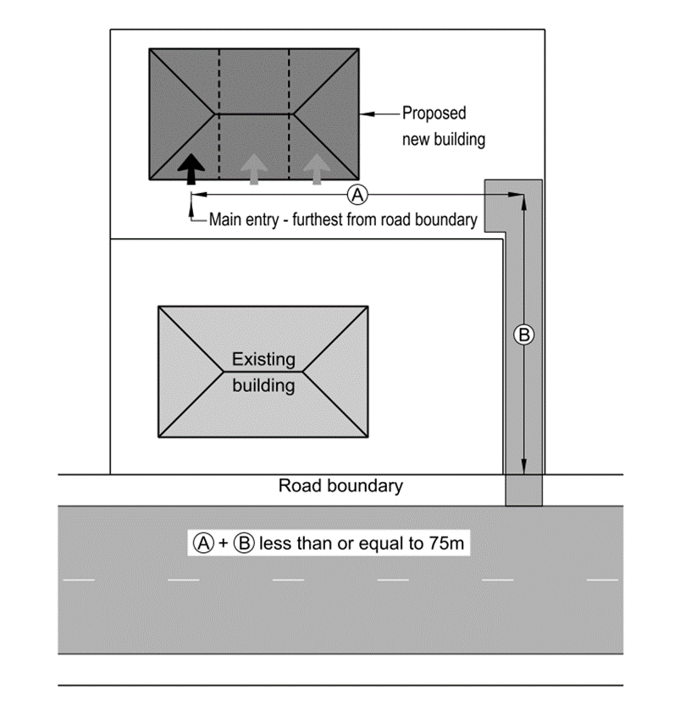

h. i. In car parking buildings there shall be a vertical clearance of not less than 2.5m above car park spaces for people whose mobility is restricted, and along the full length of any accessible route providing vehicular access to those car parking spaces.
i. j. Where a mix of activities is proposed, the largest relevant dimension is applicable.
j. k. Emergency service facilities do not need to comply with the maximum formed width, unless located on a key pedestrian frontage.
k. l. In Central City, height refers to the minimum clear height from the surface of the formed access.
l. m. Any access located on a Central City ‘Active Frontage and Verandas’ as shown on the planning maps shall have a maximum formed width of 7 metres.
m. n. The maximum gradient at any point on a vehicle access shall be in accordance with Table 7.5.7.2, except a maximum gradient of 1 in 5 (minimum 4.0 metres long transition ramps for a change of grade 1 in 8 or greater) shall apply for accesses that are identified in (g). For curved accesses, the maximum gradient shall be measured on the inside of a curved vehicle access.
n. o. The maximum change in gradient without a transition shall be no greater than 1 in 8 (12.5%). Changes of grade of more than 1 in 8 (12.5%) shall be separated by a minimum transition length of 2 metres (see Figure 9 for an example).
o. p. Where the gradient exceeds 1 in 10 (10%) the vehicle access is to be sealed with a surface that enables safe access in wet or icy conditions.
p. q. Where a vehicle access serves more than six car parking spaces (or more than six residential units) and a footpath is provided on the frontage road, the gradient of the first 4.5 metres measured from the road boundary into the site shall be no greater than 1 in 10 (10%) (see Figure 10 for an example).

Advice note:
      - See Rule 7.4.3.4 for when onsite manoeuvring is required.
      - The difference between minimum formed width and minimum legal width may be utilised for planting.
      - For accesses of less than 6m the vehicle control point is at the property boundary.
      - Design guidance for ramp design may be obtained from the Australian/New Zealand Standard for Offstreet Parking, Part 1: Car Parking Facilities, and any subsequent amendments. Compliance with the Australian/New Zealand Standard is recommended, but is not a requirement to achieve permitted activity status.
Table 7.5.7.1 – Minimum requirements for private ways and vehicle access
 | Activity | Number of marked parking spaces provided (For residential activities, the number of residential units) | Minimum legal width (metres) | Minimum formed width (metres) (refer to b) | Maximum formed width (metres) | Central City  Height  clearance  (metres)
a. | Residential activity and offices | 1 to 3 | 3.0  4.0 (refer to d) | 2.7  3.0 | 4.5 | 3.5
b. | Residential activity and offices | 4 to 8 | 3.6  4.0 4.6  (refer to d) | 3.0 | 6.0 | 4.0
c. | Residential activity and offices | 9 to 15 | 5.0  6.0 (refer to c and d) | 4.0  5.0 | 6.0 | 4.0
d. | All other activities | 1 to 15¹ | 5.0 (refer to c) | 4.0 | 7.0 | 4.0
e. | All activities | More than 15 | 6.5 (refer to c) | 5.5 | 9.0 | 4.0

¹ Any activity that has 1 to 15 parking spaces, but requires a swept path of 9 metres for a large vehicle, shall comply with row e. unless located on a Key Pedestrian Frontage.
Advice note: For any buildings that are greater than 75m from the road, Appendix 7.5.7 Access design and gradient clause h is applicable.
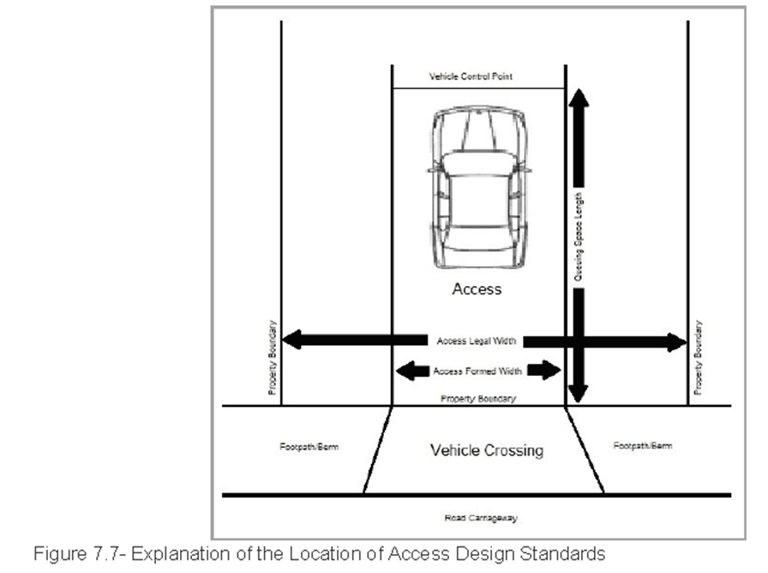
Figure 8 – Explanation of the location of access design standards
Table 7.5.7.2 – Maximum gradients for vehicle access
          - Straight Ramps – Private car parking areas or residential activities
Length | Gradient
Up to 20 metres¹ | 1 in 4 (25%)
More than 20 metres | 1 in 5 (20%)
For access to 1 or 2 car parking spaces the maximum gradients can be 1 in 4 (25%) for any length
          - Straight Ramps – All other car parking spaces
Length | Gradient
Up to 20 metres | 1 in 5 (20%)
More than 20 metres | 1 in 6 (16.7%)

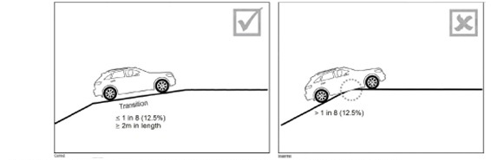
Figure 9 Example of correct and incorrect vehicle access gradient transition.
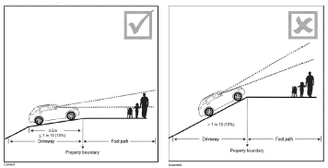

Figure 10 – Example of correct and incorrect vehicle access gradients in relation to footpaths.
Appendix 7.5.8 – Queuing spaces
            - On site queuing spaces shall be provided for all vehicles entering a parking area or loading area in accordance with Table 7.5.8.1.
            - Queuing spaces shall be available during hours of operation.
            - Where the parking area has more than one access, the number of parking spaces may be apportioned between the accesses in accordance with their potential usage for the calculation of the queuing space.
            - Queuing space length shall be measured from the road boundary to the nearest vehicle control point or point where conflict with vehicles already on the site may arise (see Figure 8).
Table 7.5.8.1 – Queuing spaces
 |  | Minimum queuing space (metres), if access serves:
 | Number of parking spaces provided (For residential activities – the number of residential units) | Car parking spaces accessed from local roads and collector roads and local distributor roads | Car parking spaces accessed from main distributor roads and arterial roads
a. | 4 – 10 | 0 | 6.0
b. | 11 – 20 | 6.0 | 12.0
c. | 21 – 50 | 12.0
d. | 51 – 100 | 18.0
e. | 101 – 150 | 18.0
f. | 151 or over | 24.0
Appendix 7.5.9 – Visibility splay
            - The visibility splay areas (as shown on Figure 11) are to be kept clear of obstructions in all cases for visibility reasons. Landscaping or other features may be contained within the visibility splay areas, as long as it does not exceed 0.5 metres in height.
            - If the access is 4.5 metres wide or greater, and the access provides for two-way traffic flow, then there is no requirement to provide a visibility splay on the side of the access marked with an ‘X’ in Figure 11.

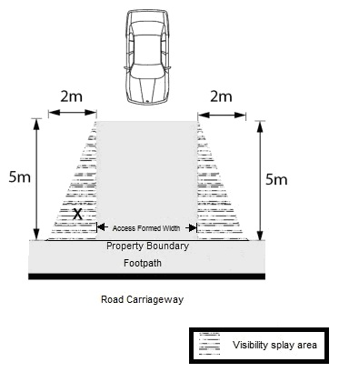

Figure 11 – Visibility splay measurement
Appendix 7.5.10 – Design of rural vehicle crossings
            - Design for vehicle crossings on arterial roads and collector roads with a speed limit of 70km/hr or greater shall comply with the relevant figure in accordance with Table 7.5.10.1.
Table 7.5.10.1 – Design of rural vehicle crossings
 | Heavy vehicle movements per week | Volume of traffic using the vehicle crossing per day | Is the vehicle crossing located on a state highway? | Which figure to use for vehicle crossing design
a. | ≤1 | 1 – 30 | No | 12
b. | ≤1 | 1 – 30 | Yes | 14
c. | ≤1 | 31 – 100 | Yes or No | 14
d. | > 1 | 1 – 30 | Yes or No | 13
e. | > 1 | 31 – 100 | Yes or No | 14

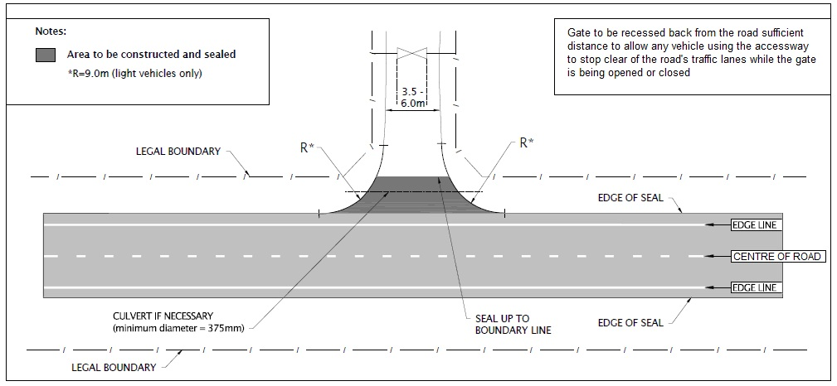

Figure 12 - Design of rural vehicle crossings without shoulder widening

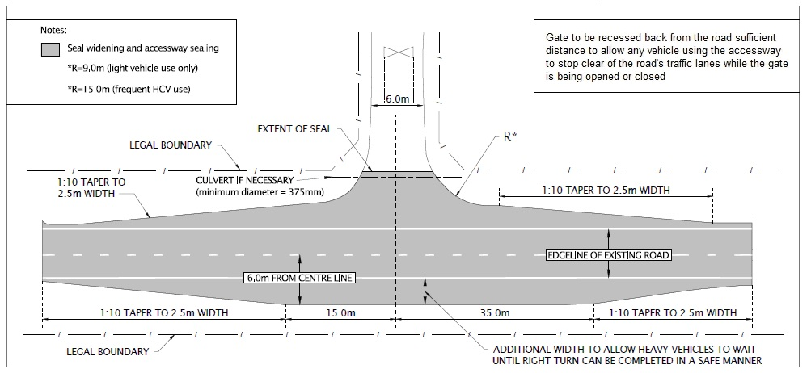

Figure 13 - Design of special use rural vehicle crossings
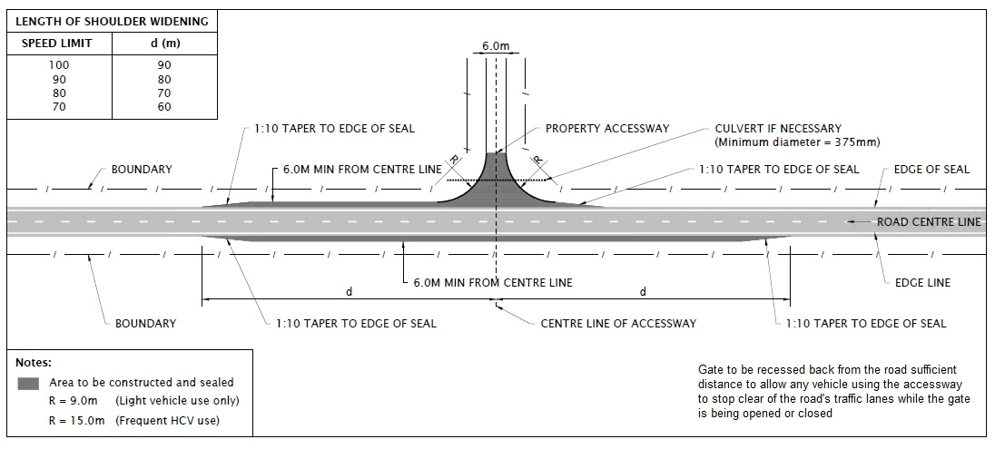

Figure 14 - Design of rural vehicle crossings with shoulder widening

Advice note:
      - R – radius
      - HCV = Heavy commercial vehicle (see ‘heavy vehicle’ for definition)
Appendix 7.5.11 – Standards for the location of vehicle crossings
            - Vehicle crossings to a frontage road with a speed limit of 70 Km/hr or greater shall have a minimum spacing to an adjacent vehicle crossing on the same side of the frontage road, on the same or an adjacent site, in accordance with the minimum distances set out in Table 7.5.11.1.
Table 7.5.11.1 – Minimum distance between vehicle crossings (distance in metres)
 | Type of road frontage
 | Frontage road speed limit (km/h) | Arterial | Collector | Local
a. | 70 | 40 | 40 | 40
b. | 80 | 100 | 70 | 50
c. | 90 | 200 | 85 | 65
d. | 100 | 200 | 105 | 80

            - Where the boundaries of a site do not enable any vehicle crossing to conform to the above distances, a single vehicle crossing for the site may be constructed in the position which most nearly complies with the provisions of Table 7.5.11.1.
            - The maximum number of vehicle crossings permitted on each road frontage of any site shall be in accordance with Table 7.5.11.2. (outside the Central City) and Table 7.5.11.3 (within the Central City).
Table 7.5.11.2 – Maximum number of vehicle crossings outside the Central City
 | Type of road frontage
 | Frontage length (metres) | Local road and collector road | Minor arterial road | Major arterial road
a. | 0 – 16 | 1 | 1 | 1
b. | > 16 – 60 | 2 | 1 | 1
c. | > 60 – 100 | 2 | 2 | 1
d. | > 100 | 3 | 2 | 2
Table 7.5.11.3 – Maximum number of vehicle crossings within Central City
 | Type of road frontage
 | Frontage length (m) | Inner Core Streets (See Figure 7.13i) | Arterial Route | All other streets

a.
 | 0 – 16 | 1 | 1 | 1

b.
 | > 16 – 60 | 1 | 1 | 2

c.
 | > 60 – 100 | 1 | 1 | 2

d.
 | > 100 | 2 | 2 | 2

- Any part of a vehicle crossing shall not be located closer to the intersection of any roads than the distances specified in Table 7.5.11.45 (outside the Central City) and Table 7.5.11.56 (within the Central City).

7.5.11.4 ­ Layout of Vehicle Crossings
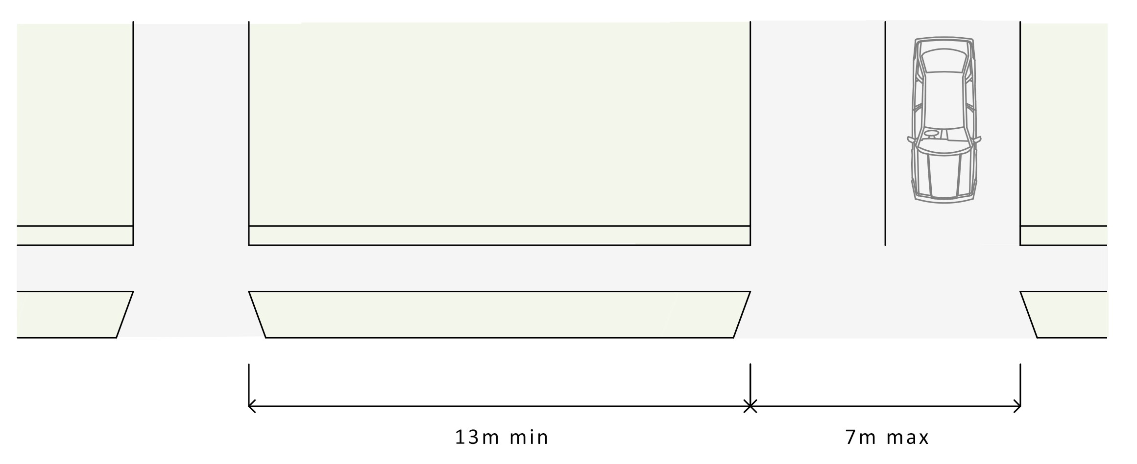

Table 7.5.11. 4 5 – Minimum distance of vehicle crossings from intersections outside the Central City
 | Speed limit < 70 km/h
 | Frontage road | Intersecting road type (distance in metres)
 |  | Arterial road | Collector road | Local road
a. | Arterial road | 30 | 30 | 30
b. | Collector road | 20 | 20 | 10
c. | Local road | 20 | 15 | 10
 | Speed limit 70 – 90 km/h
 | Frontage road | Intersecting road type (distance in metres)
 |  | Arterial road | Collector road | Local road
d. | Arterial road | 100 | 100 | 100
e. | Collector road | 45 | 45 | 45
f. | Local road | 45 | 45 | 45
 | Speed limit > 90 km/h
 | Frontage road | Intersecting road type (distance in metres)
 |  | Arterial road | Collector road | Local road
g. | Arterial road | 200 | 200 | 200
h. | Collector road | 60 | 60 | 60
i. | Local road | 60 | 60 | 60

Table 7.5.11.5 6 Minimum distance of vehicle crossings from intersections within the Central City

 | Intersecting road type (distance in metres)
 | Frontage road | Arterial Route | Main Distributor Street | Local Distributor Street | Local Street
a. | Arterial Route | 45 | 30 | 30 | 25
b. | Main Distributor Street | 30 | 30 | 30 | 10
c. | Local Distributor Street | 30 | 30 outside the Core  15 within the Core | 30 outside the Core  15 within the Core | 10 outside the Core  6 within the Core
d. | Local Street | 15 | 15 outside the Core  10 within the Core | 15 outside the Core  10 within the Core | 10 outside the Core  6 within the Core

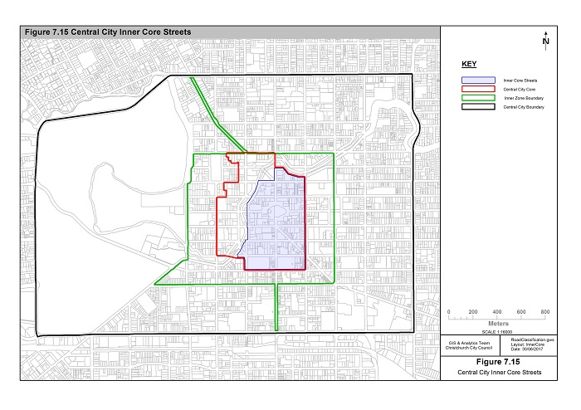
Figure 15 Inner Core Streets
- Where the boundaries of a site do not enable any vehicle crossing to conform to the above distances, a single vehicle crossing may be constructed in the position which most nearly complies with the provisions of Table 7.5.11.45 (outside the Central City) and Table 7.5.11.56 (within the Central City).
- The measurement of the distances between the vehicle crossings and intersections shall be in accordance with Figure 16 (outside the Central City) and Figure 17 (within the Central City).

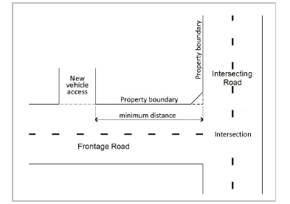

Figure 16 — Minimum distance of vehicle crossings from intersections outside the Central City

Advice note:
1. Outside the Central City, the minimum distance of vehicle crossings from intersections only applies to an intersection on the same side of the road as the site

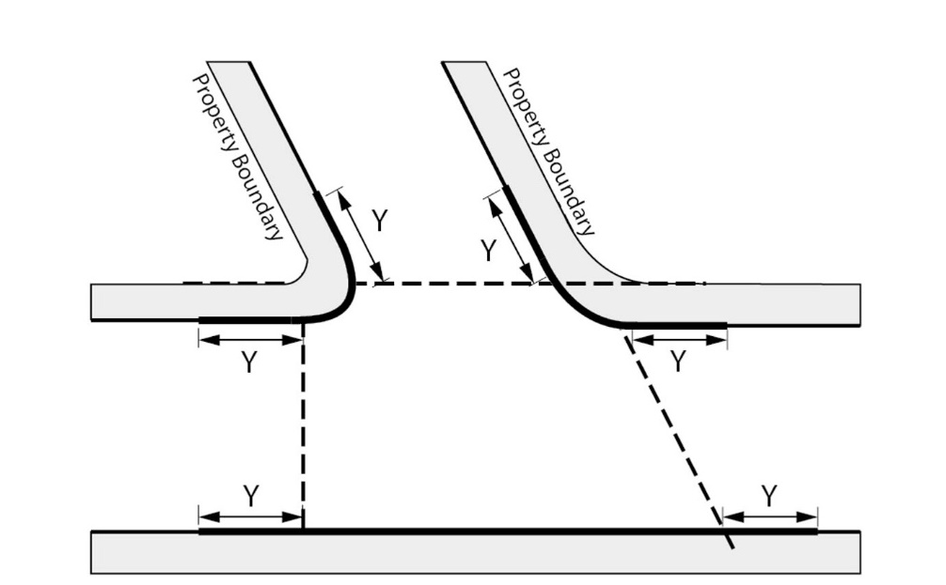
Figure 17- Minimum distance of vehicle crossings from intersections within the Central City
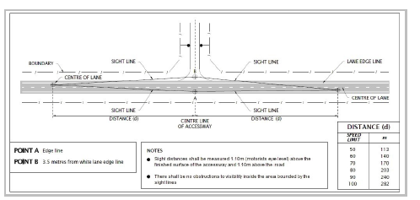
Figure 18 - Minimum sight lines for vehicle crossing for rural roads
Appendix 7.5.12 – Road classification system
          - The purpose of Appendix 7.5.12 is to outline the Road Classification System, which is used to distinguish roads into categories, as some of the rules in the District Plan only apply to some of the roads in a particular category.
- Description of the Road Classification System
          - Functional hierarchy (Movement and Place Functions):
              - The Road Classification System (based on the Road Classification System adopted in the Christchurch Transport Strategic Plan) presents a dual role for roads by applying a ‘place’ (land use) function for roads, alongside a ‘movement’ (or link) function.
              - The Road Classification System in the Christchurch Transport Strategic Plan has been simplified for use in the District Plan. The traditional four ‘movement’ function categories remain (Major arterial road, Minor arterial road, Collector road and Local road) to show the role that the road plays in moving people and goods around the transport network. Some roads have changed their classification from the previous District Plans as changes to the network have occurred over the last few years. Within the Central City the collector category is referred to and further distinguished as Main Distributors and Local Distributors to be consistent with the Christchurch Central Recovery Plan.
              - In addition to the four ‘movement categories’, four ‘place categories’ now sit within the system to reflect the different ‘place’ requirements: Rural, Industrial, Residential, and Centres. These additions to the categories take into account the surrounding land use, and show the role the road plays in contributing to the amenity values, identity and public space of the adjoining area. All of the Central City is classified as within the centres category. However it is referred to and further distinguished as Outer Zone, Inner Zone and Core to be consistent with the Christchurch Central Recovery Plan.
              - When the four place types are combined with the four levels of movement function, a two-dimensional array, or ‘matrix’, with 16 potential cells is created. This gives roads a dual classification, of one ‘place’ function and one ‘movement’ function. This ensures, for example, that arterial roads in residential areas are managed differently to reflect their context in a different manner than arterial roads in industrial areas or local roads in residential areas.
          - Use hierarchy (modal networks):
          - In addition to the functional hierarchy, a road use hierarchy has also been defined within the Christchurch Transport Strategic Plan. These networks highlight that different modes of transport have different priorities within the network. There are five modal networks defined in the Christchurch Transport Strategic Plan:
              - the cycle network of major, local and recreational cycle routes (including on- and off-road cycle ways, and cycle ways within rail corridors);
              - the core public transport route network;
              - the walking network;
              - the freight network (including the rail network); and
              - the strategic road network.
          - These networks are not specifically shown in the District Plan as they will be subject to change over time. However, they are an important part of Christchurch’s transport network and will be considered as part of the Integrated Transport Assessment process.
          - In addition to the classification system the Christchurch Transport Strategic Plan highlights the need to manage the road network more efficiently. The Christchurch Network Management Plan is being developed to guide how the network will be managed based on user priority and the time of day, to reflect the different demands that occur on the networks and the importance of prioritising users during different times of the day.
Advice note:
1. that Appendix 8.10.3 of Chapter 8 contains the standards for new roads.
- Summary of the Road Classification categories
          - Each road will have a dual classification both a ‘movement’ and ‘place’ classification (see Figures 20 (a-f) for maps of the road classification). The ‘movement’ and ‘place’ function categories are described in Table 7.5.12.1.
Table 7.5.12.1 Explanation of movement and place categories
 | Movement function category | Explanation
a. | Major arterial roads | State Highways and key roads in Christchurch District that cater especially for longer trips. Major arterial roads are the dominant elements of the roading network which connect the major localities of the region, both within and beyond the main urban area, and link to the most important external localities. Some major arterials, particularly some state highways, serve an important bypass function within Christchurch District, directing traffic through it to areas beyond. They are managed to minimise adverse effects from access on network efficiency. All motorways within Christchurch District are classified as major arterial roads.
b. | Minor arterial roads | Roads that provide connections between major arterial roads and the major rural, suburban and industrial areas and commercial centres. Generally, these roads cater for trips of intermediate length. They will generally connect to other minor arterial roads and major arterial roads and to collector roads. Arterial roads provide the most important movement function and as such require the highest degree of movement function protection. They may also define the boundaries of neighbourhood areas.
c. | Collector roads | Roads that distribute and collect local traffic between neighbourhood areas and the arterial road network. These are of little or no regional significance, except for the loads they place on the arterial road network. They link to the arterial road network and act as local spine roads, and often as bus routes within neighbourhoods, but generally do not contain traffic signals. Their traffic movement function must be balanced against the significant property access function which they provide. Collector roads within the Central City are known as distributor roads. These roads have a similar ‘movement’ function to the distributor streets in the Central City, which are shown in the Christchurch Central Recovery Plan.
d. | Main Distributor Streets (within Central City only) | A specific type of collector road which form key movement corridors into the Central City from the surrounding areas. Main Distributor Streets are the second highest order link types within the Central City and form key movement corridors within the Central City from surrounding areas.
e. | Local Distributor Streets (within Central City only) | A specific type of collector road which are important for distribution of traffic to parking precincts or provide for public transport movements. Local Distributor Streets are the third highest order link types and are important for the distribution of traffic to parking precincts, or to provide for public transport movement.
f. | Local roads | All other roads in Christchurch District. These roads function almost entirely for access purposes and are not intended to act as through routes for motor vehicles.
 | Place function category (outside the Central City)
g. | Urban (Centres) | Any road that is adjacent to a Commercial Zone. These are the areas which are shown as the Urban (Centres) Place Type on the Road Classification Maps (Figures 20(a - f)).
h. | Urban (Industrial) | Any road that is adjacent to an Industrial Zone. These are the areas which are shown as the Urban (Industrial) Place Type on the Road Classification Maps (Figures 20(a - f))¹.
i. | Urban (Residential) | All other roads within the existing urban area as defined by Map A of Chapter 6 of the Canterbury Regional Policy Statement, as well as roads that are adjacent to any other Residential Zone in Christchurch District. These are the areas which are shown as the Urban (Residential) Place Type on the Road Classification Maps (Figures 20(a - f)).
j. | Rural | All roads outside the existing urban area as defined by Map A of Chapter 6 of the Canterbury Regional Policy Statement, except for roads adjoining to any Residential, Industrial, and/or Commercial Zone in Christchurch District. Rural roads are generally the roads classified as rural or semirural in the road classification system in the Christchurch Transport Strategic Plan.
 | Place Function Category (within the Central City)
k. | Core | Any road within the core as shown on Figure 19
l. | Inner zone | Any road that is within an area bordered by Kilmore, Madras, St Asaph Streets and the eastern edge of Hagley Park, and also all of Victoria Street, and Colombo Street between St Asaph St and Moorhouse Ave. This area is shown on the Road Classification Map - Figure 19.
m. | Outer zone | Any other road within the Central City.

¹ If a road is adjacent to a Commercial Zone on one side of the road and adjacent to an Industrial Zone on the other side of the road, then the place function is Urban (centres).

Figure 19 - Central City Road Classification Map
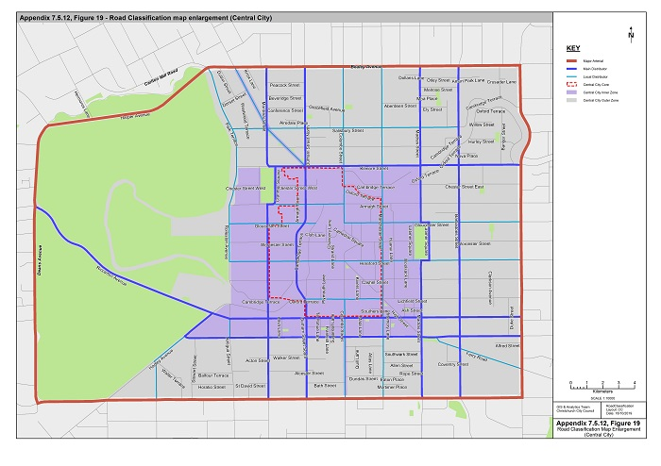
Figure 20a – Map of Road Classification
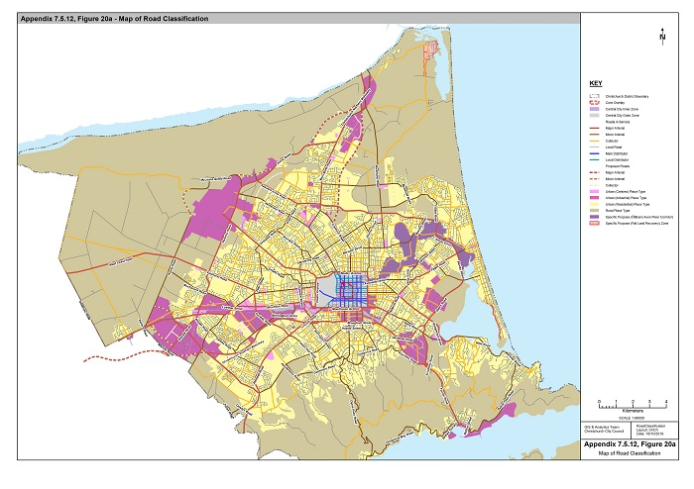
Figure 20b – Map of Road Classification (Banks Peninsula)
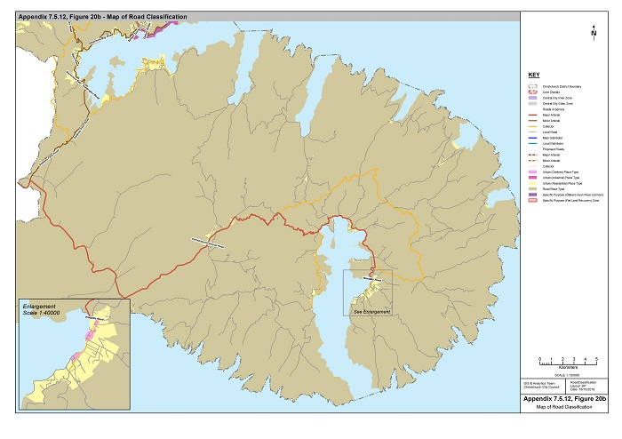
Figure 20c –Road Classification Map Enlargement
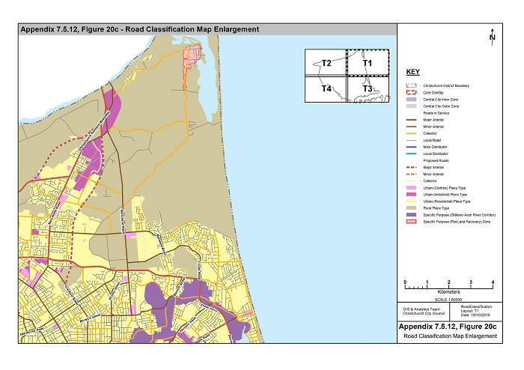

Figure 20d –Road Classification Map Enlargement
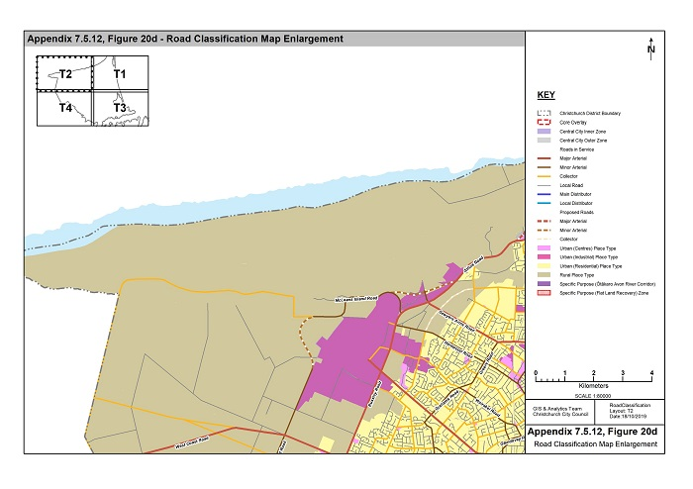

Figure 20e –Road Classification Map Enlargement

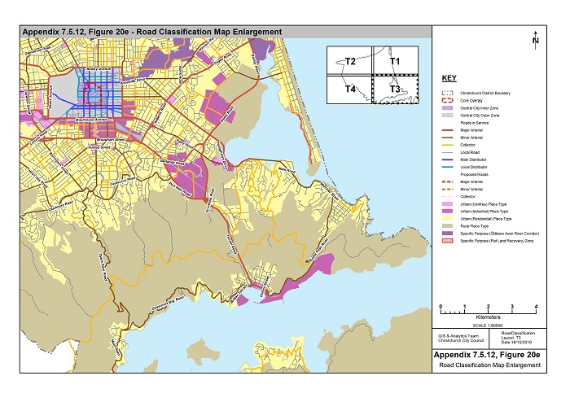
Figure 20f –Road Classification Map Enlargement
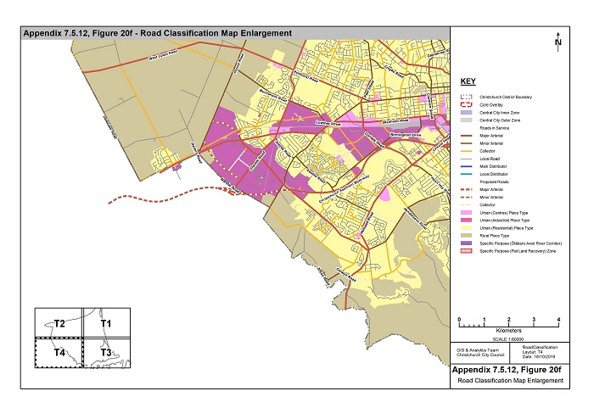

Table 7.5.12.2 – List of Arterial roads and Collector roads

Road | Classification
Acheson Avenue (Emmett Street – Hills Road) | Collector
Aidanfield Drive (Halswell Road – Wigram Road) | Collector
Akaroa Street (Briggs Road-Hills Road) | Minor arterial
Aldwins Road (Ferry Road – Linwood Avenue) | Major arterial
Alvaston Drive (Patterson Terrace – Halswell Junction Road) | Collector
Ambleside Drive (Grahams Road Kendal Avenue) | Collector
Amyes Road (Shands Road – Springs Road) | Minor arterial
Annex Road (Blenheim Road-Birmingham Drive) | Collector
Antigua Street (Moorhouse Avenue – Broughton Street) | Collector
Antigua Street (Tuam Street-St Asaph Street) | Local Distributor Street
Anzac Drive (Travis Road – Bexley Road) | Major Arterial
Apsley Drive (Withells Road – Cutts Road) | Collector
Armagh Street (Cranmer Square (east side)-Colombo Street) | Local Distributor Street
Armagh Street (Montreal Street-Cranmer Square (east side)) | Main Distributor Street
Athol Terrace (Brodie Street-Peer Street) | Collector
Avondale Road (Breezes Road-New Brighton Road) | Collector
Avonhead Road (Yaldhurst Road-Russley Road) | Collector
Avonside Drive (Fitzgerald Avenue-Linwood Avenue) | Minor arterial
Avonside Drive (Swanns Road-Retreat Road West) | Collector
Avonside Drive (Retreat Road East-Wainoni Road) | Collector
Awatea Road (Springs Road – Dunbars Road) | Minor Arterial
Aylesford Street (Westminster Street – Hills Road) | Collector
Aynsley Terrace (Opawa Road – Garlands Road) | Collector
Balcairn Street (Hindness St – Revell Street) | Collector
Barbadoes Street (Bealey Avenue Warrington Street) | Collector
Barbadoes Street (Bealey Avenue-Moorhouse Avenue) | Main Distributor Street
Barrington Street (Jerrold Street South-Cashmere Road) | Minor arterial
Barrington Street (Jerrold Street South-Lincoln Road) | Major arterial
Barters Road (Waterloo Road-Main South Road) | Minor arterial
Bassett Street (Travis Road – New Brighton Road) | Minor arterial
Beach Road (Frosts Road-Marine Parade) | Collector
Beach Road, Akaroa (Rue Lavaud – Rue Jolie) | Collector
Bealey Avenue (Park Terrace-Fitzgerald Avenue) | Major arterial
Belfast Road (Main North Road-Marshland Road) | Collector
Belleview Terrace (Major Hornbrook Road-Mt Pleasant Road) | Collector
Beresford Street (Hardy Street-Marine Parade) | Collector
Berwick Street (Cranford Street-Forfar Street) | Minor arterial
Bexley Road (Anzac Drive-Breezes Road) | Major arterial
Birdwood Avenue (Eastern Terrace – Sandwich Road) | Collector
Birmingham Drive (Annex Road-Wrights Road) | Minor arterial
Blakes Road (Belfast Road – Radcliffe Road) | Collector
Blenheim Road (Main South Road-Moorhouse Ave) | Major arterial
Blighs Road (Wairakei Road-Papanui Road) | Collector
Blighs Road (Wairakei Road-Idris Road) | Collector
Bowenvale Avenue Bridge (Centaurus Road – Eastern Avenue) | Collector
Bower Avenue (New Brighton Road-Broadhaven Avenue) | Collector
Bowhill Road (Palmers Road-Marine Parade) | Collector
Breens Road (Wairakei Road-Harewood Road) | Collector
Breezes Road (Avondale Road-Pages Road) | Collector
Breezes Road (Pages Road-Bexley Road) | Minor arterial
Bridge Street (Bexley Road-Estuary Road) | Minor arterial
Bridge Street (Estuary Road- Marine Parade) | Collector
Bridle Path Road (Main Road-Tunnel Road) | Collector
Briggs Road (Innes Road – Akaroa Street) | Collector
Briggs Road (Akaroa Street-Marshland Road) | Minor arterial
Brittan Terrace (Simeon Quay – Park Terrace) | Minor arterial
Broadhaven Avenue (Queenspark Drive-Bower Avenue) | Collector
Brodie Street (Parkstone Avenue – Athol Terrace) | Collector
Brougham Street (Simeon Street – Opawa Road) (Southeast of Heathcote River) | Major arterial
Buchanans Road (Racecourse Road-Pound Rd) | Minor arterial
Buchanans Road (Pound Rd – Old West Coast Road) | Collector
Buckleys Road (Linwood Avenue – Rudds Road) | Major arterial
Burlington Street (Huxley Street – Brougham Street) | Minor arterial
Burnbrae Street (Tennyson Street – St Martins Road) | Collector
Burwood Road (Lake Terrace Road – Mairehau Road) | Collector
Burwood Road (Mairehau Road – Waitikiri Drive Road) | Minor arterial
Byron Street (Colombo Street-Waltham Road) | Collector
Cambridge Terrace (Gloucester Street-Cashel Street) | Main Distributor Street
Candys Road (Sabys Road-Halswell Road) | Minor arterial
Carlton Mill Road (Harper Avenue-Rossall Street) | Minor arterial
Carmen Road (Main South Road-Masham Road) | Major arterial
Cashel Street (Linwood Avenue – Fitzgerald Avenue) | Collector
Cashmere Road (Kennedys Bush Road-Hendersons Road) | Collector
Cashmere Road (Hendersons Road-Colombo Street) | Minor arterial
Caspian Street (Ebbtide Street-Rockinghorse Road) | Collector
Caulfield Avenue (Murphys Road – Hamill Road) | Collector
Cavendish Road (Northcote Road-Veitches Road) | Collector
Cavendish Road (Grampian Street-Styx Mill Road) | Collector
Centaurus Road (Colombo Street-Port Hills Road) | Major arterial
Chapmans Road (Port Hills Road-Cumnor Terrace) | Collector
Charteris Bay Road (Governors Bay Teddington Road – Marine Drive) | Collector
Chattertons Road (McLeans Island Road-West Coast Road) | Collector
Checketts Avenue (Ensign Street – Wales Street) | Collector
Christchurch Akaroa Road (Selwyn District Boundary – Woodills Road) | Major arterial
Clarence Street (Riccarton Road – Blenheim Road) | Minor arterial
Clarence Street (Blenheim Road – Whiteleigh Avenue) | Major arterial
Claridges Road (Gardiners Road-Grampian Street) | Collector
Clyde Road (Riccarton Road-Greers Road) | Collector
Cobham Street (Barrington Street – Lyttelton Street | Collector
Colombo Street (Bealey Avenue-Gloucester Street) | Local Distributor Street
Colombo Street (Centaurus Road-Brougham Street) | Minor arterial
Colombo Street (Brougham Street-Moorhouse Avenue) | Collector
Colombo Street (Lichfield Street-Moorhouse Avenue) | Local Distributor Street
Condell Avenue (Greers Road-Blighs Road) | Collector
Connaught Drive (Halswell Junction Road – Produce Place) | Collector
Coronation Street (Barrington Street-Selwyn Street) | Collector
Corsair Drive (Springs Road – Kittyhawk Avenue) | Collector
Courtenay Street (Trafalgar Street-Westminster Street) | Collector
Cranford Street (Edgeware Road-Innes Road) | Minor arterial
Cranford Street (Innes Road-Proposed Northern Arterial Extension) | Major arterial
Cranford Street (Proposed Northern Arterial Extension –Main North Road) | Minor arterial
Cranmer Square (east side) (Kilmore Street-Armagh Street) | Main Distributor Street
Cresswell Avenue (Gayhurst Road-westwards-New Brighton Road) | Collector
Creyke Road (Clyde Road-Ilam Road) | Minor arterial
Croydon Street (Southhampton Street – Huxley Street) | Collector
Cumnor Terrace (Maunsell Street-Chapmans Road) | Collector
Curletts Road (Halswell Road-Yaldhurst Road) | Major arterial
Curries Road (Port Hills Road-Maunsell Street) | Collector
Cuthberts Road (Ruru Road-Breezes Road) | Collector
Cutts Road (Yaldhurst Road-Woodbury Street | Collector
Daniels Road (Main North Road-Grimseys Road) | Collector
Dawsons Road (Jones Road-West Coast Road) | Minor arterial
Deans Avenue (Moorhouse Avenue-Harper Avenue) | Major arterial
Disraeli Street (Selwyn Street-Orbell Street) | Collector
Dunbars Road (Awatea Road-Halswell Road) | Minor arterial
Dunbars Road (Awatea Road Wigram Road) | Collector
Durham Street North (Bealey Avenue-Gloucester Street) | Main Distributor Street
Durham Street North (Bealey Avenue-Springfield Road) | Collector
Durham Street South (Brougham Street-Moorhouse Avenue) | Minor arterial
Durham Street South (Cashel Street-Moorhouse Avenue) | Main Distributor Street
Dyers Pass Road (Colombo Street-Governors Bay Road) | Minor arterial
Dyers Road (Ferry Road-Breezes Road) | Major arterial
Eastern Terrace (Birdwood Avenue-Bowenvale Bridge) | Collector
Ebbtide Street (Estuary Road-Caspian Street) | Collector
Edgeware Road (Springfield Road-Hills Road) | Collector
Emmett Street (Briggs Road – Shirley Road) | Collector
Ensign Street (Checketts Avenue – Lillian Street) | Collector
Ensors Road (Brougham Street-Ferry Road) | Major arterial
Ensors Road (Fifield Terrace-Brougham Street) | Collector
Epsom Road (Racecourse Road-Main South Road) | Collector
Estuary Road (Jervois Street – Ebbtide Street | Collector
Evans Pass Road (Summit Road Wakefield Avenue) | Minor arterial
Farquhars Road (Main North Road-Grimseys Road) | Collector
Farrington Avenue (Wairakei Road-Harewood Road) | Collector
Fendalton Road (Clyde Road-Deans Avenue) | Major arterial
Ferry Road (Fitzgerald Avenue-Moorhouse Avenue) | Collector
Ferry Road (Aldwins Road-Humphreys Drive) | Minor arterial
Ferry Road (Moorhouse Avenue-Aldwins Road) | Major arterial
Ferry Road (Humphreys Drive-St Andrews Hill Road) | Major arterial
Ferry Road (St Asaph Street-Fitzgerald Avenue) | Local Distributor Street
Fitzgerald Avenue (Bealey Avenue-Moorhouse Avenue) | Major arterial
Forfar Street (Winton Street – Warrington Street) | Collector
Frankleigh Street (Lyttelton Street-Barrington Street) | Minor arterial
Frosts Road (Beach Road-Travis Road) | Minor arterial
Gamblins Road (Wilsons Road-St Martins Road) | Collector
Gardiners Road (Johns Road-Harewood Road) | Collector
Garlands Road (Aynsley Terrace-Opawa Expressway) | Collector
Garlands Road (Opawa Expressway-Rutherford Street) | Major arterial
Gasson Street (Brougham Street-Moorhouse Avenue) | Minor arterial
Gayhurst Road (Cresswell Avenue-Avonside Drive) | Collector
Gebbies Pass Road (Governors Bay Teddington Road – Christchurch Akaroa Road) | Minor arterial
Gilberthorpes Road (Waterloo Road-Buchanans Road) | Collector
Gladstone Quay (Norwich Quay – Cashin Quay) | Major arterial
Glandovey Road (Fendalton Road-Idris Road) | Collector
Glandovey Road (Idris Road-Rossall Street) | Minor arterial
Glenstrae Road (McCormacks Bay Road – Monks Spur Road) | Collector
Gloucester Street (Colombo Street-Madras Street) | Local Distributor Street
Gloucester Street (Fitzgerald Avenue – Gayhurst Road) | Collector
Gloucester Street (Latimer Square (east side)-Fitzgerald Avenue) | Local Distributor Street
Gloucester Street (Madras Street-Latimer Square (east side)) | Main Distributor Street
Gloucester Street (Rolleston Avenue-Oxford Terrace) | Local Distributor Street
Glovers Road (Halswell Road-Kennedys Bush Road) | Collector
Goulding Avenue (Main South Road – Shands Road) | Collector
Governors Bay Road (Park Terrace Dyers Pass Road) | Minor arterial
Governors Bay Teddington Road (Main Road, Governors Bay Gebbies Pass Road) | Minor arterial
Grahams Road (Avonhead Road – Waimairi Road) | Collector
Grahams Road (Waimairi Road-Greers Road) | Minor arterial
Grampian Street (Veitches Road-Claridges Road) | Collector
Greers Road (Grahams Road-Sawyers Arms Road) | Minor arterial
Greers Road (Waimairi Road-Grahams Road) | Collector
Grimseys Road (Queen Elizabeth II Drive Farquhars Road) | Collector
Guildford Street (Greers Road-Grahams Road) | Collector
Hackthorne Road (Cashmere Road - Pentre Terrace) | Collector
Hagley Avenue (Riccarton Avenue-St Asaph Street) | Main Distributor Street
Hagley Avenue (St Asaph Street-Selwyn Street) | Local Distributor Street
Halswell Junction Road (Main South Road -Foremans Road) | Minor arterial
Halswell Junction Road (Main South Road-Halswell Road) | Major arterial
Halswell Junction Road (Waterloo Road -Foremans Road) | Collector
Halswell Road (Curletts Road-Old Tai Tapu Road) | Major arterial
Hamill Road (Halswell Junction Road – Caulfield Avenue) | Collector
Hammersley Avenue (Quinns Road – Marshland Road) | Collector
Hampshire Street (Wainoni Road – Breezes Road) | Collector
Hansons Lane (Riccarton Road-Blenheim Road) | Collector
Harbour Road (Kainga Road – Lower Styx Road) | Collector
Harewood Road (Orchard Road – Johns Road) | Collector
Harewood Road (Papanui Road-Johns Road) | Minor arterial
Hargood Street (Ferry Road-Linwood Avenue) | Collector
Harman Street (Lincoln Road- Selwyn Street) | Collector
Harper Avenue (Deans Avenue-Bealey Avenue) | Major arterial
Harrow Street (Olliviers Road-Aldwins Road) | Collector
Hawke Street (New Brighton Road-Marine Parade) | Collector
Hawkins Road (Radcliffe Road – Quaids Road) | Collector
Hay Street (Linwood Avenue-Ruru Road) | Collector
Hayton Road (Symes Road – Wigram Road) | Collector
Heaton Street (Strowan Road-Papanui Road) | Minor arterial
Heberden Avenue (Nayland Street-Scarborough Road) | Collector
Hendersons Road (Halswell Road-Sparks Road) | Collector
Hendersons Road (Sparks Road - Cashmere Road) | Minor arterial
Hereford Street (Fitzgerald Avenue-Linwood Avenue) | Minor arterial
Hereford Street (Latimer Square (east side)-Fitzgerald Avenue) | Local Distributor Street
Hereford Street (Madras Street-Latimer Square (east side)) | Main Distributor Street
Hereford Street (Rolleston Avenue-Madras Street) | Local Distributor Street
Highsted Road (Harewood Road-Styx Mill Road) | Collector
Hills Road (Whitmore Street – Innes Road) | Minor arterial
Hindness St (Dunbars Road – Balcairn Street) | Collector
Holmwood Road (Fendalton Road-Rossall Street) | Collector
Hoon Hay Road (Halswell Road-Cashmere Road) | Minor arterial
Humphreys Drive (Linwood Avenue-Ferry Road) | Major arterial
Huxley Street (Colombo Street-Burlington Street) | Minor arterial
Huxley Street (Croydon Street – Burlington Street) | Collector
Idris Road (Fendalton Road-Wairakei Road) | Minor arterial
Idris Road (Wairakei Road - Blighs Road) | Collector
Ilam Road (Riccarton Road-Wairakei Road) | Collector
Innes Road (Papanui Road-Queen Elizabeth II Drive) | Minor arterial
Inwoods Road (Broadhaven Avenue-Mairehau Road) | Collector
Jarnac Boulevard (Buchanans Road – Millesimes Way) | Collector
Jeffreys Road (Clyde Road-Idris Road) | Collector
Jerrold Street North (Collins Street-Barrington Street) | Major arterial
Jerrold Street South (Collins Street-Barrington Street) | Major arterial
Johns Road (Harewood Road-Main North Road) | Major arterial
Jones Road (Railway Terrace Dawsons Road) | Collector
Kahu Road (Kotare Street-Straven Road) | Minor arterial
Kainga Road (Main North Road-Harbour Road) | Collector
Kendal Avenue (Memorial Avenue-Wairakei Road) | Collector
Kennedys Bush Road (Glovers Road-Cashmere Road) | Collector
Kensington Avenue (Innes Road – Westminster Street) | Collector
Kerrs Road (Pages Road-Wainoni Road) | Minor arterial
Keyes Road (Bowhill Road-Hawke Street) | Collector
Kilburn Street (Greers Road-Farrington Avenue) | Collector
Kilmarnock Street (Deans Avenue-Straven Road) | Minor arterial
Kilmore Street (Montreal Street-Fitzgerald Avenue) | Main Distributor Street
Kirk Road (West Coast Road-Main South Road) | Collector
Kittyhawk Avenue (The Runway – Corsair Drive) | Collector
Kotare Street (Clyde Road-Kahu Road) | Minor arterial
Lake Terrace Road (Marshland Road-New Brighton Road) | Collector
Langdons Road (Greers Road-Main North Road) | Collector
Latimer Square (east side) | Main Distributor Street
Lichfield Street (Durham Street-Manchester Street) | Local Distributor Street
Lillian Street (Ensign Street – Halswell Road) | Collector
Lincoln Road (Moorhouse Avenue-Whiteleigh Avenue) | Minor arterial
Lincoln Road (Whiteleigh Avenue-Curletts Road) | Major arterial
Linwood Avenue (Avonside Drive-Aldwins Road) | Minor arterial
Linwood Avenue (Aldwins Road – Humphreys Drive) | Major arterial
Locksley Avenue (McBratneys Road-New Brighton Road) | Collector
Lodestar Avenue (Hayton Road – Stark Drive) | Collector
Long Bay Road (Summit Road – Christchurch Akaroa Road | Collector
Lower Styx Road (Marshland Road-Harbour Road) | Collector
Lowther Street (Racecourse Road – Main South Road) | Minor arterial
Lyttelton Street (Lincoln Road-Rose Street) | Collector
Maces Road (Cuthberts Road-Dyers Road) | Collector
Madras Street (Bealey Avenue – Winton Street) | Collector
Madras Street (Bealey Avenue-Gloucester Street) | Main Distributor Street
Madras Street (Hereford Street-Moorhouse Avenue) | Main Distributor Street
Magdala Place (Birmingham Drive – Proposed Bridge Link to Wigram Road) | Minor arterial
Maidstone Road (Waimairi Road-Withells Road) | Collector
Maidstone Road (Ilam Road - Waimairi Road) | Minor arterial
Main North Road (Northcote Road – Dickeys Road) | Major arterial
Main North Road (Cranford Street –Northcote Road) | Minor arterial
Main North Road (Dickeys Road – Waimakariri District Boundary) | Minor arterial
Main Road (McCormacks Bay Road West The - Esplanade) | Minor arterial
Main Road (St Andrews Hill Road-McCormacks - Bay Road west) | Major arterial
Main Road, Governors Bay (Dyers Pass Road – Governors Bay Teddington Road) | Minor arterial
Main South Road (Blenheim Road – Selwyn District Boundary) | Major arterial
Main South Road (Riccarton Road-Blenheim Road) | Minor arterial
Mairehau Road (Marshland Road – Frosts Road) | Minor arterial
Major Hornbrook Road (Belleview Terrace-St Andrews Hill Road) | Collector
Malcolm Avenue (Eastern Terrace – Colombo Street) | Collector
Manchester Street (Bealey Avenue – Edgeware Road) | Collector
Manchester Street (Bealey Avenue-Moorhouse Avenue) | Local Distributor Street
Mandeville Street (Riccarton Road – Blenheim Road) | Collector
Marine Drive (Charteris Bay Road – Waipapa Avenue) | Collector
Marine Parade (Bridge Street-Beach Road) | Collector
Marriner Street (Wakefield Avenue – Main Road) | Minor arterial
Marshland Road (Shirley Road – Main North Road) | Minor arterial
Marshs Road (Main South Road – Springs Road)1 | Minor arterial
Marshs Road (Springs Road – Whincops Road) | Collector
Martindales Road (Port Hills Road-Bridle Path Road) | Collector
Masham Road (Yaldhurst Road-Carmen Road) | Major arterial
Matipo Street (Riccarton Road-Blenheim Road) | Collector
Matipo Street (Blenheim Road – Wrights Road | Minor arterial
Maunsell Street (Tanner Street – Cumnor Terrace) | Collector
McBratneys Road (River Road-Locksley Avenue) | Collector
McCormacks Bay Road (Main Road (west) Main Road (east)) | Collector
McFaddens Road (Rutland Street-Cranford Street) | Collector
McGregors Road (Ruru Road-Rudds Road) | Collector
McLeans Island Road (Johns Road-Proposed Pound Road deviation) | Minor arterial
McLeans Island Road (Proposed Pound Road deviation– Chattertons Road) | Collector
McMahon Drive (Aidanfield Drive – Dunbars Road) | Collector
Memorial Avenue (Clyde Road-Orchard Road) | Major arterial
Merrin Street (Avonhead Road-Withells Road) | Collector
Middleton Road (Blenheim Road-Riccarton Road) | Collector
Milton Street (Barrington Street-Colombo Street) | Minor arterial
Moncks Spur Road (Mt Pleasant Road-Glenstrae Road) | Collector
Montreal Street (Armagh Street-Moorhouse Avenue) | Main Distributor Street
Montreal Street (Bealey Avenue-Kilmore Street) | Main Distributor Street
Montreal Street (Brougham Street Moorhouse Avenue) | Minor arterial
Moorhouse Avenue (Deans Avenue-Ferry Road) | Major arterial
Mt Pleasant Road (Main Road Summit Road) | Collector
Mustang Avenue (Awatea Road – Corsair Drive) | Collector
Nayland Street (Wakefield Avenue-Heberden Avenue) | Collector
New Brighton Road (Marshland Road-Avondale Road) | Minor arterial
New Brighton Road (Avondale Road Pages Road) | Collector
Nicholls Road (Halswell Junction Road – Halswell Road) | Collector
Normans Road (Strowan Road-Papanui Road) | Collector
North Avon Road (Whitmore Street-River Road) | Collector
North Parade (North Avon Road-Shirley Road) | Collector
Northcote Road (Greers Road-Main North Road) | Major arterial
Northern Motorway and Connectors (Waimakariri District Boundary-Dickeys Road) | Major arterial
Northwood Boulevard (Main North Road – Springbrook Lane) | Collector
Norwich Quay (Tunnel Road – Gladstone Quay) | Major arterial
Norwood Street (Sandwich Road – Tennyson Street) | Collector
Nottingham Avenue (Wales Street – Patterson Terrace) | Collector
Nursery Road (Tuam Street – Ferry Road) | Collector
Old West Coast Road (Chattertons Road- West Coast Road) | Collector
Opawa Road (Wilsons Road North - Aynsley Terrace) | Collector
Opawa Road (Brougham Street (southeast of the Heathcote River) Port Hills Road) | Major arterial
Orchard Road (Memorial Ave – Wairakei Road) | Collector
Orion Street (Emmett Street – Quinns Road) | Collector
Ottawa Road (Wainoni Road – Pages Road) | Collector
Owles Terrace (Pages Road Union Street) | Collector
Oxford Street (Norwich Quay – Sumner Road) | Minor Arterial
Pages Road (Rudds Road-Anzac Drive) | Major arterial
Pages Road (Anzac Drive – New Brighton Road) | Minor Arterial
Palinurus Road (Dyers Road-Ferry Road) | Major arterial
Papanui Road (Bealey Avenue-Harewood Road) | Minor arterial
Park Terrace (Brittan Terrace – Governors Bay Road) | Minor arterial
Park Terrace / Rolleston Avenue (Bealey Avenue-Hereford Street) | Local Distributor Street
Parker Street (Waterloo Road-Main South Road) | Collector
Parkhouse Road (Hayton Road-Curletts Road) | Collector
Parkstone Avenue (Avonhead Road-Brodie Street) | Collector
Parnwell Street (Basset Street – Travis Road) | Collector
Patterson Terrace (Nottingham Avenue – Alvaston Drive) | Collector
Peer Street (Waimairi Road-Yaldhurst Road) | Minor arterial
Philpotts Road (Queen Elizabeth II Drive – Innes Road) | Collector
Port Hills Road (Centaurus Road-Opawa Road) | Minor arterial
Port Hills Road (Opawa Road-Tunnel Road) | Major arterial
Port Hills Road (Horotane Valley Road-Martindales Road) | Collector
Pound Road (Waterloo Road-McLeans Island Road) | Minor arterial
Prestons Road (Main North Road-Waitikiri Drive Road) | Minor arterial
Purau Avenue (Waipapa Avenue – Camp Bay Road) | Collector
Putake Drive (Mairehau Road – Rothesay Road) | Collector
Quaids Road (Hawkins Road – Prestons Road) | Collector
Quaifes Road (Whincops Road – Sabys Road) | Collector
Queen Elizabeth II Drive (Travis Road-Main North Road) | Major arterial
Queenspark Drive (Rothesay Road-Bower Avenue) | Collector
Racecourse Road (Main South Road-Buchanans Road) | Minor arterial
Racecourse Road (Yaldhurst Road-Buchanans Road) | Collector
Radcliffe Road (Hawkins Road – Main North Road) | Collector
Radley Street (Garlands Road-Ferry Road) | Collector
Railway Terrace (Kirk Road-Jones Road) | Collector
Retreat Road (Avonside Drive-Avonside Drive) | Collector
Revell Street (Balcairn Street – Checketts Ave) | Collector
Riccarton Avenue | Main Distributor Street
Riccarton Road (Yaldhurst Road-Riccarton Avenue) | Minor arterial
River Road (North Avon Road-McBratneys Road) | Collector
Rookwood Avenue (Bower Avenue-Bowhill Road) | Collector
Rose Street (Hoon Hay Road-Barrington Street) | Collector
Rossall Street (Glandovey Road-Carlton Mill Road) | Minor arterial
Rothesay Road (Queenspark Drive –Burwood Road) | Collector
Roydvale Avenue (Avonhead Road Wairakei Road) | Collector
Rudds Road (McGregors Road-Pages Road) | Collector
Rue Jolie (Beach Road, Akaroa – Alymers Valley Road) | Collector
Rue Lavaud (Woodills Road – Beach Road, Akaroa) | Collector
Ruru Road (McGregors Road-Maces Road) | Collector
Russley Road (Johns Road-Yaldhurst Road) | Major arterial
Rutherford Street (Garlands Road-Ferry Road) | Major arterial
Rutland Street (Tomes Road-St Albans Street) | Collector
Sabys Road (Trices Road-Candys Road) | Minor arterial
Sabys Road (Candys Road – Halswell Junction Road) | Collector
Salisbury Street (Park Terrace-Barbadoes Street) | Local Distributor Street
Sandwich Road (Birdwood Avenue – Norwood Street) | Collector
Sandyford Street (Orbell Street – Colombo Street) | Collector
Sawyers Arms Road (Johns Road-Greers Road) | Major arterial
Sawyers Arms Road (Johns Road – Broughs Road) | Minor arterial
Sawyers Arms Road (Northcote Road-Main North Road) | Collector
Scarborough Road (Taylors Mistake Road-Heberden Avenue) | Collector
Scruttons Road (Port Hills Road – Tunnel Road on-ramp) | Major arterial
Selwyn Street (Hagley Avenue-Moorhouse Avenue) | Local Distributor Street
Selwyn Street (Somerfield Street-Hagley Avenue) | Collector
Seymour Street (Main South Road – Shands Road) | Collector
Shakespeare Road (Waltham Road – Wilsons Road North) | Collector
Shands Road (Main South Road-Selwyn District Boundary) | Major arterial
Sherborne Street (Bealey Avenue-Edgeware Road) | Minor arterial
Shirley Road (Hills Road-Marshland Road) | Minor arterial
Simeon Quay (Norwich Quay – Brittan Terrace) | Minor arterial
Somerfield Street (Barrington Street – Colombo Street) | Collector
Southern Motorway and connectors (Simeon Street – Haswell Junction Road) | Major arterial
Southampton Street (Tennyson Street – Croydon Street) | Collector
Sparks Road (Halswell Road-Lyttelton Street) | Minor arterial
Spencerville Road (Main North Road-Lower Styx Road) | Collector
Springfield Road (Durham Street North-St Albans Street) | Collector
Springs Road (Main South Road-Selwyn District Boundary) | Minor arterial
St Albans Street (Papanui Road-Trafalgar Street) | Collector
St Andrews Hill Road (Main Road-Major Hornbrook Road) | Collector
St Asaph Street (Hagley Avenue-Fitzgerald Avenue) | Main Distributor Street
St Martins Road (Fifield Terrace-Centaurus Road) | Collector
Stanmore Road (Tuam Street-North Avon Road) | Collector
Straven Road (Fendalton Road-Riccarton Road) | Minor arterial
Strickland Street (Brougham Street-Colombo Street) | Collector
Strowan Road (Heaton Street-Wairakei Road) | Minor arterial
Sturrocks Road (Cavendish Road-Main North Road) | Collector
Styx Mill Road (Gardiners Road-Main North Road) | Collector
Summit Road (Evans Pass Road-Selwyn District Boundary (west of Dyers Pass Road)) | Collector
Summit Road (Gebbies Pass Road - Selwyn District Boundary (north of Gebbies Pass Road)) | Collector
Summit Road (Christchurch Akaroa Road – Long Bay Road) | Collector
Sumner Road (Oxford Street – Evans Pass Road) | Minor arterial
Sutherlands Road (Cashmere Road – Sparks Road) | Collector
Swanns Road (Stanmore Road-Avonside Drive) | Collector
Symes Road (Haytons Road-Main South Road) | Collector
Symes Road (Vickerys Road – Main South Road) | Collector
Tai Tapu Road (Old Tai Tapu Road-Selwyn District Boundary) | Major arterial
Tanner Street (Garlands Road – Maunsell Street) | Collector
Te Korari Street (Prestons Road - Te Aue Street) | Collector
Te Rito Street (Prestons Road - Urihia Street) | Collector
Tennyson Street (Colombo Street-Burnbrae Street) | Collector
The Runway (Awatea Road – Kittyhawk Avenue) | Collector
The Runway (Stark Drive – Hayton Road) | Collector
Tomes Road (Rutland Street – Papanui Road) | Collector
Travis Road (Queen Elizabeth Drive – Anzac Drive) | Major arterial
Travis Road (Frosts Road-Bower Avenue) | Collector
Treffers Road (Parkhouse Road-Wigram Road) | Collector
Trices Road (Sabys Road-Selwyn District Boundary) | Minor arterial
Tuam Street (Fitzgerald Avenue-Olliviers Road) | Collector
Tuam Street (Hagley Avenue-Fitzgerald Avenue) | Main Distributor Street
Tunnel Road (Ferry Road-Norwich Quay) | Major arterial
Union Street (Jervois Street-Owles Terrace) | Collector
Veitches Road (Sawyers Arms Road-Cavendish Road) | Collector
Vickerys Road (Pilkington Way – Symes Road) | Collector
Victoria Street | Local Distributor Street
Waimairi Road (Grahams Road-Peer Street) | Minor arterial
Waimairi Road (Peer Street - Riccarton Road) | Collector
Wainoni Road (Kerrs Road-New Brighton Road) | Minor arterial
Wainui Main Road (Christchurch-Akaroa Road – Jubilee Road) | Collector
Waipapa Avenue (Marine Drive – Purau Avenue) | Collector
Wairakei Road (Strowan Road-Grahams Road) | Minor arterial
Wairakei Road (Grahams Road-Orchard Road) | Collector
Wakefield Avenue (Evans Pass Road-Marriner Street) | Minor arterial
Wales Street (Checketts Avenue – Nottingham Avenue) | Collector
Waltham Road (Brougham Street-Moorhouse Avenue) | Major arterial
Waltham Road (Riverlaw Terrace-Brougham Street) | Minor arterial
Warrington Street (Forfar Street-Hills Road) | Minor arterial
Waterloo Road (Racecourse Road-Pound Road) | Collector
Waterloo Road (Pound Road-Barters Road) | Minor arterial
Waterloo Road (Barters Road-Kirk Road) | Collector
West Coast Road (Yaldhurst Road– Selwyn District Boundary) | Major arterial
Westminster Street (Courtenay Street-Hills Road) | Collector
Wharenui Road (Riccarton Road-Blenheim Road) | Collector
Whincops Road (Halswell Junction Road-Marshs Road) | Collector
Whiteleigh Avenue (Clarence Street-Lincoln Road) | Major arterial
Whitmore Street (Bealey Avenue-Hills Road) | Minor arterial
Wickham Street (Maces Road – Dyers Road) | Collector
Wigram Road (Halswell Junction Road-Dunbars Road) | Collector
Wigram Road (Awatea Road – Treffers Road) | Minor arterial
Wilsons Road North (Shakespeare Road-Ferry Road) | Collector
Wilsons Road South (Centaurus Road-Riverlaw Terrace) | Minor arterial
Withells Road (Yaldhurst Road-Avonhead Road) | Collector
Woodham Road (Avonside Drive Pages Road) | Minor arterial
Woodills Road (Christchurch Akaroa Road – 60 metres east of Old Coach Road (end of State Highway 75) ) | Major arterial
Woodills Road (60 metres east of Old Coach Road (end of State Highway 75) Rue Lavaud) | Collector
Wooldridge Road (Wairakei Road- Harewood Road) | Collector
Wordsworth Street (Durham Street-Waltham Street) | Collector
Wrights Road (Matipo Street- Birmingham Drive) | Minor arterial
Wrights Road (Birmingham Drive – Lincoln Road) | Collector
Yaldhurst Road (Riccarton Road-Curletts Road) | Minor arterial
Yaldhurst Road (Curletts Road-West Coast Road) | Major arterial

¹ Marshs Road (Shands Road to Main South Road) is a Minor Arterial. However, a new road between Main South Road and Shands Road (north of Marshs Road) is proposed to link with the Pound Road/Barters Road realignment (see the Road Classification maps). It is intended that in future this new road will be a Minor Arterial instead of Marshs Road between Main South Road and Shands Road.

Appendix 7.5.13 – Building setbacks to level crossings
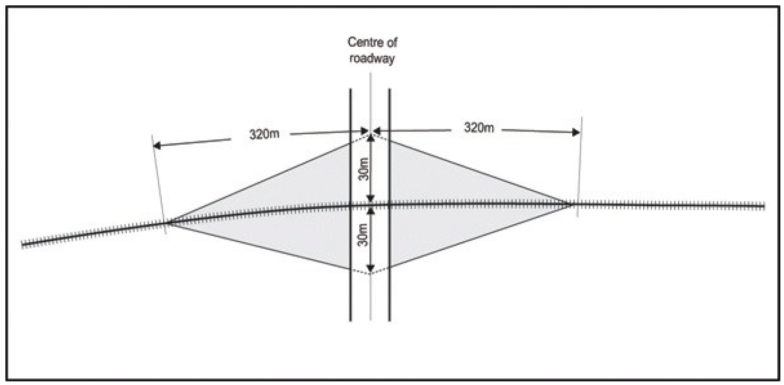
- Sight triangles for road/rail level crossings

Figure 21 - Approach sight triangles for public road/rail level crossings

Advice note:
- The 30 metre distance is measured from the closest outside rail.
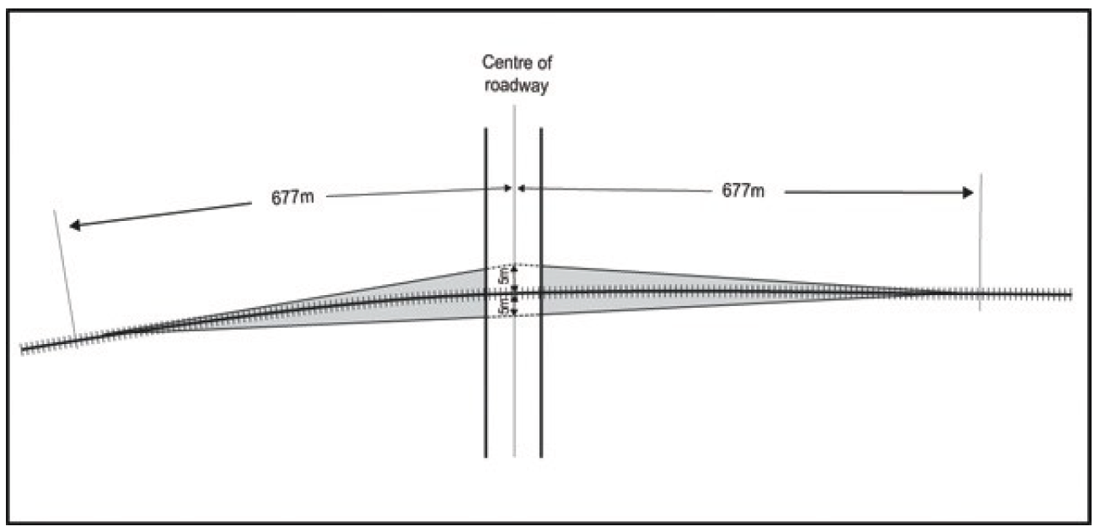
- Where there is more than one set of railway tracks, then 25 metres is added to the 320 metre distance along the railway track for each additional set of tracks.

Figure 22 - Restart sight triangles for public road/rail level crossings

Advice note:
- The 5 metre distance is measured from the closest outside rail.

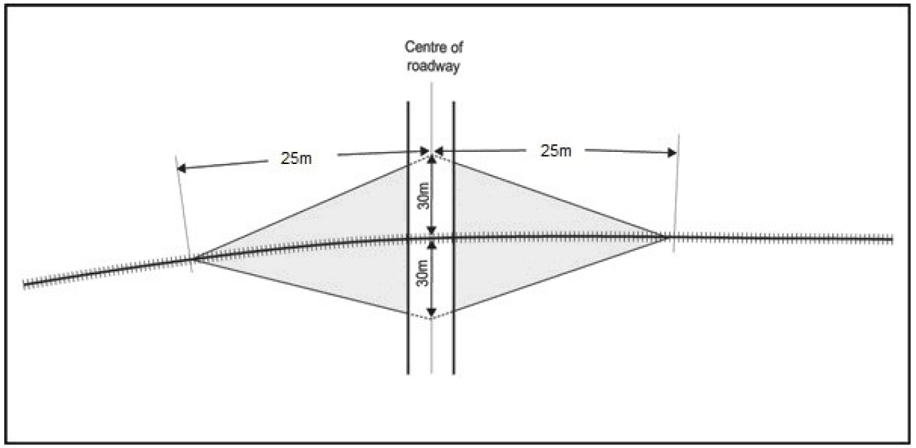
- Sight triangles for rail siding level crossings

Figure 23 - Approach sight triangles for public road/rail siding level crossings.

Advice note:
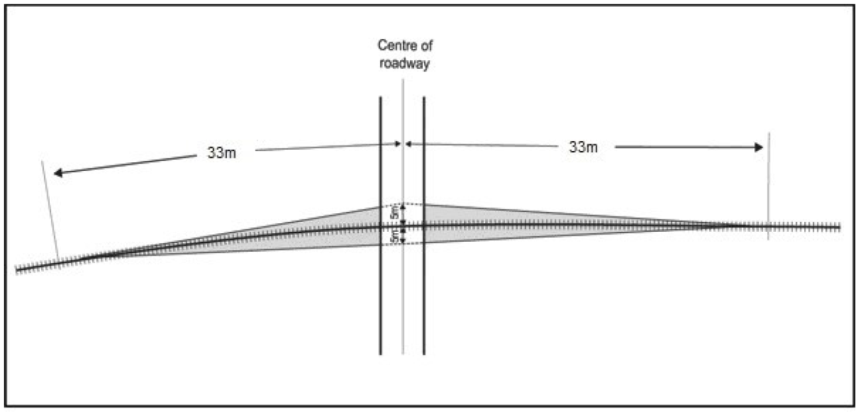
      - The 30 metre distance is measured from the closest outside rail.

Figure 24 - Restart sight triangles for public road/rail siding level crossings.

Advice note:
      - The 5 metre distance is measured from the closest outside rail.
Appendix 7.5.14 – Vehicle access to sites fronting more than one road – In Central City
            - If a site fronts more than one road then vehicle access shall only be gained from the most preferred road that the site has frontage to, as shown in Table 7.5.14.1, except that, where the higher preference road is a one-way road or is divided by a raised median, a second vehicle access point may be gained from the next most preferred road. The vehicle access standard in Appendix 7.5.14 does not apply to the fire station site (Lot 1 DP53863).
Table 7.5.14.1 Location of access (priority ranking)

Rank | Road class
Most Preferred | Local Distributor Street outside the Core
2nd choice | Local Street outside the Core
3rd choice | Main Distributor Street outside the Core
4th choice | Arterial Route
5th choice | Local Distributor Street within the Core
6th choice | Local Street within the Core
Least preferred | Main Distributor within the Core

