DISTRICT PLAN TEXT AMENDMENTS
Key:
For the purposes of this plan change, any unchanged text is shown as normal text or in bold, any text proposed to be added by the plan change is shown as bold underlined and text to be deleted as bold strikethrough.
Text in green font identifies existing terms in Chapter 2 – Definitions.
Text in purple shaded in grey is a Plan Change Council Decision.
Text in blue font indicates links to other provisions in the district Plan and/or external documents. These will have pop-ups and links, respectively, in the on-line Christchurch District Plan.

- Industrial
  - Introduction
            - This introduction is to assist the lay reader to understand how this chapter works and what it applies to. It is not an aid to interpretation in a legal sense.
            - This chapter provides for industrial and other compatible activities to occur in three industrial zones throughout the City, being the Industrial General, Industrial Heavy and Industrial Park Zones. Each zone has a different function, recognising its compatibility with surrounding land uses, the anticipated level of amenity in the zone, and the nature and scale of activities provided for. The adverse effects of activities are managed to support the anticipated outcome for the zone, while recognising that non-industrial sites adjoining an industrial zone will not have the same level of amenity anticipated by the Plan as other areas with the same zoning.
            - A description of each of the three industrial zones is included in Policy 16.2.1.3 - Range of industrial zones.
            - The provisions in this chapter give effect to the Chapter 3 Strategic Directions Objectives.
  - Objectives and Policies
    - Objective - Recovery and growth
            - The recovery and economic growth of the district’s industry is supported and strengthened in existing and new greenfield industrial zones.
      - Policy - Sufficient land supply
            - Maintain a sufficient supply of industrial zoned land to meet short, medium and long term supply needs of industrial activities future demand up to 2028, having regard to the requirements of different industries, and to avoid the need for industrial activities to locate in non-industrial zones.
(Plan Change 5C Council Decision)
      - Policy - Enable the development of industrial areas to support recovery
            - Encourage the redevelopment of existing industrial zones for industrial activities, particularly in areas that have lost industry and associated employment opportunities due to the earthquakes.
      - Policy - Range of industrial zones
            - Recognise and provide for industrial zones with different functions that cater for a range of industrial and other compatible activities depending on their needs and effects as follows:
              - Industrial General Zone
- Recognise and provide for industrial and other compatible activities that can operate in close proximity to more sensitive zones due to the nature and limited effects of activities including noise, odour, and traffic, providing a buffer between residential areas and the Industrial Heavy Zone.
              - Industrial Heavy Zone
- Recognise and provide for a full range of industrial and other compatible activities that generate potentially significant effects, including relatively high levels of noise, odour, heavy traffic movements, and the presence of significant amounts of hazardous substances, necessitating separation from more sensitive activities.
              - Industrial Park Zone
- Recognise and provide for industrial activities in the high technology sector and other industries in a high amenity environment dominated by open space and landscaping, and that generate higher volumes of traffic than other industries while having negligible effects in terms of noise, odour or the use and storage of hazardous substances.
      - Policy - Activities in industrial zones
            - Maintain and support the function of industrial zones while, subject to Clauses (b) and (c), providing for limited non-industrial activities that:
              - are ancillary in scale (subject to Clause (d)) and on the same site as a permitted or consented activity;
              - are not appropriate in more sensitive environments due to their potential noise, odour or other environmental effects;
              - incorporate characteristics that are compatible with the industrial zone and do not cause an undue constraint on other permitted activities within the zone;
              - comprise yard based supplier or trade suppliers in the Industrial General Zone;
              - provide an emergency service emergency service facilities and/or provide for community activities community corrections facilities;
              - support the needs of workers and businesses in the zone including food and beverage outlets, commercial services, gymnasiums, and the care of children;
              - meet the convenience needs of residents, workers and businesses in the Industrial General Zone (Waterloo Park) in a Local Centre Neighbourhood Centre;
              - are rural activities associated with the irrigation of food processing wastewater in the identified area of the Industrial Heavy Zone (South West Hornby) (Appendix 16.8.8) that is integral to the ongoing operation of an established industrial activity.
              - are recreation facilities in the Industrial General Zone that:
- provide for active indoor recreation activities that due to scale are not appropriately located in the Central City or a commercial centre; and
- are located near a commercial centre to support that centre; and
- do not give rise to reverse sensitivity effects on industrial activities, and do not undermine the ability of industrial activities to continue to operate or establish in the zone.
            - Avoid any activity in industrial zones with the potential to hinder or constrain the establishment or ongoing operation or development of industrial activities and strategic infrastructure, or with the potential to be exposed to unacceptable risk. This includes but is not limited to avoiding:
              - sensitive activities located within the 50 dB L_{dn} Air Noise Contour, the Lyttelton Port Influences Overlay Area, the Woolston Risk Management Area and in proximity to the National Grid;
              - non-sensitive discretionary or non-complying activities specified by Rule 16.4.1.4 D1, Rule 16.5.1.4, and Rule 16.5.1.5 NC1 in the Woolston Risk Management Area unless the proposed activity in its location meets risk acceptability criteria appropriate to the applicable land use.
            - Avoid the use of industrial zones for non-industrial activities that could adversely affect the strategic role of the Central City, District Centres Town Centres and Neighbourhood Local Centres as focal points for commercial activities, community activities, residential activities, and other activities.
            - Provide for ancillary activities, recognising their role in supporting industry, while being incidental in scale and function to a principal activity on the same site, and not inconsistent with Clauses b. and c.
(Plan Change 5C Council Decision)

Advice note for Clause b. ii:
                - The Woolston Risk Management Area is shown on Planning Map 47A.
                - Appropriate risk acceptability criteria were developed in accordance with the Planning NSW Hazardous Industry Planning Advisory Papers No. 3 and 4 Risk Criteria for Land Use Safety Planning 2011. Those criteria were used in determining the geographic extent of the Woolston Risk Management Area.
                - Council holds and will make freely available to the public, the Quantitative Risk Assessments (QRAs) prepared by the LPG and oil depot companies for the Woolston Risk Management Area. The titles of these documents are:
                - The Woolston LPG Depot Quantitative Risk Assessment May 2018 (WorleyParsons);
                - The Mobil Woolston Terminal Quantitative Risk Assessment for Determination of Planning Overlay 22 June 2018 (Sherpa Consulting);
                - The Technical Note: Christchurch District Plan - Risk Overlay for Discussion 21 September 2018 (Sherpa Consulting); and
                - The Joint Response to Aurecon Peer Review of Woolston QRAs for input to CDP risk overlay 20 June 2019.
                - The QRAs include individual risk contours and identify the types of activities that would not meet the acceptability criteria if located inside a particular risk contour. The more vulnerable the activity the greater the distance from the depot the activity has to be before meeting the acceptability criteria. Early consultation with the companies responsible for the LPG and oil depots is encouraged for any proposed activity within the Woolston Risk Management Area, as the companies will be able to assist with the identification of appropriate risk issues relating to any proposed development.
                - For the avoidance of doubt, Policy 16.2.1.4(b)(ii) does not apply to retail and office activities (whether permitted or restricted discretionary) that are ancillary to an activity that is otherwise permitted in the zone.
      - Policy - Office development
            - Avoid office development in industrial areas other than where it is:
              - ancillary to a permitted or consented activity on the same site (subject to Policy 16.2.1.4 d.);
              - a secondary component to a high technology industrial activity located in the Industrial Park Zone that supports the function of the zone for primarily industrial activities.
      - Policy ­ Regionally significant infrastructure ­ Inland Port
            - Enable regionally significant inland port infrastructure to operate and develop efficiently and safely through provisions that enable port activities while avoiding the potential for reverse sensitivity effects associated with sensitive land uses.
    - Objective – Brownfield redevelopment
            - The recovery and economic growth of the Christchurch District is provided for by enabling residential, mixed-use or commercial redevelopment, including mixed-use development, of appropriate brownfield sites and areas while not compromising the function of the wider industrial area for primarily industrial activities. ensuring that:
- Commercial activities are primarily directed to the Central City and commercial centres; and
- Where commercial activities are located out of centres as a result of brownfield redevelopment, there are no significant adverse distributional or urban form effects on the Central City and commercial centres; and
- For brownfield sites not identified within the Brownfield Overlay, the function of the wider industrial area for primarily industrial activities is not compromised.; and
iv. For brownfield sites within the Brownfield Overlay at Woolston (excludes the Tannery), Hornby, Cranford and Papanui, a high-quality residential environment is achieved that is consistent with the outcomes sought for residential medium density zones.
Advice note:
1. 16.2.2 Objective – Brownfield development and 16.2.2.1 Policy - Brownfield site identification and 16.2.2.2 Policy – Brownfield redevelopment are the only objective and policies in the Industrial Chapter to be considered for any proposal for residential or mixed-use development of a brownfield site.
(Plan Change 5C Council Decision)
      - Policy - Brownfield site identification
            - Unless a site is identified by a ‘brownfield’ overlay on the planning maps, a brownfield site shall meet the following criteria:
              - the land is abandoned previously used industrial land that is no longer being used; or
              - the land is underutilised industrial land, taking into consideration (including, but not limited to):
- the intensity of existing and recent land use activities on the site, including the period of time the land has not been used, or used for low intensity land uses;
- quality of built form, including the age and condition of existing buildings;
- the extent of buildings or other physical development on the site relative to the total area of the site; or
              - or the land is no longer required by a requiring authority for a designated purpose.; and
              - in addition, the redevelopment of the brownfield site will not adversely affect the supply of land to meet anticipated short, medium and long term supply needs of industrial activities to 2028, including industrial activities with specific locational requirements; and
              - the brownfield site is in a location that is not surrounded by industrial activities and/or will not erode the anticipated outcomes, including the function and amenity levels, of those parts of the zone not subject to brownfield redevelopment.
(Plan Change 5C Council Decision)
      - Policy – Brownfield redevelopment
            - Support Provide for the redevelopment of brownfield sites identified by a brownfield overlay at Waterloo Business Park and the Tannery or identified in accordance with Policy 16.2.2.1 for residential activities, or mixed use activities or including a limited quantum of commercial activities where:.
- Commercial activities are of a scale and/or type that do not have significant adverse distributional or urban form effects on the Central City and commercial centres; and
- Industrial activities remain the predominant use in the same geographic area zoned industrial.
b. Provide for the redevelopment of brownfield sites identified within the Brownfield Overlay at Hornby, Papanui, Cranford and Woolston (excludes the Tannery), for medium density residential activities.
c. b. Brownfield regeneration redevelopment proposals as provided for in sub-clause a. and b. above shall also ensure that:
              - any residential or mixed use redevelopment will not give rise to:
                - significant reverse sensitivity effects on existing industrial activities, or other effects, including reverse sensitivity, that may hinder or constrain the establishment or ongoing operation or development of industrial activities and;
                - Reverse sensitivity effects on and strategic infrastructure;
              - the safety and efficiency of the current and future transport system is not significantly adversely affected;
              - good quality urban design and an appropriate level of residential amenity can will be achieved on the site;
              - the site enhances connectivity to public transport routes, commercial and community services, and open space where appropriate;
              - any contaminated land is managed in accordance with national and regional standards;
              - the redevelopment maintains the strategic role of the Central City and commercial centres as the focal points for commercial and other activities, and the efficient and effective use of land and/or community and transport infrastructure investment in centres; and
              - any the environmental and cultural values of waterways within or adjoining the site are recognised and provided for in any redevelopment.;
              - the development is comprehensively planned;
              - the effects of natural hazards are managed in accordance with the framework in Chapter 5;
              - the principles of crime prevention through environmental design are incorporated into the development; and
              - the design of the development mitigates the effects of noise from traffic, railway activity, and other sources where necessary to protect residential amenity.
(Plan Change 5C Council Decision)
    - Objective – Effects of industrial activities
            - Adverse effects of industrial activities and development on the environment are managed to support the anticipated outcome for the zone while recognising that sites adjoining an industrial zone will not have the same level of amenity anticipated by the Plan as other areas with the same zoning.
            - The cultural values of Ngāi Tahu/ mana whenua are recognised, protected and enhanced through the use of indigenous species in landscaping and tree planting, a multi-value approach to stormwater management in greenfield areas, low impact urban design, and the protection and enhancement of wāhi tapu and wāhi taonga including waipuna.
      - Policy – Development in greenfield areas
            - Manage effects at the interface between greenfield areas and arterial roads, rural and residential areas with setbacks and landscaping.
            - Manage the development of greenfield areas in a manner aligned with the delivery of infrastructure, including upgrades to networks, to avoid adverse effects on networks serving these areas.
            - Development shall recognise and support Ngāi Tahu cultural values through low impact urban design, the protection of sites of Ngāi Tahu cultural significance identified in Schedule 9.5.6.1, and recognition of other sites of Ngāi Tahu cultural significance identified in Appendix 9.5.6 including waterways, springs, wetlands and sites of indigenous vegetation where practicable.
            - Enable the ongoing use of land in the Industrial Heavy Zone (South West Hornby), (identified on Appendix 16.8.8) for rural activities and the associated irrigation of food processing wastewater at South West Hornby as an integral component of the adjoining industrial activity.
      - Policy – Managing effects on the environment
            - The effects of development and activities in industrial zones, including reverse sensitivity effects on existing industrial activities as well as, visual, traffic, noise, glare and other effects, are managed through the location of uses, controls on bulk and form, landscaping and screening, particularly at the interface with arterial roads fulfilling a gateway function, and rural and residential areas, while recognising the functional needs of the activity.
            - Effects of industrial activities are managed in a way that the level of residential amenity (including health, safety, and privacy of residents) adjoining an industrial zone is not adversely affected while recognising that it may be of a lower level than other residential areas.
            - Development and activities are managed to avoid adverse effects on strategic infrastructure within or in proximity to industrial zones.
            - The quantity of wastewater discharged in areas over unconfined or semi-confined aquifers is restricted to minimise any risk of contamination.
            - The cultural values of Ngāi Tahu/mana whenua are recognised and supported through the protection of wāhi tapu and wāhi taonga, including waipuna, from the adverse effects of development, through the use of low impact urban design, use of indigenous species appropriate to the local environment, and stormwater management.
            - Development in the Industrial Park Zone is designed and laid out to promote a safe environment and reflects principles of Crime Prevention through Environmental Design (CPTED).
      - Policy - Managing stormwater
            - Ensure that stormwater is managed in a way that:
              - mitigates the adverse effects of flooding; and
              - improves water quality in a manner which is consistent with maintaining environmental and public health.
            - Encourage methods that achieve:
              - a multi-value approach, using swales, wetlands, infiltration and retention basins, having regard to the location and environmental constraints; and
              - integration with the wider network, reflecting a catchment based approach.
    - Objective - Amenity at the western gateway to the City
            - Development at the western gateway to the City and adjacent to Memorial Avenue has a high visual and aesthetic quality given its prominent location.
      - Policy - Amenity values along Memorial Avenue
            - Maintain the amenity values along Memorial Avenue as a visitor gateway through the provision of buildings of a high visual and aesthetic quality, limited signage, a large building setback and landscaping along the frontage with Memorial Avenue.

  - How to interpret and apply the rules
            - The rules that apply to activities in the various industrial zones are contained in the activity status tables (including activity specific standards) and built form standards in:
              - Rule 16.4 – Industrial General Zone;
              - Rule 16.5 - Industrial Heavy Zone;
              - Rule 16.6 – Industrial Park Zone;
              - Rule 16.7 - Matters of discretion.
            - Area specific rules also apply to activities within the Industrial General, Industrial Heavy and Industrial Park Zones in the following areas:
              - Industrial General Zone (Waterloo Park) (as identified in Appendix 16.8.2) - Rule 16.4.3;
              - Industrial General Zone (Portlink Industrial Park) (as identified in Appendix 16.8.3) - Rule 16.4.4;
              - Industrial General Zone (Musgroves) (as identified in Appendix 16.8.4) - Rule 16.4.5;
              - Industrial General Zone (North Belfast) (as identified in Appendix 16.8.5) - Rule 16.4.6;
              - Industrial General Zone (Stanleys Road) (as identified in Appendix 16.8.9) – Rule 16.4.7;
              - Industrial General Zone (Trents Road) (as identified in Appendix 16.8.6) - Rule 16.4.8;
              - Industrial General Zone (South West Hornby) (as identified in Appendix 16.8.8) – Rule 16.4.9;
              - Industrial Heavy Zone (Sir James Wattie Drive) (as identified in Appendix 16.8.7) - Rule 16.5.3;
              - Industrial Heavy Zone (South West Hornby) (as identified in Appendix 16.8.8) - Rule 16.5.4; and
              - Industrial Heavy Zone (Springs Road) (as identified in Appendix 16.8.13) – Rule 16.5.5;
              - Industrial Park Zone (Tait Campus) (as identified in Appendix 16.8.9) - Rule 16.6.3;
              - Industrial Park Zone (Awatea) (as identified in Appendix 16.8.10) - Rule 16.6.4;
              - Industrial Park Zone (Wairakei Road) (as identified in Appendix 16.8.14) - Rule 16.6.5; and
              - Industrial Park Zone (Memorial Avenue) (as identified in Appendix 16.8.15) - Rule 16.6.6.
            - The activity status tables and standards in the following chapters also apply to activities in all areas of all industrial zones:

4 Hazardous Substances and Contaminated Land;

5 Natural Hazards;

6 General Rules and Procedures;

7 Transport;

8 Subdivision, Development and Earthworks;

9 Natural and Cultural Heritage; and

11 Utilities and Energy.
  - Rules - Industrial General Zone
    - Activity status tables – Industrial General Zone
      - Permitted activities
            - The activities listed below are permitted activities in the Industrial General Zone if they meet the activity specific standards set out in this table and the built form standards in Rule 16.4.2. Note, the built form standards do not apply to an activity that does not involve any development.
            - Activities may also be controlled, restricted discretionary, discretionary, non-complying or prohibited, as specified in Rules 16.4.1.2, 16.4.1.3, 16.4.1.4, 16.4.1.5, and 16.4.1.6.
            - The activities listed below include any associated landscaping, access, parking areas, loading, waste management areas and other hard standing areas.

Activity |  | Activity specific standards
P1 | Any new building or addition to a building for any activity listed in Rule 16.4.1.1 P2 to P21 | Nil
P2 | Industrial activity
P3 | Warehousing and distribution activities
P4 | High technology industrial activity
P5 | Service industry
P6 | Trade and industry training activity
P7 | Ancillary retail activity | a. Any ancillary retail activity shall:  - occupy no more than 250m² or 25% of the GFA of all buildings on the same site, whichever is the lesser; and  - have visually transparent glazing on the ground floor elevation facing the street for a minimum of 20% of that elevation where goods are displayed for sale within the building and the retail activity fronts the street.  - be limited to the display and sale of goods produced, processed or stored on the site.
P8 | Retail activity on the Tannery site (between Cumnor Terrace and Tanner street), within the brownfield overlay on Planning Map 47. | - The maximum GFA of retail activity shall be 2,278m².
P9 | Food and beverage outlet | Nil
P10 | Trade supplier
P11 | Yard-based supplier
P12 | Service station
P13 | Second-hand goods outlet
P14 | Ancillary office | a. Any ancillary offices shall:  - occupy no more than 500m² or 30% of the GFA of all buildings on the same site, whichever is the lesser, or for yard based activities, shall occupy no more than 250m² of floor area on the whole site; and  - have visually transparent glazing on the ground floor elevation facing the road for a minimum of 20% of that elevation where the office fronts the road.  Advice note:  1. Clause i. shall not apply to land legally described as Lot 1 DP 2951, Lot 2 DP 2951, and Pt Sec 16 Lyttelton Town, where any office shall be ancillary to port activities.
P15 | Public transport facility | Nil
P16 | Emergency service facilities
P17 | Gymnasium
P18 | Preschool:  - outside the 50 dB _{Ldn} Air Noise Contour;  - in Lyttelton, outside the Lyttelton Port Influences Overlay Area as defined on the planning maps;  - outside the Woolston Risk Management Area as defined on the planning maps. | a. Any preschool activity shall be:  - be located more than 100 metres from the boundary of an Industrial Heavy Zone; and  - have any habitable space indoor areas (excluding bathroom, laundry, toilet, pantry, walk-in wardrobe, corridor, hallway, lobby or clothes drying room) must be designed and constructed to achieve an external to internal noise reduction of not less than 25 dB D_{tr, 2m, nT,w}+ C_{tr}; and  - have any bedroom or sleeping area must be designed and constructed to achieve an external to internal noise reduction of not less than 30dB D_{tr,2m,nT,w}+ C_{tr}  (Plan Change 5C Council Decision)
P19 | Parking lots and parking buildings | Nil
P20 | Community corrections facility
P21 | Any activity listed in Rule 16.4.1.1 P1 to P20 at 65 – 67 Racecourse Road (Refer to Appendix 16.8.12) | - Development is to be in accordance with the development plan in Appendix 16.8.12.
P22 | Commercial film or video production | Nil

      - Controlled activities
            - There are no controlled activities.
      - Restricted discretionary activities
            - The activities listed below are restricted discretionary activities.
            - Discretion to grant or decline consent and impose conditions is restricted to the matters of discretion set out in Rules 16.7.1 and 16.7.2, as set out in the following table.

 | Activity | The Council's discretion shall be limited to the following matters:
RD1 | - Any activity listed in Rule 16.4.1.1 P1-P21 and Rule 16.4.1.3 RD2 to RD4 that does not meet one or more of the built form standards in Rule 16.4.2, unless otherwise specified.  Advice note:  1. Refer to relevant built form standard for provisions regarding notification. | a. As relevant to the built form standard that is not met:  - Maximum height of buildings and fencing or screening structure – Rule 16.7.1.1  - Minimum building setback from road boundaries/ railway corridor – Rule 16.7.1.3  - Minimum building setback from the boundary with a residential zone, residential property – Rule 16.7.1.4  - Sunlight and outlook at boundary with a residential zone, residential property and road – Rule 16.7.1.5  - Outdoor storage of materials – Rule 16.7.1.6  - Landscaped areas – Rule 16.7.1.7  - Access to the Industrial General Zone (Deans Ave) – Rule 16.7.1.8  - Water supply for fire-fighting – Rule 16.7.1.9  - For Rule 16.4.2.5, Outdoor storage of materials - Rule 16.7.1.6 (a), (c) and (d)
RD2 | Any activity listed in Rule 16.4.1.1 P18 that does not meet one or more of the activity specific standards. | - Sensitive activities – Rule 16.7.2.3
RD3 | - Commercial services  - Any application for this activity shall not be limited or publicly notified. | a. Display of goods, show room and non-industrial activities – Rule 16.7.2.1
RD4 | - Any activity listed in Rule 16.4.1.1 P7, P8 and P14, that does not meet one or more of the activity specific standards.  - Any application for this activity shall not be limited or publicly notified. | - Display of goods, showroom and non-industrial activities - Rule 16.7.2.1
RD5 | Any activity listed in Rule 16.4.1.1 P21 that does not comply with the development plan for the land at 65 – 67 Racecourse Road (refer to Appendix 16.8.12) | - Development Plan for land at 65 – 67 Racecourse Road – Rule 16.7.1.10
RD6 | Boarding of domestic animals.  (Plan Change 5C Council Decision | - Boarding of domestic animals – Rule 16.7.2.4  (Plan Change 5C Council Decision
RD7 | Recreation facilities  (Plan Change 5C Council Decision | - Display of goods, showroom and non-industrial activities – Rule 16.7.2.1  (Plan Change 5C Council Decision
RD8 | Comprehensive residential development on sites identified by a Brownfield Overlay at Hornby, Papanui, Cranford and Woolston. | - Brownfield Area Redevelopment

      - Discretionary activities
            - The activities listed below are discretionary activities.

 | Activity
D1 | Any activity not provided for as a permitted, controlled, restricted discretionary, non-complying or prohibited activity.
D2 | Heavy industrial activity

      - Non-complying activities
            - The activities listed below are non-complying activities.

 | Activity
NC1 | - Sensitive activities:  - within 12 metres of the centre line of a 220kV National Grid transmission line or within 12 metres of the foundation of an associated support structure.  - within 10 metres of the centre line of a 66 kV electricity distribution line or within 10 metres of a foundation of an associated support structure.  - within 5 metres of the centre line of a 33 kV electricity distribution line or within 5 metres of a foundation of an associated support structure.  - Buildings on greenfield sites:  - within 12 metres of the centre line of a 220kV National Grid transmission line or within 12 metres of the foundation of an associated support structure.  - within 10 metres of the centre line of a 66 kV electricity distribution line or within 10 metres of a foundation of an associated support structure.  - within 5 metres of the centre line of a 33 kV electricity distribution line or within 5 metres of a foundation of an associated support structure.  - Buildings, other than those in b. above:  - within 12 metres of the foundation of a 220 kV National Grid transmission support structure.  - within 10 metres of the foundation of a 66 kV electricity distribution support structure.  - within 5 metres of the foundation of a 33 kV electricity distribution support structure.  - Fences within 5 metres of a National Grid transmission line support structure foundation or 5 metres of a 66 kV and 33 kV electricity distribution support structure foundation.  e. Any application made in relation to this rule shall not be publicly notified, and shall, absent written approval, be limited notified only to Transpower New Zealand Limited and/or Orion New Zealand Limited or other electricity distribution network operator.  Advice notes:  - The National Grid transmission lines and 66 kV and 33 kV electricity distribution lines are shown on the planning maps.  - Vegetation to be planted around the National Grid or electricity distribution lines should be selected and/or managed to ensure that it will not result in that vegetation breaching the Electricity (Hazards from Trees) Regulations 2003.  - The New Zealand Electrical Code of Practice for Electrical Safe Distances (NZECP 34:2001) contains restrictions on the location of structures and activities in relation to National Grid transmission lines and electricity distribution lines. Buildings and activity in the vicinity of National Grid transmission lines or electricity distribution lines must comply with the NZECP 34:2001.
NC2 | Sensitive activity within the 50 dB _{Ldn} Air Noise Contour, the Woolston Risk Management Area or within the Lyttelton Port Influences Overlay Area as defined on the planning maps.
NC3 | Any activity in the Industrial General Zone between Main South Road and the railway line, south west of 15 Foremans Road which results in the daily average sewage flow from a site exceeding 0.09 l/s/ha. [Removed]  (Plan Change 5C Council Decision)
NC4 | Residential activity on the Tannery site (between Cumnor Terrace and Tanner Street)
NC5 | Any activity within the area defined in by the overlay on the planning maps Appendix 16.8.1 as "Area subject to wastewater discharge restrictions", which results in daily average sewage flows from a site to the Council's reticulated network exceeding 0.09 l/s/ha.  (Plan Change 5C Council Decision)

      - Prohibited activities
There are no prohibited activities.
    - Built form standards – Industrial General Zone
            - The following built form standards shall be met by all permitted activities and restricted discretionary activities RD2, RD3 and RD4 unless otherwise stated.
      - Maximum height for buildings
            - The maximum height of any building within 20 metres of a residential zone shall be 15 metres.
            - Any application arising from this rule shall not be publicly notified.
      - Minimum building setback from road boundaries/ railway corridor
            - The minimum building setback from a road boundary and a rail corridor boundary shall be as follows:
 | Applicable to | Standard
i. | Any activity unless specified below | 1.5 metres
ii. | Any activity fronting on to an arterial road or opposite a residential zone unless specified in (iii) | 3 metres
iii. | Buildings, balconies and decks on sites adjacent to or abutting railway lines. | 4 metres from the rail corridor boundary
            - Any application arising from this rule (other than clause iii.) shall not be limited or publicly notified.
            - Any application arising from clause iii. of this rule shall not be publicly notified and shall be limited notified only to KiwiRail (absent its written approval).
      - Minimum building setback from the boundary with a residential zone
            - The minimum building setback from the boundary with a residential zone shall be as follows:
 | Applicable to: | Standard
i. | All buildings within sites which share a boundary with a residential zone | - 3 metres  - Clause (i) shall not apply to the Industrial General zone off Haytons Road.
            - Any application arising from this rule shall not be publicly notified.
      - Sunlight and outlook at boundary with a residential zone and road
 | Standard
a. | i. Where an internal site boundary adjoins a residential zone, no part of any building shall project beyond a building envelope contained by a 60◦ recession plane measured at any point 2.3 metres above the internal boundary in accordance with the relevant diagram in Appendix 16.8.11, unless specified below.  ii. Clause (a) shall not apply to the Industrial General Zone off Haytons Road.
b. | Where a site adjoins Blakes Road at East Belfast, no buildings shall project beyond a building envelope constructed by recession planes commencing at a point 8 metres above the road boundary with Blakes Road and climbing at an angle of 15 degrees until it reaches a line 50 metres back from and parallel to the road boundary with Blakes Road.
c. | Within the Brownfield Overlay, where an internal site boundary adjoins a residential zone, no part of any building shall project beyond a building envelope contained by a 60˚ recession plane measured at any point 4 metres above the internal boundary.
            - Where sites are located within a Flood Management Area, recession plane breaches created by the need to raise floor levels shall not be publicly or limited notified.
            - Any application arising from this rule shall not be publicly notified.
      - Outdoor storage of materials
            - Any outdoor storage areas shall:
              - not be located within the minimum setbacks specified in Rule 16.4.2.2.
              - be screened by landscaping, fencing or other screening to a minimum of 1.8 metres in height from any adjoining residential zone.
            - Any application arising from this rule shall not be limited or publicly notified, except where the adjoining zone is residential.
      - Landscaped areas
            - Landscaping and trees shall be provided as follows:
 | Standard
i. | The road frontage of all sites opposite a residential zone or listed below shall have a landscaping strip with a minimum width of 1.5 metres, and minimum of 1 tree for every 10 metres of road frontage or part thereof.  - Sites adjoining Main North Road (SH1) between Dickeys Road and Factory Road;  - Sites adjoining Main South Road, between Barters Road and Halswell Junction Road; and  - Sites adjoining Tunnel Road.  - This standard shall not apply to an emergency service facility or vehicle access to any site.
ii. | On sites adjoining a residential zone, trees shall be planted adjacent to the shared boundary at a ratio of at least 1 tree for every 10 metres of the boundary or part thereof.
iii. | All landscaping / trees required by these rules shall be in accordance with the provisions in Appendix 6.11.6 of Chapter 6.

            - Any application arising from clause i. of this rule shall not be limited or publicly notified.

Advice note:
                - Vegetation in close proximity to the electricity transmission network will need to be planted and managed in accordance with the Electricity (Hazards from Trees) Regulations 2003.
                - Stormwater facilities shall be incorporated into any development to achieve effective stormwater management and to protect groundwater. The stormwater facilities, which support multiple values such as stormwater retention, water quality treatment, biodiversity enhancement, Ngāi Tahu/ mana whenua values and landscape amenity, should be incorporated into landscaped areas, where practicable, to achieve effective stormwater management and the protection of groundwater in an integrated manner. Stormwater treatment sites or treatment facilities should be separated from natural waterways with vegetated buffers to ensure stormwater is treated before it is discharged into natural waterways or natural wetlands.
      - Visual amenity and screening
            - Where a site adjoins an Open Space, Specific Purpose (School), Specific Purpose (Cemetery) or Specific Purpose (Tertiary Education) Zone, provision shall be made for landscaping, fence(s), wall(s) or a combination to at least 1.8 metres in height along the length of the zone boundary, excluding any road frontages. Where landscaping is provided, it shall be continuous and for a minimum depth of 1.5 metres along the zone boundary.
            - Any application arising from this rule shall not be limited or publicly notified.
      - Access to Industrial General Zone (Deans Avenue)
            - Any activity in the Industrial General zone bound by Deans Avenue, Lester Lane and the railway line shall only have access from Lester Lane. In the event that Lester Lane is realigned, site access shall be solely from the realigned Lester Lane.
            - Any application arising from this rule shall not be publicly notified.
      - Water supply for fire fighting
            - Provision for sufficient water supply and access to water supplies for firefighting shall be made available to all buildings via Council’s urban reticulated system (where available) in accordance with the New Zealand Fire Service Firefighting Water Supplies Code of Practice (SNZ PAS: 4509:2008).
            - Any application arising from this rule shall not be publicly notified and shall be limited notified only to New Zealand Fire Service Commission (absent its written approval).
    - Area-specific rules - Industrial General Zone (Waterloo Park)
            - The following rules and the Waterloo Park Outline Development Plan (Appendix 16.8.2) shall apply to the Industrial General Zone (Waterloo Park). All activities specified are also subject to the rules in 16.4.1 (Activity status tables) and 16.4.2 (Built form standards) unless specified otherwise in 16.4.3.
      - Area-specific activities–Industrial General Zone (Waterloo Park)
        - Area-specific permitted activities
            - The activities listed below are permitted activities in the Industrial General Zone (Waterloo Park) if they meet the activity specific standards set out in this table and the built form standards in Rule 16.4.3.2.
Activity |  | Activity specific standards
P1 | Activities listed in Rule 16.4.1.1 P1-P21 | a. Development shall comply with:  - All of the key structuring elements on the Waterloo Park Outline Development Plan (Appendix 16.8.2), being:  - Indicative location of new roads  - Indicative stormwater management area  - Indicative other open space  - Built form standards in Rule 16.4.3.2, and Rule 16.4.2 unless specified otherwise in Rule 16.4.3.2.
P2 | Residential activity outside the 50 dB Ldn Air Noise Contour line defined on the planning maps. | - Any bedroom must be designed and constructed to achieve an external to internal noise reduction of not less than 35 dB Dtr, 2m, nT,w+ Ctr.  - Any residential activity shall have a minimum net floor area (including toilets and bathrooms but excluding lobby and/or reception area, parking area, garage and balconies) per unit of:  - Studio 35m²  - 1 bedroom 45m²  - 2 bedroom 60m²  - 3 or more bedrooms 90m²  - Each residential unit shall have:  - an outdoor service space of 3m² and a waste management area of 2m² per unit, each with a minimum dimension of 1.5 metres in either a private or communal area;  - a single, indoor storage space of 4m³ with a minimum dimension of 1 metre; and  - space designated for waste management, whether private or communal, which shall not be located between the road boundary and any building, and shall be screened from adjoining sites, roads, and adjoining outdoor living spaces by screening from the floor level of the waste management area to a height of 1.5 metres.  - Each residential unit shall have an outdoor living space with a minimum area and dimension as set out in the following table, located immediately outside and accessible from an internal living area of the residential unit.  Type Area Dimension  i. Studio, 1 bedroom 6m² 1.5 metres  ii. 2 or 3 bedroom 10m² 1.5 metres  iii. 3 or more bedrooms 15m² 1.5 metres
P3 | Retail activity | - The maximum GLFA of retail activity within the Industrial General Zone (Waterloo Park) shall be 3,000m² and shall be located in a local neighbourhood centre.  - The maximum GLFA per tenancy for any retail activity shall be 350m².
P4 | Office | - The maximum GLFA of offices within the Industrial General Zone (Waterloo Park) shall be 6,000m².  - The maximum GLFA of offices at ground floor level shall be 3000m² GLFA.  - The maximum GLFA of office per tenancy shall be 500m².
P5 | Key structuring elements identified on the outline development plan in Appendix 16.8.2. | - Development is to be in accordance with the key structuring elements on the outline development plan, as identified in Rule 16.4.3.1.1 P1.
P6 | Hosted visitor accommodation outside the 50 dB _{Ldn} Air Noise Contour line defined on the planning maps  (Plan Change 4 Council Decision subject to appeal) | - A maximum of six guests shall be accommodated at any one time in a residential unit.  - The Council shall be notified in writing prior to commencement.  - The owner of the unit shall keep records of the number of nights booked per year, as commencing on 1 January of that year, and the dates used for hosted visitor accommodation and provide those records to the Council on request.  (Plan Change 4 Council Decision subject to appeal)

        - Area-specific controlled activities
There are no controlled activities.
 | Activity | The matters over which Council reserves its control
C1 | Unhosted visitor accommodation in a residential unit outside the 50 dB _{Ldn} Air Noise Contour line defined on the planning maps:  - for a total per site of 60 nights or fewer per year;  - for a maximum of six guests at any one time.  (Plan Change 4 Council Decision subject to appeal) | - Provision of information for neighbours and guests, including contact information, parking restrictions, and, where appropriate, hazards information  - Record keeping and provision of information to the Council  - Management of outdoor entertainment and recreation facilities  - Management of solid waste disposal  - Number and size of vehicles accommodated including large vehicles  - Building access arrangements and wayfinding  - Controls on the effects and scale of functions or events.  (Plan Change 4 Council Decision subject to appeal)

        - Area-specific restricted discretionary activities
            - The activities listed below are restricted discretionary activities.
            - Discretion to grant or decline consent and impose conditions is restricted to the matters of discretion set out in Rules 16.7.1, 16.7.2 and 16.7.3.1, as set out in the following table.
 | Activity | The Council's discretion shall be limited to the following matters:
RD1 | - Any site access directly onto Pound Road, Brixton, Wilson, or Mortlake Streets.  - Any application arising from this rule shall not be publicly notified. | - Outline development plan – Rule 16.7.3.1.1 (b)
RD2 | - Any activity listed in Rule 16.4.3.1.1 P1-P4 and Rule 16.4.3.1.3 RD3 that does not meet one or more of the built form standards in Rule 16.4.3.2.  Advice note:  1. Refer to relevant built form standard for provisions regarding notification. | a. As relevant to the built form standard that is not met:  i. For Rule 16.4.3.2.1, Minimum building setback from road boundaries/ railway corridor – Rule 16.7.1.3  ii. For Rule 16.4.3.2.1, Outline Development Plan – Rule 16.7.3.1.1  iii. Landscaped areas Rule 16.7.1.7
RD3 | - Any activity listed in Rule 16.4.3.1.1 P2 that does not meet one or more of the activity specific standards b., c. or d.  - Any application arising from this rule shall not be limited or publicly notified. | - Residential activity - Rule 16.7.2.2
RD4 | - Any development not complying with a key structuring element on the outline development plan in Appendix 16.8.2.  - Any application arising from this rule shall not be publicly notified. | - Outline development plan – Rule 16.7.3.1.1
        - Area-specific discretionary activities
            - The activities listed below are discretionary activities.

D1 | Any activity listed in Rule 16.4.3.1.1 P3 or P4 that does not meet the activity specific standards.
D2 | - Hosted visitor accommodation that does not comply with activity specific standards in Rule 16.4.6.1.1 P6 and that does not exceed twelve guests per site at any one time.  - Any application arising from this rule shall not be publicly notified but may be limited notified.  (Plan Change 4 Council Decision subject to appeal)
D3 | - Unhosted visitor accommodation not subject to Rule 16.4.6.1.2 C1 and that does not exceed twelve guests per site at any one time.  - Any application arising from this rule shall not be publicly notified but may be limited notified.  (Plan Change 4 Council Decision subject to appeal)

        - Area-specific non-complying activities
            - The activities listed below are non-complying activities.
 | Activity
NC1 | Any activity which results in the daily average sewage flow from the Industrial General Zone (Waterloo Park) to exceed 0.09l/s/ha, and the average daily sewage discharge to exceed 863m³/ day.
NC2 | Any residential activity listed in Rule 16.4.3.1.1 P2 that does not meet activity specific standard a.
NC3 | - Visitor accommodation that is:  - not hosted visitor accommodation, or unhosted visitor accommodation;  - hosted visitor accommodation that exceeds the maximum number of guests in Rule 16.4.6.1.4 D2;  - unhosted visitor accommodation that exceeds the maximum number of guests in Rule 16.4.6.1.4 D3;  - Any application arising from this rule shall not be publicly notified but may be limited notified.  (Plan Change 4 Council Decision subject to appeal)
        - Area-specific prohibited activities
There are no prohibited activities.
      - Area-specific built form standards – General Industrial Zone (Waterloo Park)
        - Minimum building setback from road boundaries
            - The minimum building setback from road boundaries shall be as follows:

 | Applicable to | Standard
i. | Pound Road north of setback line identified on the outline development plan in Appendix 16.8.2i. | 10 metres
ii. | Pound Road south of setback line identified on the outline development plan in Appendix 16.8.2i. | 20 metres
            - Any application arising from rule shall not be limited or publicly notified.
        - Landscaped areas
            - Landscaping shall be provided as follows:
 | Applicable to | Standard
i. | Pound Road frontage only | - A landscaping strip shall be provided adjacent to the Pound Road frontage with a minimum width of 10 metres along and adjoining the site boundary with Pound Road, excluding vehicle crossings and rear sites.  - On sites with frontage to Pound Road and within the area identified as requiring specific landscape treatment on the outline development plan in Appendices 16.8.2 ii. and iii., all landscaping shall be in accordance with the relevant design in that Appendix.  - The requirements of (A) and (B) shall be completed as a condition of subdivision consent, or if there is no subdivision required, in conjunction with development in the locations that clauses (A) and (B) relate to as a permitted activity standard.
            - Any application arising from this rule shall not be limited or publicly notified.
    - Area-specific rules - Industrial General Zone (Portlink Industrial Park)
            - The following rules and the Portlink Industrial Park Development Plan (Appendix 16.8.3) shall apply to the Industrial General Zone (Portlink Industrial Park). All activities specified are also subject to the rules in 16.4.1 (Activity status tables) and 16.4.2 (Built form standards) unless specified otherwise in 16.4.4.
      - Area-specific activities – Industrial General Zone (Portlink Industrial Park)
        - Area-specific permitted activities
            - The activities listed below are permitted activities in the Industrial General Zone (Portlink Industrial Park) if they meet the activity specific standards set out in this table and the built form standards in Rule 16.4.4.2.
Activity |  | Activity specific standards
P1 | Activities listed in Rule 16.4.1.1 P1-P21 | a. Development shall comply with:  - The key structuring element on the Portlink Industrial Park Development Plan (Appendix 16.8.3), being:  - Road access.  - Built form standards in Rule 16.4.4.2, and Rule 16.4.2 unless specified otherwise in Rule 16.4.4.2.
P2 | Key structuring elements identified on the development plan in Appendix 16.8.3. | - Development is to be in accordance with the key structuring element on the Portlink Industrial Park Development Plan (Appendix 16.8.3): being as identified in Rule 16.4.4.1.1 P1.

        - Area-specific controlled activities
There are no controlled activities.
        - Area-specific restricted discretionary activities
            - The activities listed below are restricted discretionary activities.
            - Discretion to grant or decline consent and impose conditions is restricted to the matters of discretion set out in Rules 16.7.1, 16.7.2 and 16.7.3.2, as set out in the following table.

 | Activity | The Council's discretion shall be limited to the following matters:
RD1 | - Any activity listed in Rule 16.4.4.1.1 P1 that does not meet one or more of the built form standards in Rule 16.4.4.2.  Advice note:  - Refer to relevant built form standard for provisions regarding notification. | a. As relevant to the built form standard that is not met:  - Maximum height of buildings and fencing or screening structure – Rule 16.7.1.1  - Minimum building setback from road boundaries/ railway corridor – Rule 16.7.1.3  - For Rule 16.4.4.2.3, Landscaped areas – Rule 16.7.1.7  - For Rule 16.4.4.2.3, Landscaping in Portlink Industrial Park Development Plan – Rule 16.7.3.2.2  - For Rule 16.4.4.2.3 b., Cycle and pedestrian links – Rule 16.7.3.2.3
RD2 | - Any development not complying with a key structuring element on the Portlink Industrial Park Development Plan in Appendix 16.8.3.  - Any application arising from this rule shall not be publicly notified. | - Development plan – Rule 16.7.3.2.1

        - Area-specific discretionary activities
There are no discretionary activities.
        - Area-specific non-complying activities
            - The activities listed below are non-complying activities. There are no area-specific non-complying activities.
 | Activity
NC1 | Any development resulting in more than 10 hectares (excluding roads) of land within the development plan area in Appendix 16.8.3 being occupied by businesses before completion of the upgrade of the intersection of Kennaway Road and Chapmans Road to provide dedicated right turn bays with two approach lanes on the minor arm that are continuous for a length of no less than 35 metres.  (Plan Change 5C Council Decision)

        - Area-specific prohibited activities
There are no prohibited activities.
      - Area-specific built form standards – Industrial General Zone (Portlink Industrial Park)
        - Maximum height of buildings
            - The maximum height of any building within the ‘11m Building Height Limit Area’ defined on the development plan in Appendix 16.8.3 shall be 11 metres.
            - Any application arising from this rule shall not be publicly notified.
        - Minimum building setback from road boundaries
            - The minimum building setback from the road boundary with Tunnel Road shall be 3 metres.
            - Any application arising from this rule shall not be limited or publicly notified.
        - Landscaped areas
            - Landscaping and trees shall be provided as follows:
 | Applicable to: | Standard
i. | Tunnel Road frontage only | - Any site that adjoins Tunnel Road shall have a landscaping strip with a minimum width of 1.5 metres along the site boundary with Tunnel Road with the exception of that part defined on the development plan in Appendix 16.8.3 as ‘Landscape and stormwater area (Green Space)’; and  - Planting of trees and shrubs within the landscaping strip adjacent to Tunnel Road shall be in accordance with the Landscape Plan and Plant Species List (see Appendix 16.8.3) and shall meet the requirements specified in Part A of Appendix 6.11.6 of Chapter 6; and  - The landscaping required under Rule 16.4.4.2.3.i. shall be completed as a condition of subdivision consent, or if there is no subdivision required, in conjunction with development in the locations that clause a. relates to as a permitted activity standard.
ii. | Landscaping adjacent to the Heathcote River and within the zone | - Planting of trees and shrubs within the 'Landscape and stormwater area (Green Space)' defined on the development plan in Appendix 16.8.3 adjacent to the Heathcote River shall be in accordance with the Landscape Plan and Plant Species List (see Appendix 16.8.3) and the requirements specified in Part A of Appendix 6.11.6 of Chapter 6; and  - Legal public access ways within the landscaping strip adjoining the Heathcote River shall be provided as indicated by ‘Pedestrian access’ on the development plan in Appendix 16.8.3; and  - There shall be no erection of buildings, fences, the display of outdoor advertisements, parking of vehicles or use for any purpose other than landscaping, passive recreation or ecological enhancement within the ‘Landscape and Stormwater Area (Green Space)’ defined on the development plan in Appendix 16.8.3, and  - Existing vegetation as marked on the development plan in Appendix 16.8.3 as ‘Existing vegetation to be retained’ shall be maintained.

            - Any application arising from this rule shall not be limited or publicly notified.

Advice note:
                - Stormwater facilities shall be incorporated into any development to achieve effective stormwater management and to protect groundwater. The stormwater facilities, which support multiple values such as stormwater retention, water quality treatment, biodiversity enhancement, Ngāi Tahu/mana whenua values and landscape amenity, should be incorporated into landscaped areas, where practicable, to achieve effective stormwater management and the protection of groundwater in an integrated manner. Stormwater treatment sites or treatment facilities should be separated from natural waterways with vegetated buffers to ensure stormwater is treated before it is discharged into natural waterways or natural wetlands.
    - Area-specific rules – Industrial General Zone (Musgroves)
            - The following rules and the Musgroves Development Plan (Appendix 16.8.4) shall apply to the Industrial General Zone (Musgroves). All activities specified are also subject to the rules in 16.4.1 (Activity status tables) and 16.4.2 (Built form standards) unless specified otherwise in 16.4.5.
      - Area-specific activities – Industrial General Zone (Musgroves)
        - Area-specific permitted activities
There are no permitted activities.
        - Area-specific controlled activities
There are no controlled activities.
        - Area-specific restricted discretionary activities
            - The activities listed below are restricted discretionary activities. There are no area-specific restricted discretionary activities.
            - Discretion to grant or decline consent and impose conditions is restricted to the matters of discretion set out in Rule 16.7.3.3, as set out in the following table.

 | Activity | The Council's discretion shall be limited to the following matters:
RD1 | - Any activity listed in Rule 16.4.1.1 P1-P21 that does not meet one or more of the built form standards in Rule 16.4.5.2.  Advice note:  1. Refer to relevant built form standard for provisions regarding notification.  (Plan Change 5C Council Decision) | a. Roading and access - Rule 16.7.3.3.1

        - Area-specific discretionary activities
There are no discretionary activities.
        - Area-specific non-complying activities
            - The activities listed below are non-complying activities.
 | Activity
NC1 | Any site access to Wigram Road or Aidanfield Drive.
NC2 | Any activity which results in the daily average sewage flow from a site exceeding 0.09l/s/ha. [Removed]  (Plan Change 5C Council Decision)
        - Area-specific prohibited activities
- There are no prohibited activities.
      - Area-specific built form standards – Industrial General Zone (Musgroves)
            - There are no area-specific built form standards.

(Plan Change 5C Council Decision)
        - Roading and access
- There shall be no development, preceding subdivision, within the development plan area defined in Appendix 16.8.4 unless a road is formed through the zone that links Wigram Road with Aidanfield Drive.
- This road shall include the formation of a road connection with Aidanfield Drive, located between points (c) and (d) or at point (e) as marked on the development plan in Appendix 16.8.4 and described below:
- the road connection shall be at least 40 metres south-east of the centreline of Wigram Road and its intersection with Aidanfield Drive; and
- at least 40 metres north-west of the centreline of the future Glen Arrife Place extension intersection with Aidanfield Drive.
- This road shall be completed prior to or in conjunction with development in the locations that clause a. relates to as a permitted activity standard.
- Any application arising from this rule shall not be publicly notified.
(Plan Change 5C Council Decision)

    - Area-specific rules – Industrial General Zone (North Belfast)
            - The following rules and the North Belfast Outline Development Plan (Appendix 16.8.5) shall apply to the Industrial General Zone (North Belfast). All activities specified are also subject to the rules in 16.4.1 (Activity status tables) and 16.4.2 (Built form standards) unless specified otherwise in 16.4.6.
      - Area-specific activities – Industrial General Zone (North Belfast)
            - The area of land within the boundary of the North Belfast Outline Development Plan (Appendix 16.8.5) between Factory Road and Kaputone Stream is subject to the rules applicable to the Rural Urban Fringe Zone and Rule 16.4.6.1.1 (P2) and Rule 16.4.6.1.4 (D1) set out below. It is not subject to any other provisions of Rule 16.4.6.1 until such time as the landowner advises the Council in writing that it proposes to cease undertaking rural activities and composting on the land, or, at the latest, on 30 March 2026. From that date, the provisions of the Industrial General Zone (North Belfast) shall apply.
        - Area-specific permitted activities
            - The activities listed below are permitted activities in the Industrial General Zone (North Belfast) if they meet the activity specific standards set out in this table and the built form standards in Rule 16.4.6.2.

Activity |  | Activity specific standards
P1 | Activities listed in Rule 16.4.1.1 P1-P21 | a. Development shall comply with:  - The key structuring elements on the North Belfast Outline Development Plan (Appendix 16.8.5), being:  - Proposed Collector Road  - Stormwater Facility Locations  - Springs  - Stormwater Management Area 1 (sizing indicative)  - Built form standards in Rule 16.4.6.2, and Rule 16.4.2 unless otherwise specified in Rule 16.4.6.2.
P2 | - Within the area between Factory Road and Kaputone Stream on the North Belfast Outline Development Plan (Appendix 16.8.5), those activities permitted in the Rural Urban Fringe Zone and the composting of materials authorised by resource consent from Canterbury Regional Council.  - This rule shall apply until the landowner advises the Council in writing that it proposes to cease undertaking rural activities and composting on the land, or, at the latest, until 30 March 2026. From that date, the provisions of the Industrial General Zone (North Belfast) shall apply. | - Compliance with the relevant Rural Urban Fringe Zone activity specific standards for permitted activities.  - Any activity listed as a permitted activity in the Rural Urban Fringe Zone, but which does not meet any one or more of the relevant activity specific standards, is subject to Rule 16.4.6.1.4 D1.
P3 | Key structuring elements identified on the Outline Development Plan in Appendix 16.8.5. | - Development is to be in accordance with the key structuring elements on the North Belfast Outline Development Plan (Appendix 16.8.5): being as identified in Rule 16.4.6.1.1 P1.

        - Area-specific controlled activities
            - The activities listed below are controlled activities.
            - Discretion to impose conditions is restricted to the matters over which control is reserved in Rule 16.7.3.4, as set out in the following table.

Activity |  | The Council’s control is reserved to the following matters:
C1 | a. Buildings that do not meet Rule 16.4.6.2.4 and that are between 10 and 20 metres from:  - the surveyed point of the spring identified on the Outline Development Plan in Appendix 16.8.5; or  - any spring not identified on the Outline Development Plan in Appendix 16.8.5, and not within Lots 5, 6 and 7 DP 71209, in which case the setback shall be measured from the head or heads of the spring where visible. | - Springs - Rule 16.7.3.4.3.

        - Area-specific restricted discretionary activities
            - The activities listed below are restricted discretionary activities.
            - Discretion to grant or decline consent and impose conditions is restricted to the matters of discretion set out in Rules 16.7.1, 16.7.2 and 16.7.3.4, as set out in the following table.
Activity |  | The Council's discretion shall be limited to the following matters:
RD1 | - Any proposed road access into the Outline Development Plan area (defined in Appendix 16.8.5 by 'ODP boundary') from Main North Road (State Highway 1), excluding the section of Main North Road north east of State Highway 1.  - Any application arising from this rule shall not be publicly notified, and shall be limited notified only to the road controlling authority (absent its written approval). | - Additional road access – Rule 16.7.3.4.2
RD2 | - Activities P1 and P2 listed in Rule 16.4.6.1.1 that do not meet one or more of the built form standards in Rule 16.4.6.2 (except for Rule 16.4.6.2.4)  Advice note:  - Refer to relevant built form standard for provisions regarding notification. | a. As relevant to the built form standard that is not met:  - Minimum building setback from road boundaries/ railway corridor – Rule 16.7.1.3  - Minimum building setback from the boundary with a residential zone, residential property – Rule 16.7.1.4  - For Rule 16.4.6.2.3, Landscaped areas – Rule 16.7.1.7  - For Rule 16.4.6.2.3, Outline development plan- Rule 16.7.3.4.1
RD3 | - Buildings that do not meet Rule 16.4.6.2.4 and that are less than 10 metres from:  - the surveyed point of the spring identified on the Outline Development Plan in Appendix 16.8.5; or  - any spring not identified on the Outline Development Plan in Appendix 16.8.5, and not within Lots 5, 6 and 7 DP 71209, in which case the setback shall be measured from the head or heads of the spring where visible. | - Springs - Rule 16.7.3.4.3
RD4 | - Any development not complying with a key structuring element on the North Belfast Outline Development Plan (Appendix 16.8.5).  - Any application arising from this rule shall not be publicly notified. | - Outline development plan – Rule 16.7.3.4.1

        - Area-specific discretionary activities
            - The activities listed below are discretionary activities.

Activity
D1 | - Within the area between Factory Road and Kaputone Stream on the North Belfast Outline Development Plan (Appendix 16.8.5), any activity not otherwise permitted in the Rural Urban Fringe Zone and not being the composting of materials authorised by resource consent from Canterbury Regional Council.  - This rule shall apply until the landowner advises the Council in writing that it proposes to cease undertaking rural activities on the land, or, at the latest, until 30 March 2026. From that date, the provisions of the Industrial General Zone (North Belfast) shall apply.
        - Area-specific non-complying activities
            - The activities listed below are non-complying activities.

Activity
NC1 | Any activity which results in the daily average sewage flow from a site exceeding 0.09l/s/ha. [Removed]  (Proposed Plan Change 5C subject to Council Decision)
NC2 | Any site access directly onto Main North Road or the Northern Arterial.

        - Area-specific prohibited activities
- There are no prohibited activities.
      - Area-specific built form standards – Industrial General Zone (North Belfast)
        - Minimum building setback from road boundaries
            - The minimum building setback from the Northern Arterial designation shall be 10 metres.
            - Any application arising from this rule shall not be limited or publicly notified.
        - Minimum building setback from a boundary with Belfast cemetery or an esplanade reserve or strip
            - Buildings shall be setback from the specified boundaries as follows:
 | Applicable to: | Permitted
i. | Boundary with 'Belfast cemetery' or 'Future area for Cemetery purposes' as defined on the North Belfast Outline Development Plan in Appendix 16.8.5.i | 6 metres
ii. | Boundaries with an esplanade reserve or esplanade strip | 3 metres
            - Any application arising from this rule shall not be limited or publicly notified.
        - Landscaped areas
            - Landscaping and trees shall be provided as follows:
 | Applicable to: | Standard
i. | Sites adjoining 'Belfast cemetery' and 'Future area for cemetery purposes' as defined on the North Belfast Outline Development Plan (Appendix 16.8.5), or a residential zone | - Sites adjoining 'Belfast cemetery' or 'Future area for cemetery purposes' as defined on the North Belfast Outline Development Plan (Appendix 16.8.5), or a residential zone, shall have a landscaping strip with a minimum width of 3 metres along that boundary with the 'Belfast cemetery', 'Future area for cemetery purposes' and residential zone.  - All landscaping / trees required under (a.) shall be in accordance with the provisions in Appendix 6.11.6 of Chapter 6.  - The requirements of clause (a) shall be completed as a condition of subdivision consent, or if there is no subdivision required, in conjunction with development in the locations that clause (a) relates to.
ii. | Setback from the outer edge of esplanade reserves | - Any site that adjoins an esplanade reserve shall have a landscaping strip with a minimum width of 3 metres along the site boundary with the esplanade reserve.  - All landscaping / trees required under (a) shall be in accordance with the provisions in Appendix 6.11.6 of Chapter 6.  - The requirements of clause (a) shall be completed as a condition of subdivision consent, or if there is no subdivision required, in conjunction with development in the locations that clause (a) relates to.

            - Any application arising from this rule shall not be limited or publicly notified.
        - Minimum building setback from springs
            - Buildings shall be setback more than 20 metres from:
              - the surveyed point of the spring identified on the Outline Development Plan in Appendix 16.8.5; or
              - any spring not identified on the Outline Development Plan in Appendix 16.8.5, and not within Lots 5, 6 and 7 DP 71209, in which case the setback shall be measured from the head or heads of the spring where visible.
    - Area-specific rules – Industrial General Zone (Stanleys Road)
            - The following rules shall apply to the Industrial General Zone (Stanleys Road). All activities specified are also subject to the rules in 16.4.1 (Activity status tables) and 16.4.2 (Built form standards) unless specified otherwise in 16.4.7.
      - Area-specific activities – Industrial General Zone (Stanleys Road)
        - Area-specific permitted activities
There are no permitted activities.
        - Area-specific controlled activities
There are no controlled activities.
        - Area-specific restricted discretionary activities
            - The activities listed below are restricted discretionary activities.
            - Discretion to grant or decline consent and impose conditions is restricted to the matters of discretion set out in Rule 16.7.3.5, as set out in the following table.

 | Activity | The Council's discretion shall be limited to the following matters:
RD1 | - Any activity listed in Rule 16.4.1.1 P1-P21 that does not meet one or more of the built form standards in Rule 16.4.7.2.  Advice note:  - Refer to relevant built form standard for provisions regarding notification. | - Roading and access- Rule 16.7.3.5.1

        - Area-specific discretionary activities
There are no discretionary activities.
        - Area-specific non-complying activities
            - The activities listed below are non-complying activities: There are no area-specific non-complying activities.

NC1 | Any activity which results in the daily average sewage flow from a site exceeding 0.09 l/s/ha.
(Plan Change 5C Council Decision)
        - Area-specific prohibited activities
There are no prohibited activities.
      - Area-specific built form standards – Industrial General Zone (Stanleys Road)
        - Roading and access
            - Any development preceding subdivision at 6 Stanleys Road shall include a footpath along the road frontage of 6 Stanleys Road.
            - Any application arising from this rule shall not be limited or publicly notified.
    - Area-specific rules – Industrial General Zone (Trents Road)
            - The following rules and the Trents Road Outline Development Plan (Appendix 16.8.6) shall apply to the Industrial General Zone (Trents Road). All activities specified are also subject to the rules in 16.4.1 (Activity status tables) and 16.4.2 (Built form standards) unless specified otherwise in 16.4.8.
      - Area-specific activities – Industrial General Zone (Trents Road)
        - Area-specific permitted activities
There are no permitted activities.
        - Area-specific controlled activities
There are no controlled activities.
        - Area-specific restricted discretionary activities
            - The activities listed below are restricted discretionary activities.
            - Discretion to grant or decline consent and impose conditions is restricted to the matters of discretion set out in Rules 16.7.1, 16.7.2 and 16.7.3.6, as set out in the following table.

 | Activity | The Council's discretion shall be limited to the following matters:
RD1 | - Any activity listed in Rule 16.4.1.1 P1-P21 that does not meet one or more of the built form standards in Rule 16.4.8.2, except for built form standard 16.4.8.2.3.  Advice note:  - Refer to relevant built form standard for provisions regarding notification. | - As relevant to the built form standard that is not met:  - Minimum building setback from the boundary with a residential zone, residential property - Rule 16.7.1.4  - For Rule 16.4.8.2.2, Landscaped areas – Rule 16.7.1.7  - For Rule 16.4.8.2.2, Landscaping in the Industrial General Zone (Trents Road) – Rule 16.7.3.6.1  - Stormwater management – Rule 16.7.3.6.2  - Roading and access – Rule 16.7.3.6.3

        - Area-specific discretionary activities
            - The activities listed below are discretionary activities.

D1 | Any activity that does not meet the built form standards in Rule 16.4.8.2.3.
        - Area-specific non-complying activities
There are no non-complying activities.
        - Area-specific prohibited activities
There are no prohibited activities.
      - Area-specific built form standards – Industrial General Zone (Trents Road)
        - Minimum building setback from the boundary with adjoining zones
            - The minimum building setback shall be as follows:
 | Applicable to: | Standard
i. | Any site adjoining the north eastern boundary of the Zone, as specified on the outline development plan in Appendix 16.8.6 (refer to ‘Building Setbacks’). | 15 metres
ii. | Any sites adjoining the south-eastern boundary of the Zone, as specified on the outline development plan in Appendix 16.8.6 (refer to ‘Building Setbacks’). | 20 metres
iii. | Industrial activity on sites adjoining a residential zone as specified on the outline development plan in Appendix 16.8.6 (refer to ‘Building Setback Exemption’). | 25 metres
iv. | Ancillary retail activities, ancillary offices, commercial services and gymnasium on sites adjoining a residential zone. | 10 metres
v. | Setback from other internal boundaries of the outline development plan area as specified on the outline development plan in Appendix 16.8.6 (refer to ‘Building Setbacks’). | 6 metres
            - Any application arising from this rule shall not be publicly notified.
        - Landscaped areas and amenity
            - In addition to the landscaping requirements in Rule 16.4.2.6, the following shall also be provided:
 | Standard
i. | A minimum of 10% of a site shall be set aside as a landscaped area.
ii. | Any development on a site adjoining one or more of the following boundaries shall include a landscaping strip along that boundary with a minimum width as prescribed below and as specified on the outline development plan in Appendix 16.8.6:  - north-eastern boundary with the Residential Suburban Zone and Selwyn District: 10 metres;  - south-eastern boundary with Selwyn District: 15 metres;  - either side of the northern most Trents Road access to the Zone: 2 metres;  - along the remaining Zone boundary, except vehicle crossings: 5 metres;  - along the frontages of all internal roads within the zone and all internal private roads open to the public within the zone, whether vested in the Council or not, except vehicle crossings: 1.5 metres.
iii. | Any proposed fence on the boundary of a site adjoining the boundary with Selwyn District Council (as shown on the outline development plan in Appendix 16.8.6 as ‘Post and Wire Fencing requirement’) shall be a post and wire fence, except across vehicle crossings.
iv. | Existing vegetation as marked on the outline development plan in Appendix 16.8.6 as ‘Existing vegetation to be retained’ shall be maintained.

            - Any application arising from this rule shall not be publicly notified.
        - Noise mitigation
 | Standard
a. | i. Any development on a site with a boundary shown on the outline development plan in Appendix 16.8.6 as ‘Noise Control Fencing Requirement’ shall include a fence along that boundary with a minimum height of 1.8 metres. The fence shall be constructed from solid surface materials with a minimum surface mass of 10kg/m², built and maintained free of gaps (including under the fence), cracks or holes.  ii. This shall be completed prior to a Code of Compliance being issued under the Building Act for any development within 30 metres of the boundary of the adjoining Residential Suburban Zone.
b. | Any application arising from this rule shall not be publicly notified.

        - Stormwater management
 | Standard
a. | Any stormwater generated by an activity shall be treated and discharged to ground within the outline development plan area identified in Appendix 16.8.6 unless specified below.
b. | There shall be no discharge to surface water from any site for all events up to the critical duration 2% annual exceedance probability event.
c. | Any application arising from this rule shall not be publicly notified.

Advice note:
                - Stormwater facilities shall be incorporated into any development to achieve effective stormwater management and to protect groundwater. The stormwater facilities, which support multiple values such as stormwater retention, water quality treatment, biodiversity enhancement, Ngāi Tahu/ mana whenua values and landscape amenity, should be incorporated into landscaped areas, where practicable, to achieve effective stormwater management and the protection of groundwater in an integrated manner. Stormwater treatment sites or treatment facilities should be separated from natural waterways with vegetated buffers to ensure stormwater is treated before it is discharged into natural waterways or natural wetlands.
        - Roading and access
 | Standard
a. | Road connections:  - There shall be no development, preceding subdivision, within the outline development plan area defined in Appendix 16.8.6 unless the southern-most road connection with Trents Road as marked on the outline development plan is completed prior to, or in conjunction with, the development.  - Any activity shall only access Trents Road by way of the two vehicle access points defined on the outline development plan in Appendix 16.8.6, comprising:  - a northern road connection provided it is designed and with signage to limit its use to vehicles entering the zone (as shown on the outline development plan in Appendix 16.8.6); and  - a southern road connection provided it is designed and with signage to limit its use to vehicles exiting the zone (as shown on the outline development plan in Appendix 16.8.6).  - Any activity shall only access Main South Road by way of the one vehicle access point defined on the outline development plan in Appendix 16.8.6, and comprising a road designed, and with signage displayed, to restrict vehicle movements to light vehicles and to left entry into the zone and left exit out of the zone as shown on the outline development plan in Appendix 16.8.6.
b. | Internal road within the zone:  - There shall be no development, preceding subdivision, within the outline development plan area in Appendix 16.8.6 unless the internal road shown on the outline development plan in Appendix 16.8.6 as ‘Indicative internal roading/access way layout’, including a footpath along one side of the internal road, is completed prior to, or in conjunction with, the development.
c. | Any application arising from this rule shall not be publicly notified.

    - Area-specific rules - Industrial General Zone (South West Hornby)
            - The following rules and the South West Hornby Industrial Area Outline Development Plan (Appendix 16.8.8) shall apply to the Industrial General Zone (South West Hornby). All activities specified are also subject to the rules in 16.4.1 (Activity status tables) and 16.4.2 (Built form standards) unless specified otherwise in 16.4.9.
      - Area-specific activities – Industrial General Zone (South West Hornby)
        - Area-specific permitted activities
            - The activities listed below are permitted activities in the Industrial General Zone (South West Hornby) if they meet the activity specific standards set out in this table.

Activity |  | Activity specific standards
P1 | Activities listed in Rule 16.4.1.1 P1-P21 | - Development shall comply with:  i. The key structuring element on the South West Hornby Industrial Area Outline Development Plan (Appendix 16.8.8), being:  - Collector Road  ii. Built form standards in Rule 16.4.2.
P2 | Key structuring element identified on the outline development plan in Appendix 16.8.8. | - Development is to be in accordance with the key structuring element on the South West Hornby Industrial Area Outline Development Plan (Appendix 16.8.8), as identified in Rule 16.4.9.1.1 P1.

        - Area-specific controlled activities
There are no controlled activities.
        - Area-specific restricted discretionary activities
            - The activities listed below are restricted discretionary activities.
            - Discretion to grant or decline consent and impose conditions is restricted to the matters of discretion set out in Rule 16.7.3.7, as set out in the following table.
 | Activity | The Council's discretion shall be limited to the following matters:
RD1 | - Any development not complying with a key structuring element on the outline development plan in Appendix 16.8.8.  - Any application arising from this rule shall not be publicly notified. | - Industrial General Zone (South West Hornby) – Rule 16.7.3.7

        - Area-specific discretionary activities
There are no discretionary activities.
        - Area-specific non-complying activities
There are no non-complying activities.
        - Area-specific prohibited activities
There are no prohibited activities.
  - Rules – Industrial Heavy Zone
    - Activity status tables – Industrial Heavy Zone
      - Permitted activities
            - The activities listed below are permitted activities in the Industrial Heavy Zone if they meet the activity specific standards set out in this table and the built form standards in Rule 16.5.2. Note, the built form standards do not apply to an activity that does not involve any development.
            - Activities may also be controlled, restricted discretionary, discretionary, non-complying or prohibited as specified in Rules 16.5.1.2, 16.5.1.3, 16.5.1.4, 16.5.1.5 and 16.5.1.6.
            - The activities listed below include any associated landscaping, access, parking area, loading, waste management and other hard standing areas.
Activity |  | Activity specific standards
P1 | Any new building or addition to a building for any activity listed in Rule 16.5.1.1 P2 to P18. | Nil
P2 | Industrial activity
P3 | Heavy industrial activity
P4 | Warehousing and distribution activities
P5 | High technology industrial activity
P6 | Service industry
P7 | Trade and industry training activity
P8 | Ancillary retail activity, unless specified below | a. Any ancillary retail activity shall:  - occupy no more than 250m² or 25% of the GFA of all buildings on the same site, whichever is the lesser; and  - be limited to the display and sale of goods produced, processed or stored on the site.
P9 | Food and beverage outlet | Nil
P10 | Service station
P11 | Ancillary office | a. Any ancillary offices shall occupy no more than 500m² or 30% of the GFA of all buildings on the same site, whichever is the lesser, or for yard based activities, shall occupy no more than 250m² of floor area on the whole site.
P12 | Public transport facility | Nil
P13 | Emergency service facilities
P14 | Parking lots and parking buildings
P15 | Gymnasium
P16 | Poultry hatchery
P17 | Bulk fuel supply infrastructure
P18 | Community corrections facility
P19 | Commercial film or video production | Nil

      - Controlled activities
There are no controlled activities.
      - Restricted discretionary activities
            - The activities listed below are restricted discretionary activities.
            - Discretion to grant or decline consent and impose conditions is restricted to the matters of discretion set out in 16.7.1 and 16.7.2, as set out in the following table.

 | Activity | The Council's discretion shall be limited to the following matters:
RD1 | - Any activity listed in Rule 16.5.1.1 P1-P18 and Rule 16.5.1.3 RD2 that does not meet one or more of the built form standards in Rule 16.5.2, unless otherwise specified.  Advice note:  - Refer to relevant built form standard for provisions regarding notification. | - As relevant to the built form standard that is not met:  - Maximum height of buildings and fencing or screening structure – Rule 16.7.1.1  - Minimum building setback from road boundaries/ railway corridor – Rule 16.7.1.3  - Minimum building setback from the boundary with a residential zone, residential property – Rule 16.7.1.4  - Sunlight and outlook at boundary with a residential zone, residential property and road – Rule 16.7.1.5  - Outdoor storage of materials – Rule 16.7.1.6  - Landscaped areas – Rule 16.7.1.7  - Water supply for firefighting – Rule 16.7.1.9  - For Rule 16.5.2.8, Outdoor storage of materials - Rule 16.7.1.6 a., c. and d.
RD2 | - Any activity listed in Rule 16.5.1.1 P8 and P11 that does not meet one or more of the activity specific standards.  - Any application arising from this rule shall not be limited or publicly notified. | - Display of goods, showroom and non-industrial activities - Rule 16.7.2.1.
      - Discretionary activities
            - The activities listed below are discretionary activities.

 | Activity
D1 | Commercial services
D2 | The processing of quarried materials by screening, crushing, washing and/or mixing with additive materials.
      - Non complying activities
            - The activities listed below are non-complying activities.

 | Activity
NC1 | Any activity not provided for as a permitted, controlled, restricted discretionary, discretionary or prohibited activity.
NC2 | Any activity on the land legally described as Lot 3, DP 49632 (330 Springs Road), or on land north of Johns Road, which results in the daily average sewage flow from a site exceeding 0.09l/s/ha (litres/ second/ hectare). [Removed]  (Plan Change 5C Council Decision)
NC3 | - Sensitive activities  - within 12 metres of the centre line of a 220kV National Grid transmission line or within 12 metres of the foundation of an associated support structure.  - within 10 metres of the centre line of a 66 kV electricity distribution line or within 10 metres of a foundation of an associated support structure.  - within 5 metres of the centre line of a 33 kV electricity distribution line or within 5 metres of a foundation of an associated support structure.  - Buildings on greenfield sites  - within 12 metres of the centre line of a 220kV National Grid transmission line or within 12 metres of the foundation of an associated support structure.  - within 10 metres of the centre line of a 66 kV electricity distribution line or within 10 metres of a foundation of an associated support structure.  - within 5 metres of the centre line of a 33 kV electricity distribution line or within 5 metres of a foundation of an associated support structure.  - Buildings, other than those in (b) above,  - within 12 metres of the foundation of an 220 kV National Grid transmission support structure.  - within 10 metres of the foundation of a 66 kV electricity distribution support structure.  - within 5 metres of the foundation of a 33 kV electricity distribution support structure.  - Fences within 5 metres of a National Grid transmission line support structure foundation or 5 metres of a 66 kV and 33 kV electricity distribution support structure foundation.  - Any application made in relation to this rule shall not be publicly notified, and shall, absent written approval, be limited notified only to Transpower New Zealand Limited and/or Orion New Zealand Limited or other electricity distribution network operator.  Advice notes:  - The National Grid transmission lines and 66 kV and 33 kV electricity distribution lines are shown on the planning maps.  - Vegetation to be planted around the National Grid or electricity distribution lines should be selected and/or managed to ensure that it will not result in that vegetation breaching the Electricity (Hazards from Trees) Regulations 2003.  - The New Zealand Electrical Code of Practice for Electrical Safe Distances (NZECP 34:2001) contains restrictions on the location of structures and activities in relation to National Grid transmission lines and electricity distribution lines. Buildings and activity in the vicinity of National Grid transmission lines or electricity distribution lines must comply with the NZECP 34:2001.
NC4 | Residential activity, health care facility, education activity, preschool, guest accommodation
NC5 | Any activity within the area defined in by the overlay on the planning maps Appendix 16.8.1 as "Areas subject to wastewater discharge restrictions", which results in daily average sewage flows from a site to the Council's reticulated network exceeding 0.09 l/s/ha.  (Plan Change 5C Council Decision)

      - Prohibited activities
There are no prohibited activities.
    - Built form standards - Industrial Heavy Zone
            - The following built form standards shall be met by all permitted activities and restricted discretionary activity RD2 unless otherwise stated.
      - Maximum height for buildings
            - The maximum height of any building within 20 metres of a residential or rural zone shall be 15 metres.
            - Any application arising from this rule shall not be publicly notified.
      - Minimum building setback from road boundaries/ railway corridor
            - The minimum building setback from road boundaries and rail corridor boundaries shall be as follows:
 | Applicable to: | Standard
i. | Any activity unless specified below | 1.5 metres
ii. | Any activity fronting an arterial road or opposite a residential zone, unless specified below | 3 metres
iii. | Buildings, balconies and decks on sites adjacent to or abutting railway line | 4 metres from the rail corridor boundary

            - Any application arising from this rule (other than clause iii.) shall not be limited or publicly notified.
            - Any application arising from clause iii. of this rule shall not be publicly notified and shall be limited notified only to KiwiRail (absent its written approval).
      - Minimum building setback from the boundary with a residential zone
            - The minimum building setback from the boundary with a residential zone shall be as follows:
 | Applicable to: | Standard
i. | All sites which share a boundary with a residential zone, other than specified in ii. | 3 metres
ii. | Sites adjoining the residential zone at Wigram | Nil

            - Any application arising from this rule shall not be publicly notified.
      - Sunlight and outlook at boundary with a residential zone
 | Applicable to: | Standard
a. | All sites which share a boundary with a residential zone, other than those adjoining the residential zone at Wigram | - Where an internal site boundary adjoins a residential zone, no part of any building shall project beyond a building envelope contained by a 60◦ recession plane measured at any point 2.3 4 metres above the internal boundary in accordance with the diagrams in Appendix 16.8.11, unless specified below.
b. | All sites within the Brownfield Overlay which share a boundary with a residential zone | - Where an internal site boundary adjoins a residential zone, no part of ant building shall project a building envelope contained by a 60˚ recession plane measured at any point 4 metres above the internal boundary.

c. b. Where sites are located within a Flood Management Area, recession plane breaches created by the need to raise floor levels shall not be publicly or limited notified.
d. c. Any application arising from this rule shall not be publicly notified.
      - Outdoor storage of materials
            - Any outdoor storage area shall be screened by landscaping, fencing or other screening to a minimum of 1.8 metres in height from any adjoining residential zone.
            - Any application arising from this rule shall not be limited or publicly notified, except where the adjoining zone is residential.
      - Landscaped areas
            - Landscaping and trees shall be provided as follows:
 | Standard
i. | - The road frontage of all sites opposite a residential zone or listed below shall have a landscaping strip with a minimum width of 1.5 metres, and minimum of 1 tree for every 10 metres of road frontage or part thereof:  - Land adjoining Main South Road between Marshs Road and Halswell Junction Road; and  - Land at Chaneys, north of Main North Road, between State Highway 1 and the railway line  - This standard shall not apply to an emergency service facility or vehicle access to any site.
ii. | The road frontage of all sites opposite a rural zone shall have a landscaping strip in accordance with the following standards:  - minimum width – 10 metres, except for sites in the Industrial Heavy Zone (Sir James Wattie Drive) adjoining Marshs Road to the east of the Southern Motorway designation where the minimum width is 6 metres.  - minimum density of tree planting – 1 tree for every 10 metres of road frontage or part thereof.
iii. | On sites adjoining a residential zone, trees shall be planted adjacent to the shared boundary at a ratio of at least 1 tree for every 10 metres of the boundary or part thereof, with the trees evenly spaced along that boundary.
iv. | All landscaping/trees required for these rules shall be in accordance with the provisions in Appendix 6.11.6 of Chapter 6.
v. | On the land legally described as Lot 3, DP 49632 (330 Springs Road) the existing line of eucalyptus trees along the southern boundary of the site shall be retained.

            - Any application arising from clause (a)(ii) of this rule shall not be limited or publicly notified.

Advice notes:
                - Vegetation in close proximity to the electricity transmission network will need to be planted and managed in accordance with the Electricity (Hazards from Trees) Regulations 2003.
                - Stormwater facilities shall be incorporated into any development to achieve effective stormwater management and to protect groundwater. The stormwater facilities, which support multiple values such as stormwater retention, water quality treatment, biodiversity enhancement, Ngāi Tahu/ mana whenua values and landscape amenity, should be incorporated into landscaped areas, where practicable, to achieve effective stormwater management and the protection of groundwater in an integrated manner. Stormwater treatment sites or treatment facilities should be separated from natural waterways with vegetated buffers to ensure stormwater is treated before it is discharged into natural waterways or natural wetlands.
      - Water supply for fire fighting
            - Provision for sufficient water supply and access to water supplies for firefighting shall be made available to all buildings via Council’s urban reticulated system (where available) in accordance with the New Zealand Fire Service Firefighting Water Supplies Code of Practice (SNZ PAS: 4509:2008).
            - Any application arising from this rule shall not be publicly notified and shall be limited notified only to New Zealand Fire Service Commission (absent its written approval).
      - Visual amenity and screening
            - Where a site adjoins an Open Space, Specific Purpose (Cemetery) or Specific Purpose (Tertiary Education) Zone, provision shall be made for landscaping, fence(s), wall(s) or a combination to at least 1.8 metres in height along the length of the zone boundary, excluding any road frontages. Where landscaping is provided, it shall be continuous and for a minimum depth of 1.5 metres along the zone boundary.
            - Any application arising from this rule shall not be limited or publicly notified.

    - Area-specific rules – Industrial Heavy Zone (Sir James Wattie Drive)
            - The following rules and the Sir James Wattie Drive Outline Development Plan (Appendix 16.8.7) shall apply to the Industrial Heavy Zone (Sir James Wattie Drive). All activities specified are also subject to the rules in 16.5.1 (Activity status tables) and 16.5.2 (Built form standards) unless specified otherwise in 16.5.3.
      - Area-specific activities – Industrial Heavy Zone (Sir James Wattie Drive)
        - Area-specific permitted activities
            - The activities listed below are permitted activities in the Industrial Heavy Zone (Sir James Wattie Drive) if they meet the activity specific standards set out in this table and the built form standards in Rule 16.5.3.2.

Activity |  | Activity specific standards
P1 | Activities listed in Rule 16.5.1.1 P1-P18, subject to the completion of the upgrade of the intersection of Shands Road and Sir James Wattie Drive (Refer to Rule 16.5.3.1.5 NC2 for development preceding completion of the upgrade) | a. Development shall comply with:  - All of the following key structuring elements on the Sir James Wattie Drive Outline Development Plan (Appendix 16.8.7), being:  - Access  - Built form standards in Rule 16.5.3.2 and 16.5.2.
P2 | Key structuring elements identified on the outline development plan in Appendix 16.8.7. | - Development is to be in accordance with the following key structuring elements on the outline development plan, being:  - Access

        - Area-specific controlled activities
There are no controlled activities.
        - Area-specific restricted discretionary activities
            - The activities listed below are restricted discretionary activities.
            - Discretion to grant or decline consent and impose conditions is restricted to the matters of discretion set out in Rules 16.7.1, 16.7.2 and 16.7.3.8, as set out in the following table.
 | Activity | The Council's discretion shall be limited to the following matters:
RD1 | - Any activity listed in Rule 16.5.1.1 P1-P18 that does not meet one or more of the built form standards in Rule 16.5.3.2.  Advice note:  - Refer to relevant built form standard for provisions regarding notification. | - As relevant to the built form standard that is not met:  - For Rule 16.5.3.2.1 a.i. and ii., Minimum building setback from road boundaries/ railway corridor – Rule 16.7.1.3  - For Rule 16.5.3.2.1 a.i., Setback from Marshs Road – Rule 16.7.3.8.2  - Landscaped areas – Rule 16.7.1.7
RD2 | - Any development not complying with a key structuring element on the outline development plan in Appendix 16.8.7.  - Any application arising from this rule shall not be publicly notified. | - Outline development plan – Rule 16.7.3.8.1

        - Area-specific discretionary activities
There are no discretionary activities.
        - Area-specific non-complying Activities
            - The activities listed below are non-complying activities.
 | Activity
NC1 | Any activity which results in the daily average sewage flow from a site exceeding 0.09l/s/ha. [Removed]  Plan Change 5C Council Decision
NC2 | Any development within the area covered by the Outline Development Plan (Sir James Wattie Drive) in Appendix 16.8.7 until the upgrade of the intersection of Shands Road and Sir James Wattie Drive is completed by way of a roundabout or traffic lights.
NC3 | Any site access directly onto that part of Marshs Road west of the Southern Motorway designation or Shands Road.

        - Area-specific prohibited activities
There are no prohibited activities.
      - Area-specific built form standards – Industrial Heavy Zone (Sir James Wattie Drive)
        - Minimum building setback from road boundaries
            - The minimum building setback from road boundaries shall be as follows:
 | Applicable to: | Standard
i. | Sites adjoining Marshs Road to the east of the Southern Motorway designation | 6 metres
ii. | Sites adjoining the designation for the Southern Motorway | 6 metres

            - Any application arising from this rule shall not be publicly notified.
        - Landscaped areas
            - The building setback from the designation for the Southern Motorway required under Rule 16.5.3.2.1 ii. shall contain a landscaping strip with a minimum width of 1.5 metres, and minimum of 1 tree for every 10 metres of road frontage or part thereof.
            - Any application arising from this rule shall not be publicly notified.
    - Area-specific rules - Industrial Heavy Zone (South West Hornby)
- The following rules and the South West Hornby Industrial Area Outline Development Plan (Appendix 16.8.8) shall apply to the Industrial Heavy Zone (South West Hornby Industrial Area). All activities specified are also subject to the rules in 16.5.1 (Activity status tables) and 16.5.2 (Built form standards) unless specified otherwise in 16.5.4.
      - Area-specific activities – Industrial Heavy Zone (South West Hornby)
        - Area-specific permitted activities
- The activities listed below are permitted activities in the Industrial Heavy Zone (South West Hornby) if they meet the activity specific standards set out in this table and the built form standards in Rule 16.5.4.2.

Activity |  | Activity specific standards
P1 | Activities listed in Rule 16.5.1.1 P1-P18. | - Development shall comply with:  i. all of the key structuring elements on the South West Hornby Outline Development Plan (Appendix 16.8.8), being:  - Collector Road  - Minor Arterial Road.  ii. Built form standards in Rule 16.5.4.2, and Rule 16.5.2 unless specified otherwise in Rule 16.5.4.2.
P2 | - Within the area identified as ‘rural wastewater irrigation area’ on the outline development plan (Appendix 16.8.8), rural activities permitted in the Rural Urban Fringe Zone and the irrigation of water from industrial processes.  - Rural activities and irrigation of water from industrial processes are not required to comply with Rule 16.5.4.1.1 P1. | - Compliance with the Rural Urban Fringe Zone built form standards.  - Any rural activity that does not comply with the Rural Urban Fringe Zone built form standards is subject to the subsequent Rural Urban Fringe Zone rules relating to those standards.
P3 | Key structuring elements identified on the outline development plan in Appendix 16.8.8. | - Development is to be in accordance with the key structuring elements on the South West Hornby Outline Development Plan (Appendix 16.8.8), as identified in Rule 16.5.4.1.1 P1.

        - Area-specific controlled activities
There are no controlled activities.
        - Area-specific restricted discretionary activities
- The activities listed below are restricted discretionary activities.
- Discretion to grant or decline consent and impose conditions is restricted to the matters of discretion set out in Rules 16.7.1, 16.7.2 and 16.7.3.9, as set out in the following table.
 | Activity | The Council's discretion shall be limited to the following matters:
RD1 | - Any development within the Industrial Heavy Zone (South West Hornby) south west of the area identified as ‘rural wastewater irrigation area’ on the outline development plan in Appendix 16.8.8 until the construction (being physical works) of the intersection of Shands Road and the southern spine road (marked as ‘A’ on outline development plan in Appendix 16.8.8) including traffic signals has commenced.  - Any application arising from this rule shall not be publicly notified. | - Roading and access - Rule 16.7.3.9.4
RD2 | - Any development resulting in more than 15 hectares of land (excluding roads) being developed within the Industrial Heavy Zone (South West Hornby) south west of the area identified as ‘rural wastewater irrigation area’ on the outline development plan in Appendix 16.8.8, until construction (being physical works) of the Christchurch Southern Motorway has commenced.  - Any application arising from this rule shall not be publicly notified.  [Removed]  Plan Change 5C Council Decision
RD3 | - Any development (excluding rural activities and irrigation of water from industrial processes) within the area shown as 'rural wastewater irrigation area’ on the outline development plan in Appendix 16.8.8 until:  - The full southern spine road between Main South Road and Shands Road (marked as ‘C’ on the outline development plan in Appendix 16.8.8) has been constructed and is open to traffic; and  - Capacity upgrades have commenced at the following intersections:  - Intersection of the southern spine road and Shands Road (marked as ‘A’ on outline development plan in Appendix 16.8.8)  - Intersection of the northern spine road and Shands Road (marked as ‘B’ on outline development plan in Appendix 16.8.8).  b. Any application arising from this rule shall not be publicly notified.  c. Information requirement for RD3: A full Integrated Transport Assessment shall be completed and included in the application.
RD4 | - Any site access directly onto Marshs Road.  - Any application arising from this rule shall not be publicly notified.
RD5 | - Any activity listed in Rule 16.5.4.1.1 P1- P2 that does not meet one or more of the built form standards in Rule 16.5.4.2.  Advice note:  - Refer to relevant built form standard for provisions regarding notification. | a. As relevant to the built form standard that is not met:  - Maximum height of buildings and fencing or screening structure – Rule 16.7.1.1  - For Rule 16.5.4.2.2, Minimum building setback from road boundaries/ railway corridor – Rule 16.7.1.3  - For Rule 16.5.4.2.2 and 16.5.4.2.3 a., Setback from boundaries adjoining rural zone - Rule 16.7.3.9.2  - For Rule 16.5.4.2.3, Minimum building setback from the boundary with a residential zone, residential property – Rule 16.7.1.4  - For Rule 16.5.4.2.4, Landscaped areas – Rule 16.7.1.7  - For Rule 16.5.4.2.4, Landscaping at rural urban interface – Rule 16.7.3.9.3
RD6 | - Any development not complying with a key structuring element on the outline development plan in Appendix 16.8.8.  - Any application arising from this rule shall not be publicly notified. | - Outline development plan – Rule 16.7.3.9.1

        - Area-specific discretionary activities
There are no discretionary activities.
        - Area-specific non-complying activities
- The activities listed below are non-complying activities.

 | Activity
NC1 | Any activity within the area defined by the overlay on the planning maps as “Area subject to wastewater discharge restrictions” which results in the daily average sewage flow from a site exceeding 0.09l/s/ha, excluding wastewater that is discharged to ground in the ‘rural wastewater irrigation area’ on the outline development plan (Appendix 16.8.8).  (Plan Change 5C Council Decision)
NC2 | Any site access directly onto Shands Road or Main South Road.

        - Area-specific prohibited activities
There are no prohibited activities.
      - Area-specific built form standards – Industrial Heavy Zone (South West Hornby)
        - Maximum height for buildings
            - The maximum height of any building within 20 metres of the rural zone boundary and the Marshs Road road boundary shall be 10 metres.
            - Any application arising from this rule shall not be publicly notified.
        - Minimum building setback from road boundaries
- The minimum building setback from road boundaries shall be as follows:
 | Applicable to: | Standard
i. | Office buildings and Parking buildings on sites with frontage to Marshs Road | 10 metres
ii. | All other buildings not provided for in clause (i). | 20 metres
- Any application arising from this rule shall not be publicly notified.
        - Minimum building setback from the south west boundary and residential properties

a. The minimum building setback from a boundary with a rural zone and from residential properties shall be as follows:
 | Applicable to: | Standard
i. | A. Sites with a boundary adjoining the rural zone.  B. This rule shall not apply to sites adjoining the land identified on the outline development plan in Appendix 16.8.8 as 'rural wastewater irrigation area’. | 10 metres
ii. | - Sites adjoining Lot 1 DP64487 (until the existing residential activity ceases - following which no setback shall apply).  - Clause (ii) shall only apply until 30 March 2026 at which time the rule shall no longer apply. | 20 metres

b. Any application arising from this rule shall not be publicly notified.
        - Landscaped areas

a. Landscaping and trees shall be provided as follows:
 | Standard
i. | The setback from Marshs Road and the rural zone required under Rules 16.5.4.2.2 and 16.5.4.2.3 a. shall comprise a landscaping strip of a depth equivalent to the setback, comprising:  - Two rows of trees, staggered in a manner that one row is off-set from the other row.  - Trees shall be spaced 10 metres apart in each row.  - The trees used in the landscaping strip shall comprise one or more of the following species: Podocarpus totara – totara, Hoheria angustifolia – houhere/ narrow-leaved lacebark, Plagianthus regius – manatu/ lowland ribbonwood.  - The existing shelterbelt on the Marshs Road frontage shall be retained until trees required under clause ii. are 6 metres in height.  - Shrubs shall be planted between the two rows of trees, using the species listed in Appendix 6.11.6 of Chapter 6, Section 3.  - The requirements of Appendix 6.11.6 of Chapter 6, Part A shall apply.  - Maintenance of the landscaping strip shall be undertaken for a period of no less than 5 years from the date of planting.

b. Any application arising from this rule shall not be publicly notified.
    - Area-specific rules ­ Industrial Heavy Zone (Springs Road)
- The following rules and the Industrial Heavy Zone (Springs Road) Outline Development Plan (Appendix 16.8.13) shall apply to the Industrial Heavy Zone (Springs Road). All activities specified are also subject to the rules in 16.5.1 (Activity status tables) and 16.5.2 (Built form standards) unless specified otherwise in 16.5.5.
      - Area-specific activities ­ Industrial Heavy Zone (Springs Road)
        - Area-specific permitted activities
There are no permitted activities.
        - Area-specific controlled activities
There are no controlled activities.
        - Area-specific restricted discretionary activities
- The activities listed below are restricted discretionary activities.
- Discretion to grant or decline consent and impose conditions is restricted to the matters of discretion set out in Rule 16.7.3.10, and as specified in the following table.
Activity |  | The Council's discretion shall be limited to the following matters:
RD1 | - Any activity listed in Rule 16.5.1.1 P1-P18 that does not meet one or more of the built form standards in Rule 16.5.5.2.  Advice note:  - Refer to relevant built form standard for provisions regarding notification. | - Minimum building setback from road boundaries/ railway corridor - Rule 16.7.1.3.  - Landscaping on boundaries adjoining the Southern Motorway ­ Rule 16.7.3.10.1.
RD2 | Any new road to Springs Road in the location marked on the outline development plan in Appendix 16.8.13 as “Road access to Springs Road”. | - Road access to Springs Road ­ Rule 16.7.3.10.2.
        - Area-specific discretionary activities
There are no discretionary activities.
        - Non­complying activities
- The activities listed below are non-complying activities.

 | Activity
NC1 | Any direct site access to Springs Road.
NC2 | Any new road to Springs Road in locations other than as marked on the outline development plan in Appendix 16.8.13 as “Road access to Springs Road”.
NC3 | Any activity which results in the daily average sewage flow from a site exceeding 0.09 l/s/ha. [Removed]  (Plan Change 5C Council Decision)

        - Area-specific prohibited activities
There are no prohibited activities.
      - Area-specific built form standards – Industrial Heavy Zone (Springs Road)
        - Minimum building setback from the Southern Motorway
            - The minimum building setback from a road boundary with the “Christchurch Southern Motorway Stage 2 Designation”, as marked on the outline development plan in Appendix 16.8.13, shall be 10 metres.
- Any application arising from this rule shall not be limited or publicly notified.
        - Landscaping adjoining the Southern Motorway
- The setback required under Rule 16.5.5.2.1 above shall be landscaped with one tree per 10 metres of road frontage or part thereof.
- Any application arising from this rule shall not be limited or publicly notified.

  - Rules – Industrial Park Zone
    - Activity status tables – Industrial Park Zone
      - Permitted activities
- The activities listed below are permitted activities in the Industrial Park Zone if they meet the activity specific standards set out in this table and the built form standards in Rule 16.6.2. Note, the built form standards do not apply to an activity that does not involve any development.
- Activities may also be controlled, restricted discretionary, discretionary, non-complying or prohibited, as specified in Rules 16.6.1.2, 16.6.1.3, 16.6.1.4, 16.6.1.5 and 16.6.1.6.
- The activities listed below include any associated landscaping, access, parking areas, loading, waste management areas and other hard standing areas.

Activity |  | Activity specific standards
P1 | Any new building or addition to a building for any activity listed in Rule 16.6.1.1 P2 to P18. | Nil
P2 | Industrial activity | Nil
P3 | Warehousing and distribution activities
P4 | High technology industrial activity | Nil
P5 | Service industry
P6 | Trade and industry training activity
P7 | Ancillary retail activity | - Any ancillary retail activity shall:  - occupy no more than 250m² or 25% of the GFA of all buildings on the same site, whichever is the lesser; and  - have visually transparent glazing on the ground floor elevation facing the road for a minimum of 20% of that elevation where goods are displayed for sale within the building and the retail activity fronts the road.  - be limited to the display and sale of goods produced, processed or stored on the site.
P8 | Food and beverage outlet | Nil
P9 | Service station
P10 | Commercial services | - Commercial services within the Industrial Park Zone (Memorial Avenue) shall be limited to a total GLFA of 8,200m²
P11 | [Relocated]  Offices within the Industrial Park Zone (Tait, Awatea)  (Plan Change 5C Council Decision) | [Relocated]  - Offices within each Industrial Park Zone (Tait, Awatea) shall:  - be limited to a total of 5,000 m²;  - have visually transparent glazing on the ground floor elevation facing the road for a minimum of 20% of that elevation where the office activity fronts the road;  - have a maximum tenancy size of 500m² GLFA.  (Plan Change 5C Council Decision)
P12 | Ancillary office | - Any ancillary offices shall:  - occupy no more than 500m² or 30% of the GFA of all buildings on the same site, whichever is the lesser; and  - have visually transparent glazing on the ground floor elevation facing the road for a minimum of 20% of that elevation where the office fronts the road.
P13 | Public transport facility | Nil
P14 | Emergency service facilities
P15 | Gymnasium
P16 | Preschool outside the 50 dB _{Ldn} Air Noise Contour.
P17 | Parking lots and parking buildings
P18 | Community corrections facility
P19 | Commercial film or video production | Nil

      - Controlled activities
- There are no controlled activities.
      - Restricted discretionary activities
- The activities listed below are restricted discretionary activities.
- Discretion to grant or decline consent and impose conditions is restricted to the matters of discretion set out in Rule 16.7.1 and 16.7.2, as set out in the following table.

 | Activity | The Council's discretion shall be limited to the following matters:
RD1 | - Any activity listed in Rule 16.6.1.1 P1-P18 and Rule 16.6.1.3 RD2 that does not meet one or more of the built form standards in Rule 16.6.2, unless otherwise specified.  Advice note:  - Refer to relevant built form standard for provision regarding notification. | - As relevant to the built form standard that is not met:  - Maximum height of buildings and fencing or screening structure – Rule 16.7.1.1  - Maximum building coverage of a site – Rule 16.7.1.2  - Minimum building setback from road boundaries/ railway corridor – Rule 16.7.1.3  - Minimum building setback from the boundary with a residential zone, residential property – Rule 16.7.1.4  - Sunlight and outlook at boundary with a residential zone, residential property and road – Rule 16.7.1.5  - Outdoor storage of materials – Rule 16.7.1.6  - Landscaped areas – Rule 16.7.1.7  - Water supply for firefighting – Rule 16.7.1.9
RD2 | Any activity listed in Rule 16.6.1.1 P7, P10, P11 and P12 that does not meet one or more of the activity specific standards.  (Plan Change 5C Council Decision) | - Display of goods, showroom and non-industrial activities – Rule 16.7.2.1

      - Discretionary activities
- The activities listed below are discretionary activities.

 | Activity
D1 | Any activity not provided for as a permitted, controlled, restricted discretionary, non-complying or prohibited activity.
      - Non-complying activities
- The activities listed below are non-complying activities.
 | Activity
NC1 | Heavy industrial activity
NC2 | Sensitive activity inside the 50 dB Ldn Air Noise Contour as defined on the planning maps.
NC3 | - Sensitive activities within 10 metres of the centre line of a 66kV electricity distribution line or within 10 metres of a foundation of an associated support structure.  - Buildings on greenfield sites within 10 metres of the centre line of a 66 kV electricity distribution line or within 10 metres of a foundation of an associated support structure.  - Buildings, other than those in (b) above, within 10 metres of the foundation of an associated support structure.  - Fences within 5 metres of a 66kV electricity distribution support structure foundation.  - Any application arising from this rule shall not be publicly notified and shall be limited notified only to Orion New Zealand Limited or other electricity distribution network operator (absent its written approval).  Advice notes:  - The 66kV electricity distribution lines are shown on the planning maps.  - Vegetation to be planted around the electricity distribution lines should be selected and/or managed to ensure that it will not result in that vegetation breaching the Electricity (Hazards from Trees) Regulations 2003.  - The New Zealand Electrical Code of Practice for Electrical Safe Distances (NZECP 34:2001) contains restrictions on the location of structures and activities in relation to electricity distribution lines. Buildings and activities in the vicinity of electricity distribution lines must comply with the NZECP 34:2001.
NC4 | Any activity within the area defined by the overlay on the planning maps as "Area subject to wastewater discharge restrictions", which results in daily average sewage flows from a site to the Council's reticulated network exceeding 0.09 l/s/ha.  (Plan Change 5C Council Decision)

      - Prohibited activities
There are no prohibited activities.
    - Built form standards - Industrial Park Zone
- The following built form standards shall be met by all permitted activities and restricted discretionary activity RD2 unless otherwise stated.
      - Maximum height for buildings, fences and screening structures
- The maximum height of any building, fencing or screening structure shall be as follows:
 | Applicable to: | Standard
i. | Buildings - all areas | 15 metres
ii. | Fencing and screening structures located between any building and the road boundary | 1.2 metres, or 2 metres where the whole of the structure is at least 50% visually transparent – refer to Figure 16.1 below

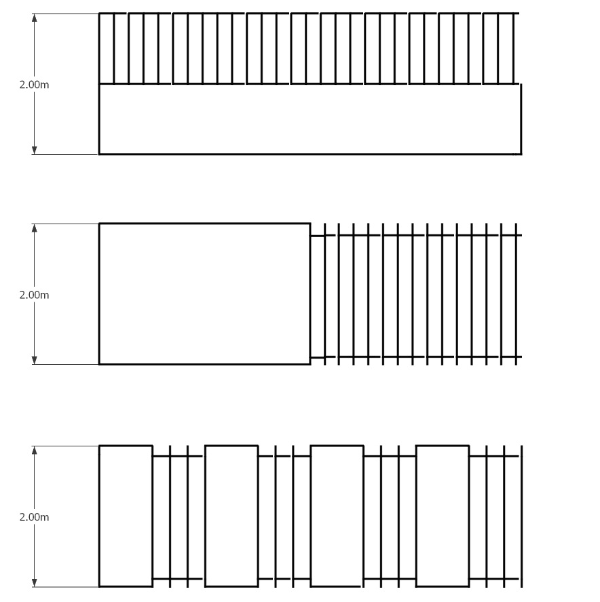

Figure 16.1: Examples of a structure/fence that is 50% visually transparent (being the top half of the first diagram, the right half of the second diagram, and every second section of the last diagram).
- Any application arising from this rule shall not be publicly notified.
      - Maximum building coverage of a site
            - In all areas, the maximum percentage of the net site area covered by buildings shall be 50%.
            - Any application arising from this rule shall not be limited or publicly notified.
      - Minimum building setback from road boundaries/ railway corridor
- The minimum building setback from road boundaries and rail corridor boundaries shall be as follows:
 | Applicable to: | Standard
i. | Any activity unless specified in (ii) – (v) below | 6 metres
ii. | Ancillary offices | 1.5 metres
iii. | Service station canopies | 3 metres
iv. | Sites with more than one road boundary | 1.5 metres on one road boundary  and 6 metres on any other road boundary
v. | Buildings, balconies and decks on sites adjacent to or abutting railway lines. | 4 metres from the rail corridor boundary
- Any application arising from with this rule (other than clause v.) shall not be limited or publicly notified.
- Any application arising from clause v. of this rule shall not be publicly notified and shall be limited notified only to KiwiRail (absent its written approval).
      - Minimum building setback from the boundary with a residential zone
            - The minimum building setback from the boundary with a residential zone shall be 6 metres.
            - Any application arising from this rule shall not be publicly notified.
      - Sunlight and outlook at boundary with a residential zone
            - Where an internal site boundary adjoins a residential zone no part of any building shall project beyond a building envelope contained by a recession plane measured at any point 2.3 metres above the internal boundary in accordance with the relevant diagram in Appendix 16.8.11, unless specified below.
            - Within the Brownfield Overlay, where an internal site boundary adjoins a residential zone, no part of any building shall project beyond a building envelope contained by a 60˚ recession plane measured at any point 4 metres above the internal boundary.
bc. Where sites are located within a Flood management area, recession plane breaches created by the need to raise floor levels shall not be limited or publicly notified.
cd. Any application arising from this rule shall not be publicly notified.
      - Outdoor storage of materials/ car parking
 | Standard
a. | - The outdoor storage of materials shall not be located within the minimum setbacks specified in Rule 16.6.2.3.  - Any outdoor storage area shall be screened by landscaping, fencing or other screening to a minimum of 1.8 metres in height from any adjoining residential zone.
b. | Parking spaces shall be provided to the side or rear of sites and not between buildings and the road, except for visitor parking.
c. | Any application arising from this rule shall not be limited or publicly, except where the adjoining zone is residential.
      - Landscaped areas
- Landscaping and trees shall be provided as follows:
 | Standard
i. | The minimum percentage of the site to have landscaping shall be 10%, excluding those areas required to be set aside for trees within or adjacent to parking areas (refer to clause (iv) below).
ii. | The area adjoining the road frontage of all sites shall have a landscaping strip in accordance with the following standards.  - Minimum width - 1.5 metres  - Minimum density of tree planting – 1 tree for every 10 metres of road frontage or part thereof.
iii. | On sites adjoining a residential zone, trees shall be planted adjacent to the shared boundary at a ratio of at least 1 tree for every 10 metres of the boundary or part thereof.
iv. | In addition to clauses (i), (ii) and (iii) above, where parking areas are located at the front of a site, 1 tree shall be planted for every 5 car parking spaces (or part thereof) within any car parking area.  (Plan Change 5C Council Decision)
v. | All landscaping/ trees required for these rules shall be in accordance with the provisions in Appendix 6.11.6 of Chapter 6.
vi. | The built form standards in clauses (i) and (ii) shall not apply to emergency service facilities.
- Any application arising from clauses (a)(i), (a)(ii) and (a)(iii) of this rule shall not be limited or publicly notified.
Advice note:
                - Vegetation in close proximity to the electricity transmission network will need to be planted and managed in accordance with the Electricity (Hazards from Trees) Regulations 2003.
                - Stormwater facilities shall be incorporated into any development to achieve effective stormwater management and to protect groundwater. The stormwater facilities, which support multiple values such as stormwater retention, water quality treatment, biodiversity enhancement, Ngāi Tahu/ mana whenua values and landscape amenity, should be incorporated into landscaped areas, where practicable, to achieve effective stormwater management and the protection of groundwater in an integrated manner. Stormwater treatment sites or treatment facilities should be separated from natural waterways with vegetated buffers to ensure stormwater is treated before it is discharged into natural waterways or natural wetlands.

      - Water supply for fire fighting
            - Provision for sufficient water supply and access to water supplies for firefighting shall be made available to all buildings via Council’s urban reticulated system (where available) in accordance with the New Zealand Fire Service Firefighting Water Supplies Code of Practice (SNZ PAS: 4509:2008).
            - Any application arising from this rule shall not be publicly notified and shall be limited notified only to New Zealand Fire Service Commission (absent its written approval).

    - Area-specific rules - Industrial Park Zone (Tait Campus)
- The following rules and the Tait Campus Outline Development Plan (Appendix 16.8.9) shall apply to the Industrial Park Zone (Tait Campus). All activities specified are also subject to the rules in 16.6.1 (Activity status tables) and 16.6.2 (Built form standards) unless specified otherwise in 16.6.3.
      - Area-specific activities – Industrial Park Zone (Tait Campus)
        - Area-specific permitted activities
- The activities listed below are permitted activities in the Industrial Park Zone (Tait Campus) if they meet the activity specific standards set out in this table and the built form standards in Rule 16.6.3.2.
Activity |  | Activity specific standards
P1 | Activities listed in Rule 16.6.1.1 P1-P18 | - Development shall comply with:  - All of the key structuring elements on the Tait Campus Outline Development Plan (Appendix 16.8.9), being:  - Green Corridor  - Vehicular route to Stanleys block  - Built form standards in Rule 16.6.3.2, and Rule 16.6.2 unless specified otherwise in Rule 16.6.3.2
P2 | Key structuring elements identified on the outline development plan in Appendix 16.8.9. | - Development is to be in accordance with all of the key structuring elements on the outline development plan, as identified in Rule 16.6.3.1.1 P1.
P3 | Offices  (Plan Change 5C Council Decision) | - Offices shall:  - be limited to a total 5,000m²;  - have visually transparent glazing on the ground floor elevation facing the road for a minimum of 20% of that elevation where the office activity fronts the road;  - have a maximum tenancy size of 500m² GLFA.  (Plan Change 5C Council Decision)

        - Area-specific controlled activities
There are no controlled activities.
        - Area-specific restricted discretionary activities
- The activities listed below are restricted discretionary activities.
- Discretion to grant or decline consent and impose conditions is restricted to the matters of discretion set out in Rules 16.7.1, 16.7.2 and 16.7.3.11, as set out in the following table.
 | Activity | The Council's discretion shall be limited to the following matters:
RD1 | - Any activity listed in Rule 16.6.3.1.1 P1 that does not meet one or more of the built form standards in Rule 16.6.3.2.  Advice note:  - Refer to relevant built form standard for provisions regarding notification. | - As relevant to the built form standard that is not met:  - Minimum building setback from road boundaries/ railway corridor – Rule 16.7.1.3  - For Rule 16.6.3.2.1, Open space and character - Rule 16.7.3.11.1  - For Rule 16.6.3.2.2, Landscaped areas – Rule 16.7.1.7  - For Rule 16.6.3.2.2, Landscaping – Rule 16.7.3.11.2  - Stormwater management – Rule 16.7.3.11.6  - For Rule 16.6.3.2.4, Connectivity - Rule 16.7.3.11.3  - For Rule 16.6.3.2.4, Parking - Rule 16.7.3.11.4  - For Rule 16.6.3.2.4, Access - Rule 16.7.3.11.5
RD2 | - Any development not complying with a key structuring element on the outline development plan in Appendix 16.8.9.  - Any application arising from this rule shall not be publicly notified. | - Matters of discretion in Rule 16.6.3.3.1 – Rule 16.7.3.11.5
RD3 | Any office activity that does not meet Rule 16.6.3.1.1 P3 (a)(ii) activity specific standards.  (Plan Change 5C Council Decision) | - Display of good, showroom and non-industrial activities – Rule 16.7.2.1  (Plan Change 5C Council Decision)

        - Area-specific discretionary activities
There are no discretionary activities.
        - Area-specific non-complying activities
- The activities listed below are a non-complying activity.
 | Activity
NC1 | Any development resulting in more than 10,000m² GFA across the whole Industrial Park Zone (Tait Campus) before the installation of traffic lights (being the physical work) at the intersection of Wairakei Road/ Wooldridge Road/ Roydvale Avenue has been completed.  Advice note:  - The extent of the developer’s contribution to the costs of the upgrade of the intersection of Wairakei/ Wooldridge Roads will be agreed with the Council in accordance with the Council Development Contributions Policy, which may include a Private Developer Agreement.
NC2 | Any activity which results in the daily average sewage flow from a site exceeding 0.09l/s/ha. [Removed]  (Plan Change 5C Council Decision)
NC3 | Any office activity that does not meet Rule 16.6.3.1.1 P3 (a)(i) or (a)(iii) activity specific standards.  (Plan Change 5C Council Decision)

        - Area-specific prohibited activities
There are no prohibited activities.
      - Area-specific built form standards – Industrial Park Zone (Tait Campus)
        - Minimum building setback from road boundaries
            - For sites adjoining Wooldridge Road, the minimum building setback from road boundaries shall be 10 metres, as marked on the outline development plan in Appendix 16.8.9.
            - Any application arising from this rule shall not be publicly notified.
        - Landscaped areas
- Landscaping and trees shall be provided as follows:
 | Standard
i. | A 10 metre wide landscaping strip shall be provided adjacent to the road boundary on sites adjoining Wooldridge Road, excluding roads and pedestrian crossings, and shall comprise:  - at least 1 tree for every 10 metres of road frontage or part thereof;  - deciduous trees, planted in groups of no less than 5 with a minimum of 5 metre spacing between trees;  - tree species shall be capable of reaching a minimum height of 10 metres at maturity and be not less than 3 metres high at the time of planting;  - The two lime trees identified on the outline development plan in Appendix 16.8.9 as 'Retained Lime Trees' shall be maintained and incorporated into the Landscaping buffer adjoining Wooldridge Road;  - The protected trees identified on the outline development plan in Appendix 16.8.9 as 'Protected Trees' and specimen trees immediately surrounding the protected trees in the North West corner of the Zone shall be incorporated into the landscaping buffer adjoining Stanleys Road.
ii. | 1 tree shall be planted for every 5 car parking spaces within any car parking area.
- Any application arising from this rule shall not be publicly notified.
        - Stormwater management

 | Standard
a. | Any stormwater from an activity within the zone shall be managed to meet the following requirements:  - First flush treatment for the first 25mm of runoff from hardstanding areas shall be provided using vegetated dry sedimentation basins.  - Flows in excess of the first flush and including the 50 year return events (9 hour duration) shall be attenuated in the locations defined on the outline development plan in Appendix 16.8.9 as 'On site stormwater treatment and attenuation'.  - Stormwater discharge from the zone to the Council stormwater network shall be attenuated to pre-development levels (for up to 50 year storm events).
b. | Any stormwater from an activity shall be conveyed by open naturalised swales (defined on the outline development plan in Appendix 16.8.9 as 'Open naturalised stormwater conveyance/swales') running through the zone from west to east via a series of basins as defined on the outline development plan in Appendix 16.8.9 as 'On site stormwater treatment and attenuation' to a point defined on the outline development plan from where stormwater shall be piped to an existing drain on the east side of Wooldridge Road.
c. | At least 80% of any planting around swales and ponds for stormwater management shall be indigenous vegetation.
d. | Any application arising from this rule shall not be publicly notified.
        - Roading and access
 | Standard
a. | Access from Stanleys Road:  - Any access to an activity from Stanleys Road shall be at a location marked on the outline development plan in Appendix 16.8.9 as 'Secondary Access'.  - Prior to any activity having access to Stanleys Road, new give-way markings on the Stanleys Road approach to its intersection with Harewood Road shall be provided at the cost of the developer or their successor/s in title.  - Within 6 months of an activity having access to Stanleys Road, a left turn lane shall be provided on the Stanleys Road approach to the Stanleys Road/ Harewood Road intersection, which shall be carried out (as agreed with the Council) at the cost of the developer or their successor/s in title.  - Any development preceding subdivision with access to Stanleys Road shall include a footpath along the Stanleys Road frontage of the zone.
b. | General:  - All work associated with design and construction of vehicle access to the zone, intersection works, internal roads and footpaths within the zone, and a footpath along the road frontage of Stanleys Road shall be provided at the cost of the developer or their successor/s in title.  - Any development preceding subdivision with access to Stanleys Road shall include a shared cycleway and footpath of minimum 2.5 metre width from Wooldridge Road to Stanleys Road as marked on the outline development plan in Appendix 16.8.9 as 'Public shared walk and cycle connection', connecting with pedestrian and cycle facilities adjoining the zone.  - Any surface car parking area associated with an activity shall be in the locations identified on the outline development plan in Appendix 16.8.9 as 'pocket car parks at grade associated with buildings'. Any car parking area elsewhere in the zone shall be located under or within buildings.  - Any pedestrian and cycle way through the site shall be illuminated to a level between 2 and 10 lux.  - Any access to an activity shall be set back from trees identified on the outline development plan in Appendix 16.8.9 as 'Existing trees not to be affected by road layout' by a distance of at least 10 metres.
c. | Any application arising from this rule shall not be publicly notified.
    - Area-specific rules – Industrial Park Zone (Awatea)
- The following rules and the Awatea Outline Development Plan (including the layer diagrams) (Appendix 16.8.10) shall apply to the Industrial Park Zone (Awatea). All activities specified are also subject to the rules in 16.6.1 (Activity status tables) and 16.6.2 (Built form standards) unless specified otherwise in 16.6.4.
      - Area-specific activities - Industrial Park Zone (Awatea)
        - Area-specific permitted activities
- The activities listed below are permitted activities in the Industrial Park Zone (Awatea) if they meet the activity specific standards set out in this table and the built form standards in Rule 16.6.4.2.
Activity |  | Activity specific standards
P1 | Activities listed in Rule 16.6.1.1 P1-P18 | - Development shall comply with:  i. All of the key structuring elements on the Awatea outline development plan (including the layer diagrams) (Appendix 16.8.10), whether they are indicated as 'Fixed Structural Elements' or not, being:  - Blue network elements  - Green network elements  - Green multiuse corridors  - Movement network  - Primary Road  - Location of access points on the movement network  - Traffic treatment to prevent heavy vehicle access  - Representative traditional places and sites of significance  - Traditional headwaters  - Proposed indigenous tree planting corridor.  ii. Built form standards in Rule 16.6.4.2, and Rule 16.6.2 unless specified otherwise in 16.6.4.2
P2 | Key structuring elements identified on the outline development plan in Appendix 16.8.10. | - Development is to be in accordance with the key structuring elements on the Awatea Outline Development Plan (including the layer diagrams) (Appendix 16.8.10), as identified in Rule 16.6.4.1.1 P1.
P3 | Offices  (Plan Change 5C Council Decision) | - Offices shall:  - be limited to a total of 5,000 m²;  - have visually transparent glazing on the ground floor elevation facing the road for a minimum of 20% of that elevation where the office activity fronts the road;  - have a maximum tenancy size of 500m² GLFA.  (Plan Change 5C Council Decision)

        - Area-specific controlled activities
There are no controlled activities.
        - Area-specific restricted discretionary activities
- The activities listed below are restricted discretionary activities.
- Discretion to grant or decline consent and impose conditions is restricted to the matters of discretion set out in Rules 16.7.1, 16.7.2 and 16.7.3.12, as set out in the following table.
 | Activity | The Council's discretion shall be limited to the following matters:
RD1 | - Any activity listed in Rule 16.6.4.1.1 P1 that does not meet one or more of the built form standards in 16.6.4.2.  Advice note:  - Refer to relevant built form standard for provisions regarding notification. | - Minimum building setback from road boundaries/ railway corridor – Rule 16.7.1.3
RD2 | - Any development not complying with a key structuring element on the outline development plan in Appendix 16.8.10.  - Any application arising from this rule shall not be publicly notified. | - Outline development plan – Rule 16.7.3.12.1
RD3 | Any office activity that does not meet Rule 16.6.4.1.1 P3 (a)(ii) activity specific standards.  (Plan Change 5C Council Decision) | - Display of goods, showroom and non-industrial activities – Rule 16.7.2.1  (Plan Change 5C Council Decision)

        - Area-specific discretionary activities
There are no discretionary activities.
        - Area-specific non complying activities
- The activities listed below are non-complying activities.
 | Activity
NC1 | Any activity which results in the daily average sewage flow from a site exceeding 0.09l/s/ha. [Removed]  (Plan Change 5C Council Decision)
NC2 | Any office activity that does not meet Rule 16.6.4.1.1 P3 (a)(i) or (a)(iii) activity specific standards.  (Plan Change 5C Council Decision)

        - Area-specific prohibited activities
There are no area-specific prohibited activities.
      - Area-specific built form standards - Industrial Park Zone (Awatea)
        - Minimum building setback from road boundaries
            - The minimum building setback from the road boundary with Halswell Junction Road or McTeigues Road shall be 10 metres.
            - Any application arising from this rule shall not be publicly notified.
    - Area-specific rules ­ Industrial Park Zone (Wairakei Road)

a. The following rules and the Industrial Park Zone (Wairakei Road) Outline Development Plan (Appendix 16.8.14) shall apply to the Industrial Park Zone (Wairakei Road). All activities specified are also subject to the rules in 16.6.1 (Activity status tables) and 16.6.2 (Built form standards) unless specified otherwise in Rule 16.6.5.

Advice note:

1. The area defined on the Industrial Park Zone (Wairakei Road) Outline Development Plan as “Industrial Park Zone (Tait) and Industrial General Zone (Stanleys Road) – Refer to Appendix 16.8.9” is for information purposes only and the relevant rules for this area are in 16.6.3 and 16.4.7.
      - Area-specific activity status tables ­ Industrial Park Zone (Wairakei Road)
        - Area-specific permitted activities
- The activities listed below are permitted activities in the Industrial Park Zone (Wairakei Road) if they meet the activity specific standards set out in this table and the built form standards in Rule 16.6.5.2.
Activity |  | Activity specific standards
P1 | Activities listed in Rule 16.6.1.1 P1-P18. | - Development shall comply with:  - The location of the key structuring elements on the Industrial Park Zone (Wairakei Road) Outline Development Plan (Appendix 16.8.14), being:  - Stormwater facility locations  - Built form standards in Rule 16.6.5.2, and Rule 16.6.2 unless specified otherwise in Rule 16.6.5.2.  - Activity specific standards in Rule 16.6.1.1 for activities P1 to P18 (Refer to Rule 16.6.1.3 RD2 for any non-compliance)
P2 | Key structuring elements identified on the Outline Development Plan in Appendix 16.8.14 | - Development is to be in accordance with the key structuring elements on the outline development plan, as identified in Rule 16.6.5.1.1 P1.
        - Area-specific controlled activities
There are no controlled activities.
        - Area-specific restricted discretionary activities

a. The activities listed below are restricted discretionary activities.

b. Discretion to grant or decline consent and impose conditions is restricted to the matters of discretion set out in Rules 16.7.1, 16.7.2 and 16.7.3.13, as set out in the following table.
 | Activity | The Council's discretion shall be limited to the following matters:
RD1 | - Any activity listed in Rule 16.6.1.1 P1-P18 that does not meet one or more of the built form standards in 16.6.5.2, unless otherwise specified in Rule 16.6.5.1.5 NC4.  Advice note:  - Refer to the relevant built form standard for provisions regarding notification. | - As relevant to the built form standard that is not met:  - For Rule 16.6.5.2.5, Minimum building setback from the boundary with a residential zone – Rule 16.7.1.4  - For Rule 16.6.5.2.5, Sunlight and outlook at boundary with a residential zone, residential property and road – Rule 16.7.1.5  - For Rule 16.6.5.2.5, Outdoor storage of materials – Rule 16.7.1.6  - Minimum building setback from the boundary with the Rural Urban Fringe Zone & Specific Purpose (Schools) Zone – Rule 16.7.3.13.1  - For Rule 16.6.5.2.2, Landscaping in the Industrial Park Zone (Wairakei Road) ­ Rule 16.7.3.13.2  - Roading and access ­ Rule 16.7.3.13.3
RD2 | - Any activity listed in Rule 16.6.5.1.1 P1 - P2 that does not meet activity specific standard P1 (a)(i) and/or P2 (a).  - Any application arising from this rule shall not be publicly notified. | - Outline development plan – Rule 16.7.3.13.4
        - Area-specific discretionary activities
There are no discretionary activities.
        - Area-specific non­complying activities

a. The activities listed below are non­complying activities.
 | Activity
NC1 | Any new road or direct site access to Russley Road, defined on the Industrial Park Zone (Wairakei Road) Outline Development Plan in Appendix 16.8.14 as “No road or site access”
NC2 | Any activity which results in the instantaneous sewage flow from a site exceeding 0.09 l/s/ha.
NC3 | Any activity resulting in more than 10ha (excluding roads) of land within the Industrial Park Zone (Wairakei Road) Outline Development Plan area as defined in Appendix 16.8.14 being developed for permitted or consented activities before completion of:  - the upgrade of the intersection of Wooldridge Road and Harewood Road comprising traffic signal controls;  - the upgrade of the intersection of Stanleys Road and Harewood Road comprising controls for managing right turning movements out of Stanleys Road.
NC4 | Any activity not complying with Rule 16.6.5.2.4 (Sewer infrastructure).
        - Area-specific prohibited activities
There are no prohibited activities.
      - Area-specific built form standards ­ Industrial Park Zone (Wairakei Road)
        - Minimum building setback from the boundary with the Rural Urban Fringe and Specific Purpose (School) zones
            - The minimum building setback from the boundary with the Rural Urban Fringe and Specific Purpose (School) zones shall be 10 metres.
            - Any application arising from this rule shall not be publicly notified.
        - Landscaped areas
- Landscaping and trees shall be provided as follows:
 | Applicable to | Standard
i. | Activities located on a site that includes or adjoins the former channel of the Styx River, identified on the Industrial Park Zone (Wairakei Road) Outline Development Plan in Appendix 16.8.14 as “Indicative Blue/ green corridor – planting” | - Planting of trees and shrubs shall:  - be completed prior to, or in conjunction with, the establishment of the activity;  - be at a density of 1 tree or shrub per 2m²;  - be undertaken as a corridor either side of the former channel of the Styx River; and  - be of indigenous species only.
ii. | Activities on sites adjoining the Rural Urban Fringe and/or Specific Purpose (School) Zones. | - A landscaping strip shall be provided adjacent to the boundary with the Rural Urban Fringe and/or Specific Purpose (School) Zones in accordance with the following standards:  - Minimum width of 10 metres  - Two rows of trees, staggered in a manner that one row is off-set from the other row;  - Trees shall be spaced 10 metres apart in each row;  - Trees used in the landscaping strip shall comprise one or more of the following species:  Podocarpus totara – Totara, Hoheria angustifolia – houhere/ narrow-leaved lacebark, Plagianthus regius – manatu/ lowland ribbonwood;  - Shrubs shall be planted between the two rows of trees, using the species listed in Appendix 6.11.6 of Chapter 6, section 3;  - The requirements of Appendix 6.11.6 of Chapter 6 Part A shall apply;  - Maintenance of the landscaping strip shall be undertaken for a period of no less than 5 years from the date of planting.  - The landscaping strip shall be completed prior to, or in conjunction with, the establishment of the activity.
iii. | Activities on sites adjoining the Specific Purpose (School) Zones. | - In addition to (a)(i) and (a)(ii), a solid, continuous fence with a minimum height of 1.8 metres shall be constructed on the boundary with the Specific Purpose (School) Zone.  - The fence shall be constructed prior to, or in conjunction with, the establishment of the activity.

- Any application arising from this rule shall not be limited or publicly notified.
        - Roading and access

 | Standard
a. | Any activity shall have vehicle access to Wairakei Road, Stanleys Road and/or Woolridge Road only in the locations marked on the Industrial Park Zone (Wairakei Road) Outline Development Plan (Appendix 16.8.14) as “Road access point – Proposed controlled intersection”.
b. | - There shall be no development of allotments which the 'Collector road' runs through on the outline development plan prior to the vesting of land and its formation as a “Collector road” along the alignment shown on the Outline Development Plan in Appendix 16.8.14.  - There shall be no development of Lot 2, DP54992 (580 Russley Road) and Lot 1, DP54992 (570 Russley Road) prior to the vesting of land and its formation as a Local road along the “Local Road” alignment shown on the Outline Development Plan in Appendix 16.8.14.
c. | Any application arising from this rule shall not be publicly notified.
        - Sewer infrastructure

 | Standard
a. | No activity shall discharge to the Council’s reticulated wastewater network until the upgrade of the Avonhead sewer and Upper Riccarton Interceptor Sewer to provide capacity to accommodate wastewater flows from the Industrial Park Zone (Wairakei Road) into the Wairakei collector sewer.
b. | Any activity which discharges to the Council’s reticulated wastewater network following the upgrades specified under a. shall have a flow meter installed at the discharge point to the Council’s reticulated network.
 | Any application arising from this rule shall not be publicly or limited notified.
        - Boundary with residential properties within the zone
            - The following built form standards shall apply to any boundary with properties used for residential activity within the zone:
  - Rule 16.6.2.4 Minimum building setback from the boundary with a residential zone;
  - Rule 16.6.2.5 Sunlight and outlook at boundary with a residential zone. For the purpose of this rule, Diagram E of Appendix 16.8.11 shall apply;
  - The minimum building setback from the boundary with properties used for residential activity within the zone shall be 6 metres;
  - Where an internal site boundary adjoins properties used for residential activity within the zone, no part of any building shall project beyond a building envelope contained by a 60◦ recession plane measured at any point 2.3 4 metres above the internal boundary in accordance with Diagram E of Appendix 16.8.11;
  - Where sites are located within a Flood management area, recession plane breaches created by the need to raise floor levels shall not be limited or publicly notified; and
  - Rule 16.6.2.6 Outdoor storage of materials/ car parking.
            - Any application arising from this rule shall not be publicly notified.

(Plan Change 5C Council Decision)

    - Area-specific rules - Industrial Park Zone (Memorial Avenue)
- The following rules and the Industrial Park Zone (Memorial Avenue) Outline Development Plan (Appendix 16.8.15) shall apply to the Industrial Park Zone (Memorial Avenue). All activities specified are also subject to the rules in 16.6.1 (Activity status tables) and 16.6.2 (Built form standards) unless specified otherwise in Rule 16.6.6.
      - Area-specific activities ­ Industrial Park Zone (Memorial Avenue)
        - Area-specific permitted activities
- The activities listed below are permitted activities in the Industrial Park Zone (Memorial Avenue) if they meet the activity specific standards set out in this table and the built form standards in Rules 16.6.2 and 16.6.6.2.
- Activities may also be controlled, restricted discretionary, discretionary, non-complying or prohibited, as specified in Rules 16.6.6.1.2, 16.6.6.1.3, 16.6.6.1.4, 16.6.6.1.5 and 16.6.6.1.6.

Activity |  | Activity specific standards
P1 | Activities listed in Rule 16.6.1.1 P1-P18 and activities listed in Rule 16.6.6.1.1 P2-P4. | - The activity shall comply with:  - All of the key structuring elements on the Industrial Park Zone (Memorial Avenue) Outline Development Plan (Appendix 16.8.15), being:  - "Road access point – controlled intersection" locations  - "Collector Road" location  - A “left in, left out only” access configuration at the western access to Memorial Avenue. “Shall comply with” in respect to clause iii. means that the activity and/or its site layout shall not compromise the provision of a left-in, left out only access.  - Built form standards in Rule 16.6.6.2, and Rule 16.6.2 unless specified otherwise in Rule 16.6.6.2.  - Activity specific standards in Rule 16.6.1 for activities listed in Rule 16.6.1.1 P1 to P18 (Refer to Rule RD2 of Rule 16.6.1.3 for any non-compliance).
P2 | Guest Visitor accommodation  (Plan Change 4 Council Decision subject to appeal) | a. No more than 200 bedrooms shall be provided in the zone.  b. Guest Visitor accommodation shall be designed and constructed to comply with the indoor design sound levels contained in Rule 6.1.7.2.1(a)(i)(B). The requirement of Rule 6.1.7.2.1(a)(i)(B) for road traffic noise shall also apply in respect of noise from industrial activity within the zone at the noise levels permitted under Rule 6.1.5.2.1, Table 1.  c. Guest Visitor accommodation shall be limited to the areas defined on the Industrial Park Zone (Memorial Avenue) Outline Development Plan (Appendix 16.8.15) as “Guest Accommodation restricted to this area”.
P3 | Veterinary care facility | Nil
P4 | Health care facility with no overnight accommodation | a. The health care facility shall comply with the indoor design sound levels contained in Rule 6.1.7.2.1(a)(i)(B). The requirement of Rule 6.1.7.2.1(a)(i)(B) for road traffic noise shall also apply in respect of noise from industrial activity within the zone at the noise levels permitted under Rule 6.1.5.2.1, Table 1.
P5 | Key structuring elements identified on the outline development plan in Appendix 16.8.15 | a. The activity shall be in accordance with the key structuring elements on the Industrial Park Zone (Memorial Avenue) Outline Development Plan (Appendix 16.8.15), as identified in Rule 16.6.6.1.1 P1.

        - Area-specific controlled activities
- The activities listed below are controlled activities.
- Discretion to impose conditions is restricted to the matters over which control is reserved in Rule 16.7.3.14, as set out in the following table (the matters of discretion are to be treated as a matter of control for the purposes of this rule).
Activity |  | The Council’s control is reserved to the following matters:
C1 | - The erection of new buildings and additions to existing buildings either wholly or partly within any area between 10 metres and 50 metres of Russley Road and/or between 20 metres and 50 metres of Memorial Avenue.  - Any application arising from this rule shall not be limited or publicly notified. | a. Design and amenity - Rule 16.7.3.14.2
        - Area-specific restricted discretionary activities
a. The activities listed below are restricted discretionary activities.
b. Discretion to grant or decline consent and impose conditions is restricted to the matters of discretion set out in Rules 16.7.1, 16.7.2 and 16.7.3.14, as set out in the following table.
Activity |  | The Council's discretion shall be limited to the following matters:
RD1 | - Any activity listed in Rule 16.6.6.1.1 P1, other than as provided for in Rule 16.6.6.1.5 NC1, that does not meet activity specific standard (a)(i).  - Any application arising from this rule shall not be publicly notified. | a. Outline development plan – Rule 16.7.3.14.1
RD2 | - Any activity listed in Rule 16.6.6.1.1 P1-P4 or Rule 16.6.6.1.3 RD3 that does not meet one or more of the built form standards in Rule 16.6.2 and 16.6.6.2, other than Rule 16.6.6.2.6.  Advice note:  - Refer to the relevant built form standard for provisions regarding notification. | - As relevant to the built form standard that is not met:  i. Maximum height of buildings and fencing or screening structure – Rule 16.7.1.1  ii. Maximum building coverage of a site – Rule 16.7.1.2  iii. Minimum building setback from road boundaries/ railway corridor – Rule 16.7.1.3  iv. Minimum building setback from the boundary with a residential zone, residential property – Rule 16.7.1.4  v. Sunlight and outlook at boundary with a residential zone, residential property and road – Rule 16.7.1.5  vi. Outdoor Storage areas of materials – Rule 16.7.1.6  vii. Landscaped areas – Rule 16.7.1.7  viii. Water supply for fire-fighting – Rule 16.7.1.9  ix. For Rule 16.6.6.2.7, Outline development plan – Rule 16.7.3.14.1  x. For Rule 16.6.6.2.2, Design and amenity - Rule 16.7.3.14.2
RD3 | - Trade suppliers resulting in no more than 10,000m² GLFA in the Industrial Park Zone (Memorial Avenue).  - Any application arising from this rule shall not be limited or publicly notified. | a. Display of goods, showroom and non-industrial activities – Rule 16.7.2.1(a)(i) - (iii), (v), (vi), (ix)  b. Design and amenity – Rule 16.7.3.14.2
        - Area-specific discretionary activities
- The activities listed below are discretionary activities.
 | Activity
D1 | Buildings for permitted, controlled and restricted discretionary activities in Rules 16.6.1 and 16.6.6.1 within the area defined on the Industrial Park Zone (Memorial Avenue) Outline Development Plan (Appendix 16.8.15) as “Airport Runway End Protection Area”, other than enclosed walkways which:  a. are not greater than 2.4 metres in height and/or 1.8 metres in width, and  b. are associated with vehicle parking areas.

- Any application arising from this rule shall not be publicly notified and shall be limited notified only to Christchurch International Airport Limited (absent its written approval).
        - Area-specific non­complying activities

a. The activities listed below are non­complying activities.
 | Activity
NC1 | Any access or road connection from the Industrial Park Zone (Memorial Avenue) to Memorial Avenue or Russley Road in locations other than as shown on the Outline Development Plan in Appendix 16.8.15 as “Road access point – controlled intersection”.
NC2 | Any activity not complying with Rule 16.6.6.2.6 (Sewer infrastructure).
NC3 | Industrial activity or warehousing and distribution activity on any part of a site within 50 metres of Memorial Avenue.
NC4 | Food and beverage outlets with drive-through facilities on any part of a site within 50 metres of Memorial Avenue and/or Russley Road.
NC5 | Activities not complying with Rule 16.6.6.1.1. P2 (a)(i) to (a)(iii) and/or P4 a.
        - Area-specific prohibited activities

There are no prohibited activities.
      - Area-specific built form standards — Industrial Park Zone (Memorial Avenue)

a. The following built form standards shall be met by all permitted activities, controlled activities, and for restricted discretionary activity RD3, unless otherwise stated.
        - Maximum height for buildings

a. The maximum height of any building shall be as follows:
 | Applicable to: | Standard
i. | Buildings – All areas, unless specified below | 15 metres
ii. | Buildings, unless specified below, within 50 metres of Memorial Avenue or adjoining a ‘Key Open Space Location’ defined on the Outline Development Plan in Appendix 16.8.15. | 12 metres
iii. | Buildings for guest visitor accommodation in the area defined on the Outline Development Plan in Appendix 16.8.15 as “Guest Accommodation restricted to this area (20m height limit)”  (Plan Change 4 Council Decision subject to appeal) | 20 metres

b. Any application arising from this rule shall not be publicly notified.

        - Minimum building setback from road boundaries adjacent to Memorial Avenue and Russley Road

a. The minimum building setback from road boundaries shall be as follows:
 | Applicable to: | Standard
i. | Buildings on a site adjacent to Memorial Avenue | 20 metres
ii. | Buildings on a site adjacent to Russley Road | 10 metres

b. Any application arising from clause (a)(i) of this rule shall not be limited or publicly notified.

c. Any application arising from clause (a)(ii) shall not be publicly notified. Limited notification, if required, shall only be to New Zealand Transport Agency (absent its written approval).
        - Sunlight and outlook at boundary with residential properties and guest visitor accommodation within the zone
            - Where a site boundary adjoins a site used for residential activity or guest visitor accommodation within the zone, no part of any building shall project beyond a building envelope contained by a 60◦ recession plane measured from any point 2.3 4 metres above the site internal boundary in accordance with diagram E in Appendix 16.8.11.

b. Any application arising from this rule shall not be publicly notified.

(Plan Change 4 Council Decision subject to appeal)
        - Outdoor storage areas / car parking
 | Standard
a. | Any outdoor storage area (including car parking) shall not be located within the minimum building setbacks specified in Rule 16.6.6.2.2.
b. | i. On sites adjacent to Memorial Avenue, all car parking areas shall be provided to the side or rear of sites and not between buildings and the road.  ii. Car parking areas to the side of buildings shall not occupy more than 40% of the Memorial Avenue road frontage of each site.
c. | Any application arising from this rule shall not be limited or publicly notified.
        - Landscaped areas adjacent to Memorial Avenue and Russley Road

a. Landscaping and trees shall be provided as follows:
 | Standard
i. | A. A landscaping strip shall be provided within the building setback from Memorial Avenue of at least 10 metres in depth.  B. Within the landscaping strip, at least 1 tree shall be planted for every 10 metres of the boundary or part thereof.
ii. | Provision shall be made for landscaping to at least 1.8 metres in height along the length of the zone boundary adjacent to Russley Road. Landscaping, comprising shrubs and trees, shall create a continuous screen along the zone boundary for a minimum depth of 1.5 metres.

b. Any application arising from clause (a)(i) of this rule shall not be limited or publicly notified.

c. Any application arising from clause (a)(ii) shall not be publicly notified. Limited notification, if required, shall only be to New Zealand Transport Agency (absent its written approval).
        - Sewer infrastructure
 | Standard
a. | Any activity that discharges to the Council's wastewater network shall not exceed the flows specified in Table A below before the upgrade of the infrastructure identified.
b. | The discharge flow from the site shall be able to be remotely monitored and controlled by Council.
c. | Any application arising from this rule shall not be limited or publicly notified.

Table A
 | Timeframes | Allowable discharge during a storm event (Refer below) | Allowable discharge outside storm event
 | Prior to the upgrade of any part of the Riccarton Interceptor | 0 | 0
 | Maximum discharge after upgrade of the Lower Riccarton Interceptor. | 6.7l/s | 7.8 l/s
 | Maximum discharge following the upgrade of the Upper Riccarton Interceptor and Lower Riccarton Interceptor. | 7.6 l/s | 7.8 l/s
 | Maximum discharge following the full upgrade of the Upper Avonhead Road sewer, Upper Riccarton Interceptor and Lower Riccarton Interceptor sewers. | 0.75 l/s/ha | 0.75 l/s/ha

Advice note:
                - A storm event is defined by the measured water level in the Riccarton Interceptor exceeding the daily Peak Dry Weather flow water level (measured as an average for the month of September each year) by more than 100mm.
        - Roading and access
            - No development undertaken pursuant to Rules 16.6.6.1.1, 16.6.6.1.2 and 16.6.6.1.3 shall occur until the “Main Access” shown on the Outline Development Plan in Appendix 16.8.15 is constructed.

b. Any application arising from this rule shall not be publicly notified.

  - Rules - Matters of discretion
    - Matters of discretion for built form standards
      - Maximum height of buildings and fencing or screening structure
            - Building height:
              - The distance the building is setback from any residential zone and the extent to which this mitigates any adverse effects of the increased height.
              - The extent to which the additional building height may enable the more efficient use of the reminder of the site or the long-term protection of sites of Ngāi Tahu cultural significance identified in Schedule 9.5.6.1, significant trees listed in Appendix 9.4.7.1, or natural features on the site.
              - The design and appearance of the building in mitigating the visual impact of exceeding the height limit.
              - The extent to which the building may visually dominate the area it is located in, having regard to the scale and form of buildings in the surrounding area.
              - The extent to which the location of the building on the site and its visibility minimises visual effects on the surrounding area.
              - The extent to which the increase in height reflects functional requirements of the activity.
            - Fencing or screening structures in the Industrial Park Zone:
              - The extent to which visibility is maintained between the building and the street.
              - The extent to which screening maintains public safety and other Crime Prevention through Environment Design (CPTED) principles.
      - Maximum building coverage of a site
            - The ability to mitigate any adverse effects of increased coverage by additional landscaping or screening.
            - In the Industrial Park Zone, the degree to which the existing and anticipated open space and park-like character of the zone will be retained.
            - Any adverse effects of increased building coverage on the character of the surrounding environment.
            - The extent to which a greater site coverage reflects functional requirements of the activity.
      - Minimum building setback from road boundaries/ railway corridor
            - The extent to which the reduced setback of the building impacts on the amenity of the street environment, having regard to its location within the zone, function of the zone and the anticipated level of amenity.
            - The extent and quality of landscaping to be provided.
            - The effect of a building’s reduced setback, taking account of such factors as existing road widths, existing building setbacks, functional requirements, street planting, and the orientation of buildings on adjoining sites, particularly those in residential zones.
            - Whether the reduced setback from the rail corridor will enable buildings to be maintained without requiring access above, over, or on the rail corridor.
      - Minimum building setback from the boundary with a residential zone, residential property
            - Any adverse visual effects on any adjoining residential property as a result of a reduced building setback.
            - Whether landscaping or screening within the setback mitigates the dominance of buildings.
            - The scale and height of buildings within the reduced setback and their impact on the visual outlook of residents and users on the adjoining site(s).
            - The extent to which buildings in the setback enable better use of the site and improve the level of amenity elsewhere on the site.
            - The proposed use of the setback, the visual and other effects of this use and whether a reduced setback and the use of that setback achieves a better outcome.
            - The effect of a reduced setback on the character of the Industrial Park Zone as a park-like environment.
            - The extent to which the proposed setback intrusion would impact on the visual amenity or use of any esplanade reserve or strip.
      - Sunlight and outlook at boundary with a residential zone, residential property and road
            - The effect of any reduced sunlight admission on properties in adjoining zones, taking account of the extent of overshadowing, the intended use of spaces and for residential properties, the position of outdoor living spaces or main living areas in buildings.
            - The effect on privacy of residents and other users in the adjoining zones.
            - The scale of building and its effects on the character of any adjoining residential zone.
            - The effects of any landscaping and trees proposed within the site, or on the boundary of the site in mitigating adverse visual effects.
            - The effect on outlook from adjoining properties.
            - For sites fronting Blakes Road, Belfast, the extent to which any intrusion of the road boundary recession plane results in additional building scale and bulk and associated effects on the visual and residential amenity of residential properties and the visual amenity of sites on the opposite side of Blakes Road.
      - Outdoor storage of materials
            - The extent of visual impacts on the adjoining environment.
            - The extent to which site constraints necessitate the location of storage within the setback.
            - The type and volume of materials to be stored.
            - The extent, appearance and type of screening or landscaping proposed.
            - The functional requirements of the activity.
      - Landscaped areas
            - The visual effects of buildings taking account of their scale and appearance, outdoor storage areas, car parking areas or other activities as a result of reduced landscaping.
            - The extent to which the site is visible from adjoining residential sites and/or identified arterial roads fulfilling a gateway function and the likely consequences of any reduction in landscaping or screening on the amenity of those sites.
            - Whether there are any compensating factors for reduced landscaping or screening, including the nature or scale of planting proposed, the location of parking areas, manoeuvring areas or storage areas, or the location of ancillary offices/wholesale display of goods/showrooms.
            - The extent to which the length of the road frontage to any adjoining zone boundary reduces the need for tree planting.
            - The relative importance of landscaping on the site, taking account of the visual quality of an adjoining zone.
            - The extent to which the proposal is consistent with the anticipated amenity of the zone.
            - The extent to which tree planting under the electricity transmission network would adversely affect the safe and efficient functioning of the electricity network or restrict maintenance of that network.
            - The extent to which indigenous species are used to recognise and enhance Ngāi Tahu/mana whenua cultural values, particularly where development is located within a Site of Ngāi Tahu Cultural Significance identified in Appendix 9.5.6.
            - The extent to which stormwater facilities are integrated into landscaped areas to achieve a multi-value approach.
            - The appropriateness and placement of landscaping having regard to the potential adverse effects on safety for pedestrians and vehicles and the functional requirements of the activity.
      - Access to the Industrial General Zone (Deans Ave)
            - Whether any conflict may be created by vehicles queuing across the vehicle crossing.
            - Whether there may be potential confusion between vehicles turning at the crossing or the intersection.
            - The effect on safety for all road users of the proposed road access points to the Industrial General Zone (Deans Ave).
            - Whether the speed and volume of vehicles on the road will exacerbate the adverse effects of access on the safety of users of all transport modes.
            - Whether the geometry of the frontage road and intersections will mitigate the adverse effects of the access.
            - The present traffic controls along the road corridor where vehicular access is proposed.
            - Any cumulative effects when considered in the context of existing access points serving other activities in the vicinity.
            - The proposed traffic mitigation measures such as medians, no right turn or left turn signs, or traffic calming measures.
      - Water supply for fire fighting
            - Whether sufficient firefighting water supply is available to ensure the health and safety of the community, including neighbouring properties.
      - Development Plan for land at 65 – 67 Racecourse Road
            - Whether there may be potential confusion between vehicles turning at the crossing or the intersection.
            - The effect on safety for all road users of the proposed road access points.
            - Whether the geometry of the frontage road and intersections will mitigate the adverse effects of the access.
            - The present traffic controls along the road corridor where vehicular access is proposed.
            - Any cumulative effects when considered in the context of existing access points serving other activities in the vicinity.
            - The proposed measures to mitigate traffic effects.
            - Whether residential amenity is maintained on the frontage with Racecourse Road through the provision of landscaping and setback of buildings.
            - The provision made for trees and planting to mitigate any effects.
    - Matters of discretion for activity specific standards
      - Display of goods, showroom and non-industrial activities
            - General:
              - The extent to which the activity does not adversely affect the function of the zone to provide for primarily industrial activities.
              - The impact of the activity on the ability of existing or future permitted industrial activities to operate or establish without undue constraint.
              - The effect of the development on the capacity to accommodate future demand for industrial activities.
              - The extent to which the activity is ancillary to the primary use of a site for industrial activities.
              - The extent to which the activity contributes to the accumulation of other non-industrial activities that may discourage or displace industrial activities.
              - Whether there are any benefits of a non-industrial activity providing a buffer between industrial activities and more sensitive land use activities.
              - Whether the establishment of non-industrial activities would enable or assist the retention of an historic building.
              - The extent to which the activity will be integrated with other commercial activities in an adjoining commercial zone.
              - The extent to which the activity generates traffic and other effects that impact on the day to day operation of the industrial area.
              - The functional requirements of the activity and the necessity for additional floorspace.
            - Retail activity, commercial service, gymnasium and preschool:
              - The extent to which the activity serves the needs of workers and visitors to the industrial area.
              - The extent to which the activity is accessible by a range of modes of transport for communities served by the proposed activity.
            - Offices:
              - The visual effect of the extent of areas of glazing facing the street, particularly at ground level.
      - Residential activity
            - In relation to minimum unit size, whether:
              - The floorspace available and the internal layout represents a viable residential unit that would support the amenity of current and future occupants;
              - Other on-site factors compensate for a reduction in unit sizes e.g. communal facilities;
              - The units are to be a part of a development delivered by a social housing provider and have been designed to meet any specific needs of future social housing tenants and/or atypical housing needs.
            - In relation to the amount of storage and waste management spaces, whether:
              - The amount of space to store rubbish and recycling, whether communal, outdoor or indoor is adequate;
              - The volume of space provided for personal storage is adequate.
            - In relation to the configuration of storage and waste management space, whether:
              - The location of rubbish and recycling space for residents is convenient;
              - The lack of screening of any outdoor service space will impact on the visual amenity within the site and of any adjoining site, activity, or the street scene;
              - The size and flexibility of the residential unit layout provides other indoor storage options where an indoor storage space is not provided for each unit;
              - The alternative storage areas provided on the site are adequate, accessible and convenient, where indoor storage space is not provided for each residential unit.
            - In relation to the amount of outdoor living space, whether:
              - There is any alternative provision of publicly available space on, or in close proximity to the site to meet the needs of occupants now and in the future;
              - The reduction in outdoor living space is proportional to the size of the residential unit and the demands of the likely number of occupants now and in the future;
              - The reduction in outdoor living space or the lack of its access to sunlight is compensated for by alternative indoor or outdoor living space.
            - In relation to the location and configuration of outdoor living space:
              - Whether the allocation between private and communal outdoor living spaces within the site is adequate and appropriately located to meet the current and future needs of occupants of the site;
              - Where the communal outdoor/indoor spaces are not contiguous on a large site, the ability of the spaces to meet the needs of residents and provide a high level of residential amenity;
              - Whether the reduction in outdoor living space will result in additional loss of mature on-site vegetation and/or spaciousness of the area.
            - In relation to noise insulation:
              - The extent to which the building specifications, nature and/or purpose of the proposed residential accommodation reduce the impact of noise and minimise reverse sensitivity effects.
      - Sensitive activities
            - For preschools:
              - The potential for reverse sensitivity effects on port activities located at Lyttelton Port and/or industrial activities within the Industrial Heavy Zone.
              - Whether any methods to reduce the potential for reverse sensitivity effects on industrial activities within the Industrial Heavy Zone and/or the port operator, other than acoustic insulation, have been incorporated into the design of the proposal.
              - The provision of a report from an acoustic specialist provides evidence that the level of external to internal noise reduction is appropriate to ensure the amenity of present and future occupiers of the site.
      - Boarding of domestic animals
- The extent to which the proposal takes into account:
- the number and type of animals;
- building design, including soundproofing and ventilation;
- effluent management and disposal;
- prevailing climatic conditions and topography of the site and surrounding area that may affect odour and noise generation;
- existing and proposed landscaping;
- the frequency and nature of management and supervision; and
- the sensitivity of the receiving environment.
- The extent to which the scale of the operation and location of associated building/s maintain the anticipated level of amenity of the zone, including relevant zone built form standards.
- The extent to which buildings, compounds or part of a site used for animals are sufficiently designed and located or separated from sensitive activities, identified building areas and residential zone boundaries to avoid adverse effects on residents.
- The effects of the hours of operation and public visiting the site on the surrounding environment.
- Any other mitigation proposed including visual screening.
(Plan Change 5C Council Decision)

      - Brownfield Area Redevelopment
- The extent to which the proposal meets the criteria set out in Policy 16.2.2.2(c).
- Whether a high-quality residential environment is achieved that is consistent with the outcomes sought for Medium Density Residential Zone.
- The extent to which the proposal addresses the Residential Design Principles in Rule 14.15.1.
    - Matters of discretion for area-specific standards
      - Area-specific rules - Matters of discretion – Industrial General Zone (Waterloo Park)
        - Outline development plan - Industrial General Zone (Waterloo Park)
            - The extent to which development is in accordance with the outline development plan.
            - The extent to which the location of vehicular access points, the design of the transport network (including road alignment and intersection design within the outline development plan area and connections with the wider network), and the associated vehicle movements (including the type and volume of vehicles) may individually or cumulatively impact on residential amenity values and the safety and efficiency of the transport network.
            - The degree to which stormwater management areas are suitably located for managing stormwater quality and quantity within the outline development plan area.
            - The extent to which any stormwater system recognises and/or provides for values of importance to Ngāi Tahu/ mana whenua and in particular the maintenance and enhancement of water quality and mahinga kai values.
            - The degree to which stormwater retention basins and open space are located so as to provide an effective buffer between industrial and residential activities.
            - The extent to which stormwater basins and open space areas are co-located so as to maximise recreational and amenity opportunities.
            - The extent to which development has adverse effects on the anticipated amenity values of adjoining zones and the means of mitigating this.
      - Area-specific rules - Matters of discretion – Industrial General Zone (Portlink Industrial Park)
        - Development Plan – Industrial General Zone (Portlink Industrial Park)
            - The extent to which development is in accordance with the development plan.
            - The extent to which the location of vehicular access points, the design of the transport network (including road alignment and intersection design within the development plan area and connections with the wider network), and the associated vehicle movements (including the type and volume of vehicles) may individually or cumulatively impact on the safety and efficiency of the transport network.
        - Landscaping in Portlink Industrial Park Development Plan
            - The extent to which landscaping, planting and stormwater treatment ponds maintain or enhance the visual amenity and ecological values of the margins of the Heathcote River.
            - The extent to which landscaping of the Heathcote River margin can contribute to the enhancement of Ngāi Tahu/ mana whenua cultural values.
            - The extent to which planting and the location of pedestrian/cycle ways protect and enhance the habitat of birds.
        - Cycle and pedestrian links – Industrial General Zone (Portlink Industrial Park)
- The extent to which the development provides safe and efficient linkages within the development plan area and connections to the wider transport network for walking and cycling.
      - Area-specific rules - Matters of discretion – Industrial General Zone (Musgroves)
        - Roading and access - Industrial General Zone (Musgroves)
            - The extent to which the location of vehicular access points, the design of the transport network (including road alignment and intersection design within the development plan area and connections with the wider network) and the associated vehicle movements (including the type and volume of vehicles) may individually or cumulatively impact on residential amenity values and the safety and efficiency of the transport network.
      - Area-specific rules - Matters of control and discretion – Industrial General Zone (North Belfast)
        - Outline development plan – Industrial General Zone (North Belfast)
            - The extent to which development is in accordance with the Outline Development Plan.
            - The extent to which the location of vehicular access points, the design of the transport network (including road alignment and intersection design within the outline development plan area and connections with the wider network) and the associated vehicle movements (including the type and volume of vehicles) may individually or cumulatively impact on residential amenity values and the safety and efficiency of the transport network including the main north line railway corridor.
            - The degree to which stormwater retention basins and swales are located so as to provide an effective buffer between industrial and other activities, and to avoid adverse effects on the rail corridor.
            - The extent to which stormwater areas and open space areas are co-located so as to maximise recreational and amenity opportunities.
            - The extent to which stormwater is separated from springs to protect Ngāi Tahu/ mana whenua values.
        - Additional road access – Industrial General Zone (North Belfast)
            - The effect of any additional access points on the safety and efficiency of the adjoining road network, and on connectivity with adjoining properties, having regard to:
              - the level and type of traffic using the proposed access point;
              - the location and design of the proposed access point;
              - the adequacy of existing access points;
              - the nature and extent of consultation with adjoining landowners; and
              - the extent to which the access point and its associated access road enables comprehensive development of the wider outline development plan area by a legal mechanism and other appropriate method.
        - Springs – Industrial General Zone (North Belfast)
            - The extent to which springs within the outline development plan area are protected, maintained and enhanced with a suitable buffer.
            - The degree to which springs in the outline development plan area are affected by development and any measures proposed to mitigate the effects.
            - The effects on ecological, cultural and amenity values associated with the springs.
            - Whether the development proposed has regard to any existing natural flowpath of water from a spring in its design.
            - The benefits of incorporating springs into stormwater management areas and the provision of buffers or similar within these areas to avoid stormwater entering springs and the mixing of waters.
      - Area-specific rules - Matters of discretion - Industrial General Zone (Stanleys Road)
        - Roading and access - Industrial General Zone (Stanleys Road)
            - The degree to which safe and efficient pedestrian and cycle access is provided with the adjoining area and transport networks.
      - Area-specific rules - Matters of discretion – Industrial General Zone (Trents Road)
        - Landscaping in the Industrial General Zone (Trents Road)
            - The extent to which development is in accordance with the outline development plan.
            - The extent to which the planting (species and density) will maintain an attractive green edge to the adjoining residential and rural areas.
        - Stormwater management in the Industrial General Zone (Trents Road)
            - The effectiveness of the design, construction and operation of stormwater facilities in managing stormwater on-site including retention and treatment.
            - The ability for the stormwater system to be adequately maintained, particularly if it remains in private ownership.
            - The extent to which treatment and disposal methods conform to the Council’s guidelines for stormwater management systems.
            - The extent to which any stormwater system recognises and/or provides for those values of importance to Ngāi Tahu/ mana whenua and in particular the maintenance and enhancement of water quality and mahinga kai values.
        - Roading and access in the Industrial General Zone (Trents Road)
            - The effect of any additional access points on the safety and efficiency of the adjoining road network, having regard to the level and type of traffic using the proposed access point, the location and design of the proposed access point and the adequacy of existing or alternative access points.
            - The extent to which the location of vehicular access points, the design of the transport network (including road alignment and intersection design within the outline development plan area and connections with the wider network), and the associated vehicle movements (including the type and volume of vehicles) may individually or cumulatively impact on residential amenity values and the safety and efficiency of the transport network.
            - The degree to which safe and efficient pedestrian access is provided through the site.
      - Area-specific rules - Matters of discretion - Industrial General Zone (South West Hornby)
            - The extent to which development is in accordance with the outline development plan.
            - The extent to which development provides for future road connections within the South West Hornby Industrial area and the wider network.
      - Area-specific rules - Matters of discretion – Industrial Heavy Zone (Sir James Wattie Drive)
        - Outline development plan – Industrial Heavy Zone (Sir James Wattie Drive)
            - The extent to which development is in accordance with the outline development plan.
            - The extent to which the development provides for safe and efficient connectivity within the outline development plan area and to the surrounding area and transport network for vehicles, pedestrians and cyclists including to Marshs Road and the public cycleway between Little River, Prebbleton and Hornby.
            - The extent to which the landscaping, (planting and maintenance) and stormwater infiltration enhance the visual amenity and cultural values of the site and in particular the urban-rural edge at Marshs Road and the approach to Christchurch City on Shands Road.
        - Setback from Marshs Road – Industrial Heavy Zone (Sir James Wattie Drive)
            - The effect of reducing the setback on the visual amenity of the adjoining rural zone.
      - Area-specific rules - Matters of discretion – Industrial Heavy Zone (South West Hornby)
        - Outline Development Plan – Industrial Heavy Zone (South West Hornby)
            - The extent to which development is in accordance with the outline development plan.
            - The extent to which landscaping (planting and maintenance) enhances the visual amenity and Ngāi Tahu/mana whenua cultural values of the site and in particular the urban-rural edge at Marshs Road and the approach to Christchurch City on Shands Road.
        - Setback from boundaries adjoining rural zone – Industrial Heavy Zone (South West Hornby)
            - The effect of reducing the setback on the visual amenity of the adjoining rural zone and the approach to Christchurch City along Marshs Road, Main South Road and Shands Road.
        - Landscaping at rural urban interface – Industrial Heavy Zone (South West Hornby)
            - The extent to which planting (species and density) will maintain an attractive green edge to the urban area and support biodiversity and Ngāi Tahu cultural values.
        - Roading and access – Industrial Heavy Zone (South West Hornby)
            - The extent to which the location of vehicular access points, the design of the transport network (including road alignment and intersection design within the outline development plan area and connections with the wider network), and the associated vehicle movements (including the type and volume of vehicles) may individually or cumulatively impact on the amenity values of the surrounding area and the safety and efficiency of the transport network.
            - The effect of any additional access points on the safety and efficiency of the adjoining road network, having regard to the level and type of traffic using the proposed access point, the location and design of the proposed access point and the adequacy of existing or alternative access points.
            - The extent to which the measures for mitigating the effects of development support a comprehensive and integrated approach to development of the South West Hornby industrial area.
            - The extent to which the development affects the construction and future operation of the movement network as shown on the outline development plan.
            - The extent to which the use of sympathetic design and landscaping treatment integrate the proposed vehicle access into the surrounding rural environment, in particular with regards to character and amenity.
      - Area-specific rules - Matters of discretion ­ Industrial Heavy Zone (Springs Road)
        - Landscaping on boundaries adjoining the Southern Motorway - Industrial Heavy Zone (Springs Road)
            - The extent to which planting will maintain a green edge to the urban area.
        - Road access to Springs Road - Industrial Heavy Zone (Springs Road)
            - The extent to which the design (including geometry and layout) of the road access to Springs Road in the location marked on the outline development plan (Appendix 16.8.13) affects the following, having regard to the volume and type of traffic using the access:
              - safety for all road users on Springs Road; and
              - the function and efficiency of Springs Road.
            - The effectiveness of proposed mitigation measures, including a median strip, controls on turning movements and other measures, relating to the function, efficiency and safety of the road network.
      - Area-specific rules - Matters of discretion – Industrial Park Zone (Tait Campus)
        - Open space and character – Industrial Park Zone (Tait Campus)
            - The extent to which the building form, location, site design and layout of development:
              - contributes to a high amenity environment with significant areas of landscaping and open space, compatible with the character of Nunweek Park and the adjoining rural zones;
              - minimises the visual impact of development as viewed from Stanleys Road, Nunweek Park and adjacent rural properties;
              - maintains views across the zone;
              - provides for and creates a green corridor through the zone that incorporates and enhances landscape and water features including existing trees;
              - recognises the cultural values of Ngāi Tahu/mana whenua.
        - Landscaping – Industrial Park Zone (Tait Campus)
            - The extent to which landscaping provides a transition between the industrial zone and the surrounding rural zones by maintaining an open character, while effectively screening buildings, parking areas and outdoor storage areas.
            - The quality and effectiveness of landscaping proposed along the Wooldridge Road and Stanleys Road frontages in creating an attractive appearance to the zone as viewed from the road.
            - The extent to which stormwater basins, open space, and landscaped areas are co-located so as to maximize recreational and amenity opportunities.
            - The degree to which any reverse sensitivity effects are avoided or mitigated through landscaping.
            - The suitability of planting along the water feature’s edge to the local conditions.
            - The extent to which landscaping incorporates indigenous vegetation, enhances mahinga kai values and water quality of the development.
        - Connectivity – Industrial Park Zone (Tait Campus)
            - The extent to which pedestrian and cycle movement through the zone between Wooldridge Road and Stanleys Road and then to the wider transport network and Nunweek Park are facilitated by pedestrian and cycle ways.
            - The extent to which the principles of Crime Prevention through Environmental Design have been incorporated into the design of pedestrian and cycle ways.
            - The extent to which pedestrian and cycle ways are incorporated within landscaped areas.
            - The provision for vehicle and pedestrian movement between buildings within the site.
        - Parking – Industrial Park Zone (Tait Campus)
            - The visual effect of car parking areas both from within the site and as seen from outside the site, in particular from Nunweek Park and Stanleys Road, and the effectiveness of any mitigation including landscaping.
        - Access – Industrial Park Zone (Tait Campus)
            - The location and design of the external vehicle access points to Stanleys and Wooldridge Roads and their effect on the character, safety and efficiency of the adjoining road network.
            - The effectiveness and safety of pedestrian access to and from the site, including access to the public transport network.
            - The extent to which the location and design of the vehicle access points is integrated with landscaping along the zone boundary and does not compromise the amenity and appearance of the zone as viewed from Wooldridge Road and Stanleys Road
            - The effect of any additional access points in respect to:
              - the likely level and type of traffic using the proposed access points;
              - the effect on the safety and efficiency of the adjoining road network.
        - Stormwater management – Industrial Park Zone (Tait Campus)
            - The extent to which stormwater basins and open space are integrated to maximise recreational opportunities and amenities.
            - The extent to which any stormwater system recognises and/or provides for those values of importance to Ngāi Tahu/ mana whenua and in particular the maintenance and enhancement of water quality and mahinga kai values.
            - The effectiveness of the design, construction and operation of stormwater facilities in treatment and retention of stormwater.
            - The ability for the stormwater system to be adequately maintained, particularly if it remains in private ownership.
            - The extent to which treatment and disposal methods conform to the Council’s guidelines for stormwater management systems.
      - Area-specific rules - Matters of discretion - Industrial Park Zone (Awatea)
        - Outline development plan - Industrial Park Zone (Awatea)
            - The extent to which development is in accordance with the outline development plan.
            - The extent to which the location of vehicular access points, the design of the transport network (including road alignment and intersection design within the outline development plan area and connections with the wider network), and the associated vehicle movements (including the type and volume of vehicles) may individually or cumulatively impact on residential amenity values and the safety and efficiency of the transport network.
            - The effect of any additional access points on the safety and efficiency of the adjoining road network, having regard to the level and type of traffic using the proposed access point, the location and design of the proposed access point and the adequacy of existing or alternative access points.
            - The degree to which safe and efficient pedestrian and cycle access is provided through the industrial zone, and with the adjoining area and wider transport networks.
            - The effectiveness of treatment in the location marked on the outline development plan as 'Traffic treatment to prevent heavy vehicle access' or alternative measures to avoid heavy vehicle movement through the adjoining residential zone.
            - The degree to which the industrial zone is easily accessible by public transport including any bus services.
            - The effectiveness of the design, construction and operation of stormwater facilities in managing stormwater on-site including retention, infiltration and treatment.
            - The ability for the stormwater system to be adequately maintained, particularly if it remains in private ownership.
            - The extent to which treatment and disposal methods conform to the Council’s guidelines for stormwater management systems.
            - The extent to which any stormwater system recognises and/or provides for those values of importance to Ngāi Tahu/mana whenua and in particular the maintenance and enhancement of water quality and mahinga kai values.
            - The extent to which open space corridors are wide and landscaped to a high standard to promote safe and convenient movement through the zone and with adjoining areas while enhancing amenity, supporting ecological values, and recognising Ngāi Tahu/mana whenua values.
            - The extent to which development recognises and protects sites of significance to Ngāi Tahu/mana whenua and values associated with traditional places including headwaters.
            - The extent to which the Rūnanga have been consulted on the proposal and are satisfied that any effects on wāhi tapu and wāhi taonga are mitigated.
            - Whether a Cultural Impact Assessment has been undertaken that demonstrates that a development will not adversely affect wāhi tapu me wāhi taonga.
            - The degree to which the recommendations of the Cultural Impact Assessment have been addressed in the design/ development of the site.
            - The development provides for an indigenous tree planting corridor, and planting of indigenous species within the corridor.
      - Area-specific rules - Matters of discretion ­ Industrial Park Zone (Wairakei Road)
        - Minimum building setback from the boundary with the Rural Urban Fringe Zone & Specific Purpose (School) Zone ­ Industrial Park Zone (Wairakei Road)
            - The extent to which an intrusion into the setback from the boundary:
              - adversely affects the amenity and character of the adjoining zone, and
              - adversely affects the anticipated character and amenity of the zone as a park­like environment, as viewed from the adjoining properties.
            - The extent to which effects of an intrusion into the setback are minimised by screening, landscaping, building scale, form and design to the extent that the intended character and high level of amenity of the Industrial Park Zone (Wairakei Road) is maintained.
        - Landscaping in the Industrial Park Zone (Wairakei Road)
            - The extent to which development provides for and creates a green corridor through the zone that incorporates landscaping including existing vegetation, and enhances multiple values including stormwater retention, water quality treatment, biodiversity enhancement, Ngāi Tahu/ mana whenua values and landscape amenity.
            - The extent to which landscaping provides a buffer between the industrial zone and the adjacent Rural Urban Fringe Zone and Specific Purpose (School) Zone, while effectively screening buildings, parking and storage areas.
            - The degree to which any effects on amenity and character of the adjoining environment are mitigated through landscaping.
        - Roading and access ­ Industrial Park Zone (Wairakei Road)
            - The extent to which the location of vehicle access points (including additional road access points), the design of the transport network (including road alignment and intersection design within the Industrial Park Zone (Wairakei Road) Outline Development Plan (Appendix 16.8.14) area and connections with the wider network), and the associated vehicle movements (including the type and volume of vehicles) may individually or cumulatively impact on the character and amenity of the zone, and safety and efficiency of the transport network.
            - The extent to which the location and design of the vehicle access points are integrated with landscaping along the zone boundary and does not compromise the amenity and appearance of the zone as viewed from an adjoining road.
            - The extent to which pedestrian and cycle movement through the zone and to the wider transport network and Nunweek Park are facilitated by pedestrian and cycle ways.
            - The extent to which the principles of Crime Prevention through Environmental Design have been incorporated into the design of pedestrian and cycle ways to support their use and the safety of users.
        - Outline development plan ­ Industrial Park Zone (Wairakei Road)
            - The extent to which development is in accordance with the Industrial Park Zone (Wairakei Road) Outline Development Plan (Appendix 16.8.14).
            - The degree to which stormwater management areas are suitably located for managing stormwater quality and quantity within the Industrial Park Zone (Wairakei Road) Outline Development Plan (Appendix 16.8.14) area.
            - The extent to which any stormwater system recognises and/or provides for values of importance to Ngāi Tahu/ mana whenua and in particular the maintenance and enhancement of water quality and mahinga kai values.
            - The degree to which stormwater retention basins and open space are located so as to provide an effective buffer between industrial and residential properties.
            - The extent to which stormwater basins and open space areas are co-located so as to maximise recreational and amenity opportunities.

      - Activity-specific rules - Matters of discretion - Industrial Park Zone (Memorial Avenue)
        - Outline development plan - Industrial Park Zone (Memorial Avenue)
            - The extent to which development is in accordance with the Industrial Park Zone (Memorial Avenue) Outline Development Plan in Appendix 16.8.15.
            - The extent to which the location and staging of vehicular access points and the design of the transport network (including road alignment and intersection design within the Industrial Park Zone (Memorial Avenue) Outline Development Plan in Appendix 16.8.15 and connections with the wider network) may individually or cumulatively impact on residential amenity values and the safety, efficiency and connectivity of the transport network.
            - The extent to which the location of guest visitor accommodation outside the areas defined on the Industrial Park Zone (Memorial Avenue) Outline Development Plan in Appendix 16.8.15 as “Guest accommodation restricted to this area” reduces the opportunity for guest visitor accommodation fronting Memorial Avenue and Russley Road, having regard to the limit of 200 bedrooms within the zone.
            - The degree to which guest visitor accommodation outside the areas defined on the Industrial Park Zone (Memorial Avenue) Outline Development Plan in Appendix 16.8.15 as “Guest accommodation restricted to this area” reduces capacity or erodes the integrity and function of the zone for industrial activities.
            - The degree to which guest visitor accommodation outside the areas defined on the Industrial Park Zone (Memorial Avenue) Outline Development Plan in Appendix 16.8.15 as “Guest accommodation restricted to this area” may lead to reverse sensitivity effects on existing and/or potential use of the land for industrial activities.
(Plan Change 4 Council Decision subject to appeal)
        - Design and amenity - Industrial Park Zone (Memorial Avenue)
            - The extent to which the design of the buildings will support the development of and maintain a high quality urban environment, having regard to:
              - the degree of variation in form, bulk, location, orientation and height of the building; and
              - the avoidance of large expanses of wall or repetitious building forms; and
              - the choice of materials.
            - The architectural treatment of the building elevations including the design, architectural features and details, use of colour and building materials.
            - The extent to which space and landscaping is as prominent as the built form to achieve a high amenity environment.
            - The extent to which the location of security fencing detracts from the visual amenity and landscape planting along the street frontage.
            - The extent to which any signage on buildings is integrated with the architectural detail of a building.
            - The extent to which showrooms, offices and areas for the display of goods are positioned to face Memorial Avenue and Russley Road to maximise visual interest.
            - The extent to which car parking and loading areas, service areas and outdoor storage are effectively screened from public view by landscaping.
            - The effectiveness of mitigation including landscaping in reducing the adverse effects of buildings, including their scale and appearance, on the adjoining environment including Memorial Avenue, Russley Road and Avonhead Road.
            - The choice of materials and colours/reflectivity of facades to reduce the prominence of buildings in the landscape.
            - Whether development is oriented to Memorial Avenue and encourages pedestrian movement between buildings and spaces within the zone.

  - Appendices
Appendix 16.8.1 Areas subject to wastewater discharge restrictions – To be removed as being replaced by overlays on planning maps as shown on following pages.
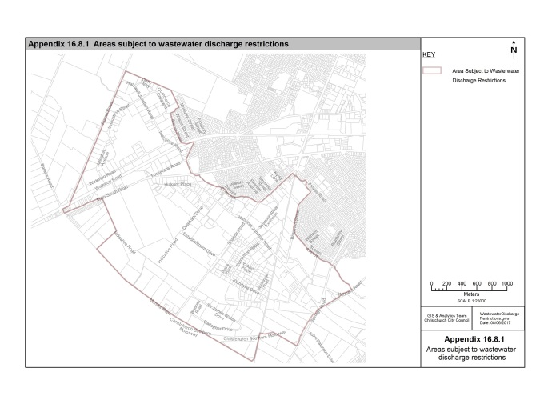
(Plan Change 5C Council Decision)
Planning Map Legend

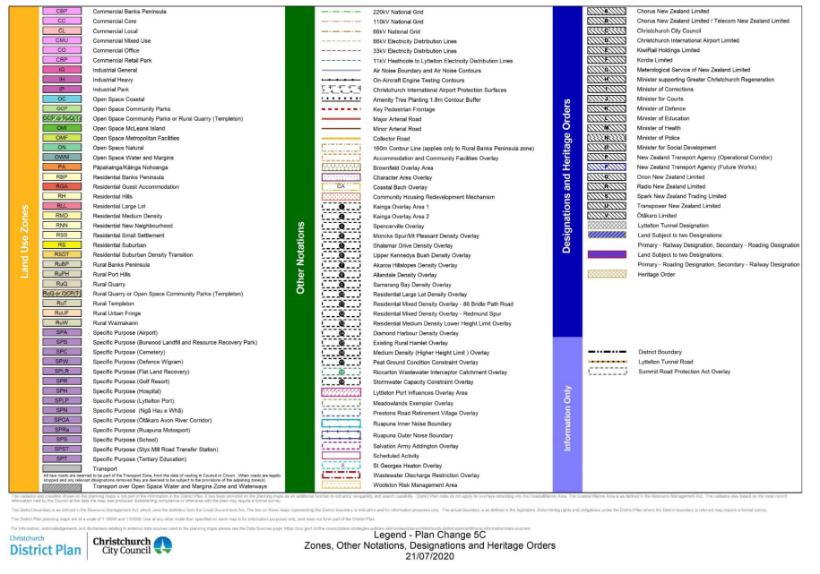

Planning Map 5A

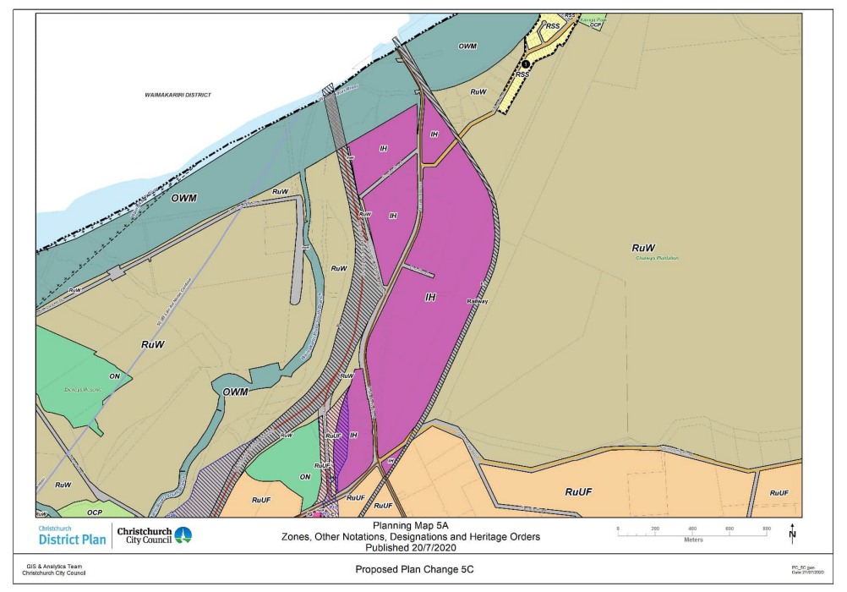

Planning Map 12A

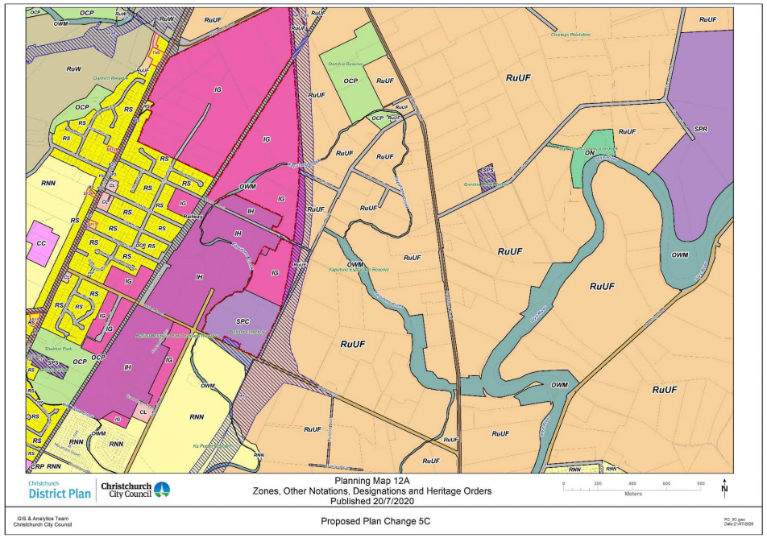

Planning Map 17A
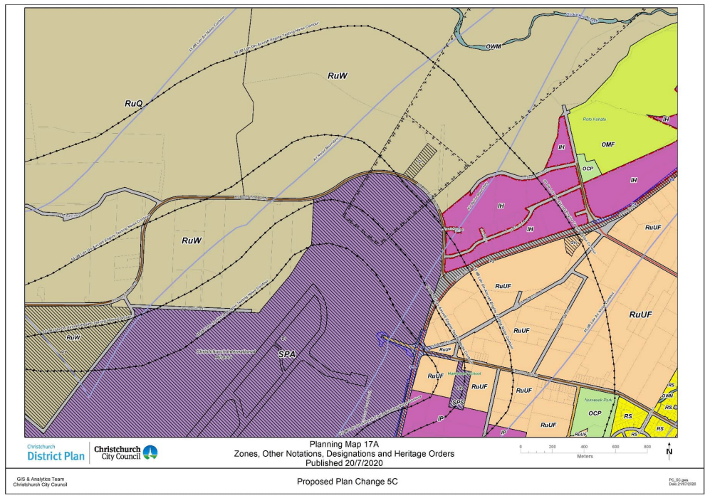

Planning Map 18A

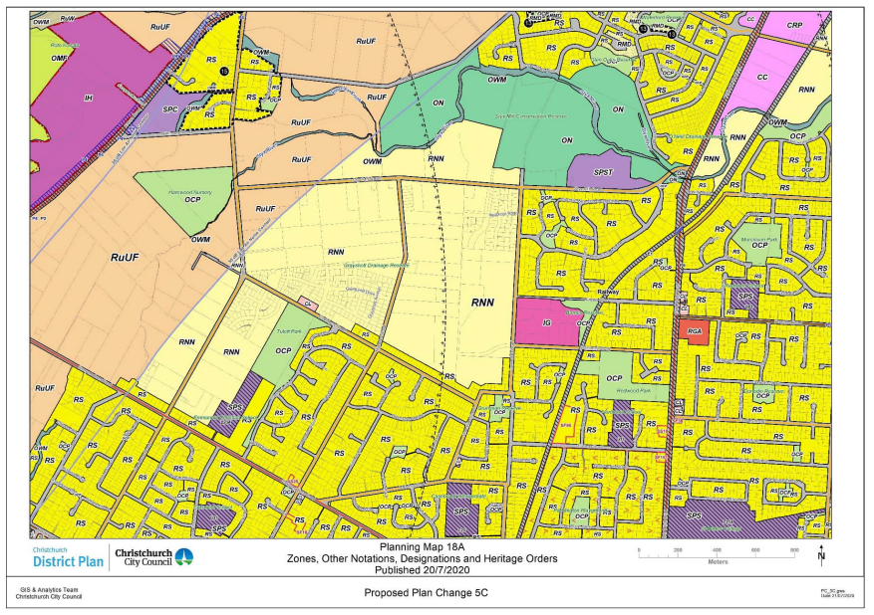

Planning Map 23A

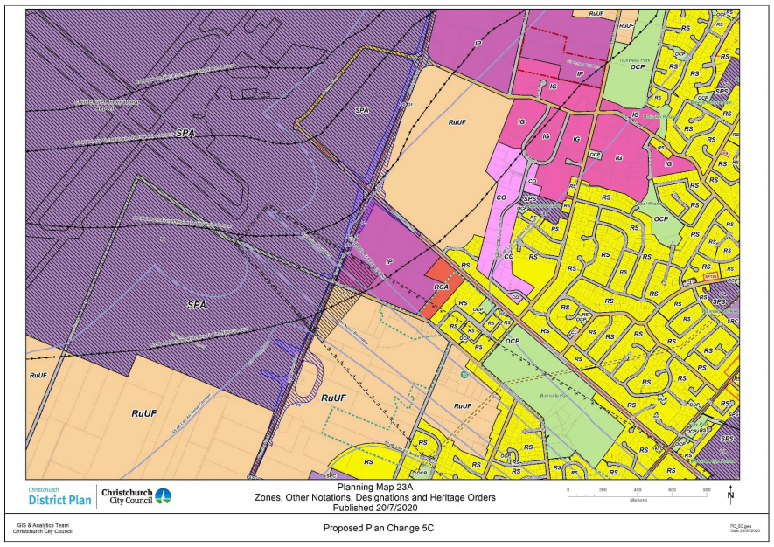

Planning Map 36A

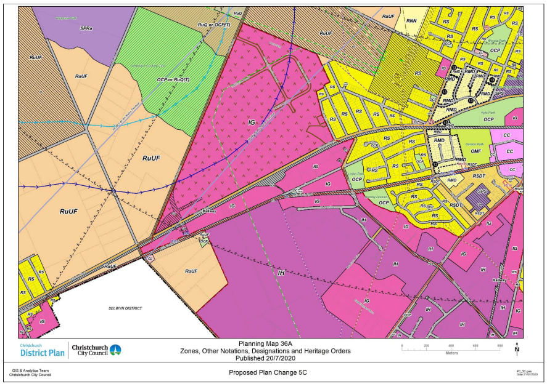

Planning Map 37A

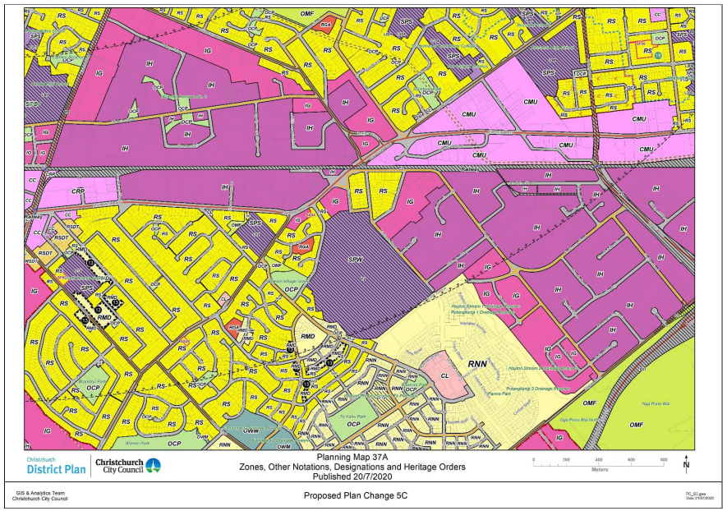
Planning Map 43A

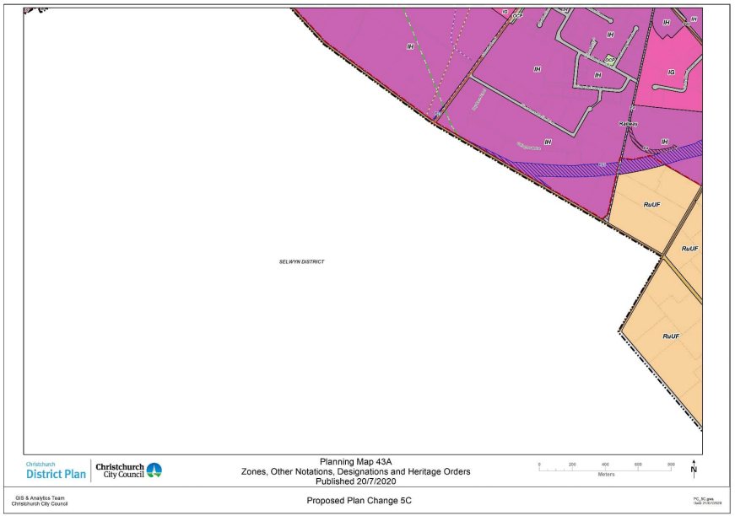

Planning Map 44A

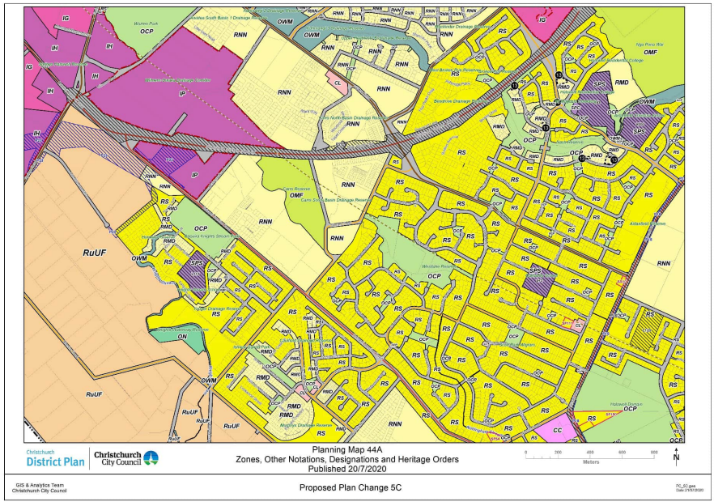
Appendix 16.8.2 Industrial General Zone (Waterloo Park)
Appendix 16.8.2i

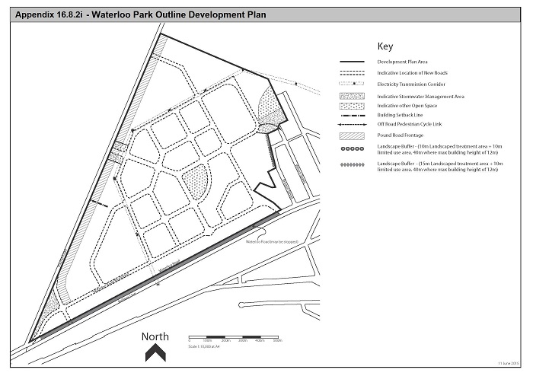

Appendix 16.8.2ii

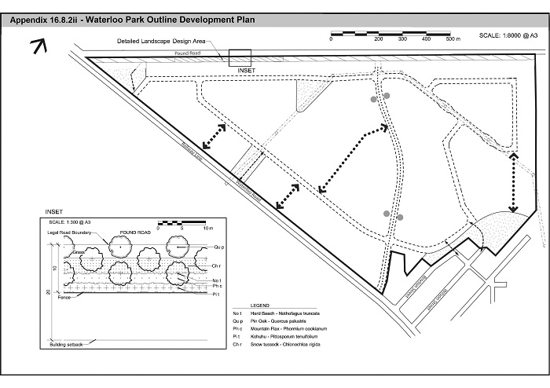

Appendix 16.8.2iii
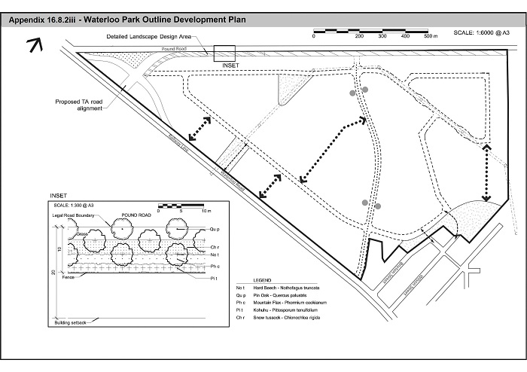
Appendix 16.8.3 Industrial General Zone (Portlink Industrial Park)
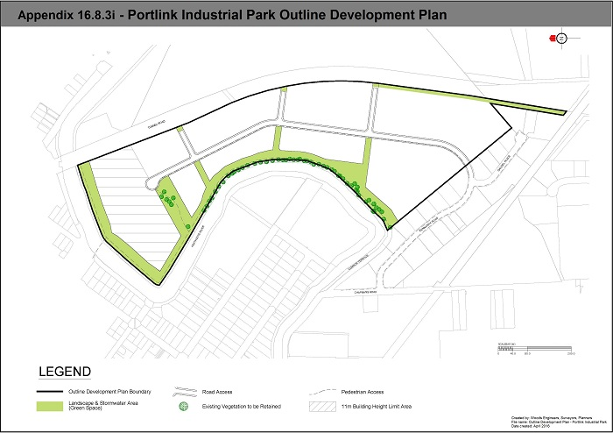

16.8.3.ii Portlink Industrial Park plant list and associated height and locations

- E = Esplanade adjacent to Heathcote River
- T = Tunnel Road landscape setback buffer
- W = Wetter areas (temporarily), such as detention basins and swales
- S = Street planting, other than main road and secondary road tree species

Botanical Name | Common Name | 10 Year Height  (metres) | Mature Height  (metres)
Trees
Cordyline australis (T,E,W) | Cabbage tree | 5 | 7
Grisilinia littoralis (T,E) | Broad leaf | 4 | 17
Pseudopanax arboreus (T,E) | Five finger | 4 | 8
Pseudopanax crassifolius (T,E) | Lancewood | 3 | 14
Pseudopanax ferox (T,E) | Toothed lancewood | 2.5 | 7
Pittosporum tenuifolium (T,E) | Kohuhu | 4 | 9
Pittosporum euginoides (T,E) | Tarata, lemonwood | 3 | 12
Dodonea viscosa (T,E) | Ake ake | 4 | 7
Olearia paniculata (T,E) | Golden Ake ake | 2 | 7
Olearia traversil (T,E) | Chatham Island Ake ake | 3 | 10
Dicksonia squarrosa (E,W) | Wheki | 2 | 5
Dicksonia fibrosa (E,W) | Wheki ponga | 2 | 5
Sophora microphylla (T,E) | South Island Kowhai | 4 | 12
Podocarpus totara (T,E) | Totara | 5 | 30
Darcycarpus dacrydoides (W) | Kahikatea / White pine | 3 | 20
Prumnopitys taxifolia (T,E,W) | Matai / Black pine | 3 | 25
Dacrydium cupressinum (T,E) | Rimu | 3 | 30
Coprosma chathamica (T,E) | Chatham Island coprosma |  | 5
Plagianthus regius (E) | Ribbonwood | 5 | 16
Plagianthus chathamica (E) |  | 4 | 10
Aristotelia serrata (E,W) | Makomako, wineberry | 4 | 8
Coprosma acutifolia (E) | Coprosma, Sp. |  | 10
Hoheria populnea (T,E) | Lacebark | 4 | 11
Hoheria angustifolia | Narrow leaved lacebark | 4 | 8
Coprosma robusta (T,E,W) | Karamu | 6 | 6
Leptospermum scoparium (T,W) | Manuka | 3.5 | 6
Pseudowintera colorata (E) | Horopito | 1.5 | 8
Plagianthus divaricatus (W) | Salt marsh ribbonwood |  | 2
Corokia contoneaster (E) | Korokio |  | 2
Myrsine australis (T,E) | Mapou | 2 | 6
Chionochloa rubra (T,E,S) | Red tussock |  | 1
Cortaderia fulvida (T,E,W) | Mini toetoe |  | 1.5
Anemanthele lessionia (T,E,S) | Wind grass |  | 0.8
Carex secta (T,E,W) | Pukio |  | 0.8
Carex virgata (T,E,W) | Swamp sedge |  | 0.8
Astelia fragrans (T,E) | Bush flax |  | 1.5
Astelia grandis (E,W) | Swamp astelia |  | 2
Hebe stricta (E,W) | Hebe sp. |  | 3
Hebe salicifolia (T,E,W) | Hebe sp. |  | 2.5
Phormium tenax (T,E,W) | Harakeke |  | 2.5
Phormium cookianum (E) | Coastal flax |  | 2
Phormium 'Surfer' (S) |  |  | 0.5
Phormium 'Black rage' (S) |  |  | 0.75
Daniella nigra (E,S) | Ink berry |  | 0.5
Libertia ixiodes (E,S) | NZ Iris |  | 0.5
Street Trees
For secondary cross roads:
Nothofagus solandri var. 'Cliffortioides' (S) | Mountain beech | 2 | 18
Street Trees
For main roads:
Tilia cordata (S) | Small leaved lime |  | 24
Tilia platyphyllos (S) | Large leaved lime |  | 24

Appendix 16.8.4 Industrial General Zone (Musgroves)
Appendix 16.8.4.i
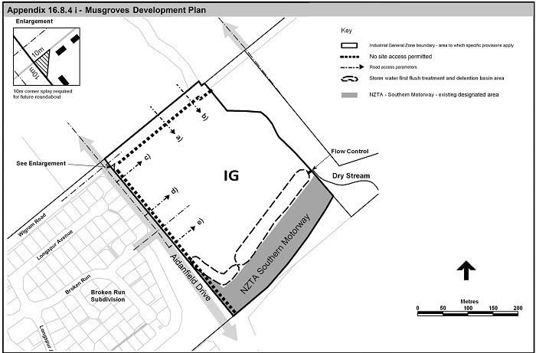

Appendix 16.8.4.ii
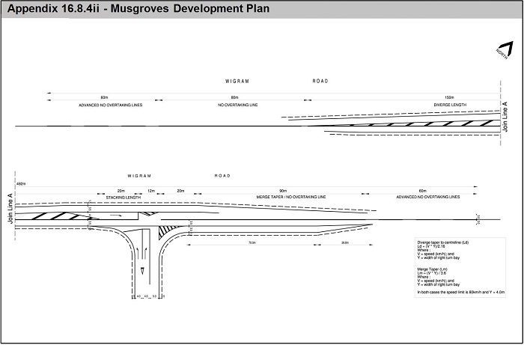

Appendix 16.8.5 Industrial General Zone (North Belfast)
Appendix 16.8.5.i
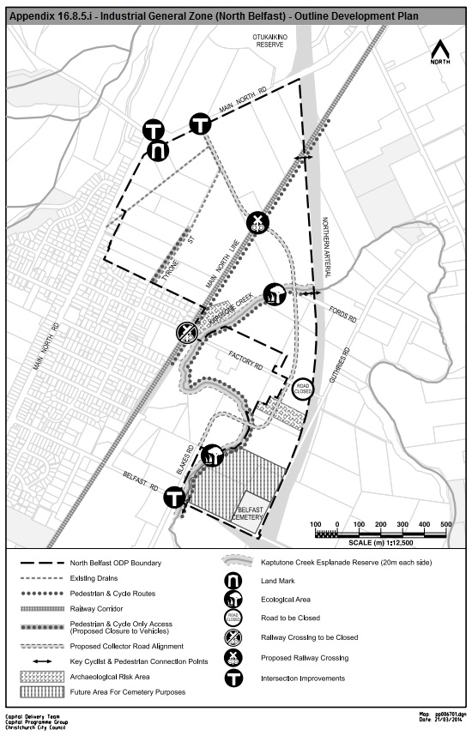

Appendix 16.8.5.ii
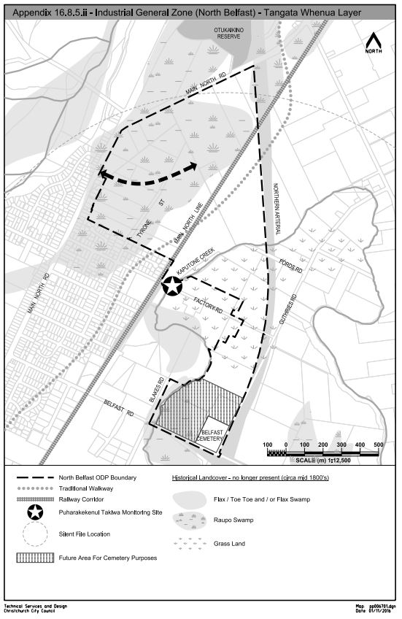

Appendix 16.8.5.iii
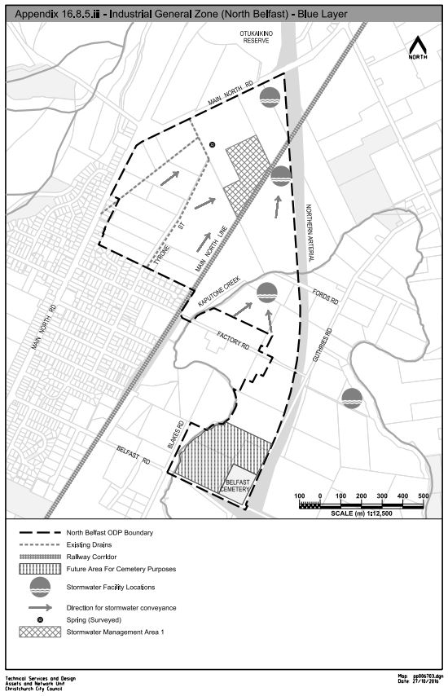

Appendix 16.8.6 Industrial General Zone (Trents Road)
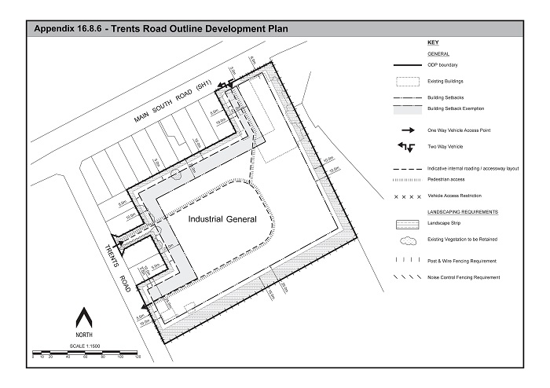
Appendix 16.8.7 Industrial Heavy Zone (Sir James Wattie Drive)
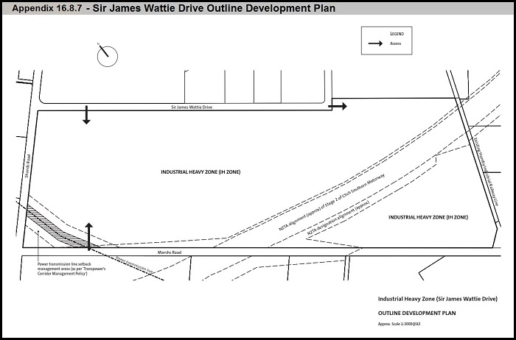

Appendix 16.8.8 South West Hornby Industrial Area
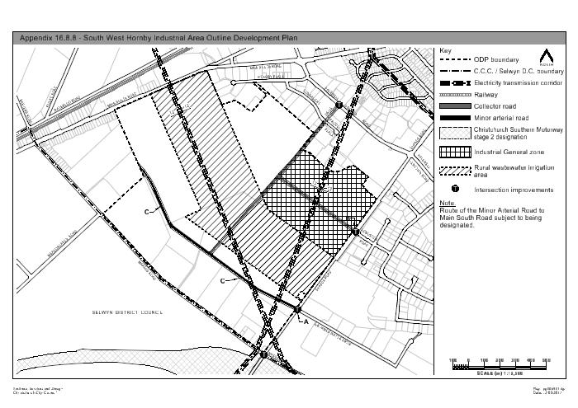

Appendix 16.8.9 Industrial Park Zone (Tait Campus) and Industrial General Zone (Stanleys Road)
Appendix 16.8.9i
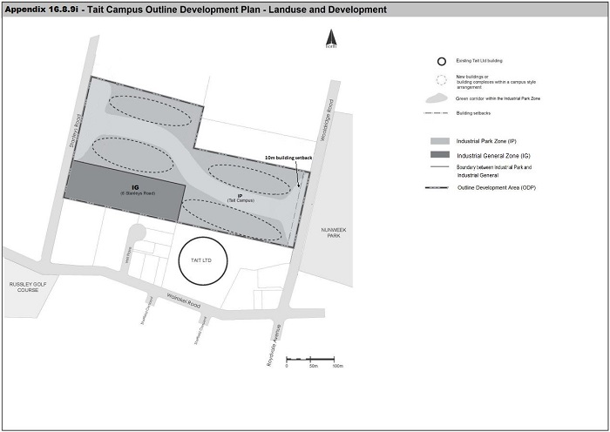

Appendix 16.8.9ii
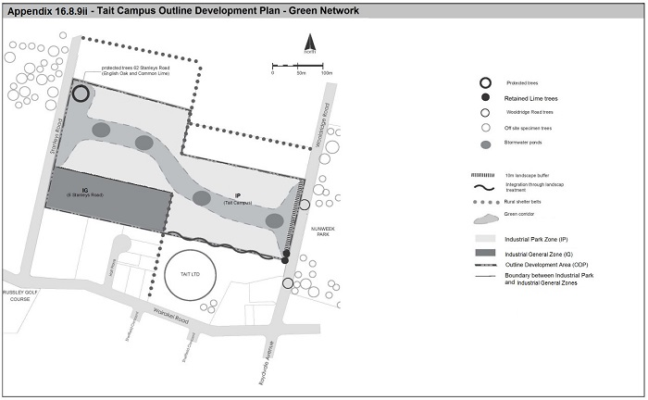

Appendix 16.8.9iii

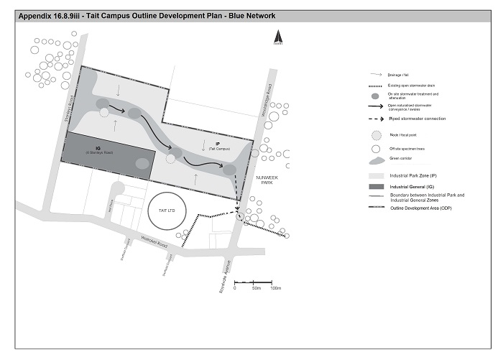

Appendix 16.8.9iv
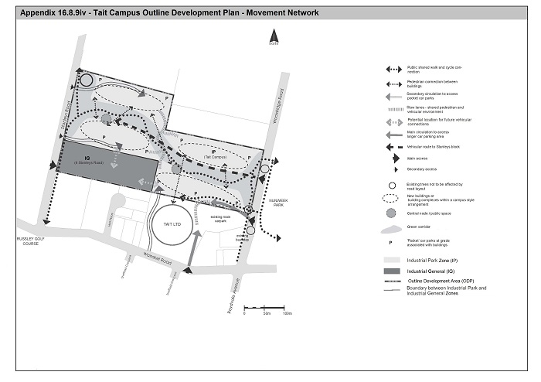
Appendix 16.8.10 Industrial Park Zone (Awatea) Outline Development Plan
Appendix 16.8.10i
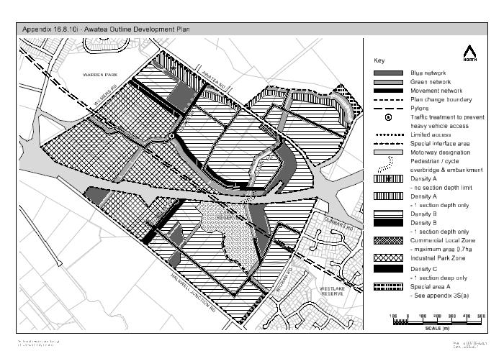
Appendix 16.8.10ii
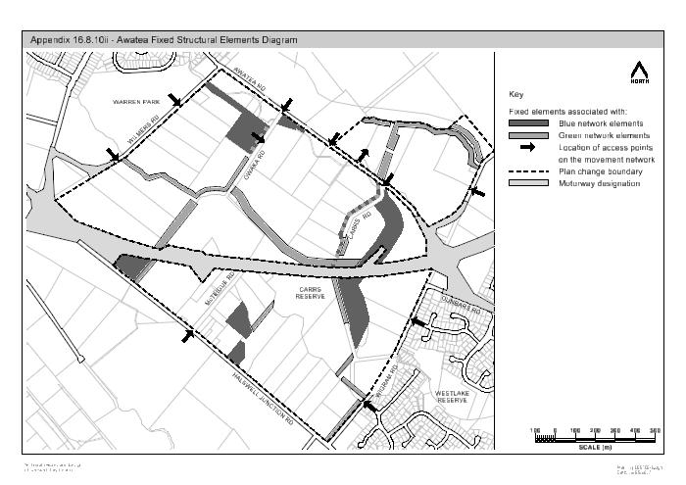

Appendix 16.8.10iii
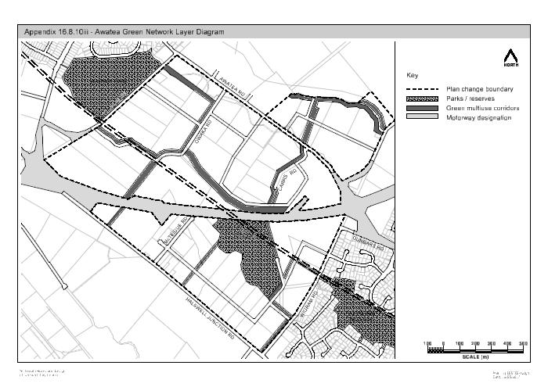

Appendix 16.8.10iv
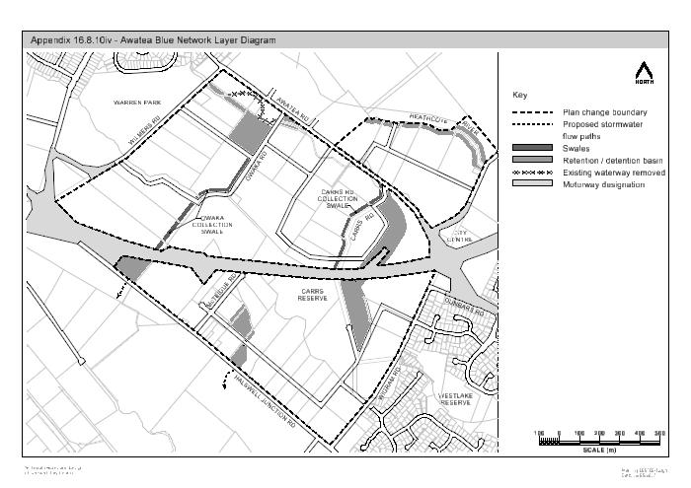

Appendix 16.8.10v
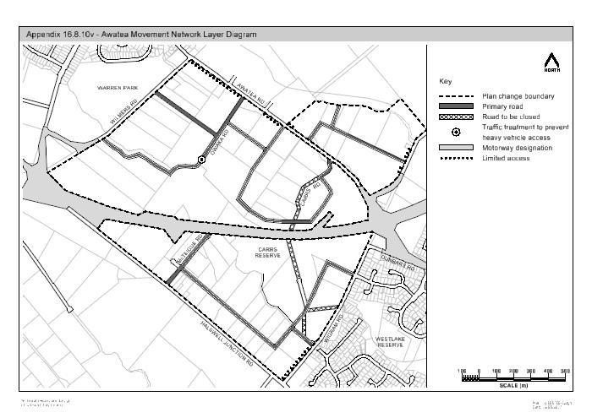

Appendix 16.8.10vi
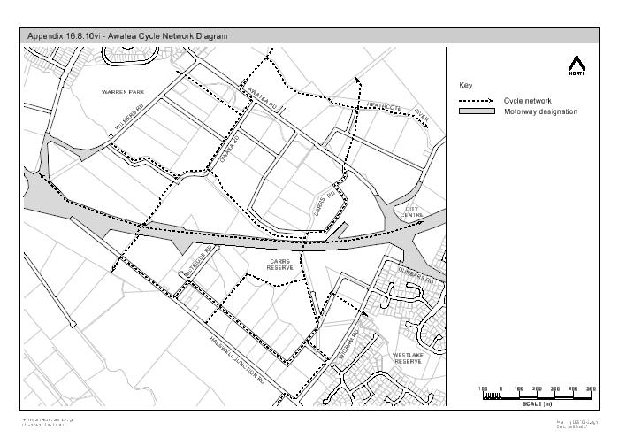

Appendix 16.8.10vii
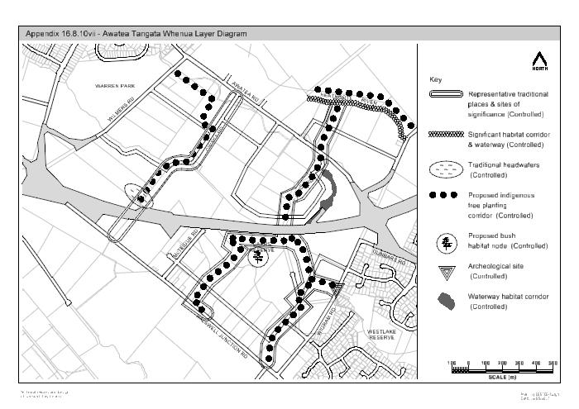
Appendix 16.8.11 Recession Plane Diagrams

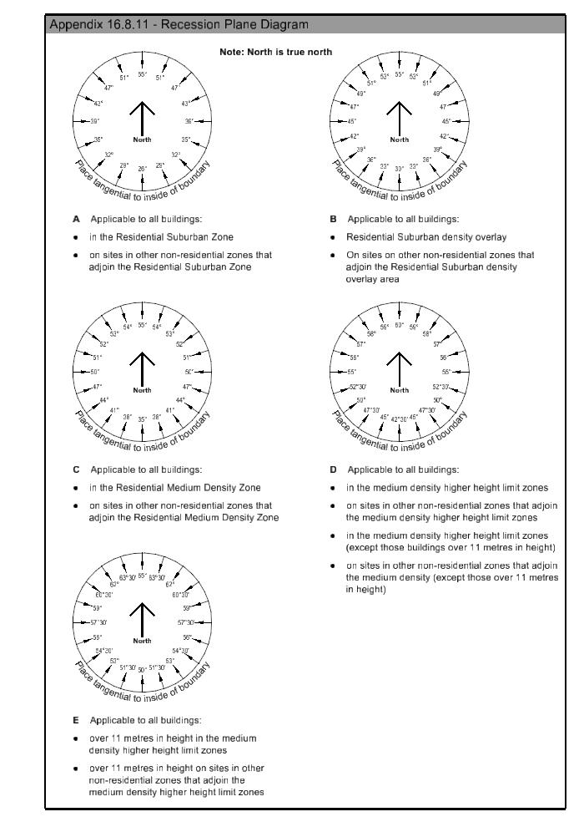
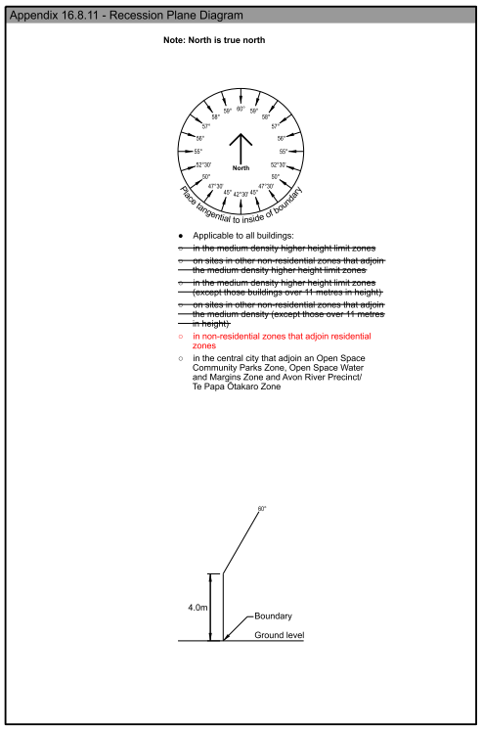

Appendix 16.8.12 Outline Development Plan for 65 – 67 Racecourse Road
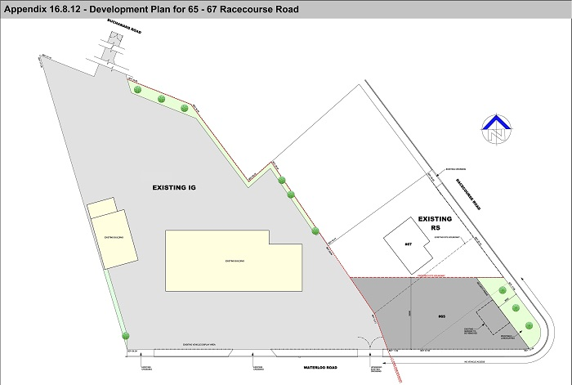

Appendix 16.8.13 Industrial Heavy Zone (Springs Road) Outline Development Plan
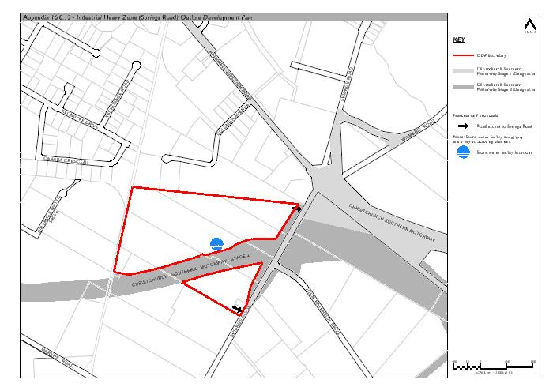
Appendix 16.8.14 Industrial Park Zone (Wairakei Road) Outline Development Plan
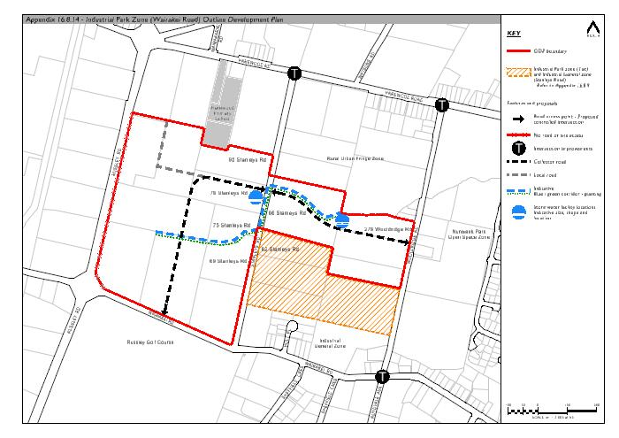

Appendix 16.8.15 Industrial Park Zone (Memorial Avenue) Outline Development Plan
